UNITED STATES

SECURITIES AND EXCHANGE COMMISSION

Washington, D.C. 20549

FORM 10-K

- ANNUAL REPORT PURSUANT TO SECTION 13 OR 15(d) OF THE SECURITIES EXCHANGE ACT OF 1934 For the fiscal year ended March 31, 2025
OR

- TRANSITION REPORT PURSUANT TO SECTION 13 OR 15(d) OF THE SECURITIES EXCHANGE ACT OF 1934 For the transition period from ________to _________

Commission file number 000-38312


8x8, Inc.

(Exact name of Registrant as Specified in its Charter)

 | Delaware |  | 77-0142404
(State or Other Jurisdiction of Incorporation or Organization) |  |  | (I.R.S. Employer Identification Number)

675 Creekside Way

Campbell, CA 95008

(Address of Principal Executive Offices including Zip Code)

(408) 727-1885

(Registrant's Telephone Number, Including Area Code)

Securities registered pursuant to Section 12(b) of the Act:

Title of each class | Trading Symbol | Name of each exchange on which registered
COMMON STOCK, PAR VALUE $.001 PER SHARE | EGHT | Nasdaq Global Select Market

Securities registered pursuant to Section 12(g) of the Act: None

Indicate by check mark if the registrant is a well-known seasoned issuer, as defined in Rule 405 of the Securities Act. Yes ☐ No ☒ Indicate by check mark if the registrant is not required to file reports pursuant to Section 13 or Section 15(d) of the Act. Yes ☐ No ☒

Indicate by check mark whether the registrant (1) has filed all reports required to be filed by Section 13 or 15 (d) of the Securities Exchange Act of 1934 during the preceding 12 months (or for such shorter period that the registrant was required to file reports), and (2) has been subject to such filing requirements for the past 90 days. Yes ☒ No ☐

Indicate by check mark whether the registrant has submitted electronically every Interactive Data File required to be submitted pursuant to Rule 405 of Regulation S-T (§232.405 of this chapter) during the preceding 12 months (or for such shorter period that the registrant was required to submit such files). Yes ☒ No ☐

Indicate by check mark whether the registrant is a large accelerated filer, an accelerated filer, a non-accelerated filer, a smaller reporting company or an emerging growth company. See definitions of "large accelerated filer," "accelerated filer," "smaller reporting company" and "emerging growth company" in Rule 12b-2 of the Exchange Act.

Large accelerated filer | ☐ | Accelerated filer | ☒
Non-accelerated filer | ☐ | Smaller reporting company | ☒
 |  | Emerging growth company | ☐

If an emerging growth company, indicate by check mark if the registrant has elected not to use the extended transition period for complying with any new or revised financial accounting standards provided pursuant to Section 13(a) of the Exchange Act. ☐

Indicate by check mark whether the registrant has filed a report on and attestation to its management’s assessment of the effectiveness of its internal control over financial reporting under Section 404(b) of the Sarbanes-Oxley Act (15 U.S.C. 7262(b)) by the registered public accounting firm that prepared or issued its audit report. ☒

If securities are registered pursuant to Section 12(b) of the Act, indicate by check mark whether the financial statements of the registrant included in the filing reflect the correction of an error to previously issued financial statements. ☐

Indicate by check mark whether any of those error corrections are restatements that required a recovery analysis of incentive-based compensation received by any of the registrant’s executive officers during the relevant recovery period pursuant to §240.10D-1(b). ☐
Indicate by check mark whether the registrant is a shell company (as defined in Rule 12b-2 of the Act). Yes ☐ No ☒

The aggregate market value of voting stock held by non-affiliates of the Registrant on September 30, 2024, based on the closing price of $2.04 for shares of the Registrant’s common stock as reported by the Nasdaq Global Select Market, was approximately $159.8 million. Shares of common stock held by each executive officer, director, and their affiliated holders have been excluded in that such persons may be deemed to be affiliates. The determination of affiliate status for this purpose is not necessarily a conclusive determination for any other purpose.

The number of shares of the Registrant's common stock outstanding as of May 12, 2025 was 134,479,292.

DOCUMENTS INCORPORATED BY REFERENCE

Items 10, 11, 12, 13 and 14 of Part III incorporate information by reference from the Proxy Statement to be filed within 120 days of March 31, 2025 for the 2025 Annual Meeting of Stockholders.

 |  |  |  |  |  |  |  |  |  |  |  |  |  |  |  |  |  |  |  |  |  |  |  |  |  | 8X8, INC.
 |  |  |  |  |  |  |  |  |  |  |  |  |  |  |  |  |  |  |  |  |  |  | INDEX TO ANNUAL REPORT ON FORM 10-K
 |  |  |  |  |  |  |  |  |  |  |  |  |  |  |  |  |  |  |  |  |  |  | FOR THE YEAR ENDED MARCH 31, 2025
 | Part I. |  |  |  |  |  |  |  |  |  |  |  |  |  |  |  |  |  |  |  |  |  |  |  |  |  |  |  |  |  | Page
 |  | Forward-Looking Statements and Risk Factors |  |  |  |  |  |  |  |  |  |  |  |  |  |  |  |  |  |  |  |  |  |  |  |  |  |  |  |  | 3
 |  | Item 1. |  |  |  |  |  |  | Business |  |  |  |  |  |  |  |  |  |  |  |  |  |  |  |  |  |  |  |  |  | 4
 |  | Item 1A. |  |  |  |  |  |  | Risk Factors |  |  |  |  |  |  |  |  |  |  |  |  |  |  |  |  |  |  |  |  |  | 12
 |  | Item 1B. |  |  |  |  |  |  | Unresolved Staff Comments |  |  |  |  |  |  |  |  |  |  |  |  |  |  |  |  |  |  |  |  |  | 33
 |  | Item 1C. |  |  |  |  |  |  | Cybersecurity |  |  |  |  |  |  |  |  |  |  |  |  |  |  |  |  |  |  |  |  |  | 33
 |  | Item 2. |  |  |  |  |  |  | Properties |  |  |  |  |  |  |  |  |  |  |  |  |  |  |  |  |  |  |  |  |  | 34
 |  | Item 3. |  |  |  |  |  |  | Legal Proceedings |  |  |  |  |  |  |  |  |  |  |  |  |  |  |  |  |  |  |  |  |  | 34
 |  | Item 4. |  |  |  |  |  |  | Mine Safety Disclosures |  |  |  |  |  |  |  |  |  |  |  |  |  |  |  |  |  |  |  |  |  | 34
 | Part II.
 |  | Item 5. |  |  |  |  |  |  | Market for Registrant's Common Equity and Related Stockholder Matters and Issuer Purchases of Equity Securities |  |  |  |  |  |  |  |  |  |  |  |  |  |  |  |  |  |  |  |  |  | 35
 |  | Item 6. |  |  |  |  |  |  | [Reserved] |  |  |  |  |  |  |  |  |  |  |  |  |  |  |  |  |  |  |  |  |  | 36
 |  | Item 7. |  |  |  |  |  |  | Management's Discussion and Analysis of Financial Condition and Results of Operations |  |  |  |  |  |  |  |  |  |  |  |  |  |  |  |  |  |  |  |  |  | 37
 |  | Item 7A. |  |  |  |  |  |  | Quantitative and Qualitative Disclosures About Market Risk |  |  |  |  |  |  |  |  |  |  |  |  |  |  |  |  |  |  |  |  |  | 47
 |  | Item 8. |  |  |  |  |  |  | Financial Statements and Supplementary Data |  |  |  |  |  |  |  |  |  |  |  |  |  |  |  |  |  |  |  |  |  | 48
 |  | Item 9. |  |  |  |  |  |  | Changes in and Disagreements with Accountants on Accounting and Financial Disclosure |  |  |  |  |  |  |  |  |  |  |  |  |  |  |  |  |  |  |  |  |  | 81
 |  | Item 9A. |  |  |  |  |  |  | Controls and Procedures |  |  |  |  |  |  |  |  |  |  |  |  |  |  |  |  |  |  |  |  |  | 81
 |  | Item 9B. |  |  |  |  |  |  | Other Information |  |  |  |  |  |  |  |  |  |  |  |  |  |  |  |  |  |  |  |  |  | 81
 |  | Item 9C. |  |  |  |  |  |  | Disclosure Regarding Foreign Jurisdictions that Prevent Inspections |  |  |  |  |  |  |  |  |  |  |  |  |  |  |  |  |  |  |  |  |  | 81
 | Part III.
 |  | Item 10. |  |  |  |  |  |  | Directors, Executive Officers and Corporate Governance |  |  |  |  |  |  |  |  |  |  |  |  |  |  |  |  |  |  |  |  |  | 82
 |  | Item 11. |  |  |  |  |  |  | Executive Compensation |  |  |  |  |  |  |  |  |  |  |  |  |  |  |  |  |  |  |  |  |  | 82
 |  | Item 12. |  |  |  |  |  |  | Security Ownership of Certain Beneficial Owners and Management and Related Stockholder Matters |  |  |  |  |  |  |  |  |  |  |  |  |  |  |  |  |  |  |  |  |  | 82
 |  | Item 13. |  |  |  |  |  |  | Certain Relationships and Related Transactions and Director Independence |  |  |  |  |  |  |  |  |  |  |  |  |  |  |  |  |  |  |  |  |  | 82
 |  | Item 14. |  |  |  |  |  |  | Principal Accountant Fees and Services |  |  |  |  |  |  |  |  |  |  |  |  |  |  |  |  |  |  |  |  |  | 82
 | Part IV.
 |  | Item 15. |  |  |  |  |  |  | Exhibits and Financial Statement Schedules |  |  |  |  |  |  |  |  |  |  |  |  |  |  |  |  |  |  |  |  |  | 83
 |  | Item 16. |  |  |  |  |  |  | Form 10-K Summary |  |  |  |  |  |  |  |  |  |  |  |  |  |  |  |  |  |  |  |  |  | 85
 | Signatures |  |  |  |  |  |  |  |  |  |  |  |  |  |  |  |  |  |  |  |  |  |  |  |  |  |  |  |  |  | 86
 |  |  |  |  |  |  |  |  | 2

PART I

Forward-Looking Statements and Risk Factors

Statements contained in this annual report on Form 10-K, or this "Annual Report", regarding our expectations, beliefs, estimates, intentions or strategies are forward-looking statements within the meaning of Section 27A of the Securities Act of 1933 (the "Securities Act") and Section 21E of the Securities Exchange Act of 1934, as amended (the "Exchange Act"). Any statements contained herein that are not statements of historical fact may be deemed to be forward-looking statements. For example, words such as "may," "will," "should," "estimates," "predicts," "potential," "continue," "strategy," "believes," "anticipates," "plans," "expects," "intends," and similar expressions are intended to identify forward-looking statements. These forward-looking statements include, but are not limited to, statements regarding: industry trends; our number of customers; growth and cost of service revenue; research and development expenses; costs related to our continued growth initiatives; hiring of employees; sales and marketing expenses; unit costs and cost reductions; gross profit margin; general and administrative expenses in future periods; liquidity; indebtedness; capital; cash, cash equivalents and investment balances; and anticipated cash flows. You should not place undue reliance on these forward-looking statements. Actual results and trends may differ materially from historical results and those projected in any such forward-looking statements depending on a variety of factors. These factors include, but are not limited to:

- the impact of economic downturns on us and our customers;

- the impact of cost increases and general inflationary pressures, as well as supply chain shortages and disruptions, on our operating expenses;

- risks related to our secured term loan facility due 2027 and convertible senior notes due 2028, including the impact of increased interest expense and timing of any future repayments or refinancing on our stock price;
- customer cancellations and rate of customer churn;
- ongoing volatility and tensions in the political and economic environment, including from trade wars and tariffs, the impact of Russia’s invasion of Ukraine and conflicts in the Middle East, and any related macro-economic impacts;
- customer acceptance and demand for our new and existing cloud communication and collaboration services and features, including voice, contact center, video, messaging, and communication application programming interfaces;
- competitive market pressures, and any changes in the competitive dynamics of the markets in which we compete;

- the quality and reliability of our services;

- our ability to scale our business;

- customer acquisition costs;

- our reliance on a network of channel partners to provide substantial new customer demand;
- complexity and length of enterprise customer sales cycle;

- dependence on new product and services to maintain and grow our business;

- the amount and timing of costs associated with recruiting, training, and integrating new employees and retaining existing employees;
- our reliance on infrastructure of third-party network service providers;

- risk of failure in our physical infrastructure;

- risk of defects or bugs in our software;

- risk of cybersecurity breaches;

- our ability to maintain the compatibility of our software with third-party applications and mobile platforms;
- continued compliance with industry standards and regulatory and privacy requirements, globally;

- introduction and adoption of our cloud software solutions in markets outside of the United States;

- risks that any reduction in spending may not achieve the desired result or may result in a reduction in revenue;

- risks related to the acquisition and integration of businesses we have acquired or may acquire in the future, including most recently, Fuze, Inc.;

- risks related to the fluctuations in the value of the United States Dollar and other currencies that underlie our business transactions;
- risks related to our substantial amount of indebtedness, which could have important consequences to our business;

- potential past and future liabilities related to federal, state, local and international taxes, fees, surcharges and levees;

- potential future intellectual property infringement claims and other litigation that could adversely impact our business and operating results;

- risk of inability to use third-party or open source software; and

- risks related to natural disasters, war, terrorist attacks, global pandemics and other unforeseen events.

The forward-looking statements may also be impacted by the additional risks faced by us as described in this Annual Report, including those set forth under the section entitled "Risk Factors." All forward-looking statements included in this Annual Report are based on information available to us on the date hereof, and we assume no obligation to update any such forward-looking statements. Readers are urged to carefully review and consider the various disclosures made in this Annual Report, which attempts to advise interested parties of the risks and factors that may affect our business, financial condition, results of operations and prospects.

Our fiscal year ends on March 31 of each calendar year. Each reference to a fiscal year in this Annual Report refers to the fiscal year ended March 31 of the calendar year indicated (for example, fiscal 2025 refers to the fiscal year ended March 31, 2025). Unless the context requires otherwise, references to "we," "us," "our," "8x8," and the "Company" refer to 8x8, Inc. and its consolidated subsidiaries. All dollar amounts within this Annual Report are in thousands of United States Dollars ("Dollars") unless otherwise noted.

3

ITEM 1. Business

Overview

8x8, Inc. (“8x8”) is a global provider of integrated customer experience and business communications solutions, purpose-built to unify customer and employee engagement across the enterprise. Our Platform for CX™ combines contact center, business communications, and application programmable interfaces, or APIs, for communications into a single, secure, AI-powered system that delivers seamless, data-driven interactions. Designed for agility and scale, our platform helps businesses eliminate silos, improve operational efficiency, and turn every conversation into actionable intelligence. By aligning technology with measurable outcomes, we empower organizations to transform how they connect, serve, and grow — from first interactions to lasting relationships.

We serve a broad customer base—from small businesses to large global enterprises—across every major industry and in over 160 countries. Our strategic focus has increasingly shifted toward mid-market, small and mid-sized enterprise, and public sector organizations, particularly those with 500 to 10,000 employees. These customers often have more complex communication and customer service needs and are more likely to benefit from—and invest in—multiple services across our platform. This focus aligns with our strengths, eliminating communication silos and enabling businesses to transform every customer interaction into a strategic asset. We also invest resources in retaining our small business customers, including world class onboarding and customer care specialists that are a single point of contact for all service and support needs.

We reach customers through a diversified go-to-market strategy that includes both direct and indirect channels. We utilize a diversified partner ecosystem to complement our direct sales efforts and expand our global market reach. Our go-to-market strategy includes technology solutions distributors, or TSDs, and their sub-agent networks, who contribute to pipeline growth through referrals. We also engage value-added resellers, or VARs, who market, sell, implement, and support our solutions, helping to drive customer acquisition and optimize our routes to market.

In addition, we collaborate closely with strategic technology partners—particularly those with whom we maintain deep integrations or original equipment manufacturer, or OEM, relationships—via structured referral agreements and coordinated lead flow processes. Our carrier partnerships extend our service availability to over 100 countries and territories, ensuring high-quality, reliable communications that support our international footprint.

To further enhance deployment speed and geographic coverage, we leverage third-party service providers, enabling us to deliver implementation and support services efficiently at a global scale.

With our unified approach to communication and a commitment to continuous innovation, 8x8 enables businesses to deliver intelligent, connected experiences that securely scale across the enterprise.

Our Strategy

We believe there is a large market opportunity to provide customer experience and communication solutions to mid-market and small- and mid-sized enterprise organizations. Our integrated platform approach enables solutions that span the entire organization and bridge the gaps in communications and customer experience that result from siloed communications and contact center environments. Our solutions are intentionally engineered for effortless adoption, enabling information technology (“IT”), teams and customer experience leaders to improve customer satisfaction, increase employee productivity and drive better business outcomes as their needs evolve and mature over time.

Our strategy is built around six key pillars:

Unified Platform for Customer Experience ("CX"): Our cloud-native 8x8 Platform for CX integrates contact center, unified communications, and communications platform-as-a-service capabilities into a single, secure architecture. The platform is powered by our Customer Interaction Data Platform, which captures, connects, and contextualizes interaction data across the organization. With embedded artificial intelligence and omnichannel functionality, the 8x8 Platform for CX enables consistent, intelligent customer and employee experiences across voice, video, chat, and messaging— helping businesses drive operational efficiency, elevate service quality, and unlock actionable insights at scale.

Outcome-Driven Innovation: We invest in innovation designed to reduce complexity for our customers, help our customers elevate their experience, improve agent and employee productivity and modernize legacy systems. Flexible user interfaces and artificial intelligence-based features are enabled across our platform to improve productivity and drive proactive customer engagement. Features such as real-time call summaries, sentiment analysis, AI-based routing, and AI coaching on next-best-action enable proactive, personalized service and faster outcomes.

Customer Focus: Mid-Market, Enterprise, and Public Sector: Our go-to-market strategy and innovation efforts are centered on serving mid-market, small to mid-sized enterprises, and public sector organizations—segments that often face complex communication and engagement challenges. With a modular platform and a comprehensive suite of capabilities, we enable these customers—many of whom may not have dedicated customer experience engineering teams—to easily adopt and integrate multiple products. This approach drives greater value and improved outcomes and fosters long-term, strategic partnerships.

4

Modern Go-To-Market Approach: We reach customers through a hybrid approach that includes direct sales, digital channels, value-added resellers, and strategic integrations with large platforms like Microsoft Teams and Salesforce. This allows us to scale efficiently while tailoring our approach to different customer segments.

Customer Lifecycle Success: Our customer success teams deliver a full lifecycle engagement model focused on rapid onboarding and long-term adoption based on account potential, resulting in increased share of wallet over time. This proactive approach is intended to drive higher customer satisfaction, increased cross-sell of additional products, and higher customer retention.

Technology Partner Ecosystem and Platform Extensibility: Our Technology Partner Ecosystem—a carefully curated set of technology innovators—enables customers to integrate best-of-breed customer experience solutions through deep platform integration for a native-like experience. The extensibility of our platform enables rapid innovation, tailored solutions, and faster deployment of best-of-breed and emerging technologies while eliminating integration complexity.

Our Platform for CX

8x8 delivers an integrated, AI-powered Platform for CX that unifies contact center-as-a-service ("CCaaS"), unified communications-as-a-service ("UCaaS"), and communications platform-as-a-service ("CPaaS") capabilities into a single cloud-native solution. At the core of the platform is the 8x8 Customer Interaction Data Platform, which captures, connects, and contextualizes interaction data across the organization. This comprehensive, high-fidelity data foundation powers a growing portfolio of AI-based features—including intelligent routing, sentiment analysis, live agent guidance, and journey optimization—that enables our customers to drive operational efficiency and proactive, personalized customer engagement with their end customers. The unified nature of our Platform for CX ensures seamless data capture, consistent processing and analytics, and continuous AI learning, offering a strategic advantage in delivering scalable, outcome-driven customer experience for our customers.

The platform also includes tools such as AI Orchestrator for managing multi-vendor virtual agent environments, JourneyIQ for visualizing end-to-end customer journeys and moving customer engagement from reactive to proactive, and 8x8 Engage™, a mobile-inclusive solution extending modern customer experience capabilities beyond the contact center to all customer-facing teams with the right-sized tool as well as visibility to all customer data, interactions and touchpoints. With support for omnichannel communications—including short messaging service (“SMS”), rich messaging services, or RCS, for business messaging, WhatsApp, video, and voice—plus AI-powered features like real-time transcription, live summaries, Customer 360, Agent Assist, customer AI-health scoring, and Compose with AI for message generation, 8x8 enables enterprises to deliver faster, more intelligent, and more empathetic customer service across every channel and interaction.

To address specialized customer needs, the 8x8 Platform for CX is supported by a curated Technology Partner Ecosystem, integrating best-of-breed solutions across areas such as workforce management, compliance, social listening, vertical-specific analytics, and more. This open, modular architecture allows enterprises to quickly incorporate emerging innovations, swap out technologies as new leaders emerge, and tailor deployments to their unique business goals with no added integration complexity or data silos. As the contact center landscape rapidly evolves—with new entrants driving innovation in targeted features—this integration flexibility enables 8x8 and its customer to remain agile and future-ready.

Our Solutions

We deliver a portfolio of cloud-based business communications and contact center solutions that integrate voice, video, messaging, and team collaboration channels through our Platform for CX. This platform leverages shared services—including a unified data model, advanced analytics, transcriptions, translations and workflow automation—to enhance productivity, scalability, customer experience and interaction intelligence. Our offerings are designed to support both horizontal and vertical use cases and are extensible through application programmable interfaces and integrations with our technology partner ecosystem.

Our solutions incorporate artificial intelligence across multiple touchpoints to improve business outcomes, optimize agent performance, and deliver more personalized and efficient customer experiences.

8x8 Work: 8x8 Work is our UCaaS solution designed to enable seamless collaboration and business continuity across voice, video, chat, and messaging. Delivered through a cloud-native platform,

8x8 Work empowers organizations to streamline communication, support hybrid work environments, and integrate with broader customer experience workflows. Key capabilities include:

- Integrated Voice, Video, Messaging, and Collaboration: A single application for business telephony, HD video meetings, team chat, and SMS enables more efficient internal and external communication, reducing tool sprawl and improving employee productivity.
- Enterprise-Grade Cloud Architecture and Global Reach: Built for resilience and scale, 8x8 Work offers secure, compliant communications with high availability in over 55 countries, supporting mobile and distributed teams with consistent reliability.

- Intelligent Integration and Platform Extensibility: Native integrations with Microsoft Teams and leading business applications, along with deep interoperability across the 8x8 Platform for CX, allow customers to unlock data-driven insights and seamlessly transition between unified communications and contact center functions.

5

8x8 Contact Center: 8x8 Contact Center is a cloud-based CCaaS solution designed to deliver consistent, intelligent, and personalized customer engagement across voice, chat, email, and digital channels. Integrated into the 8x8 Platform for CX, it enables organizations to elevate service experiences, improve agent productivity, and unlock actionable insights through AI-driven capabilities. Key capabilities include:

- Omnichannel Customer Engagement: A single interface enables agents to manage voice, email, chat, SMS, and social interactions in real time, ensuring seamless and consistent customer experiences across all channels.
- AI-Driven Performance and Analytics: Embedded artificial intelligence powers features such as speech analytics, self-service virtual bots, agent assist capabilities, and sentiment tracking— providing supervisors with real-time visibility and enabling data-informed decisions to enhance customer satisfaction and operational efficiency.
- Flexible, Scalable Deployment and Global Availability: Delivered via a cloud-native architecture, 8x8 Contact Center supports global operations with robust reliability, security, and compliance. The platform allows for rapid scaling and easy integration with customer relationship management systems, workforce optimization tools, and third-party applications.

8x8 Engage: 8x8 Engage extends digital engagement tools to non-traditional customer-facing employees—sales, field service, finance—enabling them to deliver consistent, AI-informed customer experiences at their desk, in the field or on the go. Engage merges UCaaS and CCaaS capabilities, equipping users with a team-based, collaborative customer experience solution, including:

- Unified customer profiles, interaction history and sentiment tracking.

- AI-powered interaction summaries and action items.

- Real-time insights for context-aware service.
- All interactions captured in the customer’s journey to eliminate blindspots.

- Empowering team leaders and customer facing teams to turn customer engagement from reactive to proactive.

8x8 Communications as a Service: Our communications-as-a-service solutions allow businesses to embed communications directly into digital experiences via communications application programmable interfaces, or APIs. Services include voice, SMS, rich messaging services and numerous additional digital and social channels. AI is used in several areas to improve engagement and efficiency, including:

- Proactive customer engagement and campaign management, with AI-driven audience targeting, channel selection, and personalization.

- Analytics and attribution tools, enhanced by AI, to measure engagement across journeys.
- Integrated security and global reach for omnichannel messaging.

Solutions for Microsoft Teams Users: Our integrations with Microsoft Teams enable global telephony, customer engagement, and advanced analytics without leaving the Microsoft Teams interface.

AI-driven features include:

- Real-time transcription and meeting summaries for Microsoft Teams meetings.

- Sentiment and intent analysis for customer interactions.

- Automated routing and escalation via the 8x8 Contact Center for Microsoft Teams.

Our solutions are delivered through the 8x8 X Series packages, a tiered set of service plans that align with employee communication and customer engagement needs. X1–X4 plans include core unified communications functionality. X6–X8 plans add contact center capabilities, including embedded AI features such as interactive voice response, virtual agents, predictive routing, and conversational analytics.

This modular approach allows customers to scale efficiently, match capabilities to user roles, and adopt AI-enhanced features at their own pace.

Technology Partner Ecosystem

The 8x8 TPES strategy aims to provide customers with "Best-of-Breed from a Single Source," addressing the market divide between those preferring specialized solutions and those seeking the convenience of single-vendor offerings. 8x8 deeply integrates with industry leading providers of Conversational AI, Analytics, Security and Compliance, Workforce Engagement Management, general and vertical customer relationship management, or CRMs, and enterprise resource planning, or ERPs, enabling our customers to differentiate themselves from their competition by easily assembling customized customer experience solutions and workflows using no-code approach. The Technology Partner Ecosystem delivers carefully curated, orchestrated, and unified technology partner solutions, creating a native-like user experience and positioning the ecosystem as a powerful competitive advantage that fuels innovation, leveraging substantial partner investments in research and development.

6

Routes to Market

We sell directly to customers as well as through indirect sales channels. Our indirect sales channels consist of partners with multiple operating models, including global and regional networks of value-added resellers and carriers, as well as a partner network consisting of technology solutions distributors, and a sub-agent community, independent software vendors, system integrators, and service providers selling 8x8 solutions to small, mid-market, and enterprise businesses. Our Elevate channel program supports multiple routes to market for partners, including both resale (wholesale) and agency models, and also offers 8x8 sales and technical certifications. In addition to direct and indirect sales motions, we jointly go to market with our technology partner ecosystem partners through a tiered program based on the degree of platform integration.

Our Customers

We have a diverse customer base of more than 55,000 customers with users in over 160 countries, including small business, mid-market, public sector and enterprise customers, and across a wide range of industries and use cases. No single customer represented 10% or more of our revenue in fiscal 2023, 2024, or 2025.

Marketing and Promotional Activities

We employ a range of marketing strategies to increase brand awareness, generate demand, and support our global sales organization. In fiscal 2025, we continued to take a performance-driven approach, allowing us to allocate resources more effectively by linking marketing spend directly to measurable sales outcomes.

Our marketing programs include:

- Digital marketing efforts such as paid search, search engine optimization, content syndication, email campaigns, and targeted social media advertising.

- In-person and virtual events, including industry conferences, trade shows, customer webinars, and regional roundtables that provide opportunities for deeper engagement.
- Peer reference and advocacy programs that leverage satisfied customers to influence new prospects through testimonials, case studies, and advisory engagements.

- Localized and regional advertising initiatives designed to increase visibility in key geographic markets through digital, print, and community-based channels.
- Partner and co-marketing initiatives with channel and technology partners to amplify our reach and improve campaign efficiency.

We use a suite of analytics tools and marketing automation platforms to improve targeting, personalize messaging, and optimize campaign performance. These tools also help us monitor key performance indicators such as customer acquisition cost, lead conversion rates, and marketing return on investment.

In support of ongoing market alignment, we maintain a Customer Advisory Board and operate our Customer Labs program to capture actionable feedback. These initiatives ensure that our marketing efforts are aligned with the evolving needs of our mid-market and enterprise customer base and inform future product and promotional strategies.

Research and Development

The cloud communications and contact center markets are characterized by rapid technological changes and advancements typical of most software markets. Accordingly, we make substantial investments in innovation focused on the design and development of new products and services, as well as the development of enhancements and features to our existing products and services. We make these enhancements available to our customers frequently. We currently employ individuals in research, development, and engineering activities around the world, primarily in the United States, Canada, United Kingdom, Portugal, Romania, Singapore, and Philippines. We also utilize outsourced software development consultants around the world.

Intellectual Property

As of March 31, 2025, we hold at least 405 patents, with another 90 United States and foreign patent applications pending. Our portfolio of patents, with expiration dates through 2042, and patent applications cover diverse aspects of our unified communications, video, application program interface and integrations, collaboration, contact center services, infrastructure, AI, and user experience design and functionality.

Our business relies on a combination of trade secrets, patents, copyrights, trademarks laws, and contractual restrictions, such as confidentiality agreements, licenses, and intellectual property assignment agreements. We require our employees, contractors, and other third parties to sign agreements providing for the maintenance of confidentiality and also the assignment of rights to inventions made by them while providing services to us. We also use software components in our platform that are licensed to the public under open-source licenses.

See the section entitled “Risks Related to Intellectual Property” in Part I, Item 1A "Risk Factors" for more information on our intellectual property risks.

7

Competition

The markets for cloud-based business communications and contact center solutions are competitive, dynamic, and subject to rapid technological evolution. These markets continue to attract new entrants and experience consolidation among existing participants. Our business competes across several overlapping segments, including UCaaS, CCaaS, and CPaaS.

Because we offer an integrated platform that spans multiple service categories, we face competition from a wide range of companies, including:

- Cloud-native providers such as RingCentral, Inc., Zoom Video Communications, Inc., Twilio Inc., Five9, Inc., NICE Ltd. (including NICE inContact), Genesys Telecommunications Laboratories, Inc., Dialpad, and Talkdesk, Inc.
- Legacy communications vendors such as Cisco Systems, Inc., Mitel Networks Corp., and Avaya Holdings Corp., which are shifting from on-premises to cloud-based solutions.
- Large technology and cloud service companies such as Microsoft Corporation (Teams), Alphabet Inc. (Google Meet and Google Voice), and Amazon.com, Inc. (Amazon Connect), which offer communications services either standalone or as part of broader platforms.

Many of these competitors have greater financial resources, broader customer bases, more recognized brands, or deeper integration within enterprise IT ecosystems. They may also offer bundled or subsidized pricing strategies, invest heavily in marketing and research and development, or leverage existing customer relationships to expand adoption.

We compete on several factors, including:

- Solution breadth and integration of services offered on a single cloud-native platform.

- Reliability, scalability, and security of our infrastructure.

- Native support for AI-driven capabilities and workflow automation.
- Flexibility to serve hybrid and global workforces across multiple communication channels.

- Total cost of ownership and ease of deployment.

- Customer support and success programs.

We believe that our focus on customer outcomes and our ability to deliver unified communications, contact center, and programmable communications application programmable interfaces on a single, cloud-native platform positions us to serve the complex communication needs of mid-market, small and mid-sized enterprise, and public sector organizations. However, we remain subject to competitive pressures that may affect our pricing, customer acquisition costs, and market share.

See the section entitled “Risks Related to Our Business and Industry” in Part I, Item 1A "Risk Factors" for more information on our risks related to competition.

Operations

8x8 operates a global infrastructure designed to support the delivery of its unified communications, contact center, and communications-as-a-service offerings. Our operations span software platforms, service quality monitoring, customer and technical support, and interconnection with global telecommunication networks.

Platform and Infrastructure: Our operational systems encompass data management, security, service quality control, customer relationship management, provisioning, billing, and accounting. These systems support both customer-facing services and internal business operations.

Key components include customer quoting and ordering tools, provisioning and access control, fraud prevention, network and application security, media processing, message routing, quality and reliability monitoring, detailed call and message logging, usage metering, product interfaces, billing, and integrations with third-party applications.

Our cloud software platform manages the admission, control, rating, and routing of calls and messages. It is built for scalability, redundancy, and high availability. We continuously invest in infrastructure and service monitoring to support reliable delivery and minimize downtime.

Network Operations: We operate global network operations centers staffed by experienced personnel located in the United States, United Kingdom, Romania, Indonesia, Singapore, and the Philippines. These teams provide 24/7 monitoring and support, whether onsite or remotely.

Our network operations centers use synthetic testing, application performance monitoring tools, and telemetry data to manage both our own networks and those of select partners and customers. We also collaborate with the network operations centers of our telecommunications carriers and data center providers to extend our monitoring and response capabilities. The distributed nature of our operations supports business continuity through redundant, geographically dispersed operations.

Our services are designed with failover capabilities to ensure minimal disruption in the event of data center outages, natural disasters, or other emergencies, including those related to pandemics and climate-related disasters.

8

Customer and Technical Support: We maintain a global customer support organization with personnel in 10 countries, including the United States, United Kingdom, Philippines, Singapore, Australia, and Romania. Support is available through multiple channels—phone, chat, web, SMS—and emergency assistance is provided 24/7.

Our support model follows the customer lifecycle—from onboarding and deployment through renewal—to drive user adoption and satisfaction. Enterprise customers benefit from dedicated deployment teams, active support through go-live milestones, and, where applicable, a designated customer success manager. We also offer a premium success program and user training through 8x8 University, available via instructor-led sessions and self-paced online courses.

Interconnection Agreements: 8x8 maintains interconnection agreements with SMS, voice, and mobile network operators worldwide. These agreements allow us to provide inbound and outbound voice and messaging services across global telecommunication and mobile networks via our platform.

Regulatory Matters

As a provider of cloud-based communications and Voice over Internet Protocol (VoIP) services, our business is subject to extensive regulations in the United States and internationally. Compliance with these regulations, which are evolving and complex, requires ongoing significant expenditures, including substantial investments in research and development to meet compliance obligations.

In the United States, at the federal level, our services are regulated by the Federal Communications Commission (the "FCC"). FCC regulations applicable to our VoIP services include requirements related to enhanced 911 ("E-911") services, customer proprietary network information ("CPNI") protection, phone number porting under specific conditions, and contributions to the Universal Service Fund ("USF") and other federal regulatory funding mechanisms. We are also subject to state and local regulatory requirements concerning universal service funding, emergency communications services, and other state-specific telecommunications obligations.

Additionally, we are subject to a growing array of privacy and data protection regulations at the state level. The California Consumer Privacy Act (the "CCPA") and the California Privacy Rights Act (the "CPRA") impose significant data protection obligations and potential liabilities on companies like ours that process personal data of California residents. Other states, including Colorado, Connecticut, Delaware, Florida, Iowa, Montana, New Hampshire, Nebraska, New Jersey, Oregon, Texas, Utah, and Virginia, have enacted comprehensive privacy laws with similar compliance obligations. New privacy laws in Maryland, Minnesota, and Tennessee will become effective later in 2025, and additional laws in Indiana, Kentucky, and Rhode Island will become effective in 2026. These laws create substantial compliance responsibilities and potential liabilities.

Internationally, we face a complex regulatory landscape, with significant compliance obligations in various jurisdictions. In the European Union ("EU"), our services are subject to the General Data Protection Regulation (the "GDPR"), which imposes stringent obligations on companies processing personal data and creates significant liabilities for non-compliance. Additionally, the EU Accessibility Act mandates specific requirements related to the accessibility of digital services, necessitating substantial research and development investment to ensure compliance. In the United Kingdom, we must comply with regulations under the UK Telecommunications Act, which similarly demands continuous enhancements to our technology and compliance framework.

The scope and application of regulations applicable to cloud-based communications and VoIP services continue to evolve rapidly, both domestically and internationally. Future regulatory developments, including potential new taxes, licensing obligations, and compliance mandates, may require significant additional expenditures, particularly in research and development efforts aimed at maintaining and enhancing product compliance. For more information regarding the risks associated with regulatory compliance, see Part I, Item 1A, "Risk Factors—Risks Related to Regulatory Matters."

Geographic Areas

We have one reportable segment. Financial information relating to revenue generated in different geographic areas are set forth in Note 2, Revenue, in the Notes to Consolidated Financial Statements contained in this Annual Report.

Employees and Human Capital

As of March 31, 2025, we had 1,942 full-time employees operating around the world, of which 67% are located outside of the United States. None of our employees are represented by a labor union or are subject to a collective bargaining arrangement. We have not experienced any work stoppages in fiscal 2025.

Our employees and our culture are foundational to our success. We invest in programs designed to foster engagement, promote inclusion, support development, and reward performance. Our human capital priorities are organized around five areas: employee engagement, learning and development, culture and community and social impact, and total rewards.

9

Values and Engagement

We operate in accordance with a set of core values that are closely aligned with our operating principles. These values shape our interactions with colleagues, partners, and customers, as illustrated below:
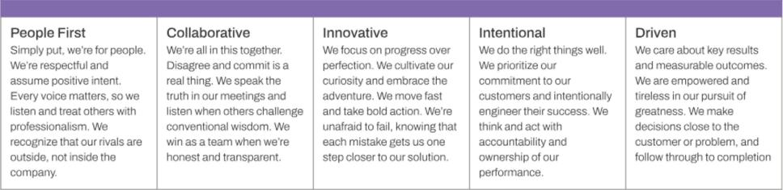

These values are reinforced through onboarding, training, everyday decision-making and our performance review process. Consistent with our values of accountability and collaboration, we support a hybrid work model and approximately 45% of our global employees are considered “remote”. We also recognize that certain roles or regions may benefit from increased in-person collaboration, and we have empowered our regional leaders, together with their site councils, to determine in-office work requirements for local employees. We rely on regular communications and our own communication and collaboration platform, 8x8 Work, to foster connection and teamwork across time zones.

We also invest in understanding and improving the employee experience through a comprehensive employee listening strategy. We leverage Qualtrics to administer a broad range of employee lifecycle and experience surveys, including onboarding, exit, performance feedback, recruiting, programmatic, and targeted surveys. In addition, we conduct multiple employee engagement surveys annually to measure workforce sentiment and identify opportunities for improvement. In our most recent engagement survey, 83% of employees participated, and we achieved 73% engagement.

Learning and Development

We are committed to continuous professional development for employees at all levels. In fiscal 2025, our employees collectively completed more than 15,800 hours of structured learning through formal programs. Our learning programs include:

- LinkedIn Learning: More than 1,700 courses and curated learning paths for role-specific and universal skills.

- Acceler8 Manager Program: An award winning four-month blended learning experience with workshops, coaching, and peer collaboration.

- Leadership Coaching: One-on-one coaching and behavioral assessments for vice presidents and senior leaders.

- Technical Skills Training: Tools and platforms to enhance product knowledge, coding skills, and platform familiarity.

- AI-Tools Training: Training in the use of AI-based tools for increased productivity and effectiveness.

We encourage employees and managers to have regular performance and development conversations, supported by tools that align individual goals with company objectives. Culture and Community

At 8x8, we stand united in our commitment to fostering a workplace where every voice is valued and every individual feels a sense of belonging. In keeping with our core value of respect, we honor the unique capabilities and characteristics each individual brings to their work and to their team. Our employees are the heart of our business, and we celebrate and commend their contributions, collaboration, and commitment.

When every voice can be heard, amazing things can happen. We are committed to ensuring our employees are equipped, enabled, and empowered to have impact. Our programs and initiatives include:

- Multiple employee resource groups.

- A global culture and community council, supported by an executive-level leadership steering committee.

- Unconscious bias training as part of our company-wide learning curriculum.
- Internal resources and programs, managed by our local site committees, to celebrate cultural and community milestones, including International Women’s Day and Veterans Day.

- Commitment to community involvement, including paid time off for volunteer activities.

We also conduct regular pay equity reviews and promote equal opportunities in our internal management and hiring practices.

10

Total Rewards and Well-Being

We provide a comprehensive total rewards package designed to support the financial, physical, and emotional well-being of our employees. Our offerings include:

- Competitive base salaries and performance-based incentive plans.

- Targeted equity compensation.

- Employee Stock Purchase Plan (ESPP) participation.

- Health, dental, and vision insurance.

- Paid parental and medical leave.

- Company-funded short- and long-term disability insurance.
- 401(k) plan with company match.

- Global employee assistance program with mental health support.

- Resources for financial wellness and family care.

- Subsidized public transportation, where available.

- Legal assistance.
- Workforce metrics.

Succession Planning and Employee Relations

We maintain a formal succession planning process to support leadership continuity and mitigate operational risk. This includes regular review of key roles and the development of high-potential employees. We are committed to fair labor practices and a culture of open communication across all regions in which we operate.

Available Information

We maintain a corporate Internet website at the address http://www.8x8.com. The contents of this website are not incorporated in or otherwise to be regarded as part of this Annual Report. We file reports with the Securities and Exchange Commission, or the SEC, which are available on our website free of charge. These reports include annual reports on Form 10-K, quarterly reports on Form 10-Q, current reports on Form 8-K, registration statements, proxy statements, and amendments to such reports, each of which is provided on our website as soon as reasonably practicable after we electronically file such materials with or furnish them to the Securities and Exchange Commission. In addition, the Securities and Exchange Commission maintains a website (www.sec.gov) that contains reports, proxy and information statements, and other information regarding issuers that file electronically with the Securities and Exchange Commission, including 8x8.

11

ITEM 1A. Risk Factors

Our operations and financial results are subject to various risks and uncertainties. You should consider carefully the risks and uncertainties described below, together with all of the other information in this report. If any of the following risks or other risks actually occur, our business, financial condition, results of operations, and future prospects could be materially harmed, and the price of our common stock could decline. Our business could also be materially and adversely affected by risks and uncertainties that are not presently known to us or that we currently believe are not material. Unless otherwise indicated, references to our business being harmed in these risk factors will include harm to our results of operations, financial condition, reputation, and future prospects.

Risk Factors Table of Contents

Risk Factors Summary

Risks Related to our Business and Industry

Risks Related to our Products and Operations

Risks Related to Regulatory Matters

Risks Related to Intellectual Property

Risks Related to our Debt, our Stock, and our Charter

General Risk Factors

Risk Factors Summary

Our business is subject to a number of risks that may adversely affect our business, financial condition, results of operations, and cash flows. These risks are discussed more fully below and include, but are not limited to:

Risks Related to our Business and Industry

- Our history of losses and anticipated continued losses.

- Unpredictability of our future operating results.

- Reductions in spending may result in reductions in revenue.

- Future increases in our customer churn.

- Dependence on new customer acquisition and retention and upsell to existing customers.

- Intense competition in our industry.
- Failure to manage and grow our indirect sales channels.

- Complexity and length of enterprise customer sales cycle.

- Dependence on new product and services to maintain and grow our business.

- Difficulty attracting and retaining key management, technical and sales personnel.

- We may not realize all of the anticipated benefits of our acquisitions, including Fuze, Inc.
- Potential past and future liabilities related to federal, state, local and international taxes, fees, surcharges and levees.

- We may incur impairments to goodwill, intangible assets or long-lived assets.

Risks Related to our Products and Operations

- Service outages due to software vulnerabilities or failures of physical infrastructure.

- Scalability of our cloud software services to meet existing and new customer demand.

- International expansion, including geopolitical tensions and increasing costs of regulatory compliance.

- Current and future acquisitions.
- Our ability to maintain compatibility with third-party applications and mobile platforms.

- Reliance on third-parties to provide network services and connectivity.

- Reliance on third-party vendors for IP phones and certain software endpoints.

- Difficulty executing local number porting requests.

Risks Related to Regulatory Matters

- Cybersecurity breaches and malicious acts.

- Liabilities related to credit card transaction processing services.
- Failure to comply with data privacy and protection laws.

- Services must comply with industry standards and government regulations including those related to telecommunications and cybersecurity.

Risks Related to Intellectual Property

- Infringement of third-party proprietary technology.

- Inability to protect our proprietary technology.

- Inability to use third-party or open-source software.

12

Risks Related to our Debt, our Stock, and our Charter

- Cash flow may be insufficient to service or pay down our substantial debt.

- Inability to raise necessary funds in the future.

- Conditional conversion features of our debt could adversely affect our financial condition.

- Change in accounting standards, including for our debt, may cause adverse financial reporting fluctuations and affect our reported operating results.

- Future sales of common stock or equity-linked securities.

- Certain provisions in our charter may discourage takeover attempts.

General Risk Factors

- Global macroeconomic and geopolitical events.

- Inability to secure financing in the future on favorable terms.

- Natural disasters, war, terrorist attacks, global pandemics and other unforeseen events.

Risks Related to our Business and Industry

We have a history of losses, have incurred significant negative cash flows in the past, and anticipate continuing losses in the future. As such, we may not be able to achieve or maintain profitability in the future.

We recorded operating income of approximately $15.2 million for the year ended March 31, 2025, and ended the period with an accumulated deficit of approximately $887.7 million. We expect to continue to incur operating losses in the near future as we continue to invest in our business. During our fiscal year ending March 31, 2026, we intend to continue to invest in sales and marketing and research and development, among other areas of our business, to compete more successfully for the business of companies that are transitioning to cloud communications and otherwise position ourselves to take advantage of long-term revenue-generating opportunities.

We expect to continue to incur losses for at least the next fiscal year and later, and we will need to increase our revenue to generate and sustain operating profitability in future periods. The investments we have made in fiscal 2025 and beyond may not generate the returns that we anticipate, which could adversely impact our financial condition and make it more difficult for us to grow revenue and/or achieve profitability in the time period that we expect, or not at all. In order to achieve profitability, we will need to manage our cost structure more efficiently and not incur significant liabilities, while continuing to grow our revenue. Despite these efforts, our revenue may continue to decline, and/or we may incur significant losses in the future due to general economic conditions, increasing competition (including competitive pricing pressures and large competitors moving into our markets), decrease in customer demand, including from the imposition of tariffs or other governmental actions, the growth of the adoption or sustained use of the cloud communications market, or if we fail for any reason to continue to capitalize on growth opportunities. Additionally, inflationary pressures impacting our cost structure, geopolitical events, interest rate fluctuations, and foreign currency fluctuations could adversely impact our profitability. Given our history of fluctuating revenue and operating losses, we cannot be certain that we will be able to achieve or maintain operating profitability in the future or that, if we do become profitable, we will sustain profitability.

Our future operating results, including revenue, expenses, losses, profits, and operating cash flow, may vary substantially from period to period and may be difficult to predict. As a result, we may fail to meet or exceed the expectations of market analysts or investors, which could negatively impact our stock price.

Our historical operating results have fluctuated and are expected to continue to fluctuate in the future. A decline in our operating results could cause our stock price to fall. There are a number of factors that may affect our operating results on a quarterly, annual, or longer-term basis, some of which are outside our control. These include, but are not limited to:

- changes in the markets we compete in, including reductions in market growth or consolidation among competitors, channel partners, or customers, and the impact of macroeconomic conditions such as inflation, interest rates, recession, tariffs, geopolitical instability, and decreased economic output;
- changes in customer demand, including cancellations, subscription downgrades, or substitution of our lower-priced, less feature-full products for our higher-priced, more feature-full products, particularly as customers transition to AI-based solutions;

- changes in the competitive dynamics in our markets, including competitors increasing compensation payable to channel partners or increasing discounts or credits issued to customers;

- lengthy sales cycles;

- changes in regulatory requirements or lengthy regulatory approval cycles;

- new product introductions by us or our competitors, including AI-based products and features;
- unpredictability of usage-based revenue products that do not involve long-term subscription commitments;

- the mix of our customer base, sales channels, and services sold;

- the number of additional customers, on a net basis;

- the amount and timing of costs associated with recruiting, training, and integrating new employees;

- the retention of our senior management and other key employees, their ability to execute on our business plan and the loss of services of senior management or other key employees, whether in the past or in the future;

13

- unforeseen costs and expenses related to the expansion of our business, operations, and infrastructure, including internationally;

- our dependency on third-party vendors of hardware, software, and services that we resell to our customers, including the effects of supplier price increases which we are unable to pass along to our customers;

- our ability to execute our operating plans successfully, including back-office system optimizations and increases in execution speed while also reducing costs and optimizing our operating margin;

- continued compliance with industry standards and regulatory requirements;
- decline in usage related to increases in return to office;

- material security breaches or service interruptions due to cyberattacks or infrastructure failures or unavailability, which may result in additional expenses, losses, legal or regulatory actions, customer credits, and reputational harm;

- introduction and adoption of our cloud software solutions in markets outside of the United States; and

- litigation involving us, our industry, or both, including securities class action lawsuits.

It is possible that in some future periods our results of operations may be below the expectations of public market analysts and investors.

In addition, changes in regulations, accounting principles, and our interpretation of these and judgments used in applying them, could have a material effect on our results of operations. We also need to revise our business processes, systems, and controls, which require significant management attention and may negatively affect our financial reporting obligations. If any of these events were to occur, the price of our common stock would likely decline significantly.

Any reduction in our spending may not achieve the desired result or may result in a reduction in revenue.

Our increased emphasis on profitability and cash flow generation may not be successful. We intend to reduce our total costs as a percentage of revenue, primarily impacting our sales and marketing expenses. There can be no assurances that our cost reduction initiatives will result in the cost savings that we anticipate as a percentage of our revenue and will not have unintended or unforeseen consequences, including a further reduction in revenue. We have experienced a reduction in revenue recently, which may have resulted from our cost reduction initiatives.

Churn in our customer base adversely impacts our revenue and requires us to spend money to retain existing customers and to capture replacement customers. If we experience increases in customer churn in the future, our revenue growth will be adversely impacted and our customer retention costs will increase.

Our customers may elect not to renew their subscriptions at the end of their contractual commitments, either entirely or by reducing the contracted services, resulting in reduced revenue from those customers. Because of churn in our customer base, we must acquire new customers and sell additional 8x8 products and services to our existing customers on an ongoing basis to maintain our existing level of revenue. As a result, sales and marketing expenditures are an ongoing requirement of our business. Our ability to maintain and grow our revenue is adversely impacted by the rate at which our customers cancel or downgrade services. Churn reduces our revenue growth rate, and if our churn rate increases, we must acquire even more new customers and/or sell more products and services to existing customers, to maintain and grow our revenue. We incur significant costs to acquire new customers, and those costs are a meaningful component in driving our net profitability. Churn may also prevent us from increasing the price of our services in the future, as well as limit our ability to sell additional 8x8 products and services to our existing customers and we may need to renew certain customers at a lower rate, of which each case would adversely impact our revenue in the future. Therefore, if we are unsuccessful in managing our existing customer churn and/or our customer churn rate increases in the future our revenue growth would decrease and our revenue may decline, causing our net loss to increase.

Our rate of customer cancellations or downgrades in services may increase in future periods due to a number of factors, some of which are beyond our control, such as the financial condition of our customers, the general economic environment, or significant shifts in geopolitical stability that affect global markets. Additionally, challenges in international expansion, including navigating diverse regulatory landscapes and adapting to local market conditions, may influence our ability to maintain or grow our customer base in certain regions. Pricing, competitive products, and migration of our customers from Fuze or other legacy products all can contribute to churn. If we are unable to maintain the quality and performance of our service whether due to a lack of feature parity or quality of service relative to the products of our competitors or service outages or disruptions, we could experience potentially sharp increases in customer cancellations and/or downgrades or customer credits which would adversely impact our revenue.

Our success hinges on our ability to acquire new customers and retain and sell additional services to our existing customers.

We generate revenue primarily from the sale of subscriptions to our cloud communications services to our customers, which include small business, mid-market and enterprise customers as well as government agencies and other organizations. Our future success depends on our ability to increase the amount of revenue we generate from new and existing customers.

If our sales and marketing efforts are not effective in identifying and qualifying prospective new customers, demonstrating the quality, value, features and capabilities of our solutions to those prospects and promoting our brand generally, we may not be able to acquire new customers at the rate necessary to achieve our revenue targets. We must also continue to design, develop, offer and sell services with quality, cost, features and capabilities that compare favorably to those offered by our competitors. As our target markets mature, or as competitors introduce lower cost and/or more differentiated products or services that compete or are perceived to compete with ours, we may be unable to attract new customers, on favorable terms, or at all, which could have an adverse effect on our revenue.

14

In addition to acquiring new customers, we generate new revenue by selling our existing customers additional quantities of subscribed services, or subscriptions to new or upgraded services. Particularly in the case of large enterprises, we often have opportunities to expand the sale of our services within an organization after we have completed an initial sale to one part of the organization (for example, a business unit, division or department, or personnel based in a particular country or region) and the organization has qualified us as a vendor. We invest in efforts to educate and train users on the features and capabilities of our services so that they can become advocates within their organizations and encourage increased adoption of our solutions. However, if existing users within an organization are dissatisfied with any aspect of our cloud services, or the technical support, training or other professional services we provide, we may face challenges in up-selling or increasing our penetration of the organization.

Intense competition for new customers and retention of existing customers (including pricing pressure) in the markets in which we compete may prevent us from increasing or sustaining our revenue growth, or achieving and maintaining profitability, which could materially harm our business.

The cloud communications industry is competitive and rapidly evolving. We expect the industry to be increasingly competitive in the future due to a number of factors including, but not limited to, the entry into the market of new competitors or the consolidation of existing competitors. Because we offer multiple services from a single platform, we compete with businesses in several overlapping industries, including voice, video meetings, chat, team messaging, contact center and enterprise-class application program interface solutions.

In connection with our voice, video meetings, chat, team messaging, contact center, and enterprise-class application program interface solutions, we face competition from other cloud service providers such as RingCentral, Inc., Genesys Telecommunications Laboratories, Inc., Zoom Video Communications, Inc., Ericsson, Five9, Inc., NICE inContact, Inc., Talkdesk, Inc., and Twilio Inc., among others, as well as from legacy on-premises communications equipment providers, such as Avaya, Inc., Cisco Systems, Inc., and Mitel Networks Corp.

We also face competition from Internet and cloud service companies such as Alphabet Inc. (Google Voice and Google Meet), Amazon Inc., and Microsoft Corporation. Some of these competitors have developed software solutions for their respective communications and/or collaboration products, such as Microsoft, which is investing significantly in its Microsoft Teams unified communication and collaboration product. Any of these companies could launch a new cloud-based business communications service, expand its existing offerings to compete with features of our services, or enter into a strategic partnership with, or complete an acquisition of, one or more of our cloud communications competitors.

Many of our current and potential competitors have greater resources and brand awareness and a larger base of customers than we have. As a result, these competitors may have greater marketing credibility. They also may adopt more aggressive pricing policies and devote greater resources to the development, promotion, and sale of their products and services. Our competitors may also offer bundled service arrangements that present a more differentiated or better integrated product and services to customers. Increased competition could require us to lower our prices, reduce our sales revenue, increase our gross losses or cause us to lose market share. Announcements or expectations as to the introduction of new products and technologies by our competitors or us could cause customers to defer purchases of our existing products and services, which also could have a material adverse effect on our business, financial condition, or operating results.

Given the significant price competition in the markets for our services, we may be at a disadvantage compared with those competitors who have substantially greater resources than us or may otherwise be better positioned to withstand an extended period of downward pricing pressure. The harm to our business may be magnified if we are unable to adjust our expenses to compensate for such shortfall, or if we determine that we need to increase our marketing and sales efforts in order to attract new customers and retain existing customers.

As the portion of our revenue increases that is usage-based or short-term subscription based, as opposed to longer-term subscriptions, we have increased exposure to macroeconomic volatility as customers can more easily reduce consumption or churn without breaching contracts.

Failure to grow and manage our network of indirect sales channels partners could materially and adversely impact our revenue in the future.

Our future business success, particularly to attract and support larger customers and expand into international markets, depends on our indirect sales channels. These channels consist of master agents and subagents, independent software vendors, system integrators, value-added resellers, and internet service providers, among others. We typically contract directly with the end customer and use these channel partners to identify, qualify and manage prospects throughout the sales cycle, although we also have arrangements with partners who purchase our services for resale to their own customers. As our business with master- and sub-agent partners has increased, we have seen our commission payments to these partners become an increasing portion of our sales and marketing expenses. Our future success depends upon our ability to develop and maintain successful relationships with these business partners, many of whom also market and sell services of our competitors, and our ability to increase the portion of sales opportunities they refer to us. To do so, we must continue to offer services that have quality, price, features, and other elements that compare favorably to those of competing services, ensure our partners are adequately trained and knowledgeable about our services, and provide sufficient incentives for these partners to sell our services in preference to those of our competitors while maintaining a cost-effective agency structure. If we are unable to persuade our existing business partners to

15

increase their sales of our services or to build successful partnerships with new organizations, or if our channel partners are unsuccessful in their marketing and sales efforts, we may not be able to grow our business and increase our revenue at the rate we predict, or at all, and our business may be materially adversely affected.

As we increase sales to enterprise customers, our sales process has become more complex and resource-intensive, our average sales cycle has become longer, and the difficulty in predicting when sales will be completed has increased.

We currently derive a majority of our revenue from sales of our cloud software solutions to mid-market and enterprise customers, and we believe that increasing our sales to these customers is the key to our future growth. Our sales cycle, which is the time between initial contact with a potential customer and the ultimate sale to that customer, is often lengthy and unpredictable for larger enterprise customers. Many of our prospective enterprise customers do not have prior experience with cloud-based communications or contact centers, and may not appreciate the benefits of a unified platform for both. Therefore, they typically spend significant time and resources evaluating our solutions before they purchase from us. Similarly, we typically spend more time and effort determining their requirements and educating these customers about the benefits and uses of our solutions. Enterprise customers also tend to demand more customizations, integrations, and additional features than smaller customers. As a result, we may be required to divert more sales and engineering resources to a smaller number of large transactions than we have in the past, which means that we will have less personnel available to support other sectors, or we will need to hire additional personnel, which would increase our operating expenses.

It is often difficult for us to forecast when a potential enterprise sale will close, the size of the customer's initial service order, and the period over which the implementation will occur, any of which may impact the amount of revenue we recognize or the timing of revenue recognition. Enterprise customers may delay their purchases from one quarter to another as they assess their budget constraints, negotiate early contract terminations with their existing providers, or wait for us to develop new features. Any delay in closing, or failure to close, a large enterprise sales opportunity in a particular quarter or year could significantly harm our projected growth rates and cause the amount of new sales we book to vary significantly from quarter to quarter. We also may have to delay revenue recognition on some of these transactions until the customer's technical or implementation requirements have been met.

The market for cloud software solutions is subject to rapid technological change, and we depend on new product and service introductions in order to maintain and grow our business.

We operate in an emerging market that is characterized by rapid changes in customer requirements, frequent introductions of new and enhanced products and services, and continuing and rapid technological advancement, particularly in artificial intelligence (AI) and machine learning. To compete successfully in this emerging market, we must continue to design, develop, manufacture, and sell highly scalable new and enhanced cloud software solutions products and services that provide higher levels of performance and reliability at lower cost. We will need to invest significantly in developing AI and automation capabilities for our products, as companies that are slow to adopt these technologies may face a competitive disadvantage. If we are unable to develop new products and services that address our customers' needs, to deliver our cloud software solution applications in one seamless integrated service offering that addresses our customers' needs, or to enhance and improve our products and services in a timely manner, we may not be able to achieve or maintain adequate market acceptance of our services.

The competitive landscape is rapidly evolving, with new market entrants leveraging AI technologies, existing competitors engaging in M&A to strengthen their market position, and large well-capitalized companies potentially poised to enter the market in a targeted way. We face intense competition from other providers of UCaaS, CCaaS and CPaaS, messaging, video, fax, virtual events, AI (including quality management, sales assistant and other AI driven functionalities), virtual assistant, work-force management/optimization and other communication products and services.

Developing new AI-powered features and products requires substantial investment and comes with risks around our ability to develop and integrate the technology in a timely and cost-effective manner, gain market acceptance, and deliver the required levels of performance and reliability. If our AI investments do not accurately anticipate demand or we fail to develop our AI capabilities in a manner that satisfies customer preferences, we may fail to retain existing customers or attract new ones. We have in the past experienced delays in new feature releases and may discover defects in new AI-powered services and applications after their introduction. Other well-capitalized competitors may spend more than we do to develop AI-related offerings, which in turn could impact our competitive position in the marketplace.

To the extent that we are unable to achieve market acceptance of our UCaaS and CCaaS products and services, we may be unable to recoup our research and development and marketing costs on the schedule we anticipated, and our results of operations may suffer.

Our ability to maintain or grow is also subject to the risk of future disruptive technologies. If new technologies emerge that are able to deliver communications and collaboration solution services at lower prices, more efficiently, more conveniently, or more securely, such technologies could adversely impact our ability to compete. This is particularly acute as AI and automation continues to transform our industry and we face the increasing risk that certain of our products and services may become redundant, that an over-reliance on AI and automation could lead to service disruptions, or that customers’ over-reliance on AI or automation will result in job cuts to roles in their IT departments which we have traditionally sold to, all of which may impact our ability to sell our products.

16

We may have difficulty attracting or retaining senior management and other personnel with the industry experience and technical skills necessary to support our desired growth.

Companies in the cloud communications industry compete aggressively for top talent in all areas of business, but particularly in senior management, sales and marketing, professional services, and engineering, where employees with industry experience, technical knowledge and specialized skill sets are particularly valued. In response to a competitive hiring environment, some of our competitors are responding by increasing employee compensation, paying more on average than we pay for the same position or offering more attractive equity compensation. Any such disparity in compensation could make us less attractive to candidates as a potential employer, which in turn may make it more difficult for us to hire and retain qualified employees, including senior executives. Training an individual who lacks prior cloud communications experience to be successful in a sales or technical role can take months or even years.

If an employee of 8x8 leaves to work for a competitor, not only are we impacted by the loss of the individual resource, but we also face the risk that the individual will share our trade secrets with the competitor in violation of his or her contractual and legal obligations to us. To the extent we hire personnel from competitors, we may be subject to allegations that they have been improperly solicited or divulged proprietary or other confidential information. Our competitors have in the past and may in the future target their hiring efforts on a particular department, and if we lose a group of employees to a competitor over a short time period, our day-to-day operations may be impaired. While we may have remedies available to us through litigation, these would likely take significant time and expense and be ineffective to the immediate operational risk as well as divert management attention from other areas of the business.

The labor market for our business is subject to external factors that are beyond our control, including our industry's highly competitive market for skilled workers and leaders. If we increase employee compensation (beyond levels that reflect customary performance-based and/or cost-of-living adjustments) in response to the competitive hiring environment, we may sustain greater operating losses than we predicted in the near term, and we may not achieve profitability within the timeframe we had expected, or at all. In addition, we may need to issue equity at increased levels, now and in the future, to attract and retain key employees and executives, including weighting a greater percentage of our employees' total compensation in the form of equity as opposed to cash, which will have the adverse effect of increasing dilution for our stockholders. Volatility in, or lack of performance of, our stock price may also affect our ability to attract and retain key personnel.

We may not realize all of the anticipated benefits of the acquisition of Fuze, Inc.

The success of our acquisition of Fuze, Inc. ("Fuze") will depend, in part, on our ability to realize the anticipated growth opportunities and synergies from combining the businesses of our company and Fuze. Our ability to realize these anticipated benefits, and the timing of this realization, depend upon a number of factors and future events, many of which we and Fuze, individually or collectively, cannot control. These factors and events include:

- our ability to successfully and timely integrate Fuze’s business and operations with ours;

- obtaining and maintaining intellectual property rights relating to Fuze technology;

- porting Fuze customers onto our 8x8 platform;

- the retention of Fuze’s customers; and
- minimizing the diversion of management’s attention from ongoing business concerns.

We are targeting completion of the migration of Fuze customers to our 8x8 platform and the shutdown of the Fuze platform by December 31, 2025. Failure to achieve this goal on the expected timeline —or at all—could result in increased costs, including the need to maintain duplicative infrastructure and support teams for a prolonged period, potential service disruptions or degradations that negatively impact customer satisfaction and retention, challenges in delivering product enhancements or updates across two platforms, and delays in realizing anticipated cost savings and synergies. Extended reliance on the Fuze platform may also expose us to heightened security, compliance, and technical risks, especially if legacy systems become harder to maintain or less compatible with evolving industry standards. Additionally, failure to complete the migration on time could lead to contractual breaches or the need to renegotiate customer agreements, and may limit our ability to efficiently scale our unified platform offerings.

Acquisitions involve risks, including inaccurate assessment of undisclosed, contingent, or other liabilities or problems. Following the completion of the acquisition, we have assumed all of Fuze’s assets and liabilities. We have already experienced unexpected liabilities as a result of the Fuze acquisition, and it is possible that undisclosed, contingent, or other liabilities may arise in the future of which we were previously unaware. These liabilities could include regulatory compliance issues, customer claims, intellectual property disputes, or other financial obligations, each of which could have a material adverse effect on our business, financial condition, and prospects.

17

Taxing authorities have asserted, or could in the future assert, that we should have collected or in the future should collect sales and use, value added, or similar taxes, including on similar services for which our competitors may not be subject to the same obligations. As a result, we could be subject to liability with respect to past or future sales, which have and could adversely affect our business.

The applicability of state and local taxes, fees, surcharges or similar taxes to our services is complex, ambiguous, and subject to interpretation and change. In the United States, for example, we collect state and local taxes, fees, and surcharges based on our understanding of the applicable laws in the relevant jurisdiction. The taxing authorities may challenge our interpretation of the laws and may assess additional taxes, penalties, and interests, which could have adverse effects on the results of operations and, to the extent we pass these through to our customers, demand for our services. Additionally, the applicability of sales and use, value added, or similar taxes may differ between services such as unified communication, voice, video, contact center, and platform communications so that the obligations to collect taxes from customers may vary between services and between companies such that we may be obligated to collect taxes at a higher rate that other services from our competitors, thereby impacting customer demand for our services. We currently file more than 1,500 state and local tax returns monthly. Periodically, we have received inquiries from state and municipal taxing agencies with respect to the remittance of state or local taxes, fees, or surcharges. Currently, several jurisdictions are conducting audits of 8x8; in the event our positions are unsuccessful, we may be subject to tax payments, interest, and penalties in excess of those that we have accrued for. As of March 31, 2025, we have paid or accrued for state or local taxes, fees, and surcharges that we believe are required to be remitted.

Our ability to use our net operating losses or research tax credits to offset future taxable income is subject to certain limitations.

As of March 31, 2025, we had federal net operating loss ("NOL"), carryforwards of $1,023.8 million, of which $321.5 million are related to years prior to fiscal 2019 and begin to expire in 2035. The remaining $702.3 million carry forward indefinitely, but can only be used to apply up to 80% of the Company's taxable income for a given tax year. As of March 31, 2025, the Company also had state NOL carryforwards of $869.4 million, the majority of which will expire at various dates between 2026 and 2044. In addition, at March 31, 2025, the Company had research and development credit carryforwards for federal and California tax purposes of approximately $15.5 million and $24.2 million, respectively. The federal income tax credit carryforwards will expire at various dates between the calendar years 2037 and 2045, while the California income tax credits will carry forward indefinitely.

Utilization of our NOLs and tax credit carryforwards can become subject to substantial annual limitation due to the ownership change limitations provided by Section 382 of the Internal Revenue Code and similar state provisions. A Section 382 ownership change generally occurs if one or more stockholders or groups of stockholders who own at least 5% of the stock increase their ownership by more than 50 percentage points over their lowest ownership percentage within a rolling three-year period. Similar rules may apply under state tax laws. In addition, California has enacted legislation that limits the use of NOLs and tax credits for taxable years beginning on or after January 1, 2024 and before January 1, 2027, which may adversely affect our company if it earns taxable income in the impacted tax years.

Such an ownership change, or any future ownership change, could have a material effect on our ability to utilize the NOLs or research credit carryforwards. In addition, under the Tax Cuts and Jobs Act, or the Tax Act, the amount of NOLs that we are permitted to deduct in any taxable year is limited to 80% of the taxable income in such year. There is a risk that due to changes under the Tax Act, regulatory changes or other unforeseen reasons, the existing NOLs could expire or otherwise be unavailable to offset future income tax liabilities, which could have a material impact on our net income (loss) in future periods.

We may incur impairments to goodwill, intangible assets, or long-lived assets which could negatively impact our operating results and financial condition.

The Company has a substantial amount of goodwill, intangible assets and long-lived assets on its consolidated balance sheet. The Company performs an annual test for indications of goodwill, intangible assets and long-lived assets impairment and more often if indicators of impairment exist. The impairment evaluation requires significant judgment and estimates by management, and unfavorable changes in these assumptions or other factors could result in future impairment charges and have a significant adverse impact on the Company’s reported earnings. Such factors include macroeconomic conditions in equity and credit markets, broader industry and market considerations, cost factors including material and labor cost, and the operating and financial performance of the Company. Additionally, a decline in the market valuation of the Company’s common shares, whether related to the Company or overall market conditions, could adversely impact the assumptions used to perform the evaluation of its goodwill, indefinite-lived intangible assets and long-lived assets.

The Company's business strategy has in the past and may, from time to time in the future, include acquiring or investing in complementary services, technologies or businesses. If the Company fails to successfully integrate such acquisitions, or the technologies associated with such acquisitions, the revenue and operating results could be adversely affected. Acquisitions may disrupt ongoing operations, divert management from their primary responsibilities, subject us to additional liabilities, increase expenses and adversely impact our business, financial condition, operating results and cash flows. Furthermore, acquisitions may require large one-time charges and can result in increased debt or contingent liabilities, adverse tax consequences, additional stock-based compensation expense and the recording and subsequent amortization or impairments of amounts related to certain purchased intangible assets or goodwill, any of which could negatively impact future results of operations.

18

Risks Related to our Products and Operations

If our platform or services experience significant or repeated disruptions, outages, or failures due to defects, bugs, vulnerabilities, or similar software problems, or if we fail to determine the cause of any disruption or failure and correct it promptly, we could lose customers, become subject to service performance or warranty claims, or incur significant costs, reducing our revenue and adversely affecting our operating results.

Our customers use our communications services to manage important aspects of their businesses, and any errors, defects, outages, or disruptions to our service or other performance problems with our service (such as those we have recently experienced and may encounter again), including those related to artificial intelligence technologies or dependencies on third-party services, could hurt our reputation and may damage our customers' businesses, any of which may result in our granting of credits to customers that in turn would reduce our revenue. Our services and the systems infrastructure underlying our cloud communications platform, including firewalls, switches and routers, incorporate software that is highly technical and complex. Our software and network infrastructure configurations have contained, and may now or in the future contain, undetected errors, bugs, or vulnerabilities, including those introduced by artificial intelligence-powered features. Such weaknesses could be exploited by hackers. These vulnerabilities include but are not limited to risks from ransomware, sophisticated nation-state attacks, and emerging malware threats. We continuously monitor these threats and work to update our defenses in response. Such weaknesses have also been the cause of, and may in the future cause, temporary service outages or other disruptions for some customers, potentially leading to significant financial and reputational damage. Our cybersecurity response plan includes incident response teams and system updates to mitigate these risks. Some errors in our software code may not be discovered until after the code has been released. Any errors, bugs, or vulnerabilities discovered in our code after release could result in damage to our reputation, loss of customers, loss of revenue, or liability for service credits or damages, any of which could adversely affect our business and financial results. We implement bug fixes and upgrades as part of our regularly scheduled system maintenance, which may lead to system downtime, but some known vulnerabilities may take increased time to address due to other system dependencies. Even if we are able to implement the bug fixes and upgrades in a timely manner, any history of defects, reliance on vulnerable third-party services, or the loss, damage, or inadvertent release of confidential customer data, could cause our reputation to be harmed, and customers may elect not to purchase or renew their agreements with us and subject us to service performance credits, warranty claims or increased insurance costs. The costs associated with any material defects or errors in our software or other performance problems may be substantial and could materially adversely affect our operating results.

Our physical infrastructure is concentrated in a few facilities (i.e., data centers and public cloud providers), and any failure in our physical infrastructure or service outages could lead to significant costs and/or disruptions and could reduce our revenue, harm our business reputation and have a material adverse effect on our financial results.

Our leased network and data centers, as well as public cloud infrastructure, are subject to various points of failure. Problems with cooling equipment, generators, uninterruptible power supply, routers, switches, or other equipment, including the software installed on such equipment, whether or not within our control, often managed by third-party service providers, expose us to cybersecurity risks such as unauthorized access or data breaches. These incidents have led to recent service interruptions and may continue to do so. These incidents could result in further service interruptions for our customers as well as equipment damage, significantly impacting our operational capability and customer satisfaction. Our infrastructure is consolidated into a few large data center facilities distributed globally across different regions. Any failure or downtime in one of our data center facilities could affect a significant percentage of our customers. The total destruction, closure, or severe impairment of any of our data center facilities could result in significant downtime of our services and the loss of customer data. Because our ability to attract and retain customers depends on our ability to provide customers with highly reliable service, even minor interruptions in our service could harm our reputation. Additionally, in connection with the expansion or consolidation of our existing data center facilities from time to time, there is an increased risk that service interruptions may occur as a result of server relocation or other unforeseen construction-related issues.

We have experienced interruptions in service in the past, including recent outages. The harm to our reputation is difficult to assess but has resulted and may result in the future in customer attrition. We have taken and continue to take steps to improve our infrastructure to prevent service interruptions, including upgrading our electrical and mechanical infrastructure. However, service interruptions continue to be a significant risk for us and could have a material adverse impact on our business.

Any future service interruptions could:

- cause our customers to seek service credits or damages for losses incurred;

- require us to replace existing equipment or add redundant facilities;

- affect our reputation as a reliable provider of communications services;
- cause existing customers to cancel or elect to not renew their contracts; or

- make it more difficult for us to attract new customers.

19

We may be required to transfer our servers to new data center facilities or public cloud load to a different public cloud provider in the event that we are unable to renew our agreement or leases on acceptable terms, or at all, or the owners of the facilities decide to close their facilities, and we may incur significant costs and possible service interruption in connection with doing so. In addition, any financial difficulties, such as bankruptcy or foreclosure, faced by our third-party data center operators, or any of the service providers with which we or they contract, may have negative effects on our business, the nature and extent of which are difficult to predict. If our data centers or our public cloud providers are unable to keep up with our increasing needs for capacity, our ability to grow our business could be materially and adversely impacted.

We may not be able to scale our business operations efficiently or quickly enough to meet our customers' growing needs, leading to increased customer churn and damage to reputation and brand, each of which could harm our operating results.

As usage of our cloud software solutions by small business, mid-market and enterprise customers expands and as customers continue to integrate our services across their enterprises, we are required to devote additional resources to improving our application architecture, integrating our products and applications across our technology platform, integrating with third-party systems, and maintaining infrastructure performance. To the extent we increase our customer base and as our customers gain more experience with our services, the number of users and transactions managed by our services, the amount of data transferred, processed, and stored by us, the number of locations where our service is being accessed, and the volume of communications managed by our services have in some cases, and may in the future, expand rapidly. In addition, the reliance on and integration with artificial intelligence technologies and third-party services may increase operational complexities and dependencies, so we may need scale and modernize our internal business systems and our services organization, including customer support, sales operations, billing services, and regulatory, privacy and cybersecurity compliance, to serve our growing customer base. Further, any inability to manage or forecast the demands associated with such scalability, especially in the context of new or evolving data protection and privacy laws, or any other failure or delay in these efforts could cause impaired system performance and reduced customer satisfaction. These issues could adversely impact our reputation and brand and reduce the attractiveness of our cloud software solutions to customers, resulting in decreased sales to new customers, lower renewal rates by existing customers, and the issuance of service credits, or requested refunds, which could hurt our revenue growth and our reputation.

Because our long-term growth strategy involves continued expansion outside the United States, our business will be susceptible to risks associated with international operations.

An important component of our growth strategy involves the further expansion of our operations and customer base internationally. We have formed subsidiaries and expanded operations outside the United States, including a subsidiary in Romania that contributes significantly to our research and development efforts. Additionally, we have expanded into the United Kingdom, the EU, and Southeast Asia. The risks and challenges associated with sales and other operations outside the United States are different in some ways from those associated with our operations in the United States, and we have a limited history addressing those risks and meeting those challenges. Our current international operations and future initiatives, including Southeast Asia, will involve a variety of risks, including:

- localization of our services, including translation into foreign languages and associated expenses;

- regulation of our services as traditional telecommunications services, requiring us to obtain authorizations or licenses to operate in foreign jurisdictions, or alternatively preventing us from selling our full suite of services, or any services at all, in such jurisdictions;

- changes in a specific country's or region's regulatory requirements, taxes, trade policies, tariffs, sanctions, trade laws, environmental laws, or political or economic condition;
- increased competition from regional and global cloud communications competitors in the various geographic markets in which we compete, where such markets may have different sales cycles, selling processes, and feature requirements, and may involve high levels of competition from local vendors that could require aggressive pricing strategies and adaptations to local market demands, which may limit our ability to compete effectively in different regions globally;

- more stringent and evolving regulations relating to data security, data privacy, data protection, data localization, cybersecurity, consumer protection, the use of AI technologies, and the unauthorized use of, access to, and transfer of, commercial and personal information, particularly in the EU, and potentially conflicting privacy regulations that could complicate data management and compliance;
- differing labor regulations, especially in the EU and Latin America, where labor laws are generally more advantageous to employees as compared to those in the United States, including deemed hourly wage and overtime regulations in these locations;

- challenges inherent in efficiently managing an increased number of employees over large geographic distances, including the need to implement appropriate systems, policies, benefits, and compliance programs;
- difficulties in managing a business in new markets with diverse cultures, languages, customs, legal systems, alternative dispute systems, and regulatory systems, which could delay or impede our ability to effectively launch our operations or scale them efficiently;

- increased travel, real estate, infrastructure, and legal compliance costs associated with international operations;

- different pricing environments, longer sales cycles, longer accounts receivable payment cycles, and other collection difficulties;

- currency exchange rate fluctuations and the resulting effect on our revenue and expenses, and the cost and risk of entering into hedging transactions if we chose to do so in the future;

20

- limitations on our ability to reinvest earnings from operations in one country to fund the capital needs of our operations in other countries;

- laws and business practices favoring local competitors or general preferences for local vendors;

- limited or insufficient intellectual property protection;

- political instability or terrorist activities, including the impact of geopolitical tensions in regions like Eastern Europe, the Middle East, and Asia, which could affect market stability and operations, or impact our employees located in those regions;

- a military conflict with China and/or Russia or other geopolitical conflicts between nation-states, that will likely involve cyberattacks on critical infrastructure, including, but not limited to, global data centers, power grids, and communication companies;

- exposure to liabilities under anti-corruption and anti-money laundering laws, including the United States Foreign Corrupt Practices Act, the United Kingdom Bribery Act 2010, trade and export laws such as those enforced by the Office of Foreign Assets Control (OFAC) of the United States Department of the Treasury, and similar laws and regulations in other jurisdictions;

- continuing uncertainty regarding social, political, immigration, and tax and trade policies in the United States and abroad, including as a result of the United Kingdom's withdrawal from the EU;

- regional travel restrictions, business closures, government actions and other restrictions in connection with geopolitical instabilities or pandemics; and
- adverse tax burdens and foreign exchange controls that could make it difficult to repatriate earnings and cash.

We have limited experience in operating our business internationally, which increases the risk that any potential future expansion efforts that we may undertake will not be successful. We expect to invest substantial time and resources to expand our international operations. The significant resources, management attention and expenses required to ensure compliance with international regulations could adversely impact our operations and profitability. We may face operational challenges as we grow our global presence, including difficulties managing foreign operations, localizing products, collecting receivables, relying on international partners, and navigating potential economic or political instability in new regions. If we are unable to do this successfully and in a timely manner, our international growth, business, and operating results could be materially adversely affected.

Global geopolitical developments, such as wars, sanctions, trade disputes, or other international tensions, could adversely affect us

The ongoing conflict between Russia and Ukraine has led to and is expected to continue to lead to disruption, instability, and volatility in global markets and industries. Our business, including our significant engineering and operations presence in Romania which borders Ukraine, could be negatively impacted if the conflict were to expand into the surrounding countries. The United States and other governments have imposed severe sanctions and export controls against Russia, which along with potential Russian responses, could adversely affect our business, supply chain, partners, or customers.

Geopolitical destabilization, including the effects of the Russia-Ukraine conflict, ongoing conflicts in the Middle East, and U.S.-China trade tensions, could impact global currency exchange rates, supply chains, trade and movement of resources, commodity prices, and technology spending of our customers and potential customers. These may be due to direct actions of a government, such as the imposition of tariffs by one government and retaliatory actions by another government, or indirectly as such governmental actions negatively affect our customers or their propensity to purchase products and services from us. Fluctuations in the value of the U.S. dollar versus foreign currencies could increase our international operating costs and expose us to foreign exchange rate risk, as some of our international agreements provide for payment in local currencies.

U.S. trade restrictions, tariffs and international trade tensions, particularly with China, may also directly increase our costs and limit access to international suppliers and markets. As we source telecom equipment internationally, trade tensions could have an adverse effect on our operations and profitability if they restrict supply or increase prices of necessary components.

We face risks related to acquisitions now and in the future that may divert our management's attention, result in dilution to our stockholders, and consume resources that are necessary to sustain and grow our existing business.

Although we have acquired several companies and business units in recent years, including Fuze, we have limited experience with purchasing and integrating other businesses. We may not be able to identify suitable acquisition candidates in the future or negotiate and complete acquisitions on favorable terms.

If appropriate opportunities present themselves, we may decide to acquire such companies or their products, technologies or assets. Acquisitions involve numerous risks, and there is no guarantee that we will ultimately strengthen our competitive position or achieve other benefits expected from the transaction. Among other risks we may encounter in connection with acquisitions:

- we may experience difficulty and delays in integrating the products, technology platform, operations, systems and personnel of the acquired business with our own, particularly if the acquired business is outside of our core competencies, has significant international operations or weaker internal controls;
- we may not be able to manage the acquired business or the integration process effectively, which may limit our ability to realize the financial and strategic benefits we expected from the transaction;

21

- the acquisition and integration may divert management's attention from our day-to-day operations and disrupt the ordinary functioning of our ongoing business;

- we may have difficulty establishing and maintaining appropriate governance, reporting relationships, policies, controls, and procedures for the acquired business, particularly if it is based in a country or region where we did not previously operate;

- any failure to successfully manage the integration process may also adversely impact relationships with our employees, suppliers, customers, and business partners, or those of the acquired business, and may result in increased churn or the loss of key customers, business partners or employees for our business or those of the acquired business;

- we may become subject to new or more stringent regulatory compliance obligations and costs by virtue of the acquisition, including risks related to international acquisitions that may operate in new jurisdictions or geographic areas where we may have no or limited experience;

- we may become subject to litigation, investigations, proceedings, fines or penalties arising from or relating to the transaction or the acquired business, including tax obligations or legal claims arising from the activities of the companies or businesses we acquire, and any resulting liabilities may exceed our forecasts;

- we may acquire businesses with different revenue models, customer concentration risks, and contractual relationships;

- we may assume long-term contractual obligations, commitments or liabilities (for example, those relating to leased facilities), which could adversely impact our efforts to achieve and maintain profitability and impair our cash flow;

- we may not successfully evaluate or utilize the acquired technology and accurately forecast the financial impact of an acquisition transaction, including accounting charges;

- the acquisition may create a drag on our overall revenue growth rate, which could lead analysts and investors to reduce their valuation of our company;
- we may be exposed to existing cyber risks not identified prior to an acquisition that could impact our core operations until mitigated; and

- if an acquired business's cybersecurity controls are materially weaker than ours, we may be exposed to existing cyber risks not identified prior to an acquisition that could impact our core operations until mitigated.

In addition, we may have to pay cash, incur debt, or issue equity securities to pay for any such acquisition, each of which could affect our financial condition or the value of our capital stock. The sale of equity to finance any such acquisitions could result in dilution to our stockholders. If we incur more debt, it would result in increased fixed obligations and could also subject us to covenants or other restrictions that would impede our ability to flexibly operate our business. Furthermore, acquisitions may require large one-time charges and can result in increased debt or contingent liabilities, adverse tax consequences, additional stock-based compensation expense and the recording and subsequent amortization or impairments of amounts related to certain purchased intangible assets or goodwill, any of which could negatively impact our future results of operations.

As a result of these potential problems and risks, among others, businesses that we may acquire or invest in may not produce the revenue, competitive advantages, or business synergies that we anticipate, and the results and effects of any such acquisition may not be favorable enough to justify the amount of consideration we pay or the other investments we make in the acquired business.

If we do not or cannot maintain the compatibility of our communications and collaboration software with third-party applications and mobile platforms that our customers use in their businesses, our revenue could decline.

The functionality and popularity of our cloud software solutions depends, in part, on our ability to integrate our services with third-party applications and platforms, including enterprise resource planning, customer relations management, human capital management, workforce management, and other proprietary application suites. Third-party providers of applications and application program interfaces may change the features of their applications and platforms, restrict our access to their applications and platforms or alter the terms governing use of their applications and application program interfaces and access to those applications and platforms in an adverse manner. Such changes could functionally limit or terminate our customers’ ability to use these third-party applications and platforms in conjunction with our services, which could negatively impact our offerings and harm our business. If we fail to integrate our software with new third-party back-end enterprise applications and platforms used by our customers, we may not be able to offer the functionality that our customers need, which would negatively impact our ability to generate revenue and adversely impact our business.

Our services also allow our customers to use and manage our cloud software solutions on smartphones, tablets, and other mobile devices. As new smart devices and operating systems are released, we may encounter difficulties supporting these devices and services, and we may need to devote significant resources to the creation, support, and maintenance of our mobile applications. In addition, if we experience difficulties in the future integrating our mobile applications into smartphones, tablets, or other mobile devices or with certain communication platforms, such as Microsoft Teams, or if problems arise with our relationships with providers of mobile operating systems, such as those of Apple Inc. or Alphabet Inc., our future growth and our results of operations could suffer.

22

To provide our services, we rely on third parties for our network service and connectivity, and any disruption or deterioration in the quality of these services or the increase in the costs we incur from these third parties could adversely affect our business, results of operations, and financial condition.

We rely on third-party network service providers to originate and terminate substantially all of the public switched telephone network calls using our cloud-based services. We leverage the infrastructure of third-party network service providers to provide telephone numbers, public switched telephone network call termination and origination services, and local number portability for our customers, rather than deploying our own network throughout the United States and internationally. We use the infrastructure of third-party network service providers, such as Equinix, Inc., and public cloud providers, including Amazon Web Services, Inc. and Oracle Corporation, to provide our cloud services over their networks rather than deploying our own network connectivity. These decisions have resulted in lower capital and operating costs for our business in the short-term but have reduced our operating flexibility and ability to make timely service changes. If any of these network service providers cease operations or otherwise terminate the services that we depend on or become unwilling to supply cost-effective services to us in the future, the delay in switching our technology to another network service provider, if available, and qualifying this new service provider could have a material adverse effect on our business, financial condition, or operating results. In addition, the rates we pay to our network service providers and other intermediaries may also change more rapidly than the change in pricing we charge our customers, which may reduce our profitability and increase the retail price of our service. Furthermore, increased cybersecurity threats to infrastructure or heightened geopolitical tensions in regions where these third parties operate could exacerbate these risks, potentially leading to further operational disruptions and financial losses.

To the extent that we internally handle the origination and termination of public switched telephone network calls, which represent an increasing portion of the calls using our cloud-based services, we are subject to significant operational, technical, and regulatory risks. We are required to maintain infrastructure, systems, and capabilities for interconnection, routing, call quality management, compliance with telecommunications regulations, lawful intercept capabilities, and support for local number portability. Building and operating these systems requires specialized expertise, and any failure to effectively manage this infrastructure could result in service disruptions, degraded call quality, regulatory non-compliance, or increased costs. If our internally managed services do not perform as reliably or cost-effectively as anticipated, or if we encounter unforeseen complexities in operating telecommunications infrastructure at scale, we may experience increased customer churn, damage to our brand, and adverse financial impacts. Our ability to manage these telecommunications services successfully depends on the timely and efficient execution by our technical, operational and legal teams, as well as continued investments in infrastructure, personnel, and compliance capabilities. If we are unable to do so, our business, results of operations, and financial condition could be materially adversely affected.

We depend on third-party vendors for IP phones and certain software endpoints, and any delay or interruption in supply by these vendors would result in delayed or reduced shipments to our customers and may harm our business.

We rely on third-party vendors for IP phones and software endpoints required to utilize our service. We currently do not have long-term supply contracts with any of these vendors. As a result, most of these third-party vendors are not obligated to provide products or services to us for any specific period, in any specific quantities, or at any specific price, except as may be provided in a particular purchase order.

The inability of these third-party vendors to deliver IP phones of acceptable quality and in a timely manner, particularly the sole source vendors, could adversely affect our operating results or cause them to fluctuate more than anticipated. Additionally, some of our products and services may require specialized or high-performance component parts that may not be available in quantities or in time frames that meet our requirements.

Difficulty executing local number porting requests could negatively impact our business.

The FCC and foreign regulators require Voice over Internet Protocol providers to support telephone number porting within specified timeframes. In order to port telephone numbers, we rely on third party telecommunications carriers to complete the process. Often, number ports take longer than the specified timeframes. For many potential customers, the ability to quickly port their existing telephone numbers into our service in a timely fashion is a very important consideration. To the extent that we cannot quickly port telephone numbers in, our ability to acquire new customers may be negatively impacted. To the extent that we cannot quickly port telephone numbers out when a customer leaves our service to go to another provider, we could be subject to regulatory enforcement action.

23

Risks Related to Regulatory Matters

Cyber intrusions, breaches of our networks or systems or those of our service and cloud storage providers, and other malicious acts could adversely impact our business.

Our business operations, from our internal and service operations to research and development activities, sales and marketing efforts and customer and partner communications, depend on our ability to protect our network from interruption by damage from hackers, social engineering and phishing, ransomware, and malicious code or software, including vulnerabilities in our network infrastructure such as firewalls, switches and routers, or similar disruptive problems or other events beyond our control. Individuals or entities have attempted, and will attempt, to penetrate our network security, and that of our platform, and try to cause harm to our business operations, including by misappropriating our proprietary information or that of our customers, employees and business partners or causing interruptions of our products and platform. In particular, cyberattacks and other malicious internet-based activity continue to increase in frequency and in magnitude both generally and specifically against us and other cloud-service providers. Ransomware attacks, including those perpetrated by organized criminal threat actors, nation-states, and nation-state-supported actors, are becoming increasingly prevalent and severe and can lead to significant interruptions in our operations, loss of data and income, reputational harm, and diversion of funds. Geopolitical tensions and events, such as the war between Russia and Ukraine, may create heightened risks to us and our vendors, business partners, and consultants of cyber-attacks from nation-state actors or their affiliated entities, including attacks that could materially disrupt our systems and operations, supply chain, and ability to provide our services. For example, a recent Oracle Cloud Infrastructure (OCI) security breach highlighted the risks posed by third-party providers. In this particular incident, there was no impact on 8x8's operations or services. However, it served as an important reminder of the need for continuous assessment and monitoring across the entire 8x8 ecosystem to maintain a robust security posture.

We continue to implement new technological measures to prevent, detect, and contain such intrusions as well as build and strengthen ongoing employee awareness, education and training, but we cannot guarantee we will be able to prevent, detect or contain all future cyber intrusions, nor can we guarantee that our backup systems, regular data backups, security protocols, denial or disruption of service (DDoS) mitigation, and other procedures that are currently in place, or may be in place in the future, will be adequate to prevent significant damage, system failure, or data loss.

While we have not been subject to cybersecurity incidents that have materially affected our results of operations or financial condition to date, actual or perceived security gaps or security compromises experienced in our industry or by our competitors, our customers, a third party with whom we work, or us could cause us to experience adverse consequences, which could be material in the future, such as government enforcement actions (for example, investigations, fines, penalties, audits, and inspections); additional reporting requirements and/or oversight; restrictions on processing sensitive data (including personal information); litigation (including class claims); indemnification obligations; negative publicity; reputational harm; monetary fund diversions; diversion of management attention; interruptions in our operations (including availability of data); financial loss; and other similar harms.

Inherent in our provision of services are the storage, processing, and transmission of our customers' data, which may include confidential and sensitive information and that confidential or sensitive information may be stored or transmitted by means not designed for confidential or sensitive information, such as the processing or storing of protected health information or payment card information in free-form text fields provided for other purposes. This exposes us to significant cybersecurity risks, including data breaches and unauthorized data access, which could compromise customer trust and subject us to financial and legal penalties. Customers may use our services to store, process, and transmit a wide variety of confidential and sensitive information, such as credit card, bank account, and other financial information, proprietary information, trade secrets, or other data that may be protected by sector-specific laws and regulations, like intellectual property laws, laws addressing the protection of personally identifiable information (or personal data in the EU), as well as the Federal Communications Commission’s, or the FCC’s, customer proprietary network information, or CPNI, rules. We also face the risk of changes in cybersecurity laws and regulations which could impose additional compliance costs or challenges. Additionally, we closely monitor legislative developments to swiftly adapt our practices, ensuring ongoing compliance and protection against emerging threats. We may be the target of direct or indirect cyber threats and security breaches, given the nature of the information that we store, process, and transmit and the fact that we provide communications services to a broad range of businesses. To the extent that state-sponsored incidents of cybersecurity breaches increase due to geopolitical tensions, this risk may continue to increase.

In addition, we use third-party vendors, which in some cases have access to our data and our customers' data. Despite the implementation of security measures by us or our vendors, our computing devices, infrastructure, or networks, or our vendors' computing devices, infrastructure, or networks may be vulnerable to hackers, social engineering and phishing, ransomware, and malicious code or software, or similar disruptive problems due to a security vulnerability in our or our vendors' infrastructure or network, or our vendors, customers, employees, business partners, consultants, or other internet users who attempt to invade our or our vendors' public and private computers, tablets, mobile devices, software, data networks, or voice networks. We also continue to incorporate AI solutions and features into our platform, which may result in security incidents or otherwise increase cybersecurity risks. Further, AI technologies may be used in connection with certain cybersecurity attacks, resulting in heightened risks of security breaches and incidents. If there is a security vulnerability in our or our vendors' infrastructure or networks that is successfully targeted, we could face increased costs, liability claims, government investigations, fines, penalties or forfeitures, class action litigation, reduced revenue, or harm to our reputation or competitive position.

24

We also rely on various third-party service providers to operate our platform and deliver our products, including network service providers, internet service providers, telecommunications carriers, providers of cloud infrastructure and cloud communications, and third-party technology and intellectual property. Our service providers (or their sub-service providers) have in the past experienced, and may in the future experience, security breaches and incidents, including unauthorized access or inadvertent disclosures, that have exposed and may expose or make available to threat actors our data or that of our customers. Even when our systems are not compromised, if our service providers experience breaches or incidents that impact our data or our customers' data, then our reputation, customer trust, business, results of operations and financial condition could be adversely affected.

Laws, regulations, and enforcement actions relating to security and privacy of information continue to evolve. For example, in 2023, the SEC adopted cybersecurity risk management and disclosure rules, which require the disclosure of information pertaining to cybersecurity incidents and cybersecurity risk management, strategy, and governance. Additionally, we are closely monitoring the development of rules and guidance that may apply to us, including, for example, pursuant to the Cyber Incident Reporting for Critical Infrastructure Act of 2022. The FCC formed the Privacy and Data Protection Task Force that focuses on approaches to data breaches and data security vulnerabilities, which may result in future privacy rulemaking and enforcement initiatives. We have incurred and expect to continue to incur significant expenses to prevent security incidents. Determining whether a cybersecurity incident is notifiable or reportable may not be straightforward and may be costly and could lead to negative publicity, loss of customer or partner confidence in the effectiveness of our security measures, diversion of management's attention, governmental investigations, and the expenditure of significant capital and other resources to respond to or alleviate problems caused by the actual or perceived security breach. It is possible that, in order to support changes to applicable laws and to support our expansion of sales into new geographic areas or into new industry segments, we will need to change or enhance our cybersecurity systems, which may make it more expensive to operate in certain jurisdictions and may also increase the risk of our non-compliance with such changing laws and regulations.

We could be liable for breaches of security on our website, fraudulent, improper or illegal activities by our users, or the failure of third-party vendors to deliver credit card transaction processing services, which could result in claims, increase the cost of operations or otherwise harm our business and reputation.

A fundamental requirement for operating an Internet-based, worldwide cloud software solution and electronically billing our customers is the secure transmission of confidential information and media over public networks. Although we have developed systems and processes that are designed to protect consumer information and prevent fraudulent credit card transactions and other security breaches, failure to mitigate such fraud or breaches may subject us to costly breach notification and other mitigation obligations, class action lawsuits, investigations, fines, forfeitures or penalties from governmental agencies that could adversely affect our operating results.

The law relating to the liability of providers of online payment services is currently unsettled and states may enact their own rules with which we may not comply. We rely on third-party providers to process and guarantee payments made by our subscribers up to certain limits, and we may be unable to prevent our customers from fraudulently receiving goods and services. Our liability risk will increase if a larger fraction of transactions affected using our cloud-based services involves fraudulent or disputed credit card transactions.

We may also experience losses due to subscriber fraud and theft of service. Subscribers have, in the past, obtained access to our service without paying for monthly service and international toll calls by unlawfully using our authorization codes or by submitting fraudulent credit card information. If our existing anti-fraud procedures are not adequate or effective, consumer fraud and theft of service could have a material adverse effect on our business, financial condition, and operating results.

Similarly, bad actors may use our products to promote their goals and encourage users to engage in improper, illegal or otherwise inappropriate activities. There have been instances where improper or illegal content may have been shared on our platform without our knowledge. As a service provider, and as a matter of policy, we do not monitor user meetings. Our terms of service prohibit such conduct. Despite our efforts to implement measures to prevent such activities, there is no guarantee that these measures will be effective or successful in all cases. If we are unable to adequately manage these risks, our business, financial condition and results of operations could be adversely affected.

While to date we have not been subject to legal or administrative actions as a result of improper or illegal content, the laws in this area are currently in a state of flux and vary widely between jurisdictions. Accordingly, it may be possible that in the future, we and our competitors may be subject to legal or regulatory actions along with the users who shared such content. In addition, regardless of any legal liability we may face, if there is an incident generating extensive negative publicity about the content shared on our platform, our business and reputation could be harmed.

25

Failure to comply with laws and contractual obligations related to data privacy and protection could have a material adverse effect on our business, financial condition and operating results.

We process many types of data, including personal data in the course of our business. As such, we are subject to the data privacy and protection laws and regulations adopted by federal, state and foreign governmental agencies, including the EU's GDPR, the UK’s Data Protection Act 2018, the CCPA/CPRA, and privacy laws enacted in Colorado, Connecticut, Delaware, Florida, Iowa, Montana, New Hampshire, Nebraska, New Jersey, Oregon, Texas, Utah, and Virginia. We are also subject to laws like the EU’s Digital Operational Resilience Act (DORA), which impose specific requirements around the resilience of information and communication technology systems and third-party risk management. Data privacy and protection is highly regulated in many jurisdictions and may become the subject of additional regulation in the future. For example, lawmakers and regulators worldwide are considering proposals that would require companies, like us, that encrypt users' data to ensure access to such data by law enforcement authorities. In addition, several additional states have comprehensive privacy laws that will become effective in 2025 or later, including Indiana, Kentucky, Maryland, Minnesota, Rhode Island, and Tennessee. Privacy laws restrict our processing of personal information, provided to us by our customers as well as data we collect from our customers and employees. We strive to comply with all applicable laws, regulations, policies and legal obligations relating to privacy and data protection. However, if we fail to comply, we may be subject to fines, penalties and lawsuits, statutory damages at both the federal and state levels in the United States, substantial fines and penalties under the EU’s GDPR and the UK’s Data Protection Act 2018, and class action lawsuits, and our reputation may suffer. We may also be required to make modifications to our data practices that could have an adverse impact on our business, including increasing our operating costs, which may cause us to increase our prices, making our services less competitive.

We are also subject to the privacy and data protection-related obligations in our contracts with our customers and other third parties. Any failure, or perceived failure, by us to comply with federal, state, or international laws, including laws and regulations regulating privacy, data, or consumer protection, or to comply with our contractual obligations related to privacy, could result in proceedings or actions against us by governmental entities, contractual parties, or others, which could result in significant liability to us, as well as harm our reputation. Additionally, third parties on which we rely enter into contracts to protect and safeguard our customers' data. Should such parties violate these agreements or suffer a breach, we could be subject to proceedings or actions against us by governmental entities, contractual parties, or others, which could result in significant liability to us as well as harm to our reputation.

Our products and services must comply with industry standards, FCC regulations, state, local, country-specific, and international regulations, and changes may require us to modify existing services, potentially increase our costs or prices we charge customers, and otherwise harm our business.

As a provider of interconnected Voice over Internet Protocol services, we are subject to various international, federal, state, and local requirements applicable to our industry, including those that address, among other matters, acceptable marketing practices, the accessibility of 9-1-1 or other international emergency services, local number porting, robo-calling, caller ID spoofing, outage notifications, call traceback, and know your customer requirements. We may also be subject to potential liability for the illegal or fraudulent activities of our customers and end users. The failure of our products and services to comply, or delays in compliance, with various existing and evolving standards could delay or interrupt our introduction of new products, subject us to fines or other imposed penalties, or harm our reputation, any of which would have a material adverse effect on our business, financial condition, or operating results.

Regulations to which we may be subject address the following matters, among others:

- license requirements that apply to providers of communications services in many jurisdictions;

- our obligation to contribute to various Universal Service Fund programs, including at the state level;

- monitoring on rural call completion rates;

- safeguarding and use of customer proprietary network information;

- rules concerning access requirements for users with disabilities;

- our obligation to offer 7-1-1 abbreviated dialing for access to relay services;
- compliance with the requirements of United States and foreign law enforcement agencies, including the Communications Assistance for Law Enforcement Act, and cooperation with local authorities in conducting wiretaps, pen traps and other surveillance activities;

- the ability to dial 9-1-1 (or corresponding numbers in regions outside the United States), auto-locate E-911 calls (or corresponding equivalents) when required, and access emergency services;

- the transmission of telephone numbers associated with calling parties between carriers and service providers like us;

- regulations governing outbound dialing, including the Telephone Consumer Protection Act;
- FCC and other regulators efforts to combat robo-calling and caller ID spoofing;

- compliance with data protection regulations such as the GDPR in Europe, which impose stringent requirements on data privacy and security;

- compliance with the Telecommunications (Security) Act 2021 in the UK, which imposes strict security requirements on telecom providers to protect the UK's telecoms network from cyber threats and vulnerabilities. Non-compliance with this act could result in significant penalties and affect our ability to operate in the UK;

- adherence to environmental regulations, including those concerning the disposal and recycling of electronic products and batteries, which are becoming increasingly relevant as we expand our hardware offerings; and

26

- reporting on climate related financial risk (such as California SB 261).

Regulation of our services as telecommunications services may require us to obtain authorizations or licenses to operate in foreign jurisdictions and comply with legal requirements applicable to traditional telephony providers. This regulation may impact our ability to differentiate ourselves from incumbent service providers and imposes substantial compliance costs on us. In addition, the reform of federal and state Universal Service Fund programs and payment of regulatory and other fees in international markets could increase the cost of our service to our customers, diminishing or eliminating any pricing advantage we may have.

As we continue to expand internationally, we may be subject to telecommunications, consumer protection, privacy, data protection, cybersecurity, emergency call services, call authentication, and other laws and regulations in the foreign countries where we offer our services. Any foreign regulations could impose substantial compliance costs on us, restrict our ability to compete, and impact our ability to expand our service offerings in certain markets. Moreover, the regulatory environment is constantly evolving and changes to the applicable regulations could impose additional compliance costs and require modifications to our technology and operations and go to market practices. European Union member states are implementing major modifications to their telecommunication laws and regulations. Updated regulations in Europe and in the United Kingdom require providers to perform security assessments and to improve the security and resilience of their networks as well as to verify the accuracy of their metering and billing systems. Regulators in many of our markets require providers to implement Know-Your-Customer vetting which may complicate and elongate the sales process. Local telecom regulatory restrictions in some European countries limit our ability to sell services in a wholesale motion to channel partners. The recent EU Digital Services Act requires cloud and digital providers to adopt measures to prevent disinformation, increase transparency and improve protection for users of digital services in the EU. Additionally, we expect an increase in the regulation of the use of AI and machine learning in products and services. For example, in Europe, the Artificial Intelligence Act became effective in August 2024 and is being implemented in stages, with full applicability expected by August 2026. This act imposes various obligations related to the development, placement on the market, and use of AI-related systems. We may have to change our business practices to comply with obligations under this or other new and evolving regimes.

We are subject to numerous domestic and foreign privacy, data protection and cybersecurity laws and regulations that restrict the collection, use, disclosure and processing of personal information, including financial and health data. These laws and regulations are expanding globally, evolving, and being tested in courts, and may result in increasing regulatory and public scrutiny of our practices relating to personal information and increased exposure to regulatory enforcement action, sanctions and litigation. For example, the GDPR in Europe and the CCPA in California (as amended by the California Privacy Rights Act) impose significant requirements regarding the processing of personal information. Similar laws have been enacted in numerous other states, with more becoming effective in the coming years. Failure to comply with these regulations could result in substantial fines, injunctions against processing personal information, and reputational harm.

Our actual or perceived failure to comply with laws, regulations, contractual commitments, or other actual or asserted obligations, including certain industry standards, regarding privacy, data protection and cybersecurity could lead to costly legal action, adverse publicity, significant liability, inability to process data, and decreased demand for our services, which could adversely affect our business, results of operations and financial condition. As a cumulative example, due to our primary data processing facilities being in the United States, we have experienced hesitancy, reluctance, or refusal by European customers to use our services following the "Schrems II" ruling. If we cannot maintain valid mechanisms for cross-border data transfers, we may face increased exposure to regulatory actions, fines, and injunctions against transferring personal information out of Europe.

Evolving laws, regulations, and other actual and asserted obligations relating to privacy, data protection, cybersecurity, and the use of AI and machine learning technologies could reduce demand for our platform, increase our costs, impair our ability to grow our business, restrict our ability to process data, or impact our ability to offer our service in some locations. We may find it necessary to fundamentally change our business activities and practices or expend significant resources to adapt to these changes. Our ability to develop new products and features could be limited.

Risks Related to Intellectual Property

If we are found to be infringing on a third party's proprietary technology, our business could be disrupted.

If we are found to be infringing the intellectual property rights of any third-party in lawsuits or proceedings that may be asserted against us, we could be subject to monetary liabilities for such infringement, which could be material. We could also be required to refrain from using, manufacturing, or selling certain products or using certain processes, either of which could have a material adverse effect on our business and operating results. Our broad range of current and former technology, including IP telephony systems, digital and analog circuits, software, and semiconductors, increases the likelihood that third parties may claim infringement by us of their intellectual property rights. We have received and may continue to receive in the future, notices of claims of infringement, misappropriation, or misuse of other parties' proprietary rights. There can be no assurance that we will prevail in these discussions and actions or that other actions alleging infringement by us of third-party patents will not be asserted or prosecuted against us. Furthermore, lawsuits like these may require significant time and expense to defend, may divert management's attention away from other aspects of our operations and, upon resolution, may have a material adverse effect on our business, results of operations, financial condition, and cash flows.

27

Inability to protect our proprietary technology would disrupt our business.

We rely, in part, on patent, trademark, copyright, and trade secret law to protect our intellectual property in the United States and abroad. We seek to protect our software, documentation, and other written materials under trade secret and copyright law, which afford only limited protection. We currently have several United States patent applications pending. We cannot predict whether such pending patent applications will result in issued patents, and if they do, whether such patents will effectively protect our intellectual property. The intellectual property rights we obtain may not be sufficient to provide us with a competitive advantage, and could be challenged, invalidated, infringed, or misappropriated. To address these risks, we also rely on confidentiality agreements with our employees, consultants, and contractors; however, these agreements may be breached, may not be enforceable in every instance, and may not provide an adequate remedy if unauthorized use or disclosure of our information occurs.

We may not be able to protect our proprietary rights in the United States or internationally (where effective intellectual property protection may be unavailable or limited), and competitors may independently develop technologies that are similar or superior to our technology, duplicate our technology or design around any patent of ours.

Litigation may be necessary in the future to enforce our intellectual property rights, determine the validity and scope of our proprietary rights or the rights of others, or defend against claims of infringement or invalidity. Such litigation could result in substantial costs and diversion of management time and resources and could have a material adverse effect on our business, financial condition, and operating results. Any settlement or adverse determination in such litigation would also subject us to significant liability. Further, in some jurisdictions we may not be able to pursue litigation effectively due to barriers inherent in foreign legal systems or customs.

Our inability to use software licensed from third parties, or our use of open-source software under license terms that interfere with our proprietary rights, could disrupt our business.

Our technology platform incorporates software licensed from third parties, including some software, known as open-source software, which we use without charge. Although we monitor our use of open source software, the terms of many open source licenses to which we are subject have not been interpreted by United States or foreign courts, and there is a risk that such licenses could be construed in a manner that imposes unanticipated conditions or restrictions on our ability to provide our platform to our customers. In the future, we could be required to seek licenses from third parties in order to continue offering our platform, which licenses may not be available on terms that are acceptable to us, or at all. Alternatively, we may need to re-engineer our platform or discontinue use of portions of the functionality provided by our platform. In addition, the terms of open-source software licenses may require us to provide software that we develop using such software to others on unfavorable license terms. This could potentially expose proprietary features of our platform to competitors, thereby eroding our competitive edge. Our inability to use third-party software could result in disruptions to our business, or delays in the development of future offerings or enhancements of existing offerings, which could impair our business.

Risks Related to our Debt, our Stock, and our Charter

We have a substantial amount of indebtedness, which could have important consequences to our business.

In August 2024, we entered into the following arrangements: (i) on August 5, 2024, we borrowed $200.0 million, (of which $152.0 million remains outstanding following $48.0 million in debt pay-downs between August 2024 and March 2025) in a senior secured term loan facility (the “Term Loan”) under the Credit Agreement entered into on July 11, 2024 (the "Credit Agreement"), which Term Loan will bear interest at an annual rate equal to the Term SOFR, plus a margin of either 2.50%, 2.75% or 3.00% based on the consolidated total net leverage ratio of the Company and its subsidiaries, and which Term Loan anticipates principal repayments of $37.5 million in fiscal year 2026 and $47.5 million in fiscal year 2027, with the remaining $92.5 million principal due before or upon maturity in fiscal 2028, and (ii) on August 11, 2022, we issued approximately $201.9 million aggregate principal amount of 4.00% convertible senior notes due February 1, 2028 (the “2028 Notes”), which bear interest at a rate of 4.00% per annum, payable semi-annually in arrears on February 1 and August 1 of each year, commencing on February 1, 2023, and will mature on February 1, 2028, unless earlier converted, redeemed or repurchased, pursuant to the indenture for the 2028 Notes.

Our substantial indebtedness could have important consequences that could have a material adverse effect on our business, financial condition and results of operations, including the following:

- requiring us to comply with restrictive covenants in our senior secured debt facility, which limits the manner in which we conduct our business, and which obligations under the Credit Agreement are guaranteed by our wholly-owned subsidiaries. For example, our Credit Agreement contains a minimum adjusted cash Earnings Before Interest, Taxes, Depreciation and Amortization (EBITDA) financial covenant, a minimum liquidity covenant and a maximum secured leverage ratio financial covenant and contains affirmative and negative covenants customary for transactions of this type, including limitations with respect to indebtedness, liens, investments, dividends, disposition of assets, change in business, and transactions with affiliates;
- making it more difficult for us to satisfy our obligations with respect to our indebtedness;

- requiring us to dedicate a substantial portion of our cash flow from operations to debt service payments on our debt, which reduces the funds available for working capital, capital expenditures, acquisitions and other general corporate purposes;

28

- limiting our flexibility in planning for, or reacting to, changes in the industry in which we operate;

- placing us at a competitive disadvantage compared to any of our less-leveraged competitors;

- increasing our vulnerability to both general and industry-specific adverse economic conditions;

- potentially complicating our ability to refinance our debt under favorable conditions, or at all, which could further restrict our operational flexibility and increase our financing costs;

- increasing our vulnerability to fluctuations in interest rates, particularly for any variable-rate debt; and

- limiting our ability to obtain additional debt or equity financing to fund future working capital, capital expenditures, acquisitions or other general corporate requirements and increasing our cost of borrowing.

Servicing our debt, including the paying down of principal, requires the use of cash and liquidity of our clearing, cash management and custodial financial institutions, and we may not have sufficient cash flow from our business to pay down our debt.

As of May 12, 2025, we currently have approximately $201.9 million aggregate principal amount of the 2028 Notes and $137.0 million of the Term Loan outstanding.

Our ability to make scheduled payments of the principal of, pay interest on, or refinance our indebtedness, including the amounts payable under the 2028 Notes and the Term Loan, depends on our future performance, which is subject to economic, financial, competitive, and other factors beyond our control, such as recent and potential future disruptions in access to bank deposits or lending commitments due to bank failure, as well as in the event of sustained deterioration in the liquidity, or failure, of our clearing, cash management and custodial financial institutions. The volatility of the global economy, changes in the credit market conditions, and fluctuations in interest rates could further complicate our ability to refinance our debt. Our business may not continue to generate cash flow from operations in the future sufficient to service our debt, including paying off the principal when due, and make necessary capital expenditures. Our notes are currently significantly out of the money, and our stock price would have to increase significantly for our notes to convert prior to maturity. If we are unable to generate such cash flow, we may be required to adopt one or more alternatives, such as selling assets, restructuring debt or obtaining additional equity capital on terms that may be onerous or highly dilutive. Our ability to refinance our indebtedness will depend on the capital markets and our financial condition at such time. We may also face heightened regulatory scrutiny or changes in financial regulation which could impact our refinancing options. We may not be able to engage in any of these activities or engage in these activities on desirable terms, which could result in a default on our debt obligations.

We may not have the ability to raise the funds necessary to settle conversions of the new notes in cash or repurchase the new notes upon a fundamental change, and our future debt may contain limitations on our ability to pay cash upon conversion or repurchase of the new notes.

Holders of the 2028 Notes have the right to require us to repurchase the 2028 Notes upon the occurrence of a fundamental change at a repurchase price equal to 100% of the principal amount of the 2028 Notes to be repurchased, plus accrued and unpaid interest, if any. In addition, upon conversion of the 2028 Notes, unless we elect to deliver solely shares of our common stock to settle such conversion (other than paying cash in lieu of delivering any fractional share), we will be required to make cash payments in respect of the 2028 Notes being converted. However, due to potential adverse market conditions or changes in the credit markets, we may not have enough available cash or be able to obtain financing at the time we are required to make repurchases of the new Notes surrendered therefor or the new Notes being converted. In addition, our ability to repurchase the 2028 Notes or to pay cash upon conversions of the 2028 Notes may be limited by law, by regulatory authority or by agreements governing our future indebtedness. If one or more holders elect to convert their notes, we may face increased financial pressure, especially if this occurs during a period of liquidity constraints within the broader financial system. The potential impact of a banking system failure could exacerbate our liquidity risks, as we rely on these institutions not only for operating cash but also for the facilitation of our debt service payments. Our failure to repurchase any of our Notes at a time when the repurchase is required by the applicable indenture or to pay any cash payable on future conversions of our Notes as required by the applicable indenture would constitute a default under such indenture. A default under an applicable indenture or the occurrence of a fundamental change may also lead to a default under agreements governing our future indebtedness. If the repayment of the related indebtedness were to be accelerated after any applicable notice or grace periods, we may not have sufficient funds to repay the indebtedness and repurchase our 2028 Notes or make cash payments upon conversions thereof.

The conditional conversion feature of our Notes, if triggered, may adversely affect our financial condition and operating results.

In the event the conditional conversion feature of our Notes is triggered, holders of our Notes will be entitled to convert such notes at any time during specified periods at their option. If one or more holders elect to convert their Notes, unless we elect to satisfy our conversion obligation by delivering solely shares of our common stock (other than paying cash in lieu of delivering any fractional share), we would be required to settle a portion or all of our conversion obligations through the payment of cash, which could adversely affect our liquidity. This could also place significant pressure on our cash reserves, particularly if market conditions or our operating results are not favorable at the time of conversion. In addition, even if holders of our Notes do not elect to convert their Notes, we could be required under applicable accounting rules to reclassify all or a portion of the outstanding principal of such Notes as a current rather than long-term liability, which would result in a material reduction of our net working capital. This reclassification could severely impact our financial ratios and may affect our ability to meet financial obligations or secure new financing under favorable terms.

29

Changes in financial accounting standards or practices may cause adverse, unexpected financial reporting fluctuations and affect our reported operating results.

U.S. GAAP is subject to interpretation by the FASB, the Securities and Exchange Commission and various bodies formed to promulgate and interpret appropriate accounting principles. A change in accounting standards or practices can have a significant effect on our reported results. New accounting pronouncements and varying interpretations of accounting pronouncements have occurred and will occur in the future. Changes to existing rules or the questioning of current practices may lead to increased compliance costs and necessitate the engagement of additional financial and legal advisors or harm our reported financial results or the way we account for or conduct our business. Furthermore, such changes could affect our compliance with loan covenants or other financial obligations, potentially affecting our borrowing capacity or the perceptions of our financial stability by investors and creditors. Moreover, these changes could complicate our efforts to comply with covenants in our debt agreements or affect our compliance with regulatory requirements, further influencing our financial stability.

Future sales of our common stock or equity-linked securities in the public market could lower the market price of our common stock, and a sustained decrease in our stock price could jeopardize our Nasdaq listing.

In the future, we may sell additional shares of our common stock or equity-linked securities to raise capital. In addition, a substantial number of shares of our common stock is reserved for issuance upon the exercise of stock options, upon the vesting and settlement of restricted stock units and performance units, stock purchases in connection with our Employee Stock Purchase Plan, and upon conversion of our Notes. We cannot predict the size of future issuances or the effect, if any, that they may have on the market price for our common stock. This uncertainty may lead to increased volatility in our share price as investors speculate on the timing and impact of these issuances. The issuance and sale of substantial amounts of common stock or equity-linked securities, or the perception that such issuances and sales may occur, could adversely affect the trading price of our Notes and the market price of our common stock and impair our ability to raise capital through the sale of additional equity or equity-linked securities. Additionally, any dilutive effect of such issuances might decrease the earnings per share and ownership interests of existing shareholders, potentially leading to further downward pressure on our stock price.

Although our common stock is currently trading well above Nasdaq’s minimum bid price requirement of $1.00 per share, future developments—including market conditions, operational performance, or other factors outside our control—could cause our stock price to decline. If our stock price were to fall below $1.00 per share for an extended period, we could become non-compliant with Nasdaq’s continued listing requirements. To maintain compliance, we may need to take steps such as effecting a reverse stock split; however, there can be no assurance that any such measures would successfully maintain our listing or that we would otherwise regain compliance if we became non-compliant. If our common stock were delisted, we may seek to list our common stock on a regional stock exchange, or if one or more broker-dealer market makers comply with applicable requirements, the over-the-counter (OTC) market. Listing on such other market or exchange could reduce the liquidity of our common stock and may result in investors finding it more difficult to dispose of, or to obtain accurate quotations for the price of, the common stock. A delisting from Nasdaq could also subject our common stock to so-called penny stock rules that impose additional sales practice and market-making requirements on broker-dealers who sell or make a market in such securities. Consequently, removal from Nasdaq and failure to obtain listing on another market or exchange could affect the ability or willingness of broker-dealers to sell or make a market in our common stock and the ability of purchasers of our common stock to sell their securities in the secondary market. A delisting from Nasdaq would also result in a fundamental change under the 2028 Notes Indenture and give holders of the 2028 Notes the right to require us to repurchase such notes for cash equal to 100% of the principal amount of the notes being repurchased, plus accrued and unpaid interest, if any. We may not have the ability to raise the funds necessary to repurchase the 2028 Notes upon a fundamental change, and we may need to unwind any related bond hedge transactions in connection therewith, which could require us to spend additional amounts to do so, depending on the value of our common stock at that time.

Certain provisions in our charter documents and Delaware law could discourage takeover attempts.

Our restated certificate of incorporation and amended and restated by-laws contain provisions that could have the effect of delaying or preventing changes in control or changes in our management without the consent of our board of directors, including, among other things:

- no cumulative voting in the election of directors, which limits the ability of minority stockholders to elect director candidates;

- the ability of our board of directors to issue shares of preferred stock and to determine the price and other terms of those shares, including preferences and voting rights, without stockholder approval, which could be used to significantly dilute the ownership of a hostile acquirer;

- the exclusive right of our board of directors to elect a director to fill a vacancy created by the expansion of our board of directors or the resignation, death or removal of a director, which prevents stockholders from being able to fill vacancies on our board of directors;

- a prohibition on stockholder action by written consent, which forces stockholder action to be taken at an annual or special meeting of our stockholders;

- the requirement that a special meeting of stockholders may be called only by a majority vote of our board of directors or by stockholders holdings share of our common stock representing in the aggregate a majority of votes then outstanding, which could delay the ability of our stockholders to force consideration of a proposal or to take action, including the removal of directors;

30

- the ability of our board of directors, by majority vote, to amend our by-laws, which may allow our board of directors to take additional actions to prevent a hostile acquisition and inhibit the ability of an acquirer to amend our by-laws to facilitate a hostile acquisition; and
- advance notice procedures with which stockholders must comply to nominate candidates to our board of directors or to propose matters to be acted upon at a stockholders' meeting, which may discourage or deter a potential acquirer from conducting a solicitation of proxies to elect the acquirer's own slate of directors or otherwise attempting to obtain control of us.

These provisions might result in our stock trading at a lower price due to perceptions of decreased acquisition potential.

We are also subject to certain anti-takeover provisions under the General Corporation Law of the State of Delaware (the "DGCL"). Under Section 203 of the DGCL, a corporation may not, in general, engage in a business combination with any holder of 15% or more of its capital stock unless the holder has held the stock for three years or (a) our board of directors approves the transaction prior to the stockholder acquiring the 15% ownership position, (b) upon consummation of the transaction that resulted in the stockholder acquiring the 15% ownership position, the stockholder owns at least 85% of the outstanding voting stock (excluding shares owned by directors or officers and shares owned by certain employee stock plans) or (c) the transaction is approved by the board of directors and by the stockholders at an annual or special meeting by a vote of 66 2/3% of the outstanding voting stock (excluding shares held or controlled by the interested stockholder). These provisions in our restated certificate of incorporation and amended and restated by-laws and under Delaware law could discourage potential takeover attempts, potentially reducing liquidity for our shareholders.

General Risk Factors

Macroeconomic and Geopolitical Conditions Could Adversely Affect Our Business, Financial Condition, and Results of Operations.

Macroeconomic and geopolitical factors—including inflation, rising interest rates, supply chain constraints, recessionary concerns, international conflicts, trade tensions, and tariffs—have created significant volatility, uncertainty, and economic disruption in recent years, particularly affecting the small- and mid-sized businesses that comprise many of our existing and prospective customers. These conditions can reduce overall demand for our services in various ways. For example, during periods of economic stress, businesses may view our cloud services as discretionary and choose to reduce spending or delay purchasing decisions. In severe cases, customers may go out of business. This could delay and lengthen sales cycles, increase customer churn, pressure us to lower prices or provide service credits, and result in slower growth or declines in our revenue, operating results, and cash flows.

The ongoing impact of these macroeconomic conditions depends on numerous evolving factors, including:

- the duration and severity of inflationary pressures and rising interest rates;

- supply chain disruptions;

- potential recessions in the U.S. and globally;

- international conflicts (e.g., Russia-Ukraine war, tensions in the Middle East, U.S.-China trade relations);

- foreign currency exchange rate fluctuations;
- the financial health of our small- and mid-sized business customers; and

- the impact of tariffs and trade policies on our operations and costs.

Additionally, changes in remote versus in-person work models could alter demand patterns for our offerings. Macroeconomic disruptions have also at times affected the functioning of financial and capital markets. We may experience lingering adverse effects from recent and future crises, including potential recessions, foreign exchange volatility, and reduced access to capital markets on attractive terms. Heightened volatility and uncertainty in capital markets could limit our ability to raise funds when needed, and there can be no assurance that financing will be available on favorable terms, if at all.

31

We may not be able to secure financing on favorable terms, or at all, to meet our future capital needs.

We may need to pursue financing in the future to make expenditures or investments to support the growth of our business (whether through acquisitions or otherwise) and may require additional capital to pursue our business objectives, respond to new competitive pressures, service our debt, and pay extraordinary expenses such as litigation settlements or judgments or fund growth, including through acquisitions, among other potential uses. Additional funds, however, may not be available when we need them on terms that are acceptable to us, or at all. We also face certain risks in the event of a sustained deterioration of financial market liquidity, as well as in the event of sustained deterioration in the liquidity, or failure, of our clearing, cash management and custodial financial institutions. If we are unable to obtain adequate financing or financing on terms satisfactory to us when we require it, our ability to continue to grow and support our business and to respond to business challenges could be significantly limited.

Natural disasters, war, terrorist attacks, global pandemics, or malicious conduct, among other unforeseen events, could disrupt our operations and negatively impact our services and financial results.

Our cloud communications services depend on uninterrupted connections to the Internet through data centers and networks. Any interruption or disruption to our network, or the third parties on which we rely, could adversely impact our ability to provide service. Our network could be disrupted by circumstances outside of our control, including natural disasters, acts of war, terrorist attacks, malicious acts (including cyberattacks), or other unforeseen events. For example, our headquarters, global network operations center, and one of our third-party data center facilities are located in the San Francisco Bay Area, a region known for seismic activity.

These events could cause physical damage to critical infrastructure, impede access to key facilities, or disrupt our service providers, which may result in outages or degradation of service. Even when disruptions originate outside our own network—such as failures in the public Internet or with customer-side connections—customers may perceive them as service interruptions. Global pandemics or a potential future virus (e.g., Bird Flu) may also impede access to critical infrastructure by limiting personnel availability, restricting travel, or causing data center and network operators to curtail operations. Prolonged or widespread disruptions could strain our operational resilience, affect employee productivity in impacted regions, and highlight gaps in our disaster recovery and business continuity planning. In addition to reputational harm, such events could materially affect our financial condition through increased operational costs, lost revenue, and customer attrition.

32

ITEM 1B. Unresolved Staff Comments

None.

ITEM 1C. Cybersecurity

8x8 recognizes that cybersecurity is critical to the trust placed in our platform by customers, partners, and other stakeholders. The Company is committed to maintaining the confidentiality, integrity, and availability of its systems and data through a comprehensive cybersecurity risk management and governance framework.

Cybersecurity Risk Management and Strategy

8x8 maintains a global cybersecurity risk management program aligned with the National Institute of Standards and Technology ("NIST") Cybersecurity Framework. This program is integrated and embedded within the Company's overall enterprise risk management, or ERM, process and designed to proactively identify, assess, and manage cybersecurity threats that could materially affect our business operations, financial condition, or reputation.

Key components of the program include:

- Continuous threat monitoring and intelligence, with real-time detection capabilities across cloud and on-premise environments.

- Periodic risk assessments and threat modeling, covering internal assets and supply chain exposure.

- Third-party penetration testing, security audits, and independent assessments conducted at least annually.
- A vulnerability management lifecycle to identify, prioritize, and remediate security flaws in infrastructure and applications.
- Employee cybersecurity training and phishing simulations, tailored by role and location.

8x8 engages reputable external security firms and consultants to support ongoing evaluations, and has obtained certifications and attestations across various jurisdictions and industries (including ISO/IEC 27001, CyberEssentials Plus et al, and compliance with frameworks applicable to communications and cloud service providers).

To date, the Company has not experienced any cybersecurity incidents that have materially impacted its operations or financial condition. Nevertheless, cybersecurity threats continue to evolve, and the Company has developed and implemented a comprehensive Incident Response Plan to effectively manage cybersecurity incidents. The plan is regularly reviewed, tested, and updated to facilitate its effectiveness in mitigating and responding to cybersecurity threats promptly.

Governance

The Company's board of directors, through its Technology & Cybersecurity Committee, oversees 8x8’s cybersecurity risk management strategy. This committee meets quarterly and receives briefings from senior leadership on cybersecurity risk trends, controls testing and efficacy, compliance posture, and incident management preparedness. The full board of directors is informed at least annually on cybersecurity matters, with additional updates as needed.

The Company’s Chief Information Security Officer, or CISO, leads the cybersecurity program and reports functionally to the Chief Legal Officer, and periodically to the CEO, the Executive Risk Management Committee, and the board of directors. The CISO has over 25 years of global cybersecurity, information security, disaster recovery, and business continuity experience, including leadership roles across UK national infrastructure and global Fortune 100 and 500 companies. The CISO holds an M.S. in Information Technology Security (with distinction), and is a Certified Information Security Manager, or CISM, and Certified Information Systems Security Professional, or CISSP.

While the board of directors has not formally designated a cybersecurity expert under SEC regulations, the Technology & Cybersecurity Committee includes directors with backgrounds in technology, data governance, and risk oversight, and all directors participate in training sessions to continue to enhance their understanding of cybersecurity issues and their implications for the Company.

33

ITEM 2. Properties

Our principal operations are located in Campbell, California. Outside the United States, our operations are conducted primarily in leased office space located in the United Kingdom (primarily used for sales and customer support in Europe), Romania (primarily used for customer support, and research and development), Ireland (primarily used for sales and customer support), Canada (primarily used for research and development), Portugal (primarily used for research and development), Singapore (primarily used for regional sales and marketing, procurement, customer support, research and development, and CPaaS), and Philippines (primarily used research and development and customer support).

In addition, we utilize space within third-party data center hosting facilities under co-location agreements primarily across North America, Europe, and the Asia Pacific region. There is one location in South America.

For additional information regarding our obligations under leases, see Note 6, Leases, in the Notes to Consolidated Financial Statements contained in Part II, Item 8 of this Annual Report.

ITEM 3. Legal Proceedings

Information with respect to this item may be found in Note 7, Commitments and Contingencies in the Notes to Consolidated Financial Statements contained in Part II, Item 8 of this Annual Report, under “Legal Proceedings”, which is incorporated herein by reference.

ITEM 4. Mine Safety Disclosures

Not applicable.

34

PART II

ITEM 5. Market for Registrant's Common Equity and Related Stockholder Matters and Issuer Purchases of Equity Securities

Market Information for Common Stock

Since November 15, 2022, our common stock has been traded under the symbol "EGHT" and is listed on the Nasdaq Global Select Market of the Nasdaq Stock Market national securities exchange. Previously, from December 8, 2017 to November 14, 2022, our common stock traded under the symbol "EGHT" and was listed on the New York Stock Exchange, or the “NYSE.”

Dividend Policy

We have never paid cash dividends on our common stock and have no plans to do so in the foreseeable future.

Number of Common Stockholders

As of May 12, 2025, there were approximately 275 holders of record of our common stock. The actual number of stockholders is greater than this number of record holders and includes stockholders who are beneficial owners but whose shares are held in street name by brokers and other nominees.

See Item 12 of Part III of this Annual Report regarding information about securities authorized for issuance under our equity compensation plans.

Stock Performance Graph

Notwithstanding any statement to the contrary in any of our previous or future filings with the Securities and Exchange Commission the following information relating to the price performance of 8x8’s common stock shall not be deemed "filed" with the Securities and Exchange Commission or "soliciting material" under the Exchange Act and shall not be incorporated by reference into any such filings.

The graph below shows the cumulative total stockholder return over a five-year period, assuming the investment of $100 on March 31, 2020 in each of 8x8's common stock, the Nasdaq Composite Index, the New York Stock Exchange Composite Index, the Russell 2000 Index, and the Nasdaq Telecommunications Index. The graph is furnished, not filed, and the historical return cannot be indicative of future performance. The New York Stock Exchange Composite Index was added to the graph below because 8x8 changed the listing of its common stock to the NYSE from the Nasdaq in November 2022. In accordance with Securities and Exchange Commission rules, the performance graph presents both the indices used in the previous year and the newly selected index.
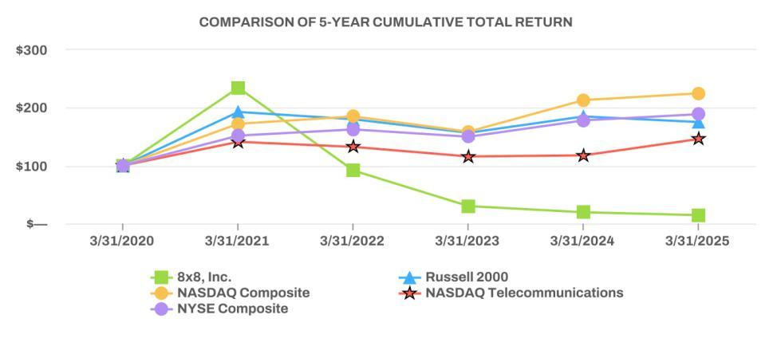

35

Issuer Issuances and Purchases of Equity Securities

Repurchases

In August 2022, the Company repurchased in privately negotiated transactions with a limited number of holders 10,695,000 shares of its common stock for approximately $60.0 million, in connection with the Exchange Transaction and negotiation of the secured term loan facility, as further described in Part II, Item 8, Note 8, Convertible Senior Notes and Term Loan.

In May 2017, the Company's board of directors authorized the Company to purchase $25.0 million of its common stock from time to time under the 2017 Repurchase Plan (the "Repurchase Plan"). The Repurchase Plan expires when the maximum purchase amount is reached, or upon the earlier revocation or termination by the Company's board of directors. The remaining amount available under the Repurchase Plan as of March 31, 2025 was approximately $7.1 million.

Issuances

On August 3, 2022, the Company agreed with its financial advisor, to settle 50% of its financial advisory fee for services provided in connection with the Exchange Transaction and negotiation of the secured term loan facility, as further described in Part II, Item 8, Note 8, Convertible Senior Notes and Term Loan, to the consolidated financial statements through the issuance of 1,015,024 shares of the Company's common stock, equivalent to approximately $5.1 million. These shares were issued in a private placement in reliance on the exemption from registration provided by Section 4(a)(2) of the Securities Act. The Company relied on this exemption based in part on representations made by the financial advisor in its engagement letter and related share payment letter.

ITEM 6. [Reserved]

36

ITEM 7. Management's Discussion and Analysis of Financial Condition and Results of Operations

The following discussion and analysis of our financial condition and results of operations should be read in conjunction with our consolidated financial statements and related notes and other information included elsewhere in this Annual Report. In addition to historical data, this discussion contains forward-looking statements about our business, results of operations, cash flows, financial condition and prospects based on current expectations that involve risks, uncertainties and assumptions. Our actual results could differ materially from such forward-looking statements. Factors that could cause or contribute to those differences include, but are not limited to, those identified below and those discussed in the sections titled “Risk Factors” and “Cautionary Note Regarding Forward-Looking Statements” included elsewhere in this Annual Report. Additionally, our historical results are not necessarily indicative of the results that may be expected for any period in the future.

This section discusses items pertaining to and comparisons of financial results between fiscal 2025 and fiscal 2024. A discussion of fiscal 2024 items and comparisons between fiscal 2024 and fiscal 2023 financial results can be found in “Management’s Discussion and Analysis of Financial Condition and Results of Operations” in Part II, Item 7 of the Company’s Annual Report on Form 10-K for the fiscal year ended March 31, 2024 (the “2024 MD&A”), filed with the Securities and Exchange Commission on May 21, 2024.

Overview

8x8, Inc. is a global provider of integrated customer experience and business communications solutions, purpose-built to unify customer and employee engagement across the enterprise. Our Platform for CX™ combines contact center, business communications, and application programmable interfaces, or APIs, for communications into a single, secure, AI-powered system that delivers seamless, data-driven interactions. Designed for agility and scale, our platform helps businesses eliminate silos, improve operational efficiency, and turn every conversation into actionable intelligence. By aligning technology with measurable outcomes, we empower organizations to transform how they connect, serve, and grow — from first interactions to lasting relationships.

We serve a broad customer base—from small businesses to large global enterprises—across every major industry and in over 160 countries. Our strategic focus has increasingly shifted toward mid-market, small and mid-sized enterprise, and public sector organizations, particularly those with 500 to 10,000 employees. These customers often have more complex communication and customer service needs and are more likely to benefit from—and invest in—multiple services across our platform. This focus aligns with our strengths, eliminating communication silos and enabling businesses to transform every customer interaction into a strategic asset. We also invest resources in retaining our small business customers, including world class onboarding and customer care specialists that are a single point of contact for all service and support needs.

We reach customers through a diversified go-to-market strategy that includes both direct and indirect channels. We utilize a diversified partner ecosystem to complement our direct sales efforts and expand our global market reach. Our go-to-market strategy includes technology solutions distributors, or TSDs, and their sub-agent networks, who contribute to pipeline growth through referrals. We also engage value-added resellers, or VARs, who market, sell, implement, and support our solutions, helping to drive customer acquisition and optimize our routes to market.

In addition, we collaborate closely with strategic technology partners—particularly those with whom we maintain deep integrations or original equipment manufacturer, or OEM, relationships—via structured referral agreements and coordinated lead flow processes. Our carrier partnerships extend our service availability to over 100 countries and territories, ensuring high-quality, reliable communications that support our international footprint.

To further enhance deployment speed and geographic coverage, we leverage third-party service providers, enabling us to deliver implementation and support services efficiently at a global scale.

With our unified approach to communication and a commitment to continuous innovation, 8x8 enables businesses to deliver intelligent, connected experiences that securely scale across the enterprise.

We generate service revenue from subscriptions to our communications services, as well as from usage of our platform. Our service subscription plans are sold on a per-user basis and are structured with increasing levels of functionality, based on the specific communication needs and customer engagement profile of each user. Platform usage, including telephony minutes, messaging, SMS, and digital and voice chat bot interactions, encompasses committed usage, which may be bundled with our service subscription plans, and uncommitted usage, which is sold on an as-used basis.

We generate other revenue from professional services and the sale of office phones and other hardware equipment. We define a “customer” as one or more legal entities to which we provide services pursuant to a single contractual arrangement. In some cases, we may have multiple billing relationships with a single customer (for example, where we establish separate billing accounts for a parent company and each of its subsidiaries).

37

Macroeconomic and Other Factors

We are subject to risks and exposures, including those caused by adverse economic conditions. Macroeconomic conditions that could adversely affect our business include geopolitical instability, tariffs, continued inflation, increased interest rates, supply chain disruptions, decreased economic output and fluctuations in currency exchange rates. We continuously monitor the direct and indirect impacts of these factors, as well as the overall global economy and geopolitical landscape on our business and financial results.

While the implications of macroeconomic events on our business, results of operations, and overall financial position remain uncertain over the long term, we expect that adverse economic conditions could adversely impact our business in future periods. For example, our installed base includes more than 50,000 small businesses, which tend to be disproportionately impacted by macroeconomic headwinds.

Summary and Outlook

As part of our long-term strategy to grow our revenue and increase profitability and cash flow, we are focused on retaining our existing customers and expanding our mid-market, enterprise and public sector customer base. We believe that continued innovation is a critical factor in attracting and retaining our customers and is an important variable in achieving sustainable growth. We are committed to maintaining a high level of investment in research and development to deliver innovation across our Platform for CX, expand our ecosystem of integrated third-party applications, and maintain the high platform availability our customers require.

Our primary focus involves the following: (i) accelerating innovation, particularly in enhancing our platform and contact center with artificial intelligence-based capabilities, and (ii) leveraging our CPaaS leadership in the Asia Pacific region to expand globally. We continue to introduce new products like 8x8 Engage, add capabilities that allow our customers to enhance employee and customer experience, and expand our Technology Partner Ecosystem to provide complete solutions tailored to specific use cases. We are also enhancing our platform foundation with cutting edge technology, such as the Customer Interaction Data Platform and composable agent and supervisor user interfaces. These innovations enable tightly integrated solutions that prioritize ease-of-use, out-of-the-box functionality, and rapid deployment.

Our investment in innovation has been complemented by initiatives to manage the cost of delivering our services and improve our sales efficiency. We continue to monitor factors that could have an impact on customer buying behavior and demand, including macroeconomic conditions, the competitive environment, contract duration, churn, upsell and down-sell, renewals, and payment terms, all of which have caused variability in our results and may continue to do in the future. We expect the cost of delivering our communication services — both in total dollars and as a percentage of service revenue — to vary with the amount of service revenue and the mix of subscription and usage revenue within service revenue. To improve our sales efficiency over time, we continue to invest in marketing programs to drive awareness for our solutions, and we have increased training for our sales teams, and invested in tools to increase productivity. We have also expanded our reseller partner programs to extend our reach within our target customer market, placing increased emphasis on developing a community of value-added resellers who provide implementation services and Tier 1 customer support in addition to sales. To support our customers and partners, we have expanded our customer success organization and continue to invest in improvements to our back-office processes to increase our operational efficiency over time.

Key GAAP Operating Results

To assess the success of our strategies to achieve growth and increase our cash flow, management reviews our financial performance as presented in our consolidated financial statements, including trends in revenue, gross profit margin, income (loss) from operations, and cash flow generated by operations in absolute dollars and as a percentage of revenue as presented in the following table:

 |  |  |  |  | Fiscal Year 2025 |  |  |  |  |  |  |  |  |  |  |  | Fiscal Year 2024
 |  |  |  |  | Three Months Ended |  |  |  |  |  |  |  |  |  |  |  | Three Months Ended
(In thousands, except percentages) |  | March 31, 2025 |  | December 31, 2024 |  |  | September 30, 2024 |  |  |  | June 30, 2024 |  |  | March 31, 2024 |  | December 31, 2023 |  |  | September 30, 2023 |  |  |  | June 30, 2023
Service revenue | $ | 171,588 |  | $ | 173,459 |  | $ | 175,075 |  | $ | 172,801 |  | $ | 172,490 |  | $ | 175,069 |  | $ | 177,782 |  | $ | 175,238
% of Total Revenue |  | 96.9 % |  |  | 97.0 % |  |  | 96.7 % |  |  | 97.0 % |  |  | 96.1 % |  |  | 96.7 % |  |  | 96.1 % |  |  | 95.6 %
Gross profit | $ | 120,052 |  | $ | 121,085 |  | $ | 123,175 |  | $ | 120,960 |  | $ | 122,444 |  | $ | 124,846 |  | $ | 127,897 |  | $ | 128,613
% of Total Revenue |  | 67.8 % |  |  | 67.7 % |  |  | 68.1 % |  |  | 67.9 % |  |  | 68.2 % |  |  | 69.0 % |  |  | 69.1 % |  |  | 70.2 %
Income (loss) from operations | $ | 419 |  | $ | 8,979 |  | $ | 7,169 |  | $ | (1,374) |  | $ | (14,219) |  | $ | (9,391) |  | $ | (2,583) |  | $ | (1,410)
% of Total Revenue |  | 0.2 % |  |  | 5.0 % |  |  | 4.0 % |  |  | (0.8)% |  |  | (7.9)% |  |  | (5.2)% |  |  | (1.4)% |  |  | (0.8)%
Net income (loss) | $ | (5,401) |  | $ | 3,022 |  | $ | (14,543) |  | $ | (10,290) |  | $ | (23,591) |  | $ | (21,222) |  | $ | (7,452) |  | $ | (15,327)
% of Total Revenue |  | (3.1)% |  |  | 1.7 % |  |  | (8.0)% |  |  | (5.8)% |  |  | (13.1)% |  |  | (11.7)% |  |  | (4.0)% |  |  | (8.4)%
Net cash provided by operating | $ | 5,873 |  | $ | 27,216 |  | $ | 12,317 |  | $ | 18,148 |  | $ | 12,653 |  | $ | 22,396 |  | $ | 17,463 |  | $ | 26,473
activities | $ | 5,873 |  | $ | 27,216 |  | $ | 12,317 |  | $ | 18,148 |  | $ | 12,653 |  | $ | 22,396 |  | $ | 17,463 |  | $ | 26,473

38

Components of Results of Operations

Service Revenue

Service revenue consists of communication services subscriptions, platform usage revenue, and related fees from our UCaaS, CCaaS, and CPaaS offerings. We plan to increase service revenue through a combination of new customer acquisition, cross-sell of additional products to existing customers, including new products resulting from our increased investment in innovation, artificial intelligence, geographic expansion of our customer base outside the United States, innovation in our products and technologies, and through strategic acquisitions of technologies and businesses.

Other Revenue

Other revenue consists of revenue from professional services, primarily in support of deployment of our solutions and/or platform, and revenue from sales and rentals of IP telephones in conjunction with our cloud telephony service. Other revenue is dependent on the number of customers who choose to purchase or rent an IP telephone hardware in conjunction with our service instead of using the solution on their cell phone, computer, or other compatible device, and/or choose to engage our professional services organization for implementation and deployment of our cloud services.

Cost of Service Revenue

Cost of service revenue consists primarily of costs associated with network operations and related personnel, technology licenses, amortization of capitalized internal-use software, other communication origination and termination services provided by third-party carriers, outsourced customer service call center operations, and other costs such as customer service, and technical support costs. We allocate overhead costs, such as information technology and facilities, to cost of service revenue, as well as to each of the operating expense categories, generally based on relative headcount. Our information technology costs include costs for information technology infrastructure and personnel. Facilities costs primarily consist of office leases and related expenses.

Cost of Other Revenue

Cost of other revenue consists primarily of direct and indirect costs associated with the purchase and shipping and handling of IP telephones as well as the scheduling, shipping and handling, personnel costs, and other expenditures incurred in connection with the professional services associated with the deployment and implementation of our products, and allocated information technology and facilities costs.

Research and Development

Research and development expenses consist primarily of personnel and related costs, third-party development, software and equipment costs necessary for us to conduct our product, platform development and engineering efforts, as well as allocated information technology and facilities costs.

Sales and Marketing

Sales and marketing expenses consist primarily of personnel and related costs, sales commissions, including those to the channel, trade shows, advertising and other marketing, demand generation, and promotional expenses, as well as allocated information technology and facilities costs.

General and Administrative

General and administrative expenses consist primarily of personnel and related costs, professional services fees, corporate administrative costs, tax and regulatory fees, and allocated information technology and facilities costs.

Impairment of Long-Lived Assets

Impairment of long-lived assets consists of non-cash impairment charges for right-of-use assets and capitalized software. During the third quarter of fiscal year 2024, we partially ceased use of the Company's Headquarters and an international office space. We reviewed the recoverability of the related right-of-use assets and determined an impairment indicator was identified as these events indicated the carrying value of the right-of-use assets may not be recoverable. In connection with partially ceasing use of the Company’s Headquarters and an international office space, the Company recorded impairment charges of $9.9 million and $1.1 million, respectively, as the carrying amount of the right-of-use assets related to the leases exceeded its fair value based on the Company’s estimate of future discounted cash flows related to the leased facility. During the year ended March 31, 2024, the non-cash charge of $11.0 million was recorded as an impairment of long-lived assets on the consolidated statements of operations and comprehensive loss and consisted of an $11.0 million impairment of operating lease right-of-use assets. See Note 1, The Company and Significant Accounting Policies, for further details.

During the year ended March 31, 2023, the impairment charge of $6.4 million was due to capitalized software and right-of-use assets of $3.7 million and $2.7 million, respectively.

39

Interest Expense

Interest expense consists primarily of interest expense related to our term loan and convertible notes, and amortization of debt discount and issuance costs.

Other Expense, Net

Other expense, net, consists primarily of losses on debt extinguishment, gain or loss on warrant remeasurement, interest income, gains or losses on foreign exchange transactions, as well as other income.

Provision for Income Taxes

Provision for income taxes consists primarily of foreign income taxes and state minimum taxes in the United States. As we expand the scale of our international business activities, any changes in the United States and foreign taxation of such activities may increase our overall provision for income taxes in the future. We have a valuation allowance for our United States deferred tax assets, including federal and state non-operating loss carryforwards. We expect to maintain this valuation allowance until it becomes more likely than not that the benefit of our federal and state deferred tax assets will be realized by way of expected future taxable income in the United States.

Results of Operations

Revenue
Service revenue
 | For the years ended March 31,
(in thousands, except percentages) | 2025 |  |  | 2024 |  |  |  | Change
Service revenue | $ | 692,923 |  | $ | 700,579 |  | $ | (7,656) | (1.1)%
Percentage of total revenue |  | 96.9 % |  |  | 96.1 %

Service revenue decreased by $7.7 million, or 1.1%, for fiscal 2025 compared to fiscal 2024. This change was driven by a decrease in revenue from subscriptions of $19.9 million primarily due to a decline in revenue from customers on the Fuze platform offset by an increase of $12.2 million in platform usage revenue.

Our business is diversified by vertical market and geography, and no single customer represented more than 10% of our total revenue during fiscal years 2025 and 2024. We continue to monitor factors that could have an impact on customer buying behavior and demand, including macroeconomic conditions, contract duration, churn, upsell and down-sell, renewals, and payment terms, all of which could cause variability in our revenue.

Other revenue
 | For the years ended March 31,
(in thousands, except percentages) | 2025 |  |  | 2024 |  |  |  | Change
Other revenue | $ | 22,147 |  | $ | 28,126 |  | $ | (5,979) | (21.3)%
Percentage of total revenue |  | 3.1 % |  |  | 3.9 %

Other revenue decreased by $6.0 million, or 21.3%, in fiscal 2025, as compared to fiscal 2024, due to lower product and professional service revenue of $3.2 million and $2.8 million, respectively.

Cost of Revenue
Cost of service revenue
 | For the years ended March 31,
(in thousands, except percentages) | 2025 |  |  | 2024 |  |  |  | Change
Cost of service revenue | $ | 200,094 |  | $ | 192,960 |  | $ | 7,134 | 3.7 %
Percentage of service revenue |  | 28.9 % |  |  | 27.5 %

Cost of service revenue increased $7.1 million, or 3.7%, during fiscal 2025 compared to fiscal 2024, primarily due to an increase of $17.5 million in costs to deliver our subscription and platform usage services. This increase was partially offset by decreases of $5.7 million from amortization of capitalized software and intangible assets, $3.1 million in stock-based compensation driven by lower weighted average grant date fair values for awards granted, $1.1 million in software costs, and $0.5 million in salaries, benefits, and consulting costs.

40

Cost of other revenue
 | For the years ended March 31,
(in thousands, except percentages) | 2025 |  |  | 2024 |  |  |  | Change
Cost of other revenue | $ | 29,704 |  | $ | 31,945 |  | $ | (2,241) | (7.0)%
Percentage of other revenue |  | 134.1 % |  |  | 113.6 %

Cost of other revenue decreased $2.2 million, or 7.0%, in fiscal 2025 compared to fiscal 2024, primarily due to decreases of $1.6 million in lower product costs associated with IP telephone hardware and $0.8 million of stock-based compensation. These decreases were offset by an increase of $0.2 million in salaries, benefits, and consulting costs to deliver our professional services.

Operating Expenses
Research and development
 | For the years ended March 31,
(in thousands, except percentages) | 2025 |  |  | 2024 |  |  |  | Change
Research and development | $ | 123,211 |  | $ | 136,216 |  | $ | (13,005) | (9.5)%
Percentage of total revenue |  | 17.2 % |  |  | 18.7 %

Research and development expenses decreased $13.0 million, or 9.5%, in fiscal 2025 compared to fiscal 2024, primarily due to decreases of $9.5 million in stock-based compensation driven by lower weighted average grant date fair values for awards granted, $4.3 million in combined salaries, benefits, and consulting costs driven by lower headcount, and $3.5 million in facilities costs. These decreases were partially offset by increases of $2.3 million to operate data centers, $1.4 million in internally-developed software, and $0.6 million in other costs necessary for us to conduct our product, platform development and engineering efforts.

Sales and marketing
 | For the years ended March 31,
(in thousands, except percentages) | 2025 |  |  | 2024 |  |  |  | Change
Sales and marketing | $ | 264,461 |  | $ | 271,944 |  | $ | (7,483) | (2.8)%
Percentage of total revenue |  | 37.0 % |  |  | 37.3 %

Sales and marketing expenses decreased $7.5 million, or 2.8%, in fiscal 2025 compared to fiscal 2024 primarily due to decreases of $8.2 million in channel commissions and amortization of contract acquisition costs and $6.7 million in stock-based compensation expense driven by lower weighted average grant date fair values for awards granted. These decreases were partially offset by an increase of $5.3 million in salaries, benefits, and consulting costs driven by increased sales organization headcount and $2.1 million in digital marketing and other costs.

General and administrative
 | For the years ended March 31,
(in thousands, except percentages) | 2025 |  |  | 2024 |  |  |  | Change
General and administrative | $ | 82,407 |  | $ | 112,209 |  | $ | (29,802) | (26.6)%
Percentage of total revenue |  | 11.5 % |  |  | 15.4 %

General and administrative expenses decreased $29.8 million, or 26.6%, in fiscal 2025 compared to fiscal 2024 primarily due to a $24.2 million decrease associated with regulatory and state and local tax matters. During fiscal 2025, we adjusted accruals related to USF and other legal, regulatory and state and local tax matters and recognized a benefit of $9.9 million, compared to $14.3 million of expenses recognized during fiscal 2024. The decrease was also due to decreases of $3.9 million in salaries, benefits, and consulting costs and $3.8 million in stock-based compensation driven by lower weighted average grant date fair values for awards granted. These decreases were partially offset by an increase of $2.1 million in other general corporate costs.

41

Impairment of long-lived assets
 | For the years ended March 31,
(in thousands, except percentages) | 2025 |  |  | 2024 |  |  |  | Change
Impairment of long-lived assets | $ | — |  | $ | 11,034 |  | $ | (11,034) | (100.0)%
Percentage of total revenue |  | — % |  |  | 1.5 %

Impairment of long-lived assets decreased $11.0 million in fiscal 2025 compared to fiscal 2024. During the third quarter of fiscal 2024, we partially ceased use of the Company's Headquarters and an international office space. We reviewed the recoverability of the related right-of-use assets and determined an impairment indicator was identified as these events indicated the carrying value of the right-of-use assets may not be recoverable. In connection with partially ceasing use of the Company’s Headquarters and an international office space, the Company recorded impairment charges of $9.9 million and $1.1 million, respectively, as the carrying amount of the right-of-use assets related to the leases exceeded its fair value based on the Company’s estimate of future discounted cash flows related to the leased facility. During the year ended March 31, 2024, the non-cash charge of $11.0 million was recorded as an impairment of long-lived assets on the consolidated statements of operations and comprehensive loss and consisted of an $11.0 million impairment of operating lease right-of-use assets. See Note 1, The Company and Significant Accounting Policies, for further details.

Other expense, net
Interest expense
 | For the years ended March 31,
(in thousands, except percentages) | 2025 |  |  | 2024 |  |  |  | Change
Interest expense | $ | (28,856) |  | $ | (39,824) |  | $ | 10,968 | (27.5)%
Percentage of total revenue |  | (4.0)% |  |  | (5.5)%

Interest expense decreased by $11.0 million, or 27.5%, in fiscal 2025 compared to fiscal 2024, primarily due to the 2022 Term Loan Debt extinguishment and decreased interest rate and principal on the Term Loan. See Note 8, Convertible Senior Notes and Term Loan, for further details.

Other expense, net
 | For the years ended March 31,
(in thousands, except percentages) | 2025 |  |  | 2024 |  |  |  | Change
Other income (expense), net | $ | (10,400) |  | $ | 3,477 |  | $ | (13,877) | NM
Percentage of total revenue |  | (1.5)% |  |  | 0.5 %

We recognized $10.4 million of other expense, net during fiscal 2025 compared to $3.5 million of other income, net during fiscal 2024 primarily due to a $10.6 million increase on loss of debt extinguishment due to the payoff of the 2022 Term Loan, an increase of $2.0 million in unrealized foreign exchange losses, a decrease of $0.7 million in interest income, and a $0.6 million increase in other expense.

Provision for income taxes
 | For the years ended March 31,
(in thousands, except percentages) | 2025 |  |  | 2024 |  |  |  | Change
Provision for income taxes | $ | 3,149 |  | $ | 3,642 |  | $ | (493) | (13.5)%
Percentage of total revenue |  | 0.4 % |  |  | 0.5 %

For the year ended March 31, 2025, we recorded an income tax provision of $3.1 million compared to $3.6 million in fiscal 2024, primarily due to a reduction in state income taxes as a result of a reduction in state taxable income offset by an increase in foreign taxes primarily due to the exhaustion of NOL carryforwards and a change in income mix of our foreign jurisdictions.

Liquidity and Capital Resources

We believe that our existing cash, cash equivalents and our anticipated cash flows from operations will be sufficient to meet our working capital, expenditure, and contractual obligation requirements for a minimum of the next twelve months and the foreseeable future. Although we believe we have adequate sources of liquidity for at least the next twelve months and for the foreseeable future, the success of our operations, the global economic outlook, and the pace of growth in our markets could impact our business and liquidity.

42

Cash, Cash Equivalents, and Investments
The following is a summary of our cash and cash equivalents and investments (in thousands):
 | March 31, 2025 |  |  |  | March 31, 2024
Cash and cash equivalents | $ | 88,050 |  | $ | 116,262
Restricted cash, current¹ |  | 462 |  |  | 356
Short-term investments |  | — |  |  | 1,048
Restricted cash, non-current¹ |  | 812 |  |  | 105
Total | $ | 89,324 |  | $ | 117,771

- Restricted cash supports letters of credit securing leases for office facilities and certain equipment for the same periods, and an accrued holdback related to a business combination (see Note 1, The Company and Significant Accounting Policies).

Our primary requirements for liquidity and capital are working capital needs due to delivery of our various products to customers, research and development, sales and marketing activities, principal and interest payments on our outstanding debt and other general corporate needs. Historically, these cash requirements have been met from cash provided by operating activities and our cash and cash equivalents balances. Our current capital deployment strategy for fiscal year 2026 is to invest excess cash on hand to support our continued growth initiatives into select markets and planned software development activities, and pay down our debt. As of March 31, 2025, we are not party to any off-balance sheet arrangements that have had or are reasonably likely to have a current or future material effect on our financial condition, results of operations, liquidity, capital expenditures, or capital resources. Significant cash requirements for the fiscal year include our operating lease obligations, interest payments related to our debt obligations, and operating and capital purchase commitments. For information regarding our expected cash requirements and timing of payments related to leases and noncancellable purchase commitments, see Note 6, Leases, and Note 7, Commitments and Contingencies, respectively, to the consolidated financial statements. Additionally, refer to Note 8, Convertible Senior Notes and Term Loan, to the consolidated financial statements for more information related to our debt obligations and applicable covenants.

Our outstanding Term Loan allows for voluntary prepayments. In order to reduce future cash interest payments, as well as future amounts due at maturity or upon redemption, we may, from time to time, make prepayments. The Company evaluates opportunities for stock repurchases, and may utilize cash and cash equivalents to repurchase shares under the 2017 Repurchase Plan. For more information, see Note 9, Stock-Based Compensation and Stockholders' Equity.

As of March 31, 2025, our 2028 Notes were trading at a discount to their respective principal amount. We may seek to retire or purchase our outstanding debt through open-market purchases, privately negotiated transactions or otherwise which may have an impact on our liquidity requirements. Any such transactions will be dependent upon several factors, including our liquidity requirements, contractual restrictions, prevailing market conditions, and other factors. Whether or not we engage in any such transactions will be determined at our discretion. For historical debt payments, see Note 8, Convertible Senior Notes and Term Loan.

Cash Flows

The following is a summary of our cash flows provided by (used in) operating, investing and financing activities (in thousands):

 |  |  |  | Years Ended March 31,
 | 2025 |  |  |  | 2024 |  |  | 2023
Net cash provided by operating activities | $ | 63,554 |  | $ | 78,985 |  | $ | 48,786
Net cash provided by (used in) investing activities |  | (16,424) |  |  | 8,546 |  |  | 6,050
Net cash used in financing activities |  | (75,106) |  |  | (83,411) |  |  | (37,784)
Effect of exchange rate changes on cash |  | 577 |  |  | (126) |  |  | (5,037)
Net increase (decrease) in cash and cash equivalents | $ | (27,399) |  | $ | 3,994 |  | $ | 12,015

Cash provided by operating activities decreased by $15.4 million to $63.6 million for fiscal 2025, mainly due to an increase in cash paid to suppliers and employees partially offset by an increase in cash received from customers. Cash used in investing activities decreased $25.0 million to $16.4 million for fiscal 2025, mainly due to decreases in the purchases, sales, and maturities of investments and $3.2 million of cash paid for the business combination. Cash used in financing activities decreased by $8.3 million to $75.1 million for fiscal 2025, due to principal repayments for our term loan and payoff of a perpetual license related to our enterprise resource planning software.

43

Debt Obligations

See Note 8, Convertible Senior Notes and Term Loan in the audited consolidated financial statements included elsewhere in this Annual Report for information regarding our debt obligations.

2024 Delayed Draw Term Loan

On July 11, 2024, we entered into a new term loan credit agreement with Wells Fargo Bank, National Association, as administrative agent, and the lenders thereto (the “2024 Credit Agreement”). The 2024 Credit Agreement establishes a delayed draw term loan facility in an aggregate principal amount of up to $200.0 million maturing on August 15, 2027.

On August 5, 2024, we drew upon the entire facility of $200.0 million under the delayed draw term loan facility (the "Term Loan") and used the proceeds of the Term Loan and cash on hand of approximately $29.0 million to repay in full the $225.0 million of outstanding principal amount and accrued interest of the 2022 Term Loan and the fees incurred in connection with the repayment (the "Repayment").

The Term Loan bears interest at an annual rate equal to the Term SOFR, plus a margin of either 2.50%, 2.75% or 3.00% based on the consolidated total net leverage ratio of the Company and its subsidiaries. The initial margin will be 3.00% for the fiscal quarter ending September 30, 2024. We have the option to pay interest monthly, quarterly, or semi-annually. During the three months ended March 31, 2025, we elected monthly payment terms which resulted in cash payments of $2.7 million. During the three months ended June 30, 2025, we have elected monthly interest payment terms, which will result in cash payments of approximately $2.6 million. As of August 5, 2024, the scheduled principal repayments of $22.5 million in fiscal year 2025 ($7.5 million on October 31, 2024, December 31, 2024 and March 31, 2025, respectively), $37.5 million in fiscal year 2026 ($7.5 million on June 30, 2025 and $10.0 million on September 30, 2025, December 31, 2025 and March 31, 2026, respectively), and $47.5 million in fiscal year 2027 ($10.0 million on June 30, 2026, $12.5 million on September 30, 2026 and each quarter thereafter through maturity) are required, and the remaining $92.5 million principal is due before or upon maturity in fiscal year 2028. These annualized repayments will be made in quarterly installments. As of March 31, 2025, the debt issuance costs are amortized to interest expense over the term of the Term Loan at an effective interest rate of 8.67%.

Under the terms of the 2024 Credit Agreement, we have the right to prepay the Term Loan at any time without any premium or penalty. We completed three principal payments of the Term Loan during fiscal 2025 for a total payment of $48.0 million in aggregate principal amount as follows:

- On October 7, 2024, we paid $15.0 million of quarterly principal payments due October 31, 2024 and December 31, 2024.

- On November 1, 2024, we prepaid $18.0 million of additional principal payments due March 31, 2025, June 30, 2025 and September 30, 2025.
- On January 10, 2025, we paid $15.0 million of quarterly principal payments due September 30, 2025 and December 31, 2025.

These short-term principal debt payments are accounted for as partial debt extinguishment transactions. The carrying value of the Term Loan, including the unamortized debt discount and issuance costs, was derecognized. The difference of $0.3 million between the cash consideration paid to partially extinguish the Term Loan and the carrying value of the Term Loan was recognized as a loss on debt extinguishment included in the loss on debt extinguishment line item recorded in other expense in the consolidated statement of operations. The remaining principal amount of the Term Loan after the payments is $152.0 million. As of March 31, 2025, we have paid $22.5 million and $25.5 million of the originally scheduled principal repayments for fiscal year 2025 and fiscal year 2026, respectively. On April 11, 2025, we paid $15.0 million of quarterly principal payments due October 31, 2025, January 31, 2026, and April 30, 2026 under the Term Loan. The Company has no remaining short-term obligations due for fiscal year 2026. See Note 13, Subsequent Events, for more information regarding this prepayment.

2022 Term Loan Extinguishment

On August 5, 2024, we repaid in full the outstanding principal amount and accrued interest of the 2022 Term Loan using the proceeds of the Term Loan and cash on hand. The Repayment was accounted for as a debt extinguishment. The carrying value of the 2022 Term Loan, including the unamortized debt discount and issuance costs, was derecognized. The difference of $12.0 million between the cash consideration paid to extinguish the 2022 Term Loan and the carrying value of the 2022 Term Loan was recognized as a loss on debt extinguishment included in the loss on debt extinguishment line item recorded in other expense in the consolidated statement of operations. The Warrants continued to be outstanding with no change in terms in connection with the Repayment or issuance of the Term Loan.

We previously used the proceeds from the 2022 Credit Agreement to fund the cash portion of an exchange of the Company's approximately $403.8 million principal amount of 0.50% convertible senior notes due 2024 for cash plus approximately $201.9 million of 4.00% convertible senior notes due 2028, and the concurrent repurchase of approximately $60.0 million of our common stock with the counterparties to such exchange. Loans made under the 2022 Credit Agreement bore interest at an annual rate equal to the Term SOFR, subject to a floor of 1.00% and a credit spread adjustment of 0.10%, plus a margin of 6.50%. During the year ended March 31, 2025, we paid $9.4 million of interest under the 2022 Term Loan. See Note 8, Convertible Senior Notes and Term Loan, to our consolidated financial statements for details.

44

Material Cash Requirements and Other Obligations
The following table summarizes the payments due for our outstanding contractual obligations as of March 31, 2025:
 | Total |  |  |  | Less than 1 year |  |  | 1-3 years |  |  | 3-5 years |  |  | Thereafter
2028 Notes
Principal payments | $ | 201,914 |  | $ | — |  | $ | 201,914 |  | $ | — |  | $ | —
Interest payments |  | 24,230 |  |  | 8,077 |  |  | 16,153 |  |  | — |  |  | —
Term Loan⁽¹⁾
Principal payments |  | 152,000 |  |  | 12,000 |  |  | 140,000 |  |  | — |  |  | —
Interest payments⁽²⁾ |  | 21,317 |  |  | 10,203 |  |  | 11,114 |  |  | — |  |  | —
Operating lease obligations⁽³⁾ |  | 67,835 |  |  | 13,501 |  |  | 23,668 |  |  | 22,708 |  |  | 7,958
Purchase obligations |  | 59,766 |  |  | 49,409 |  |  | 9,787 |  |  | 532 |  |  | 38
Total | $ | 527,062 |  | $ | 93,190 |  | $ | 402,636 |  | $ | 23,240 |  | $ | 7,996

- See Note 8, Convertible Senior Notes and Term Loan, in the Notes to Consolidated Financial Statements included in this Annual Report for further information.

- Total interest payments of $21.3 million were determined using the year-end Term SOFR rate of 7.32% plus 3.00% as of March 31, 2025. See Note 8, Convertible Senior Notes and Term Loan, in the Notes to Consolidated Financial Statements included in this Annual Report regarding the interest rate terms.

- See Note 6, Leases, in the Notes to Consolidated Financial Statements included in this Annual Report for further information.

Critical Accounting Policies and Estimates

Our consolidated financial statements are prepared in accordance with U.S. GAAP. Refer to Note 1, The Company and Significant Accounting Policies, in the Notes to Consolidated Financial Statements included in this Annual Report, which describes the significant accounting policies and methods used in the preparation of our consolidated financial statements.

We have identified the policies below as critical to our business and the understanding of our results of operations. These policies may involve a higher degree of judgment and complexity in their application and represent the critical accounting policies used in the preparation of our consolidated financial statements. Although we believe our judgments and estimates are appropriate, actual future results may differ from our estimates. If different assumptions or conditions were to prevail, the results could be materially different from our reported results. The impact and any associated risks related to these policies on our business operations is discussed throughout "Management's Discussion and Analysis of Financial Condition and Results of Operations", where such policies affect our reported and expected financial results.

Revenue Recognition

Significant management judgments and estimates must be made and used in connection with the revenue recognized in any accounting period. Material differences may result in the amount and timing of our revenue for any period if management made different judgments or utilized different estimates.

Revenue is recognized on a gross basis when the Company is considered the principal in the transaction with discretion on pricing and control, as performance obligations are satisfied, based on the transaction price. The Company recognizes revenue on a net basis when the Company is considered the agent in third party license sales, if material. We generally bill our customers on a monthly basis. Contracts typically range from annual to multi-year agreements, generally with payment terms of net 30 days.

We record reductions to revenue for estimated sales returns and customer credits at the time the related revenue is recognized. Sales returns and customer credits are estimated based on our historical experience, current trends, and our expectations regarding future service delivery and platform performance. We monitor the accuracy of its sales reserve estimates by reviewing actual returns and credits and adjust them for its future expectations to determine the adequacy of its current and future reserve needs. If actual future returns and credits differ from past experience, additional reserves may be required.

Service Revenue Recognition

Service revenue from subscriptions to our cloud-based technology platform is recognized on a ratable basis over the contractual subscription term beginning on the date that the platform is delivered to the customer until the end of the contractual period. Payments received in advance of subscription services being rendered are recorded as deferred revenue; revenue recognized for services rendered in advance of payments received are recorded as contract assets. Usage fees, when bundled, are billed in advance and recognized over time on a ratable basis over the contractual subscription term. Non-bundled usage fees are recognized as actual usage occurs.

45

Other Revenue Recognition

Other revenue is primarily comprised of product revenue and professional services revenue. We recognize product revenue for telephony equipment at a point in time when transfer of control has occurred, which is generally upon shipment. Sales returns are recorded as a reduction to revenue estimated based on historical experience. Professional services for deployment, configuration, system integration, optimization, customer training or education are primarily billed on a fixed-fee basis and are performed by us directly. Professional services revenue is recognized as services are performed or upon completion of the deployment.

Allowance for Credit Losses

We account for allowances for credit losses under the current expected credit loss, or CECL, impairment model for our financial assets, including accounts receivable, and present the net amount of the financial instrument expected to be collected. The current expected credit loss impairment model requires an estimate of expected credit losses, measured over the contractual life of an instrument, which considers forecasts of future economic conditions in addition to information about past events and current conditions. Using this model, we estimate the adequacy of the allowance for credit losses at the end of each reporting period based on the aging of the receivable balance, current and historical customer trends, communications with customers, and macro-economic conditions. Amounts are written off after considerable collection efforts have been made and the amounts are determined to be uncollectible.

Acquisitions

Acquisitions are accounted for as business combinations, which treatment requires that the various assets acquired, and liabilities assumed be recognized based on their fair value, accordingly, significant estimates and judgments are made to arrive at the fair values. The use of estimates involves uncertainty, therefore, the initial accounting for goodwill, intangible assets (and related amortization in future periods), property, plant and equipment, right of use assets (and related operating lease liabilities and amortization), prepaid and other current assets, accrued liabilities, deferred revenue, holdback consideration, and other liabilities are all subject to estimates. The actual results could be significantly different from the estimates.

Capitalized Internal-Use Software Costs

Certain costs of software are capitalized during the application development phase. We begin to capitalize costs to develop software when preliminary development efforts are successfully completed, management has authorized and committed project funding, it is probable that the project will be completed, and the software will be used as intended. Capitalized internal-use software development costs are included in property and equipment. Once the project has been completed, these costs are amortized to cost of service revenue on a straight-line basis over the estimated useful life of the related asset as noted in Property and Equipment. Costs incurred prior to meeting these criteria together with costs incurred for training and maintenance are expensed as incurred and recorded in research and development expense. We test capitalized internal-use software development costs for impairment on an annual basis, or as events occur or circumstances change that could impact the recoverability of the capitalized costs.

Accounting for Long-Lived Assets

We review the recoverability of our long-lived assets, such as property and equipment, right-of-use assets, definite lived intangibles, or capitalized internal-use software costs, when events or changes in circumstances occur that indicate that the carrying value of the asset or asset group may not be recoverable. Examples of such events could include the disposal of a significant portion of such asset, an adverse change in the market involving the business employing the related asset, or a significant change in the operation or use of an asset. The assessment of possible impairment is based on our ability to recover the carrying value of the asset or asset group from the expected future cash flows (undiscounted and without interest charges) of the related operations. If these cash flows are less than the carrying value of such asset or asset group, an impairment loss is recognized for the difference between estimated fair value and carrying value. The measurement of impairment requires management to estimate the fair value of long-lived assets and asset groups through future cash flows. During fiscal 2024, we recorded an impairment of long-lived assets related to the Company's right-of-use assets on the consolidated statements of operations and comprehensive loss. See Note 6, Leases, for further details.

Goodwill and Other Intangible Assets

Goodwill represents the excess fair value of consideration transferred over the fair value of net assets acquired in business combinations. Goodwill and intangible assets with indefinite useful lives are not amortized but are tested annually for impairment and more often if there is an indicator of impairment. We perform testing for impairment of goodwill on an annual basis, or as events occur or circumstances change that would more likely than not reduce the fair value of our single reporting unit below its carrying amount. Goodwill is considered impaired if the carrying value of the reporting unit exceeds its fair value.

Intangible assets, consisting of acquired developed technology, domain names, and customer relationships, acquired in business combinations were initially measured at fair value and were determined to have definite lives. Thereafter, intangible assets are amortized on a straight-line basis over their estimated useful lives. Amortization expense related to developed technology is included in cost of revenue. Amortization expense related to customer relationships and domain names are included in sales and marketing expense. Intangible assets are reviewed for impairment whenever events or changes in circumstances indicate an asset’s carrying value may not be recoverable.

46

ITEM 7A. Quantitative and Qualitative Disclosures about Market Risk

Interest Rate Fluctuation Risk

Cash, Cash Equivalents and Short-Term Investments

We had cash, cash equivalents, and investments totaling $88.1 million as of March 31, 2025. Cash equivalents and investments were invested primarily in money market funds, United States treasury, commercial paper, and corporate bonds. Our investment policy is focused on the preservation of capital and supporting our liquidity needs. Under the policy, we invest in highly rated securities, while limiting the amount of credit exposure to any one issuer other than the United States government. We do not invest in financial instruments for trading or speculative purposes, nor do we use leveraged financial instruments. We utilize external investment managers who adhere to the guidelines of our investment policy. A hypothetical 10% change in interest rates would not have a material impact on the value of our cash, cash equivalents, or available-for-sale investments.

Term Loan

The Company is subject to interest rate risk with the Term Loan as we pay interest on the principal balance at a variable rate. As of March 31, 2025, the aggregate principal of the Term Loan was $152.0 million. A hypothetical variable interest rate increase of 10% would increase our annual interest expense by approximately $1.0 million on our consolidated results of operations.

2028 Notes

As of March 31, 2025, we have $201.9 million aggregate principal amount of the 2028 Notes. Our 2028 Notes bear a fixed interest rate, and therefore, is not subject to interest rate risk as the 2028 Notes are recorded at face value, less unamortized discount, on our consolidated balance sheets, and we present the fair value for required disclosure purposes only.

Foreign Currency Exchange Risk

We have foreign currency risks related to our revenue and operating expenses denominated in currencies other than the United States dollar, primarily the British Pound and Singapore Dollar, causing both our revenue and our operating results to be impacted by fluctuations in the exchange rates. Gains or losses from the revaluation of certain cash balances, accounts receivable balances and intercompany balances that are denominated in these currencies impact our net income (loss). A hypothetical decrease in all foreign currencies against the United States dollar of 10% would not result in a material foreign currency loss on foreign-denominated balances as of March 31, 2025.

In addition, we are exposed to translation risk in connection with our foreign operations in Europe and Asia because our subsidiaries in these countries utilize the local currency as their functional currency and those financial results must be translated into U.S. dollars. Accordingly, the effects of exchange rate fluctuations on the net assets of these foreign subsidiaries’ operations are accounted for as translation gains or losses in accumulated other comprehensive loss within stockholders’ equity. During the year ended March 31, 2025, a hypothetical change of 10% in such foreign currency exchange rates would have resulted in additional foreign currency translation adjustment of approximately $13.0 million within accumulated other comprehensive loss.

As our foreign operations expand, our results may be more impacted by fluctuations in the exchange rates of the currencies in which we do business.

At this time, we do not, but we may in the future, enter into financial instruments to hedge our foreign currency exchange risk.

47

ITEM 8. Consolidated Financial Statements and Supplementary Data

Index To Financial Statements and Financial Statement Schedule

 |  |  |  |  |  |  | Page
 | FINANCIAL STATEMENTS:
 | Reports of Independent Registered Public Accounting Firm |  |  |  |  |  | 49
 | (Moss Adams LLP, Campbell, California, PCAOB ID: 659)
 | Consolidated Balance Sheets |  |  |  |  |  | 50
 | Consolidated Statements of Operations and Comprehensive Loss |  |  |  |  |  | 51
 | Consolidated Statements of Stockholders' Equity |  |  |  |  |  | 52
 | Consolidated Statements of Cash Flows |  |  |  |  |  | 53
 | Notes to Consolidated Financial Statements |  |  |  |  |  | 55
 |  |  |  |  |  |  | 48

Report of Independent Registered Public Accounting Firm

To the Shareholders and the Board of Directors of 8x8, Inc.

Opinions on the Financial Statements and Internal Control over Financial Reporting

We have audited the accompanying consolidated balance sheets of 8x8, Inc. (the “Company”) as of March 31, 2025 and 2024, the related consolidated statements of operations and comprehensive loss, stockholders’ equity and cash flows for each of the three years in the period ended March 31, 2025, and the related notes (collectively referred to as the “consolidated financial statements”). We also have audited the Company’s internal control over financial reporting as of March 31, 2025, based on criteria established in Internal Control - Integrated Framework (2013) issued by the Committee of Sponsoring Organizations of the Treadway Commission (COSO).

In our opinion, the consolidated financial statements referred to above present fairly, in all material respects, the consolidated financial position of the Company as of March 31, 2025 and 2024, and the consolidated results of its operations and its cash flows for each of the three years in the period ended March 31, 2025, in conformity with accounting principles generally accepted in the United States of America. Also in our opinion, the Company maintained, in all material respects, effective internal control over financial reporting as of March 31, 2025, based on criteria established in Internal Control - Integrated Framework (2013) issued by COSO.

Basis for Opinions

The Company’s management is responsible for these consolidated financial statements, for maintaining effective internal control over financial reporting, and for its assessment of the effectiveness of internal control over financial reporting, included in the Management's Report on Internal Control over Financial Reporting included in Item 9A. Our responsibility is to express an opinion on the Company’s consolidated financial statements and an opinion on the Company’s internal control over financial reporting based on our audits. We are a public accounting firm registered with the Public Company Accounting Oversight Board (United States) (“PCAOB”) and are required to be independent with respect to the Company in accordance with the U.S. federal securities laws and the applicable rules and regulations of the Securities and Exchange Commission and the PCAOB.

We conducted our audits in accordance with the standards of the PCAOB. Those standards require that we plan and perform the audits to obtain reasonable assurance about whether the consolidated financial statements are free of material misstatement, whether due to error or fraud, and whether effective internal control over financial reporting was maintained in all material respects.

Our audits of the consolidated financial statements included performing procedures to assess the risks of material misstatement of the consolidated financial statements, whether due to error or fraud, and performing procedures to respond to those risks. Such procedures included examining, on a test basis, evidence regarding the amounts and disclosures in the consolidated financial statements. Our audits also included evaluating the accounting principles used and significant estimates made by management, as well as evaluating the overall presentation of the consolidated financial statements. Our audit of internal control over financial reporting included obtaining an understanding of internal control over financial reporting, assessing the risk that a material weakness exists, and testing and evaluating the design and operating effectiveness of internal control based on the assessed risk. Our audits also included performing such other procedures as we considered necessary in the circumstances. We believe that our audits provide a reasonable basis for our opinions.

Definition and Limitations of Internal Control over Financial Reporting

A company’s internal control over financial reporting is a process designed to provide reasonable assurance regarding the reliability of financial reporting and the preparation of financial statements for external purposes in accordance with generally accepted accounting principles. A company’s internal control over financial reporting includes those policies and procedures that (1) pertain to the maintenance of records that, in reasonable detail, accurately and fairly reflect the transactions and dispositions of the assets of the company; (2) provide reasonable assurance that transactions are recorded as necessary to permit preparation of financial statements in accordance with generally accepted accounting principles, and that receipts and expenditures of the company are being made only in accordance with authorizations of management and directors of the company; and (3) provide reasonable assurance regarding prevention or timely detection of unauthorized acquisition, use, or disposition of the company’s assets that could have a material effect on the financial statements.

Because of its inherent limitations, internal control over financial reporting may not prevent or detect misstatements. Also, projections of any evaluation of effectiveness to future periods are subject to the risk that controls may become inadequate because of changes in conditions, or that the degree of compliance with the policies or procedures may deteriorate.

Critical Audit Matters

Critical audit matters are matters arising from the current period audit of the (consolidated) financial statements that were communicated or required to be communicated to the audit committee and that

- relate to accounts or disclosures that are material to the financial statements and (2) involved our especially challenging, subjective, or complex judgments. We determined that there are no critical audit matters.

/s/ Moss Adams LLP

Campbell, California

May 22, 2025

We have served as the Company’s auditor since 2008.

49

8X8, INC.

CONSOLIDATED BALANCE SHEETS

(in thousands, except per share amounts)

 | March 31, 2025 |  |  |  | March 31, 2024
ASSETS
Current assets:
Cash and cash equivalents | $ | 88,050 |  | $ | 116,262
Restricted cash |  | 462 |  |  | 356
Short-term investments |  | — |  |  | 1,048
Accounts receivable, net |  | 49,680 |  |  | 58,979
Deferred contract acquisition costs |  | 30,935 |  |  | 35,933
Other current assets |  | 34,739 |  |  | 35,258
Total current assets |  | 203,866 |  |  | 247,836
Property and equipment, net |  | 47,919 |  |  | 53,181
Operating lease, right-of-use assets |  | 33,508 |  |  | 35,924
Intangible assets, net |  | 67,949 |  |  | 86,717
Goodwill |  | 271,530 |  |  | 266,574
Restricted cash, non-current |  | 812 |  |  | 105
Deferred contract acquisition costs, non-current |  | 44,239 |  |  | 52,859
Other assets, non-current |  | 13,354 |  |  | 12,783
Total assets | $ | 683,177 |  | $ | 755,979

LIABILITIES AND STOCKHOLDERS' EQUITY

Current liabilities:
Accounts payable $

Accrued and other liabilities
Operating lease liabilities

Deferred revenue
Term loan, current

Total current liabilities

Operating lease liabilities, non-current

Deferred revenue, non-current
Convertible senior notes, non-current

Term loan
Other liabilities, non-current

Total liabilities

Commitments and contingencies (Note 7)

Stockholders' equity:
Preferred stock: $0.001 par value, 5,000 shares authorized, none issued and outstanding as of March 31, 2025 and 2024

Common stock: $0.001 par value, 300,000 shares authorized, 134,355 shares and 125,194 shares issued and outstanding at March 31, 2025 and 2024, respectively
Additional paid-in capital

Accumulated other comprehensive loss
Accumulated deficit

Total stockholders' equity

Total liabilities and stockholders' equity $

45,773 | $ | 48,862
63,025 |  | 78,102
11,102 |  | 11,295
37,751 |  | 34,325
11,593 |  | —
169,244 |  | 172,584
49,196 |  | 56,647
706 |  | 7,810
198,790 |  | 197,796
139,581 |  | 211,894
3,456 |  | 7,290
560,973 |  | 654,021
— |  | —
134 |  | 125
1,018,902 |  | 973,895
(9,111) |  | (11,553)
(887,721) |  | (860,509)
122,204 |  | 101,958
683,177 | $ | 755,979

The accompanying notes are an integral part of these consolidated financial statements.

50

8X8, INC.

CONSOLIDATED STATEMENTS OF OPERATIONS AND COMPREHENSIVE LOSS

(in thousands, except per share amounts)

 |  |  |  |  | For the years ended March 31,
 | 2025 |  |  |  | 2024 |  |  | 2023
Service revenue | $ | 692,923 |  | $ | 700,579 |  | $ | 710,044
Other revenue |  | 22,147 |  |  | 28,126 |  |  | 33,894
Total revenue |  | 715,070 |  |  | 728,705 |  |  | 743,938
Cost of service revenue |  | 200,094 |  |  | 192,960 |  |  | 198,871
Cost of other revenue |  | 29,704 |  |  | 31,945 |  |  | 42,604
Total cost of revenue |  | 229,798 |  |  | 224,905 |  |  | 241,475
Gross profit |  | 485,272 |  |  | 503,800 |  |  | 502,463
Operating expenses:
Research and development |  | 123,211 |  |  | 136,216 |  |  | 142,491
Sales and marketing |  | 264,461 |  |  | 271,944 |  |  | 311,883
General and administrative |  | 82,407 |  |  | 112,209 |  |  | 108,001
Impairment of long-lived assets |  | — |  |  | 11,034 |  |  | 6,380
Total operating expenses |  | 470,079 |  |  | 531,403 |  |  | 568,755
Income (loss) from operations |  | 15,193 |  |  | (27,603) |  |  | (66,292)
Interest expense |  | (28,856) |  |  | (39,824) |  |  | (27,274)
Other income (expense), net |  | (10,400) |  |  | 3,477 |  |  | 23,230
Loss before provision for income taxes |  | (24,063) |  |  | (63,950) |  |  | (70,336)
Provision for income taxes |  | 3,149 |  |  | 3,642 |  |  | 2,807
Net loss | $ | (27,212) |  | $ | (67,592) |  | $ | (73,143)
Net loss per share:
Basic and diluted | $ | (0.21) |  | $ | (0.56) |  | $ | (0.63)
Weighted average number of shares:
Basic and diluted |  | 129,767 |  |  | 121,106 |  |  | 115,959
Comprehensive loss
Net loss | $ | (27,212) |  | $ | (67,592) |  | $ | (73,143)
Unrealized gain (loss) on investments in securities |  | (5) |  |  | 280 |  |  | (184)
Foreign currency translation adjustment |  | 2,447 |  |  | 1,094 |  |  | (4,830)
Comprehensive loss | $ | (24,770) |  | $ | (66,218) |  | $ | (78,157)

The accompanying notes are an integral part of these consolidated financial statements.

51

8X8, INC.

CONSOLIDATED STATEMENTS OF STOCKHOLDERS' EQUITY

(in thousands)

 | Common Stock |  |  |  |  | Additional Paid- |  |  |  | Accumulated Other
 | Shares |  |  | Amount |  |  | in Capital |  |  | Comprehensive Loss |  | Accumulated Deficit |  |  |  | Total
Balance at March 31, 2022 | 117,863 |  | $ | 118 |  | $ | 956,599 |  | $ | (7,913) |  | $ | (766,438) |  | $ | 182,366
Adjustment related to adoption of ASU 2020-06 | — |  |  | — |  |  | (92,832) |  |  | — |  |  | 46,672 |  |  | (46,160)
Issuance of common stock under stock plans, less | 6,499 |  |  | 7 |  |  | 4,678 |  |  | — |  |  | — |  |  | 4,685
withholding | 6,499 |  |  | 7 |  |  | 4,678 |  |  |  |  |  |  |  |  | 4,685
Stock-based compensation expense | — |  |  | — |  |  | 92,065 |  |  | — |  |  | — |  |  | 92,065
Forfeiture of common stock related to Wavecell acquisition | (23) |  |  | — |  |  | — |  |  | — |  |  | — |  |  | —
Repurchase of capped calls | — |  |  | — |  |  | 244 |  |  | — |  |  | — |  |  | 244
Share repurchases | (10,695) |  |  | (11) |  |  | (60,203) |  |  | — |  |  | — |  |  | (60,214)
Shares issued for debt issuance | 1,015 |  |  | 1 |  |  | 5,084 |  |  | — |  |  | — |  |  | 5,085
Dissolution of investment in foreign subsidiary | — |  |  | — |  |  | — |  |  | — |  |  | (8) |  |  | (8)
Unrealized investment loss | — |  |  | — |  |  | — |  |  | (184) |  |  | — |  |  | (184)
Foreign currency translation adjustment | — |  |  | — |  |  | — |  |  | (4,830) |  |  | — |  |  | (4,830)
Net loss | — |  |  | — |  |  | — |  |  | — |  |  | (73,143) |  |  | (73,143)
Balance at March 31, 2023 | 114,659 |  |  | 115 |  |  | 905,635 |  |  | (12,927) |  |  | (792,917) |  |  | 99,906
Issuance of common stock under stock plans, less | 7,613 |  |  | 7 |  |  | (7) |  |  | — |  |  | — |  |  | —
withholding | 7,613 |  |  | 7 |  |  | (7) |  |  |  |  |  |  |  |  | —
ESPP issuance | 1,884 |  |  | 2 |  |  | 4,882 |  |  | — |  |  | — |  |  | 4,884
Stock-based compensation expense | — |  |  | — |  |  | 63,386 |  |  | — |  |  | — |  |  | 63,386
Issuance of common stock under stock plans related to Fuze | 1,038 |  |  | 1 |  |  | (1) |  |  | — |  |  | — |  |  | —
acquisition | 1,038 |  |  | 1 |  |  | (1) |  |  |  |  |  |  |  |  | —
Unrealized investment gain | — |  |  | — |  |  | — |  |  | 280 |  |  | — |  |  | 280
Foreign currency translation adjustment | — |  |  | — |  |  | — |  |  | 1,094 |  |  | — |  |  | 1,094
Net loss | — |  |  | — |  |  | — |  |  | — |  |  | (67,592) |  |  | (67,592)
Balance at March 31, 2024 | 125,194 |  |  | 125 |  |  | 973,895 |  |  | (11,553) |  |  | (860,509) |  |  | 101,958
Issuance of common stock under stock plans, less | 6,445 |  |  | 7 |  |  | (7) |  |  | — |  |  | — |  |  | —
withholding | 6,445 |  |  | 7 |  |  | (7) |  |  |  |  |  |  |  |  | —
ESPP issuance | 2,387 |  |  | 2 |  |  | 3,690 |  |  | — |  |  | — |  |  | 3,692
Common shares withheld for settlement of taxes in | (175) |  |  | — |  |  | (420) |  |  | — |  |  | — |  |  | (420)
connection with equity-based compensation | (175) |  |  |  |  |  | (420) |  |  |  |  |  |  |  |  | (420)
Stock-based compensation expense | — |  |  | — |  |  | 41,200 |  |  | — |  |  | — |  |  | 41,200
Issuance of common stock related to acquisitions | 504 |  |  | — |  |  | 544 |  |  | — |  |  | — |  |  | 544
Unrealized investment loss | — |  |  | — |  |  | — |  |  | (5) |  |  | — |  |  | (5)
Foreign currency translation adjustment | — |  |  | — |  |  | — |  |  | 2,447 |  |  | — |  |  | 2,447
Net loss | — |  |  | — |  |  | — |  |  | — |  |  | (27,212) |  |  | (27,212)
Balance at March 31, 2025 | 134,355 |  | $ | 134 |  | $ | 1,018,902 |  | $ | (9,111) |  | $ | (887,721) |  | $ | 122,204

The accompanying notes are an integral part of these consolidated financial statements.

52

8X8, INC.

CONSOLIDATED STATEMENTS OF CASH FLOWS

(in thousands)

 |  |  |  | For the years ended March 31,
 |  |  |  | 2025 |  |  | 2024 |  |  | 2023
 | Cash flows from operating activities:
 | Net loss | $ |  | (27,212) |  | $ | (67,592) |  | $ | (73,143)
 | Adjustments to reconcile net loss to net cash provided by operating activities:
 | Depreciation |  |  | 7,387 |  |  | 8,301 |  |  | 10,464
 | Amortization of intangible assets |  |  | 19,104 |  |  | 20,395 |  |  | 21,078
 | Amortization of capitalized internal-use software costs |  |  | 12,729 |  |  | 18,486 |  |  | 20,739
 | Impairment of capitalized software |  |  | — |  |  | — |  |  | 3,729
 | Amortization of debt discount and issuance costs |  |  | 2,466 |  |  | 4,472 |  |  | 4,254
 | Amortization of deferred contract acquisition costs |  |  | 37,977 |  |  | 40,181 |  |  | 38,195
 | Allowance for credit losses |  |  | 1,843 |  |  | 2,236 |  |  | 1,892
 | Operating lease expense, net of accretion |  |  | 11,631 |  |  | 10,934 |  |  | 12,030
 | Impairment of right-of-use assets |  |  | — |  |  | 11,034 |  |  | 2,651
 | Stock-based compensation expense |  |  | 39,940 |  |  | 61,910 |  |  | 89,536
 | (Gain) loss on debt extinguishment |  |  | 12,325 |  |  | 1,766 |  |  | (18,545)
 | Gain on remeasurement of warrants |  |  | (2,225) |  |  | (2,176) |  |  | (417)
 | (Gain) loss on disposal of assets |  |  | — |  |  | 179 |  |  | (1,821)
 | Other |  |  | (346) |  |  | 680 |  |  | 101
 | Changes in assets and liabilities:
 | Accounts receivable, net |  |  | 7,845 |  |  | 753 |  |  | (8,450)
 | Deferred contract acquisition costs |  |  | (23,988) |  |  | (22,879) |  |  | (31,086)
 | Other current and non-current assets |  |  | (7,617) |  |  | (2,348) |  |  | 2,150
 | Accounts payable and accrued liabilities |  |  | (24,810) |  |  | (4,182) |  |  | (24,403)
 | Deferred revenue |  |  | (3,495) |  |  | (3,165) |  |  | (168)
 | Net cash provided by operating activities |  |  | 63,554 |  |  | 78,985 |  |  | 48,786
 | Cash flows from investing activities:
 | Purchases of property and equipment |  |  | (2,401) |  |  | (2,650) |  |  | (2,991)
 | Proceeds from sale of intangible assets |  |  | — |  |  | — |  |  | 1,000
 | Capitalized internal-use software costs |  |  | (11,066) |  |  | (14,289) |  |  | (11,896)
 | Purchases of investments |  |  | — |  |  | (6,174) |  |  | (53,308)
 | Purchase of cost investment |  |  | (771) |  |  | — |  |  | —
 | Sales of investments |  |  | — |  |  | — |  |  | 8,296
 | Maturities of investments |  |  | 1,048 |  |  | 31,659 |  |  | 66,199
 | Business combination, net of cash acquired |  |  | (3,234) |  |  | — |  |  | (1,250)
 | Net cash provided by (used in) investing activities |  |  | (16,424) |  |  | 8,546 |  |  | 6,050
 | Cash flows from financing activities:
 | Proceeds from issuance of common stock under employee stock plans |  |  | 3,692 |  |  | 4,884 |  |  | 4,679
 | Repurchase of capped calls |  |  | — |  |  | — |  |  | 244
 | Payments for debt issuance costs |  |  | (1,517) |  |  | — |  |  | —
 | Repayment of principal on term loan |  |  | (273,000) |  |  | (25,000) |  |  | —
 | Proceeds from term loan |  |  | 200,000 |  |  | — |  |  | 234,806
 | Repayment and exchange of convertible notes |  |  | — |  |  | (63,295) |  |  | (217,299)
 | Repurchase of common stock |  |  | — |  |  | — |  |  | (60,214)
 | Other financing activities |  |  | (4,281) |  |  | — |  |  | —
 | Net cash used in financing activities |  |  | (75,106) |  |  | (83,411) |  |  | (37,784)
 | Effect of exchange rate changes on cash |  |  | 577 |  |  | (126) |  |  | (5,037)
 | Net increase (decrease) in cash and cash equivalents |  |  | (27,399) |  |  | 3,994 |  |  | 12,015
 | Cash, cash equivalents and restricted cash, beginning of year |  |  | 116,723 |  |  | 112,729 |  |  | 100,714
 | Cash, cash equivalents and restricted cash, end of year | $ |  | 89,324 |  | $ | 116,723 |  | $ | 112,729
 |  | 53

Supplemental disclosures of cash flow information:
 |  | For the years ended March 31,
 | 2025 |  |  |  | 2024 |  |  | 2023
Interest paid | $ | 26,297 |  | $ | 35,574 |  | $ | 22,162
Income taxes paid | $ | 3,767 |  | $ | 5,974 |  | $ | 1,530
Payables and accruals for property and equipment | $ | 132 |  | $ | 3,868 |  | $ | 38
Issuance of common stock for business combinations | $ | 544 |  | $ | — |  | $ | —
Warrants issued in connection with 2022 term loan | $ | — |  | $ | — |  | $ | 5,915
Shares issued in connection with 2022 term loan and convertible senior notes | $ | — |  | $ | — |  | $ | 5,084
Issuance of 2028 convertible senior notes in exchange of 2024 convertible senior notes | $ | — |  | $ | — |  | $ | 201,914

The accompanying notes are an integral part of these consolidated financial statements.

54

8X8, INC.

NOTES TO CONSOLIDATED FINANCIAL STATEMENTS

1. The Company and Significant Accounting Policies

The Company

8x8, Inc. ("8x8" or the "Company") was incorporated in California in February 1987 and was reincorporated in Delaware in December 1996. The Company trades under the symbol "EGHT" on the Nasdaq Global Select Market.

The Company is a leading Software-as-a-Service ("SaaS") provider of contact center, voice, video, chat, and enterprise-class API solutions powered by one global cloud communications platform. 8x8 empowers workforces worldwide by connecting individuals and teams, so they can collaborate faster and work smarter from anywhere. 8x8 provides real-time business analytics and intelligence, giving its customers unique insights across all interactions and channels on its platform, so they can support a distributed and hybrid working model while delighting their end-customers and accelerating their business. A majority of all revenue is generated from communication services subscriptions and platform usage. The Company also generates revenue from sales of hardware and professional services, which are complementary to the delivery of its integrated technology platform.

Basis of Presentation and Consolidation

The Company's fiscal year ends on March 31 of each calendar year. Each reference to a fiscal year in these Notes to Consolidated Financial Statements refers to the fiscal year ended March 31 of the calendar year indicated (for example, fiscal 2025 refers to the fiscal year ended March 31, 2025).

All dollar amounts herein are in thousands of United States Dollars ("Dollars") unless otherwise noted.

The consolidated financial statements include the accounts of 8x8 and its subsidiaries. All material intercompany accounts and transactions have been eliminated.

Change in Reporting Presentation

Historically, interest expense has been presented within other income (expense), net. During the second quarter of fiscal year 2025, the Company made voluntary changes in accounting presentation and reclassified prior period amounts to conform to current year presentation to separately state interest expense on the Company's consolidated statement of operations.

Use of Estimates

The preparation of the consolidated financial statements in conformity with U.S. GAAP requires management to make estimates and assumptions that affect the reported amounts of assets, liabilities and equity, disclosure of contingent assets and liabilities at the date of the consolidated financial statements, and the reported amounts of revenues and expenses during the reporting period. On an ongoing basis, the Company evaluates its estimates, including, but not limited to, those related to current expected credit losses, returns reserve for expected cancellations, fair value of and/or potential impairment of goodwill and value and useful life of long-lived assets (including intangible assets and right-of-use assets), capitalized internal-use software costs, benefit period for deferred commissions, stock-based compensation, incremental borrowing rate used to calculate operating lease liabilities, income and sales tax liabilities, convertible senior notes fair value, litigation, and other contingencies. The Company bases its estimates on known facts and circumstances, historical experience, and various other assumptions. Actual results could differ from those estimates under different assumptions or conditions.

Revenue Recognition

As described below, significant management judgments and estimates must be made and used in connection with the recognition of revenue. Material differences may result in the amount and timing of our revenue if management were to make different judgments or utilize different estimates.

The Company recognizes revenue using the five-step model prescribed by U.S. GAAP, as follows:

- identification of the contract, or contracts, with a customer;

- identification of the performance obligations in the contract;

- determination of the transaction price;
- allocation of the transaction price to the performance obligations in the contract; and

- recognition of revenue when, or as, the Company satisfies a performance obligation.

55

The Company identifies performance obligations in contracts with customers, which may include subscription services and related usage, product revenue, and professional services. The transaction price is determined based on the amount we expect to be entitled to receive in exchange for transferring the promised services or products to the customer. The transaction price in the contract is allocated to each distinct performance obligation in an amount that represents the relative amount of consideration expected to be received in exchange for satisfying each performance obligation. Revenue is recognized on a gross basis when the Company is considered the principal in the transaction with discretion on pricing and control, as performance obligations are satisfied, based on the transaction price, excluding amounts collected on behalf of third parties such as sales and telecommunication taxes, which are collected on behalf of and remitted to governmental authorities. The Company recognizes revenue on a net basis when the Company is considered the agent in third party license sales, if material. We generally bill our customers on a monthly basis. Contracts typically range from annual to multi-year agreements with payment terms of net 30 days. We occasionally allow a 30-day period to cancel a subscription and return products shipped for a full refund.

The Company records reductions to revenue for estimated sales returns and customer credits at the time the related revenue is recognized. Sales returns and customer credits are estimated based on historical experience, current trends, and expectations regarding future experience. The Company monitors the accuracy of its sales reserve estimates by reviewing actual returns and credits and adjusts them for its future expectations to determine the adequacy of its current and future reserve needs. If actual future returns and credits differ from past experience, additional reserves may be required.

When the Company's services do not meet certain service level commitments, customers are entitled to receive service credits, and in certain cases, refunds, each representing a form of variable consideration. The Company historically has not experienced any significant incidents affecting the defined levels of reliability and performance as required by its subscription contracts. Accordingly, the amount of any estimated refunds related to these agreements in the consolidated financial statements is not material during the periods presented.

Judgments and Estimates

The estimation of variable consideration for each performance obligation requires the Company to make subjective judgments. The Company has service-level agreements with customers warranting defined levels of uptime reliability and performance. Customers may get credits or refunds if the Company fails to meet such levels. If the services do not meet certain criteria, fees are subject to adjustment or refund representing a form of variable consideration. The Company may impose minimum revenue commitments ("MRC") on its customers at the inception of the contract. Thus, in estimating variable consideration for each of these performance obligations, the Company assesses both the probability of MRC occurring and the collectability of the MRC, both of which represent a form of variable consideration.

The Company enters into contracts with customers that regularly include promises to transfer multiple services and products, such as subscriptions, products, and professional services. For arrangements with multiple services, the Company evaluates whether the individual services qualify as distinct performance obligations. In its assessment of whether a service is a distinct performance obligation, the Company determines whether the customer can benefit from the service on its own or with other readily available resources, and whether the service is separately identifiable from other services in the contract. This evaluation requires the Company to assess the nature of each individual service offering and how the services are provided in the context of the contract, including whether the services are significantly integrated, highly interrelated, or significantly modify each other, which may require judgment based on the facts and circumstances of the contract.

When agreements involve multiple distinct performance obligations, the Company allocates arrangement consideration to all performance obligations at the inception of an arrangement based on the relative standalone selling prices ("SSP") of each performance obligation. Usage fees deemed to be variable consideration meet the allocation exception for variable consideration. Where the Company has standalone sales data for its performance obligations which are indicative of the price at which the Company sells a promised good or service separately to a customer, such data is used to establish SSP. In instances where standalone sales data is not available for a particular performance obligation, the Company estimates SSP by the use of observable market and cost-based inputs. The Company continues to review the factors used to establish list price and will adjust standalone selling price methodologies as necessary on a prospective basis.

Service Revenue

Service revenue from subscriptions to the Company's cloud-based technology platform is recognized ratably over the contractual subscription term, beginning on the date that the platform is delivered to the customer until the end of the contractual period. Payments received in advance of subscription services being rendered are recorded as deferred revenue; revenue recognized for services rendered in advance of payments received are recorded as contract assets. Usage fees, when bundled, are billed in advance and recognized over time on a ratable basis over the contractual subscription term, which is usually the monthly contractual billing period. Non-bundled usage fees are recognized as actual usage occurs.

56

Other Revenue

Other revenue comprises primarily of product revenue and professional services revenue.

The Company recognizes product revenue for telephony equipment at the point in time when transfer of control has occurred, which is generally upon shipment. Sales returns are recorded as a reduction to revenue estimated based on historical experience. Professional services for deployment, configuration, system integration, optimization, customer training, or education are primarily billed on a fixed-fee basis and are performed by the Company directly. Professional services revenue is recognized as services are performed or upon completion of the deployment.

Contract Assets

Contract assets are recorded for contract consideration not yet invoiced but for which the performance obligations are completed. The revenue is recognized when the customer receives services or equipment for a reduced consideration at the onset of an arrangement, for example, when the initial month's services or equipment are discounted. Contract assets are included in other current assets or other assets in the Company's consolidated balance sheets, depending on if their reduction will be recognized during the succeeding twelve-month period or beyond.

Deferred Revenue

Deferred revenue represents billings or payments received in advance of revenue recognition and are recognized upon transfer of control. Balances consist primarily of annual plan subscription services and professional and training services not yet provided as of the balance sheet date. Revenue that will be recognized during the twelve-month period in which the Company is providing services are recorded as deferred revenue in the consolidated balance sheets, with the remainder recorded as deferred revenue, non-current in the Company's consolidated balance sheets.

Deferred Contract Acquisition Costs

Deferred contract acquisition costs primarily consist of deferred sales commissions and are considered incremental and recoverable costs of acquiring customer contracts. These costs are capitalized as deferred contract acquisition costs and amortized on a straight-line basis over the anticipated benefit period of five years. The benefit period was estimated by taking into consideration the length of customer contracts, technology lifecycle, and other factors. This amortization expense is recorded in sales and marketing expense within the Company's consolidated statement of operations.

The Company applies a practical expedient that permits it to apply an anticipated benefit period to a portfolio of contracts, instead of on a contract-by-contract basis, as they are similar in their characteristics, and the financial statement effects of that application to the portfolio would not differ materially from applying it to the individual contracts within that portfolio.

Cash, Cash Equivalents, and Investments

The Company considers all highly liquid investments with an original maturity of three months or less to be cash equivalents.

Investments in debt securities classified as available-for-sale and reported at fair value, based either upon quoted prices in active markets, quoted prices in less active markets, or quoted market prices for similar investments, with unrealized gains and losses, net of related tax, if any, included in other comprehensive income (loss) and disclosed as a separate component of stockholders' equity. Realized gains and losses on sales of all such investments are reported within the caption of other income (expense), net in the consolidated statements of operations and comprehensive loss and computed using the specific identification method. The Company classifies any investments as short-term or long-term based on the nature of the investments and their availability for use in current operations. During fiscal year 2025, the Company did not make any new available-for-sale investments in debt securities. All available-for-sale investments reflected as of the reporting date relate to fiscal year 2024.

Investments in debt securities are monitored on a periodic basis for impairment. In the event the carrying value of an investment exceeds its fair value and the decline in value is determined to be other-than-temporary, an impairment charge is recorded and a new cost basis for the investment is established.

Allowance for Credit Losses

The Company accounts for allowance for credit losses under the current expected credit loss, or CECL, impairment model for its financial assets, including accounts receivable, and presents the net amount of the financial instrument expected to be collected. The current expected credit loss impairment model requires an estimate of expected credit losses, measured over the contractual life of an instrument, which considers forecasts of future economic conditions in addition to information about past events and current conditions. Based on this model, the Company estimates the amount of uncollectible accounts receivable at the end of each reporting period based on the aging of the receivable balance, current and historical customer trends, communications with its customers, and macro-economic conditions. Amounts are written off after considerable collection efforts have been made and the amounts are determined to be uncollectible.

57

Concentrations

Financial instruments that potentially subject the Company to significant concentrations of credit risk consist principally of cash and cash equivalents, investments, and trade accounts receivable. The Company has cash equivalents and investment policies that limit the amount of credit exposure to any one financial institution and restrict placement of these funds to financial institutions evaluated as highly credit-worthy. Although the Company deposits its cash with multiple financial institutions, its deposits may exceed federally insured limits. The Company has not experienced any material losses relating to its investments.

The Company sells its products to customers and distributors. The Company performs credit evaluations of its customers' financial condition and generally does not require collateral from its customers. As of March 31, 2025 and 2024, no customer accounted for more than 10% of accounts receivable. For the years ended March 31, 2025, 2024, and 2023, no customer accounted for more than 10% of revenue.

The Company purchases all of its hardware products from suppliers that manufacture the hardware directly and from their distributors. The inability of any supplier to fulfill supply requirements of the Company could materially impact future operating results, financial position, or cash flows.

The Company also relies primarily on third-party network service providers to provide telephone numbers and public switched telephone network ("PSTN") call termination and origination services for its customers. If these service providers failed to perform their obligations to the Company, such failure could materially impact future operating results, financial position, and cash flows.

Operating Lease, Right-of-Use Assets, and Lease Liabilities

The Company primarily leases facilities for office and data center space under non-cancellable operating leases for its United States and international locations that expire at various dates through 2030. For leases with a term greater than 12 months, the Company recognizes a right-of-use asset and a lease liability based on the present value of lease payments over the lease term. Variable lease payments are not included in the lease payments to measure the lease liability and are expensed as incurred.

The Company’s leases have remaining terms of one year to six years. Some of the leases include a Company option to extend the lease term for less than 12 months to five years, or more, which if reasonably certain to be exercised, the Company includes in the determination of lease payments. The lease agreements do not contain any material residual value guarantees or material restrictive covenants.

As most of the Company's leases do not provide a readily determinable implicit rate, the Company uses its incremental borrowing rate at lease commencement, which is determined using a portfolio approach, based on the rate of interest that the Company would have to pay to borrow an amount equal to the lease payments on a collateralized basis over a similar term. The Company uses the implicit rate when a rate is readily determinable. Operating lease expense is recognized on a straight-line basis over the lease term.

Leases with an initial term of 12 months or less are not recognized on the Company's consolidated balance sheets, and the expense for these short-term leases is recognized on a straight-line basis over the lease term.

In connection with partially ceasing use of the Company’s Headquarters and an international office space, the Company recorded impairment charges of $9.9 million and $1.1 million, respectively, as the carrying amount of the right-of-use assets related to the leases exceeded its fair value based on the Company’s estimate of future discounted cash flows related to the leased facility. During fiscal 2024, the non-cash charge of $11.0 million was recorded as an impairment of long-lived assets on the consolidated statements of operations and comprehensive loss and consisted of an $11.0 million impairment of operating lease right-of-use assets. See Note 6, Leases, for further details.

Property and Equipment

Property and equipment are stated at cost, less accumulated depreciation and amortization. Depreciation and amortization are computed using the straight-line method. Depreciation is computed using the straight-line method over the service period of the related fixed asset as follows:

Property and equipment |  | Useful Lives
Computer equipment |  |  |  | 3 years
Furniture and fixtures |  |  |  | 5 years
Capitalized internal-use software |  | 3 | - | 7 years
Leasehold improvements |  | Lesser of estimated useful life or remaining lease term

Expenditures for improvements that extend the physical or economic life of the property are capitalized. Construction in progress primarily relates to costs to acquire or internally develop internal-use software not fully completed as of March 31, 2025 and 2024.

Maintenance, repairs, and ordinary replacements are charged to expense. Gains or losses on the disposition of property and equipment are recorded in other income (expense), net within the consolidated statements of operations and comprehensive loss.

58

Capitalized Internal-Use Software Costs

Certain costs of software are capitalized during the application development phase. The Company begins to capitalize costs to develop software when preliminary development efforts are successfully completed, management has authorized and committed project funding, it is probable that the project will be completed, and the software will be used as intended. In certain cases, the Company may elect to purchase software licenses, which are recorded to property and equipment.

Capitalized internal-use software development costs are included in property and equipment. Once the project has been completed, these costs are amortized to cost of service revenue on a straight-line basis over the estimated useful life of the related asset as noted in Property and Equipment.

Costs incurred prior to meeting these criteria together with costs incurred for training and maintenance are expensed as incurred and recorded in research and development expense. The Company tests capitalized internal-use software development costs for impairment on an annual basis, or as events occur or circumstances change that could impact the recoverability of the capitalized costs.

Accounting for Long-Lived Assets

The Company reviews the recoverability of its long-lived assets, such as property and equipment, right-of-use assets, definite lived intangibles, or capitalized internal-use software costs, when events or changes in circumstances occur that indicate that the carrying value of the asset or asset group may not be recoverable. Examples of such events could include the disposal of a significant portion of such asset, an adverse change in the market involving the business employing the related asset, or a significant change in the operation or use of an asset. The assessment of possible impairment is based on the Company's ability to recover the carrying value of the asset or asset group from the expected future cash flows (undiscounted and without interest charges) of the related operations. If these cash flows are less than the carrying value of such asset or asset group, an impairment loss is recognized for the difference between estimated fair value and carrying value. The measurement of impairment requires management to estimate the fair value of long-lived assets and asset groups through future cash flows.

Business Combinations

The Company uses its best estimates and assumptions to assign fair value to the tangible and intangible assets acquired and liabilities assumed as of the acquisition date. The Company’s estimates are inherently uncertain and subject to change. During the measurement period, which may be up to one year from the acquisition date, the Company may record adjustments to the fair value of these tangible and intangible assets and liabilities assumed, with the corresponding offset to goodwill. In addition, uncertain tax positions and tax-related valuation allowances are initially established in connection with a business combination as of the acquisition date. Upon the conclusion of the measurement period or final determination of the fair value of assets acquired or liabilities assumed, whichever comes first, any subsequent adjustments are recorded to the consolidated statements of operations and comprehensive loss.

On February 24, 2025, we acquired 100% of the outstanding equity and voting interest of a telecommunications company for $5.1 million in consideration comprised of $3.8 million in cash, $0.5 million of the Company's common stock which vest one year from the acquisition close date and the remaining $0.8 million in cash that represents an accrued holdback subject to any indemnity clauses. The Company acquired $0.6 million in cash resulting in net consideration of $4.5 million and net cash outflow of $3.2 million. This acquisition supports business connectivity services. The major class of assets and liabilities to which we preliminarily allocated the purchase price were $0.3 million to identifiable intangible assets and $4.3 million to goodwill. The goodwill recognized in connection with this acquisition is primarily attributable to the synergies related to our existing products expected to be realized from the acquisition and the assembled workforce. The associated goodwill is not deductible for tax purposes. Results of operations and transaction costs are immaterial and have been included in our consolidated financial statements from the date of the acquisition. Pro forma and historical results of operations of the company have not been presented, as the results do not have a material effect on any of the periods presented in our consolidated statements of operations and comprehensive loss.

Goodwill and Other Intangible Assets

Goodwill represents the excess fair value of consideration transferred over the fair value of net assets acquired in business combinations. Goodwill and intangible assets with indefinite useful lives are not amortized but are tested annually for impairment and more often if there is an indicator of impairment.

The Company performs testing for impairment of goodwill on an annual basis, or as events occur or circumstances change that would more likely than not reduce the fair value of the Company’s single reporting unit below its carrying amount. Goodwill is considered impaired if the carrying value of the reporting unit exceeds its fair value.

Intangible assets, consisting of acquired developed technology, domain names, and customer relationships, acquired in business combinations were initially measured at fair value and were determined to have definite lives. Thereafter, intangible assets are amortized on a straight-line basis over their estimated useful lives. Amortization expense related to developed technology is included in cost of revenue. Amortization expense related to customer relationships and tradenames are included in sales and marketing expense. Intangible assets are reviewed for impairment whenever events or changes in circumstances indicate an asset’s carrying value may not be recoverable.

59

Convertible Senior Notes

In accounting for the issuance of the 4.00% Convertible Senior Notes due 2028 (collectively, the "Notes"), the Company recorded the Notes as liabilities, as the conversion features do not require bifurcation and recognition as embedded derivatives.

The excess of the principal amount of the liability over its carrying amount (“debt discount”) is amortized to interest expense over the term of the Notes.

The Company recorded the issuance costs as a reduction to the liability portion of the Notes, which are amortized as interest expense over the term of the Notes.

Warrant Liabilities

Warrants to purchase shares of the Company's common stock are classified as an other liability on the consolidated balance sheets and held at fair value, as the warrants contain certain terms that could result in cash settlement as a result of events outside of the Company’s control. The warrants are subject to remeasurement to fair value at each balance sheet date, and any change in fair value is recognized in other income (expense), net within the consolidated statements of operations and comprehensive loss. The Company will continue to adjust the liability for changes in fair value until the earlier of the exercise or expiration of the warrants.

Research and Development Expenses

Research and development expenses consist primarily of personnel and related costs, third-party development and related work, software and equipment costs necessary for us to conduct our product and platform development and engineering efforts, allocated information technology ("IT"), and facilities costs. Research and development costs are expensed as incurred.

Advertising Costs

Advertising costs are expensed as incurred and were $1.6 million, $1.0 million, and $1.5 million for the years ended March 31, 2025, 2024, and 2023, respectively.

Foreign Currency Translation

The Company has determined that the functional currency of each of its foreign subsidiaries is the subsidiary's local currency. The Company believes that this most appropriately reflects the current economic facts and circumstances of the subsidiaries' operations. The assets and liabilities of the subsidiaries are translated at the applicable exchange rate as of the end of the balance sheet period and revenue and expense amounts are translated at an average rate over the period presented. Resulting currency translation adjustments are recorded as a component of accumulated other comprehensive income or loss within the stockholder's equity.

Segment Information

The Company has one operating and reportable segment offering software-as-a-service solutions through the Company's Platform for CX which delivers unified communications-as-a-service, contact center-as-a-service, and communications platform-as-a-service. The Company derives revenue in the United States, United Kingdom and Other International geographical locations from service revenue, other revenue and manages the business activities on a consolidated basis.

The Company's Chief Executive Officer, or CEO, who reviews operating results to make decisions about allocating resources and assessing performance for the entire Company, has been identified as the chief operating decision maker, or CODM. The CEO manages and reviews financial information presented on a consolidated basis and uses consolidated net income (loss) for purposes of making operating decisions, evaluating operating expenses, assessing financial performance and the allocation of resources. The measure of segment assets is reported on the consolidated balance sheets as total assets. Our CODM does not assess segment performance or make decisions using asset or liability information.

The Company continued to conclude that it has one reporting unit, and it operates in a single reportable segment.

As the Company operated as a single reportable segment, entity-wide segment disclosures about products and services, and major customers are the same as what has been presented elsewhere in this Annual Report and in the accompanying consolidated financial statements. For additional information about how the Company derives its revenue, as well as the Company's accounting policy, refer to the "Revenue Recognition" policy and descriptions of "Service Revenue" and "Other Revenue" detailed above.

60

Fair Value of Financial Instruments

The Company defines fair value as the price that would be received to sell an asset or paid to transfer a liability in an orderly transaction between market participants at the measurement date. When determining the fair value measurements for assets and liabilities required or permitted to be recorded at fair value, the Company considers the principal market or the most advantageous market in which it would transact.

The Company maximizes the use of observable inputs and minimizes the use of unobservable inputs when measuring fair value. Observable inputs are inputs that reflect the assumptions market participants would use in valuing the asset or liability and are developed based on market data obtained from sources independent of the Company. Unobservable inputs are inputs that reflect the Company's assumptions about the factors that market participants would use in valuing the asset or liability developed based on the best information available in the circumstances.

The standard establishes a fair value hierarchy based on the level of independent, objective evidence surrounding the inputs used to measure fair value by requiring that the most observable inputs be used when available. A financial instrument's categorization within the fair value hierarchy is based upon the lowest level of input that is significant to the fair value measurement. The fair value hierarchy is as follows:

- Level 1 applies to assets or liabilities for which there are quoted prices in active markets for identical assets or liabilities that the Company has the ability to access at the measurement date.

- Level 2 applies to assets or liabilities for which there are inputs other than quoted prices included in Level 1 that are observable for the asset or liability, either directly or indirectly, such as quoted prices for similar assets or liabilities in active markets; quoted prices for identical assets or liabilities in markets with insufficient volume or infrequent transactions (less active markets).
- Level 3 applies to assets or liabilities for which fair value is derived from valuation techniques in which one or more significant inputs are unobservable, including the Company's own assumptions.

The estimated fair value of financial instruments is determined by the Company using available market information and valuation methodologies considered to be appropriate. The carrying amounts of the Company's cash and cash equivalents, accounts receivable, and accounts payable approximate their fair values due to their short maturities. The Company's investments are recorded at fair value and the Notes and the Term Loan (as defined in Note 8, Convertible Senior Notes and Term Loan) are recorded at net carrying value.

Stock-Based Compensation

The Company accounts for the fair value of restricted stock units (“RSUs”) using the closing market price of the Company’s common stock on the date of the grant. For new-hire grants and annual refresh grants, one-third of the RSUs typically vest on the first anniversary of the grant date, and the remainder vest on a one-eighth basis quarterly over the subsequent two years.

The Company recognizes stock-based compensation expense for RSUs based on the grant date fair value on a straight-line basis over the requisite service period (generally the vesting period), net of actual forfeitures.

For performance-based restricted stock units (“PSUs”), stock-based compensation expense is recognized over the requisite service period based on the grant date fair value, to the extent it is probable that the performance conditions will be satisfied. Stock-based compensation expense recognition is updated each reporting period based on the Company’s assessment of the probability of achievement and the number of awards expected to vest.

For PSUs that include market-based vesting conditions, such as stock price hurdles or relative total shareholder return metrics, the grant date fair value is determined using a Monte Carlo simulation model. Stock-based compensation expense is recognized over the requisite service period, regardless of whether the market condition is ultimately satisfied, and is also recorded net of actual forfeitures.

The Company estimates the fair value of the rights to acquire stock under its 1996 Employee Stock Purchase Plan (the “ESPP”) using the Black-Scholes option pricing formula. The ESPP provides for consecutive six-month offering periods with a one-year look-back period and the Company uses its own historical volatility data in the valuation of shares that are purchased under the ESPP.

Comprehensive Loss

Comprehensive loss, as defined, includes all changes in equity (net assets) during a period. The difference between net loss and comprehensive loss is due to foreign currency translation adjustments and unrealized gains or losses on investments classified as available-for-sale.

61

Net Loss Per Share

Basic net loss per share is computed by dividing net loss available to common stockholders (numerator) by the weighted average number of vested, unrestricted common shares outstanding during the period (denominator). Diluted net loss per share is computed on the basis of the weighted average number of shares of common stock, plus the effect of dilutive potential common shares outstanding during the period using the treasury stock method unless their effect is anti-dilutive. Dilutive potential common shares include outstanding stock options, ESPP, RSUs and PSUs.

Recently Adopted Accounting Pronouncements

In November 2023, the Financial Accounting Standards Board ("FASB") issued Accounting Standards Update ("ASU") No. 2023-07, Segment Reporting (Topic 280): Improvements to Reportable Segment Disclosures, which requires disclosure of incremental segment information on an annual and interim basis. This ASU is effective for fiscal years beginning after December 15, 2023, and interim periods within fiscal years beginning after December 15, 2024, and requires retrospective application to all prior periods presented in the financial statements. The Company's adoption of this ASU did not have a material impact on its consolidated financial statements but did result in incremental disclosures. See the Company's "Segment Information" significant accounting policy above for further information on the impact of this adoption.

Recently Issued Not Yet Adopted Accounting Pronouncements

In December 2023, the FASB issued ASU 2023-09, Income Taxes (Topic 740): Improvements to Income Tax Disclosures, which expands disclosures in an entity’s income tax rate reconciliation table and disclosures regarding cash taxes paid both in the U.S. and foreign jurisdictions. The update will be effective for annual periods beginning after December 15, 2024. The Company is currently evaluating the impact that this guidance will have on the presentation of its consolidated financial statements and accompanying notes.

In November 2024, the FASB issued ASU 2024-03, Disaggregation of Income Statement Expenses (Topic 220): Income Statement - Reporting Comprehensive Income - Expense Disaggregation Disclosures, and issued subsequent amendments to the implementation guidance (including ASU 2025-01), which requires companies to disclose additional information about specific expense categories in the notes to financial statements. The update will be effective for annual periods beginning after December 15, 2026, and interim reporting periods beginning after December 15, 2027. The Company is currently evaluating the impact that this guidance will have on the presentation of its consolidated financial statements and accompanying notes.

In November 2024, the FASB also issued ASU No. 2024-04, Debt (Topic 470): Debt with Conversion and Other Options, which clarifies whether the induced conversion guidance can be applied to the settlement of a convertible debt instrument that does not require the issuance of equity securities upon conversion. This ASU is effective for fiscal years beginning after December 15, 2025, and interim periods within fiscal years beginning after December 15, 2026. The Company is currently evaluating the impact that this guidance will have on the presentation of its consolidated financial statements and accompanying notes.

There have been no other recent accounting pronouncements, changes in accounting pronouncements or recently adopted accounting guidance during the year ended March 31, 2025 that are of significance or potential significance to us.

2. Revenue

Disaggregation of Revenue
The following tables set forth the revenue geographic information for each period (in thousands):
 |  |  |  | Years Ended March 31,
 | 2025 |  |  |  | 2024 |  |  | 2023
United States | $ | 478,338 |  | $ | 507,507 |  | $ | 536,678
United Kingdom |  | 124,124 |  |  | 121,920 |  |  | 107,585
Other International |  | 112,608 |  |  | 99,278 |  |  | 99,675
Total revenue | $ | 715,070 |  | $ | 728,705 |  | $ | 743,938

Contract Balances

The following table provides amounts of contract assets and deferred revenue from contracts with customers (in thousands):

 |  | March 31, 2025 |  |  |  | March 31, 2024
Contract assets, current (component of Other current assets) | $ |  | 7,009 |  | $ | 9,453
Contract assets, non-current (component of Other assets) |  |  | 7,268 |  |  | 7,879
Deferred revenue, current |  |  | 37,751 |  |  | 34,325
Deferred revenue, non-current |  |  | 706 |  |  | 7,810
 | 62

Contract assets are recorded for contract consideration not yet invoiced but for which the performance obligations are completed. Contract assets, net of allowances for credit losses, are included in other current assets or other assets in the Company's consolidated balance sheets, depending on if their reduction will be recognized during the succeeding twelve-month period or beyond. The allowance applied to our contract assets as of March 31, 2025 and 2024 and the activity in this account, including the current-period provision for expected credit losses for the years ended March 31, 2025, 2024 and 2023, were not material.

The change in contract assets was primarily driven by billing customers for amounts that had previously been recognized in revenue but not yet billed. During the year ended March 31, 2025, 2024, and 2023, the Company recognized revenue of approximately $34.7 million, $38.7 million, and $33.7 million that was included in deferred revenue at the beginning of the fiscal year, respectively.

Remaining Performance Obligations

The Company's subscription terms typically range from one year to five years. Contract revenue from the remaining performance obligations that had not yet been recognized as of March 31, 2025 was approximately $780.0 million. This amount excludes contracts with an original expected length of less than one year. The Company expects to recognize revenue on approximately 84% of the remaining performance obligations over the next 24 months and approximately 16% over the remainder of the subscription period. For purposes of this disclosure, the Company excludes contracts with an original expected length of less than one year.

Deferred Contract Acquisition Costs

Deferred sales commissions are considered incremental and recoverable costs of acquiring customer contracts. Amortization of deferred contract acquisition costs for the years ended March 31, 2025, 2024, and 2023 was $38.0 million, $40.2 million, and $38.2 million, respectively. There were no material write-offs during the years ended March 31, 2025, 2024, and 2023.

The following table provides amounts of deferred contract acquisition costs from contracts with customers (in thousands):

 | March 31, 2025 |  |  |  | March 31, 2024
Deferred contract acquisition costs | $ | 30,935 |  | $ | 35,933
Deferred contract acquisition costs, non-current |  | 44,239 |  |  | 52,859

3. Fair Value Measurements

Cash, cash equivalents, and available-for-sale investments were as follows (in thousands):

 |  |  |  |  |  |  |  |  |  |  | As of March 31, 2025
 |  |  | Amortized |  |  |  | Gross |  |  |  | Estimated |  |  | Cash and Cash |  |  | Restricted Cash |  |  | Short-Term
 |  |  | Costs |  |  |  | Unrealized Loss |  |  |  | Fair Value |  |  | Equivalents |  |  | (Current & Non-current) |  |  | Investments
Cash | $ |  | 64,765 |  |  | $ | — |  |  | $ | 64,765 |  | $ | 63,953 |  | $ | 812 |  | $ | —
Level 1:
Money market funds |  |  | 24,559 |  |  |  | — |  |  |  | 24,559 |  |  | 24,097 |  |  | 462 |  |  | —
Total assets | $ |  | 89,324 |  |  | $ | — |  |  | $ | 89,324 |  | $ | 88,050 |  | $ | 1,274 |  | $ | —
 |  |  |  |  |  |  |  |  |  |  | As of March 31, 2024
 |  |  | Amortized |  |  |  | Gross |  |  |  | Estimated |  |  | Cash and Cash |  |  | Restricted Cash |  |  | Short-Term
 |  |  | Costs |  |  |  | Unrealized Loss |  |  |  | Fair Value |  |  | Equivalents |  |  | (Current & Non-current) |  |  | Investments
Cash | $ |  | 53,943 |  |  | $ | — |  |  | $ | 53,943 |  | $ | 53,943 |  | $ | — |  | $ | —
Level 1:
Money market funds |  |  | 37,633 |  |  |  | — |  |  |  | 37,633 |  |  | 37,172 |  |  | 461 |  |  | —
Subtotal |  |  | 91,576 |  |  |  | — |  |  |  | 91,576 |  |  | 91,115 |  |  | 461 |  |  | —
Level 2:
Term deposit |  |  | 25,147 |  |  |  | — |  |  |  | 25,147 |  |  | 25,147 |  |  | — |  |  | —
Commercial paper |  |  | 1,049 |  |  |  | (1) |  |  |  | 1,048 |  |  | — |  |  | — |  |  | 1,048
Subtotal |  |  | 26,196 |  |  |  | (1) |  |  |  | 26,195 |  |  | 25,147 |  |  | — |  |  | 1,048
Total assets | $ |  | 117,772 |  |  | $ | (1) |  |  | $ | 117,771 |  | $ | 116,262 |  | $ | 461 |  | $ | 1,048
 |  |  |  |  |  |  |  |  |  |  | 63

As of March 31, 2023, cash, cash equivalents and restricted cash of $112.7 million included $111.4 million and $1.3 million of cash and cash equivalents, restricted cash and non-current restricted cash, respectively.

To support its current operations, the Company considers all highly liquid investments with an original maturity of three months or less to be cash equivalents. The restricted cash component of the money market funds is comprised of letters of credit securing leases for certain office facilities and an accrued holdback related to a business combination (see Note 1, The Company and Significant Accounting Policies).

The Company uses the Black-Scholes option-pricing valuation model to value its detachable warrants from inception and at each reporting period. During the three months ended March 31, 2025, the Company used historical volatility to determine the fair value of the warrants liability due to the low trading volume and moneyness assessment as of March 31, 2025. Changes in the fair values of the detachable warrants liability are recorded as a gain (loss) on warrants remeasurement within other income (expense), net in the consolidated statements of operations and comprehensive loss.

The following table presents additional information about valuation techniques and inputs used for the Warrants (see Note 8, Convertible Senior Notes and Term Loan) that are measured at fair value and categorized within Level 3 as of March 31, 2025 and March 31, 2024 (dollars in thousands):

 | March 31, 2025 |  |  |  | March 31, 2024
Estimated fair value of detachable warrants | $ | 1,096 |  | $ | 3,321
Unobservable inputs:
Stock volatility |  | 79.8 % |  |  | 87.2 %
Risk-free rate |  | 3.9 % |  |  | 4.3 %
Expected term |  | 2.4 years |  |  | 3.4 years

As of March 31, 2025 and March 31, 2024 the estimated fair value of the Company's convertible senior notes due in 2028 was $171.1 million and $161.7 million, respectively (see Note 8, Convertible Senior Notes and Term Loan). The fair value of the convertible senior notes was determined based on the closing price of each of the securities on the last trading day of the reporting period, and each is Level 2 in the fair value hierarchy due to limited trading activity of the debt instruments. As of March 31, 2025 and 2024, the carrying value of the Company's Term Loan approximates its estimated fair value.

4. Financial Statement Components

Accounts receivable, net consisted of the following (in thousands):

 | March 31, 2025 |  |  |  | March 31, 2024
Trade accounts receivable | $ | 50,839 |  | $ | 59,757
Unbilled trade accounts receivable |  | 4,972 |  |  | 4,470
Less: allowance for credit losses |  | (1,898) |  |  | (2,746)
Less: allowance for sales reserves |  | (4,233) |  |  | (2,502)
Total accounts receivable, net | $ | 49,680 |  | $ | 58,979

Allowance for credit losses and sales reserves consisted of the following (in thousands):

 |  | March 31, 2025 |  |  |  |  |  | March 31, 2024
 |  | Credit Losses |  |  | Sales Reserves |  |  | Credit Losses |  |  | Sales Reserves
Beginning balance | $ | (2,746) |  | $ | (2,502) |  | $ | (3,644) |  | $ | (3,218)
Provision (reserve) |  | (1,001) |  |  | (5,355) |  |  | (1,969) |  |  | (3,581)
Recoveries (write-offs) |  | 1,849 |  |  | 3,624 |  |  | 2,867 |  |  | 4,297
Ending balance | $ | (1,898) |  | $ | (4,233) |  | $ | (2,746) |  | $ | (2,502)
 |  | 64

Property and equipment, net consisted of the following (in thousands):
 | March 31, 2025 |  |  |  | March 31, 2024
Capitalized internal-use software⁽¹⁾ | $ | 143,866 |  | $ | 133,876
Computer equipment |  | 49,892 |  |  | 53,788
Leasehold improvements |  | 28,239 |  |  | 29,666
Furniture and fixtures |  | 10,767 |  |  | 11,675
Construction in progress |  | 11,981 |  |  | 9,593
Total property and equipment |  | 244,745 |  |  | 238,598
Less: accumulated depreciation and amortization |  | (196,826) |  |  | (185,417)
Total property and equipment, net | $ | 47,919 |  | $ | 53,181

- Current period presentation combines software development costs and software licenses into a single line item. Prior periods have been revised to conform to the current presentation.

The following table sets forth the property and equipment, net, geographic information for each period (in thousands):
 | March 31, 2025 |  |  |  | March 31, 2024
United States | $ | 45,677 |  | $ | 49,992
International |  | 2,242 |  |  | 3,189
Total property and equipment, net | $ | 47,919 |  | $ | 53,181

Depreciation and amortization expense was $20.1 million, $26.8 million, and $36.8 million for the years ended March 31, 2025, 2024, and 2023, respectively.

During the year ended March 31, 2023, the Company abandoned and wrote off certain internally-developed software with a net book value of $3.7 million.

Other current assets consisted of the following (in thousands):
 |  |  |  |  |  | March 31, 2025 |  |  |  |  | March 31, 2024
Prepaid expense |  | $ |  |  |  | 21,769 |  | $ |  |  | 18,172
Contract assets, current |  |  |  |  |  | 7,009 |  |  |  |  | 9,453
Other current assets |  |  |  |  |  | 5,961 |  |  |  |  | 7,633
Total other current assets |  | $ |  |  |  | 34,739 |  | $ |  |  | 35,258
Accrued and other liabilities consisted of the following (in thousands):
 |  |  |  |  |  | March 31, 2025 |  |  |  |  | March 31, 2024
Accrued compensation |  | $ |  |  |  | 17,745 |  | $ |  |  | 19,550
Accrued taxes |  |  |  |  |  | 24,186 |  |  |  |  | 44,096
Other accrued liabilities |  |  |  |  |  | 21,094 |  |  |  |  | 14,456
Total accrued and other liabilities |  | $ |  |  |  | 63,025 |  | $ |  |  | 78,102
Other income (expense), net consisted of the following (in thousands):
 |  |  |  |  |  | Years Ended March 31,
 | 2025 |  |  |  |  | 2024 |  |  |  |  | 2023
Gain (loss) on debt extinguishment | $ | (12,325) |  |  | $ | (1,766) |  | $ |  |  | 18,545
Gain on warrants remeasurement |  | 2,225 |  |  |  | 2,176 |  |  |  |  | 417
Interest income |  | 3,316 |  |  |  | 3,977 |  |  |  |  | 1,946
Gain (loss) on sale of assets |  | — |  |  |  | (179) |  |  |  |  | 1,821
Other income (expense) |  | (3,616) |  |  |  | (731) |  |  |  |  | 501
Other income (expense), net | $ | (10,400) |  |  | $ | 3,477 |  | $ |  |  | 23,230
 | 65

5. Intangible Assets and Goodwill

The carrying value of intangible assets consisted of the following:

 |  |  |  | March 31, 2025 |  |  |  |  |  |  |  |  |  |  |  | March 31, 2024
 | Weighted Average |  |  | Gross |  |  | Accumulated |  |  | Net Carrying |  |  | Gross |  |  | Accumulated |  |  | Net Carrying
 | Remaining Useful Life |  |  | Carrying |  |  |  |  |  |  |  |  | Carrying |  |  |  |  |  | Net Carrying
 | (in years) |  |  | Amount |  |  | Amortization |  |  | Amount |  |  | Amount |  |  | Amortization |  |  | Amount
Developed technology | 1.4 |  | $ | 46,696 |  | $ | (44,003) |  | $ | 2,693 |  | $ | 46,454 |  | $ | (36,823) |  | $ | 9,631
Customer relationships | 5.8 |  |  | 105,881 |  |  | (40,670) |  |  | 65,211 |  |  | 105,827 |  |  | (28,741) |  |  | 77,086
Trade names and domains | 2.9 |  |  | 630 |  |  | (585) |  |  | 45 |  |  | 584 |  |  | (584) |  |  | —
Total acquired identifiable |  |  | $ | 153,207 |  | $ | (85,258) |  | $ | 67,949 |  | $ | 152,865 |  | $ | (66,148) |  | $ | 86,717
intangible assets |  |  | $ | 153,207 |  | $ | (85,258) |  | $ | 67,949 |  | $ | 152,865 |  | $ | (66,148) |  | $ | 86,717

Amortization expense for related intangible assets were $19.1 million, $20.4 million, and $21.1 million for the years ended March 31, 2025, 2024, and 2023, respectively.

There were no write-offs during the year ended March 31, 2025, and 2024. During the fourth quarter of fiscal 2025, the Company acquired $0.3 million of developed technology, customer relationships, and tradenames with estimated useful lives from 3 to 6 years. See Note 1, The Company and Significant Accounting Policies, for further information.

At March 31, 2025, annual amortization of intangible assets, based upon existing intangible assets and current useful lives, is estimated to be the following (in thousands):

2026 | $ | 14,004
2027 |  | 11,865
2028 |  | 11,131
2029 |  | 11,053
2030 and thereafter |  | 19,896
Total | $ | 67,949
The following table provides a summary of the changes in the carrying amounts of goodwill (in thousands):
Balance at March 31, 2023 | $ | 266,863
Foreign currency translation |  | (289)
Balance at March 31, 2024 |  | 266,574
Acquired goodwill |  | 4,269
Foreign currency translation |  | 687
Balance at March 31, 2025 | $ | 271,530

The Company conducted its annual impairment tests of goodwill in the fourth quarter of fiscal 2025, 2024, and 2023, and determined that no adjustment to the carrying value of goodwill was required. During the fourth quarter of fiscal 2025, the Company recognized $4.3 million of additional goodwill due to the telecommunications acquisition. See Note 1, The Company and Significant Accounting Policies, for further information.

66

6. Leases

The components of lease expense were as follows (in thousands):

 |  |  | For the years ended March 31,
 |  |  | 2025 |  |  | 2024 |  |  |  |  |  | 2023
Operating lease expense | $ |  | 11,631 |  | $ | 10,934 |  |  | $ |  |  | 12,030
Variable lease expense | $ |  | 3,932 |  | $ | 3,690 |  |  | $ |  |  | 6,378
The supplemental cash flow information related to leases was as follows (in thousands):
 |  |  | For the years ended March 31,
 |  |  | 2025 |  |  | 2024 |  |  |  |  |  | 2023
Cash outflows from operating leases | $ |  | 14,590 |  | $ | 14,634 |  |  | $ |  |  | 18,985
Right-of-use assets obtained in exchange for operating lease obligations | $ |  | 1,954 |  | $ | 2,311 |  |  | $ |  |  | 3,777
Short-term lease expense was immaterial during the years ended March 31, 2025, 2024, and 2023, respectively.
The following table presents supplemental lease information:
 |  |  | March 31, 2025 |  |  |  |  |  | March 31, 2024
Weighted average remaining lease term |  |  | 5.4 years |  |  |  |  |  |  |  | 6.2 years
Weighted average discount rate |  |  | 4.7% |  |  |  |  |  |  |  |  | 4.3%
The following table presents maturity of lease liabilities under the Company's non-cancellable operating leases as of March 31, 2025:
2026 |  |  |  |  |  | $ |  |  |  |  |  | 13,501
2027 |  |  |  |  |  |  |  |  |  |  |  | 12,181
2028 |  |  |  |  |  |  |  |  |  |  |  | 11,487
2029 |  |  |  |  |  |  |  |  |  |  |  | 11,355
2030 |  |  |  |  |  |  |  |  |  |  |  | 11,353
Thereafter |  |  |  |  |  |  |  |  |  |  |  | 7,958
Total lease payments |  |  |  |  |  |  |  |  |  |  |  | 67,835
Less: imputed interest |  |  |  |  |  |  |  |  |  |  |  | (7,537)
Present value of lease liabilities |  |  |  |  |  | $ |  |  |  |  |  | 60,298

The Company renewed a lease agreement commencing in March 2025 for approximately 3,600 square feet of existing international office space in Romania over a three-year term. As of March 31, 2025, the Company increased its right-of-use asset and lease liability to $3.7 million and $3.8 million, respectively, on the Consolidated Balance Sheets.

The Company continues to evaluate its leases for potential impairments, noting no further impairments during the year ended March 31, 2025.

During the third quarter of fiscal 2024, in support of the Company's office-home hybrid workforce model, the Company's board of directors authorized the cessation of use of approximately 42% of leased space at the Company’s headquarters at 675 Creekside Way, Campbell, CA (the “Company’s Headquarters”). The Company ceased use of the space on November 2, 2023, and plans to continue to hold this space available for sublease. Additionally, the Company partially ceased use of office space for a certain international lease and does not plan to hold this available for sublease.

67

During the fiscal year ended March 31, 2024, the Company reviewed the recoverability of the related right-of-use asset and determined the changes in the intended use of these locations represented an impairment indicator, as these events indicated the carrying value of the right-of-use asset may not be recoverable. In connection with partially ceasing use of the Company’s Headquarters and an international office space, the Company recorded impairment charges of $9.9 million and $1.1 million, respectively, as the carrying amount of the right-of-use assets related to the leases exceeded its fair value based on the Company’s estimate of future discounted cash flows under the income approach. The fair value represented a Level 3 measurement and utilized certain unobservable inputs which required significant judgment and estimates, including estimated sublease income, temporary idling periods, discount rates and future cash flows based on the Company’s experience and assessment of existing market conditions. The estimation of sublease income is subject to uncertainty due to various factors, including market conditions, demand for the Company’s leased headquarters, the future financial stability of potential subtenants, market rent, any related free rent periods and uncertainties regarding demand for the commercial real estate market. Temporary idling periods are difficult to predict accurately and may arise due to unforeseen circumstances, such as availability of new tenants, economic downturns, or changes in commercial real estate market conditions. The estimated discount rate of 11% is influenced by various factors, including prevailing interest rates, credit risk, tenor, and sub-lease specific characteristics. The estimated future cash flows were calculated by factoring in the approximated sublease income, temporary idling periods, and discount rates to determine the Level 3 fair value measurement. The Company performed a sensitivity analysis and determined that variations in the aforementioned assumptions do not materially impact the Company’s fair value measurement. During fiscal 2024, the non-cash charge of $11.0 million was recorded as an impairment of long-lived assets on the consolidated statements of operations and comprehensive loss and consisted of an $11.0 million impairment of operating lease right-of-use assets.

During fiscal 2023, certain leases were impaired, and as a result, $2.7 million of right-of-use assets were written off.

7. Commitments and Contingencies

Indemnifications

In the normal course of business, the Company may agree to indemnify other parties, including customers, lessors, and parties to other transactions with the Company with respect to certain matters, such as breaches of representations or covenants or intellectual property infringement or other claims made by third parties. These agreements may limit the time within which an indemnification claim can be made and the amount of the claim. In addition, the Company has entered into indemnification agreements with its officers and directors.

It is not possible to determine the maximum potential amount of the Company's exposure under these indemnification agreements due to the limited history of prior indemnification claims and the unique facts and circumstances involved in each particular agreement. Historically, payments made by the Company under these agreements have not had a material impact on the Company's operating results, financial position, or cash flows. Under some of these agreements, however, the Company's potential indemnification liability might not have a contractual limit.

Operating Leases

The Company's lease obligations consist of the Company's principal facility and various leased facilities under operating lease agreements. See Note 6, Leases, for more information on the Company's leases and the future minimum lease payments.

Purchase Obligations

The Company's purchase obligations include contracts with third-party customer support vendors and third-party network service providers. These contracts include minimum monthly commitments and the requirements to maintain the service level for several months.

During the year ended March 31, 2025, the Company entered into a $24.1 million noncancellable three-year hosting service contract. Under this agreement, $8.5 million remains due during fiscal year 2026, $6.0 million will be due during fiscal year 2027 and $2.5 million will be due during fiscal year 2028.

The total contractual minimum commitments were approximately $59.8 million as of March 31, 2025.

Legal Proceedings

The Company may be involved in various claims, lawsuits, investigations, and other legal proceedings, including intellectual property, commercial, regulatory compliance, securities, and employment matters that arise in the normal course of business. The Company determines whether an estimated loss from a contingency should be accrued by assessing whether a loss is deemed probable and can be reasonably estimated. The Company regularly evaluates current information to determine whether any accruals should be adjusted and whether new accruals are required. Actual claims could settle or be adjudicated against the Company in the future for materially different amounts than the Company has accrued due to the inherently unpredictable nature of litigation. Legal costs are expensed as incurred.

68

The Company believes it has recorded adequate provisions for any such lawsuits and claims and proceedings as of March 31, 2025. The Company believes that damage amounts claimed in these matters are not meaningful indicators of potential liability. Some of the matters pending against the Company involve potential compensatory, punitive, or treble damage claims or sanctions, that, if granted, could require the Company to pay damages or make other expenditures in amounts that could have a material adverse effect on its Consolidated Financial Statements. Given the inherent uncertainties of litigation, the ultimate outcome of the ongoing matters described herein cannot be predicted, and the Company believes it has valid defenses with respect to the legal matters pending against it. Nevertheless, the Consolidated Financial Statements could be materially adversely affected in a particular period by the resolution of one or more of these contingencies.

State and Local Taxes and Surcharges

From time to time, the Company has received inquiries from a number of state and local taxing agencies with respect to the remittance of sales, use, telecommunications, excise, and income taxes. Several jurisdictions currently are conducting tax audits of the Company's records. The Company collects and/or accrues for all taxes and surcharges that it believes are required. The amounts that have been remitted have historically been within the accruals established by the Company. The Company conducts periodic reviews of the taxability of its services with respect to sales, use, telecommunications or other similar indirect taxes and adjusts its accrual when facts relating to specific exposures warrant such adjustment. A similar review was performed on the taxability of services provided by Fuze, and it was determined that certain services may be subject to sales, use, telecommunications or other similar indirect taxes in certain jurisdictions. Based on such assessments, as of March 31, 2025 and 2024, the Company had accrued contingent indirect tax liabilities of $11.1 million and $19.2 million, respectively.

FCC Investigation of 8x8, Inc. and Fuze, Inc.

On November 17, 2023, the Company received a letter of inquiry from the Enforcement Bureau of the Federal Communications Commission (the “FCC”) requesting certain information and supporting documents related to an investigation of potential violations by 8x8 and Fuze, Inc. in connection with certain prior period regulatory filings and payments. The Company has cooperated with the FCC in this matter and responded to the letter of inquiry. The Company subsequently received communications from the Universal Service Administrative Company (“USAC”), rejecting Fuze, Inc.'s previously filed 499-A returns for calendar years 2021 and 2022 and informing the Company that USAC would apply the safe harbor to Fuze revenues for those years for assessing Universal Service Fund ("USF") payments. The Company has since refiled the 499-A returns for calendar years 2021 and 2022 for Fuze, Inc., which have been subsequently accepted by USAC. On November 1, 2024, the Company entered into a Consent Decree with the FCC. The Company agreed to implement a compliance plan for the FCC's USF rules and submit compliance reports to the FCC in certain intervals over the next three years and paid the civil penalty of $0.3 million to the FCC during the year ended March 31, 2025. Subject to such requirements and other conditions enumerated under the Consent Decree, this concludes the FCC’s investigation of the Company and Fuze, Inc., and the Company considers the matter to be closed.

8. Convertible Senior Notes and Term Loan

Components of convertible senior notes and term loans were as follows as of March 31, 2025 and 2024, respectively (in thousands):

 |  |  |  |  | March 31, 2025 |  |  |  |  |  |  |  |  |  |  |  | March 31, 2024
 |  | Term Loan |  |  | 2022 Term Loan |  |  | 2028 Notes |  |  | Total |  |  | 2022 Term Loan |  |  | 2028 Notes |  |  | Total
Principal | $ | 152,000 |  | $ | — |  | $ | 201,914 |  | $ | 353,914 |  | $ | 225,000 |  | $ | 201,914 |  | $ | 426,914
Unamortized debt discount and
issuance costs |  | (826) |  |  | — |  |  | (3,124) |  |  | (3,950) |  |  | (13,106) |  |  | (4,118) |  |  | (17,224)
Net carrying amount | $ | 151,174 |  | $ | — |  | $ | 198,790 |  | $ | 349,964 |  | $ | 211,894 |  | $ | 197,796 |  | $ | 409,690
Current portion of long-term debt |  | 11,593 |  |  | — |  |  | — |  |  | 11,593 |  |  | — |  |  | — |  |  | —
Non-current portion of long-term debt | $ | 139,581 |  | $ | — |  | $ | 198,790 |  | $ | 338,371 |  | $ | 211,894 |  | $ | 197,796 |  | $ | 409,690
 |  |  |  |  |  |  |  | 69

Components of interest expense were as follows as of the year ended March 31, 2025, 2024, and 2023, respectively (in thousands):

 |  |  | Year ended March 31, 2025 |  |  |  |  |  |  |  |  | Year ended March 31, 2024 |  |  |  |  |  |  |  |  | Year ended March 31, 2023
 |  |  | Contractual interest |  |  | Amortization⁽¹⁾ |  |  | Total |  |  | Contractual interest |  |  | Amortization⁽¹⁾ |  |  | Total |  |  | Contractual interest |  |  | Amortization⁽¹⁾ |  |  | Total
 |  |  | expense |  |  | Amortization⁽¹⁾ |  |  | Total |  |  | expense |  |  | Amortization⁽¹⁾ |  |  | Total |  |  | expense |  |  | Amortization⁽¹⁾ |  |  | Total
Term Loan |  | $ | 8,828 |  | $ | 362 |  | $ | 9,190 |  | $ | — |  | $ | — |  | $ | — |  | $ | — |  | $ | — |  | $ | —
2022 | Term |  | 9,466 |  |  | 1,110 |  |  | 10,576 |  |  | 27,022 |  |  | 3,135 |  |  | 30,157 |  |  | 17,816 |  |  | 2,012 |  |  | 19,828
Loan |  |  | 9,466 |  |  | 1,110 |  |  | 10,576 |  |  | 27,022 |  |  | 3,135 |  |  | 30,157 |  |  | 17,816 |  |  | 2,012 |  |  | 19,828
2028 | Notes |  | 8,096 |  |  | 994 |  |  | 9,090 |  |  | 8,065 |  |  | 974 |  |  | 9,039 |  |  | 4,027 |  |  | 548 |  |  | 4,575
2024 Notes |  |  | — |  |  | — |  |  | — |  |  | 265 |  |  | 363 |  |  | 628 |  |  | 1,177 |  |  | 1,694 |  |  | 2,871
Total |  | $ | 26,390 |  | $ | 2,466 |  | $ | 28,856 |  | $ | 35,352 |  | $ | 4,472 |  | $ | 39,824 |  | $ | 23,020 |  | $ | 4,254 |  | $ | 27,274

- Amount represents the non-cash amortization of debt discount and issuance costs associated with the Company's debt instruments. These costs are amortized to interest expense over the respective terms of the debt using the effective interest method.

The Term Loan (as defined below) is the Company’s senior secured obligation and ranks senior in right of payment to any of the Company’s indebtedness. The 2028 Notes are the Company’s senior unsecured obligation but rank junior in right of payment to any of the Company’s secured indebtedness to the extent of such security.

2024 Delayed Draw Term Loan

On July 11, 2024, the Company entered into a new term loan credit agreement with Wells Fargo Bank, National Association, as administrative agent, and the lenders thereto (the “2024 Credit Agreement”). The 2024 Credit Agreement establishes a delayed draw term loan facility in an aggregate principal amount of up to $200.0 million maturing on August 15, 2027.

On August 5, 2024, the Company drew upon the entire facility of $200.0 million under the delayed draw term loan facility (the "Term Loan") and used the proceeds of the Term Loan and cash on hand of approximately $29.0 million to repay in full the $225.0 million of outstanding principal amount and accrued interest of the 2022 Term Loan (defined below) and the fees incurred in connection with the repayment (the "Repayment"). For additional information, refer to the "2022 Term Loan and Warrants" section below.

The Term Loan bears interest at an annual rate equal to Term Standard Overnight Financing Rate ("Term SOFR"), plus a margin of either 2.50%, 2.75% or 3.00% based on the consolidated total net leverage ratio of the Company and its subsidiaries. The initial margin will be 3.00% for the fiscal quarter ending September 30, 2024. The Company has the option to pay interest monthly, quarterly, or semi-annually. During the three months ended March 31, 2025, the Company elected quarterly interest payment terms resulting in contractual interest expense of $2.8 million. As of August 5, 2024, the scheduled principal repayments of $22.5 million in fiscal year 2025 ($7.5 million on October 31, 2024, December 31, 2024 and March 31, 2025, respectively), $37.5 million in fiscal year 2026 ($7.5 million on June 30, 2025 and $10.0 million on September 30, 2025, December 31, 2025 and March 31, 2026, respectively), and $47.5 million in fiscal year 2027 ($10.0 million on June 30, 2026 and $12.5 million on September 30, 2026 and each quarter thereafter through maturity) are required, and the remaining $92.5 million principal is due before or upon maturity in fiscal year 2028. These annualized repayments will be made in quarterly installments. As of March 31, 2025, the debt issuance costs are amortized to interest expense over the term of the Term Loan at an effective interest rate of 8.67%.

Under the terms of the 2024 Credit Agreement, the Company has the right to prepay the Term Loan at any time without any premium or penalty. The Company completed three principal payments of the Term Loan during fiscal 2025 for a total of $48.0 million in aggregate principal amount, noted in the following:

- On October 7, 2024, the Company paid $15.0 million of quarterly principal payments due October 31, 2024 and December 31, 2024.

- On November 1, 2024, the Company prepaid $18.0 million of additional principal payments due March 31, 2025, June 30, 2025 and September 30, 2025.

- On January 10, 2025, the Company paid $15.0 million of quarterly principal payments due September 30, 2025 and December 31, 2025.

These short-term principal debt payments are accounted for as partial debt extinguishment transactions. The carrying value of the Term Loan, including the unamortized debt discount and issuance costs, was derecognized. The difference of $0.3 million between the cash consideration paid to partial extinguish the Term Loan and the carrying value of the Term Loan was recognized as a loss on debt extinguishment included in the loss on debt extinguishment line recorded in other expense in the consolidated statement of operations. As of March 31, 2025, the remaining principal amount of the Term Loan after the payments is $152.0 million. As of March 31, 2025, the Company has paid $22.5 million and $25.5 million of the originally scheduled principal repayments for fiscal year 2025 and fiscal year 2026, respectively.

70

The obligations under the 2024 Credit Agreement are guaranteed by the Company’s wholly-owned subsidiaries, subject to certain customary exceptions, and secured by a perfected security interest in substantially all of the Company’s tangible and intangible assets, as well as substantially all of the tangible and intangible assets of the guarantors.

Mandatory prepayments of the Term Loan are required to be made upon the occurrence of certain events, including, without limitation, (i) sales of certain assets, (ii) receipt of certain casualty and condemnation awards proceeds, and (iii) the incurrence of non-permitted indebtedness, subject to certain thresholds and reinvestment rights. Voluntary prepayments are permitted at any time without premium or penalty, subject to certain customary break funding payments.

The 2024 Credit Agreement contains a consolidated interest coverage ratio financial covenant, a maximum consolidated total net leverage ratio financial covenant and a maximum consolidated secured leverage ratio financial covenant, and contains affirmative and negative covenants customary for transactions of this type, including limitations with respect to share repurchases, indebtedness, liens, investments, dividends, disposition of assets, change in business, and transactions with affiliates. As of March 31, 2025, the Company was in compliance with all covenants set forth in the 2024 Credit Agreement.

2024 Notes

The 0.5% Convertible Senior Notes due 2024 (the "2024 Notes") matured on February 1, 2024 and were paid off in full, including the remaining aggregate principal of $63.3 million and accrued interest of $0.2 million, and was in compliance with all covenants set forth in the indenture governing the 2024 Notes. In addition, during fiscal 2023, the Company completed three repurchases of the 2024 Notes totaling approximately $32.9 million in aggregate principal amount, excluding the Exchange Transaction.

2022 Term Loan and Warrants

On August 10, 2022, the Company borrowed $250.0 million in a senior secured term loan facility (the “Term Loan”) under a term loan credit agreement (the “2022 Credit Agreement”) entered into on August 3, 2022 with Wilmington Savings Fund Society, FSB, as administrative agent, and certain affiliates of Francisco Partners (“FP”), with aggregate debt issuance costs and discount of approximately $20.0 million, including $2.8 million paid in the form of shares of the Company's common stock. The 2022 Term Loan matures on August 3, 2027 and will initially bear interest at an annual rate equal to the term Standard Overnight Financing Rate (which will be subject to a floor of 1.00% and a credit spread adjustment of 0.10%), plus a margin of 6.50%. The debt discount and debt issuance costs are amortized to interest expense over the term of the Term Loan at an effective interest rate of 11.9%.

Mandatory prepayments of the 2022 Term Loan are required to be made upon the occurrence of certain events, including, without limitation, (i) sales of certain assets, (ii) receipt of certain casualty and condemnation awards proceeds, and (iii) the incurrence of non-permitted indebtedness, subject to certain thresholds and reinvestment rights. Voluntary prepayments are permitted at any time, subject to certain prepayment premiums. The company was permitted to prepay $25.0 million without a penalty, which it did on May 5, 2023. The prepayment penalty of 2% on additional early prepayment of principal expires August 3, 2024. This payment had no impact on the Company's compliance with the 2022 Term Loan covenants. Prior to the Repayment, the Company was in compliance with all covenants set forth in the 2022 Credit Agreement.

The obligations under the 2022 Credit Agreement will be guaranteed by the Company’s wholly-owned subsidiaries, subject to certain customary exceptions, and secured by a perfected security interest in substantially all of the Company’s tangible and intangible assets, as well as substantially all of the tangible and intangible assets of the guarantors.

In connection with the 2022 Credit Agreement, the Company issued detachable warrants (the “Warrants”) to affiliates of FP to purchase an aggregate of 3.1 million shares of the Company’s common stock with a five-year term and an exercise price of $7.15 per share (subject to adjustment) that represents a 27.5% premium over the closing price per share of the Company’s common stock on August 3, 2022. The Warrants are classified as liabilities as the Warrants contain certain terms that could result in cash settlement as a result of events outside of the Company’s control. Accordingly, the Company recognizes the Warrants as liabilities at fair value initially and adjusts the Warrants to fair value at each reporting period. The fair value of the Warrants was $5.9 million upon issuance, and $1.1 million at March 31, 2025, and was recorded within Other liabilities, non-current on the consolidated balance sheets with a corresponding debt discount recorded against the 2022 Term Loan. The subsequent changes in fair value were recorded through Other income (expense), net on the Company’s consolidated statement of operations.

On August 5, 2024, the Company repaid in full the outstanding principal amount and accrued interest of the 2022 Term Loan using the proceeds of the Term Loan and cash on hand. The Repayment was accounted for as a debt extinguishment. The carrying value of the 2022 Term Loan, including the unamortized debt discount and issuance costs, was derecognized. The difference of $12.0 million between the cash consideration paid to extinguish the 2022 Term Loan and the carrying value of the 2022 Term Loan was recognized as a loss on debt extinguishment included in the loss on debt extinguishment line item recorded in other expense in the consolidated statement of operations. The Warrants continue to be outstanding, with no changes in terms in connection with the Repayment or issuance of the Term Loan.

71

Exchange Transaction and 2028 Notes

Exchange Transaction

On August 11, 2022, the Company issued approximately $201.9 million aggregate principal amount of its 4.00% convertible senior notes due 2028 (the “2028 Notes”), pursuant to an indenture, dated as of August 11, 2022 (the “2028 Notes Indenture”), by and between the Company and Wilmington Trust, National Association, as trustee (the “Trustee”).

The Company used the proceeds from the issuance of the 2028 Notes, together with approximately $181.8 million in cash consideration from borrowing of the 2022 Term Loan, in exchange for approximately $403.8 million aggregate principal amount of the Company’s outstanding 2024 Notes pursuant to privately negotiated agreements (the “Exchange Agreements”) with a limited number of existing holders of the 2024 Notes (the “Exchange Transaction”). In connection with the Exchange Transaction, the Company purchased an aggregate of approximately $60.0 million of the Company’s common stock in privately negotiated transactions from existing holders of the 2024 Notes who participated in the Exchange Transaction.

The Exchange Transaction was treated as a debt extinguishment. The difference between the consideration used to extinguish the 2024 Notes and the carrying value of the 2024 Notes (including unamortized debt discount and issuance costs) subject to the Exchange Transaction resulted in an extinguishment gain of $16.1 million recorded through Other income (expense), net on the Company’s consolidated statement of operations.

The Capped Calls were not modified or settled as part of the Exchange Transaction and continued to be classified in stockholders' equity as long as they continued to meet the conditions for equity classification. These were subsequently unwound in February 2023.

2028 Notes

As part of the Exchange Transaction, the Company issued $201.9 million aggregate principal amount of the 2028 Notes, with debt issuance costs of approximately $5.6 million, of which 50% was paid in the form of shares of the Company's common stock.

The 2028 Notes are senior obligations of the Company that accrue interest, payable semi-annually in arrears on February 1 and August 1 of each year, commencing on February 1, 2023. The 2028 Notes will mature on February 1, 2028, unless earlier converted, redeemed or repurchased. The initial conversion rate is 139.8064 shares of the Company’s common stock per $1,000 principal amount of the 2028 Notes (equivalent to an initial conversion price of approximately $7.15 per share), subject to customary adjustments. Upon conversion of the 2028 Notes, the Company may elect to satisfy the conversion obligation by cash, shares of the Company’s common stock or a combination of cash and shares of the Company’s stock.

Prior to the close of business on the business day immediately preceding November 15, 2027, the 2028 Notes will be convertible only under the following circumstances:

- At any time during any fiscal quarter commencing after the fiscal quarter ending on December 31, 2022 (and only during such fiscal quarter), if the last reported sale price of the common stock for at least 20 trading days (whether or not consecutive) during the period of 30 consecutive trading days ending on, and including, the last trading day of the immediately preceding fiscal quarter is greater than or equal to 130% of the conversion price on each applicable trading day;
- During the five business day period immediately after any five consecutive trading day period (the measurement period), if the trading price per $1,000 principal amount of the 2028 Notes for each trading day of the measurement period was less than 98% of the product of the last reported sale price of the common stock and the conversion rate on each such trading day;
- If the Company calls any or all of the 2028 Notes for redemption prior to the close of business on the business day immediately preceding November 15, 2027; or

- Upon the occurrence of specified corporate events (as set forth in the 2028 Notes Indenture).

On or after November 15, 2027, holders of the 2028 Notes may convert their 2028 Notes at their option at any time until the close of business on the second Scheduled Trading Day immediately preceding the maturity date.

Under the terms of the 2028 Notes, the Company cannot redeem the 2028 Notes prior to August 6, 2025. On or after August 6, 2025, the Company may, at its option, redeem for cash all or any portion of the 2028 Notes at a redemption price equal to 100% of the principal amount, plus accrued unpaid interest, only upon the satisfaction of certain conditions and during certain periods, including if the last reported sale price of the Company’s common stock has been at least 130% of the conversion price then in effect for at least 20 trading days (whether or not consecutive) during any 30 consecutive trading day period (including the last trading day of such period) ending on, and including, the trading day immediately preceding the date on which the Company provides a redemption notice.

72

If a fundamental change (as defined in the 2028 Notes Indenture) occurs at any time prior to February 1, 2028, holders of 2028 Notes may require the Company to repurchase for cash all or any portion of their 2028 Notes at a repurchase price equal to 100% of the principal amount of the 2028 Notes to be repurchased, plus accrued and unpaid interest to, but excluding, the repurchase date. In addition, in connection with certain corporate events or if the Company issues a notice of redemption, a fundamental change will, under certain circumstances, increase the conversion rate for holders who elect to convert their 2028 Notes in connection with such corporate event or during the relevant redemption period.

The 2028 Notes Indenture contains customary terms and covenants, including that upon certain events of default occurring and continuing, either the Trustee or holders of no less than 25% in aggregate principal amount of the 2028 Notes then outstanding may declare the entire principal amount of all the 2028 Notes, and the interest accrued on such 2028 Notes, if any, to become immediately due and payable. Upon events of default in connection with specified bankruptcy events involving the Company, the 2028 Notes will become due and payable immediately.

The debt discount and debt issuance costs are amortized to interest expense over the term of the 2028 Notes at an effective interest rate of 4.7%.

9. Stock-Based Compensation and Stockholders' Equity

Common Stock Reserved for Future Issuance

Shares of common stock reserved for future issuance related to outstanding equity awards and employee equity incentive plans as of March 31, 2025, were as follows (in thousands):

 | Common Stock Reserved
Stock options outstanding | 152
Restricted stock units outstanding | 14,111
Shares available under the 2017 Plan | 178
Shares available under the 2022 Plan | 10,253
Shares available for future issuance under ESPP | 277
Total shares of common stock reserved | 24,971

2012 Equity Incentive Plan

In June 2012, the Company's board of directors approved the 2012 Equity Incentive Plan (the "2012 Plan"). The Company's stockholders subsequently adopted the 2012 Plan in July 2012, which became effective in August 2012. The 2012 Plan provided for granting incentive stock options to employees and non-statutory stock options to employees, directors or consultants, and granting of stock appreciation rights, restricted stock, restricted stock units and performance units, qualified performance-based awards, and stock grants. Options, restricted stock, and restricted stock units generally vest over three years or four years and expire ten years after grant. The 2012 Plan expired in June 2022. As of March 31, 2025, there were no shares available for future grants under the 2012 Plan.

2013 New Employee Inducement Incentive Plan

In September 2013, the Company's board of directors approved the 2013 New Employee Inducement Incentive Plan (the "2013 Plan"). The 2013 Plan provided for granting non-statutory stock options, stock appreciation rights, restricted stock, restricted stock units and performance units, and stock grants solely to newly hired employees as a material inducement to accepting employment with the Company. Options were granted at market value on the grant date under the 2013 Plan, unless determined otherwise at the time of grant by the administrator. Grants generally vest over four years and expire ten years after grant. As of March 31, 2025, there were no shares available for future grant under the 2013 Plan.

2017 New Employee Inducement Incentive Plan

In October 2017, the Company's board of directors approved the 2017 New Employee Inducement Incentive Plan (the "2017 Plan"). The Company reserved 1.0 million shares of the Company's common stock for issuance under this plan. In January 2018, the 2017 Plan was amended to allow for an additional 1.5 million shares to be reserved for issuance. In December 2020, the 2017 Plan was further amended to allow for an additional 1.4 million shares to be reserved for issuance. In February 2022, the 2017 Plan was further amended to allow for an additional 1.5 million shares to be reserved for issuance. In February 2024, the 2017 Plan was further amended to allow for an additional 0.8 million shares to be reserved for issuance. In January 2025, the 2017 Plan was further amended to allow for an additional 0.6 million shares to be reserved for issuance. The 2017 Plan provides for granting non-statutory stock options, stock appreciation rights, restricted stock, and performance units and stock grants solely to newly hired employees as a material inducement to accepting employment with the Company. Options are granted at market value on the grant date under the 2017 Plan, unless determined otherwise at the time of grant by the administrator, which generally will be the compensation committee of the board of directors. Grants generally vest over three years and expire ten years after grant. As of March 31, 2025, 0.2 million shares remained available for future grants under the 2017 plan.

73

2022 Equity Incentive Plan

The maximum number of shares reserved for the grant of awards under the 2022 Plan will be equal to the sum of the following: (i) 8.0 million shares available for grant under the 2022 Plan when it was initially adopted by shareholders on July 12, 2022, plus (ii) 14.0 million new shares approved by shareholders on August 15, 2024, plus (iii) the number of shares subject to stock options granted under the 8x8 Inc. Amended and Restated 2012 Equity Incentive Plan (the “Prior Plan”) that were outstanding as of 12:01 a.m. Pacific Time on June 22, 2022 (the “Prior Plan Expiration Time”), but only to the extent such stock options expire, terminate, are cancelled without having been exercised in full or are settled in cash after the Prior Plan Expiration Time without the delivery of shares, plus (iv) the number of shares subject to restricted stock, RSUs and performance units granted under the Prior Plan that were outstanding as of the Prior Plan Expiration Time, but only to the extent such awards are forfeited by the holder, are reacquired by the Company at less than their then market value as a means of effecting a forfeiture, or are settled in cash after the Prior Plan Expiration Time without the delivery of shares (with the number of shares that recycle based on the Applicable Ratio, which is defined in the 2022 Plan), in each case, subject to adjustment upon certain changes in the Company’s capitalization. The 2022 Plan provides for the granting of incentive stock options to employees and non-statutory stock options to employees, directors or consultants, and granting of stock appreciation rights, restricted stock, restricted stock units and performance units, qualified performance-based awards, and stock grants. The stock option price of incentive stock options granted cannot be less than the fair market value on the effective date of the grant. Options, restricted stock, and restricted stock units generally vest over three years or four years and expire ten years after the grant. As of March 31, 2025, 10.3 million shares remained available for future grants under the 2022 Plan.

Stock-Based Compensation
The following table presents stock-based compensation expense (in thousands):
 |  |  |  | Years Ended March 31,
 | 2025 |  |  |  | 2024 |  |  | 2023
Cost of service revenue | $ | 2,939 |  | $ | 4,993 |  | $ | 9,236
Cost of other revenue |  | 1,192 |  |  | 1,918 |  |  | 3,531
Research and development |  | 13,761 |  |  | 24,112 |  |  | 29,581
Sales and marketing |  | 9,863 |  |  | 15,271 |  |  | 24,921
General and administrative |  | 12,185 |  |  | 15,616 |  |  | 22,267
Total | $ | 39,940 |  | $ | 61,910 |  | $ | 89,536

As of March 31, 2025, unrecognized stock-based compensation expense by award type and their expected weighted-average recognition periods are summarized as follows (in thousands, except years):

 | RSU |  |  |  | PSU |  |  | ESPP
Unrecognized stock-based compensation expense | $ | 19,396 |  | $ | 2,284 |  | $ | 838
Weighted-average amortization period |  | 1.8 years |  |  | 0.9 years |  |  | 0.8 years

Stock Options

There were no options exercised in the years ended March 31, 2025 and 2024, respectively. The options cancelled in the years ended March 31, 2025, 2024 and 2023, were 0.2 million, 0.3 million and 0.2 million, respectively. The options outstanding as of March 31, 2025, 2024 and 2023, were 0.2 million, 0.4 million and 0.7 million, respectively. The total intrinsic value of options exercised in the year ended March 31, 2023 was $40.0 thousand.

As of March 31, 2025, there was no unrecognized compensation cost related to stock options.

The Company did not grant any stock options during fiscal years 2025, 2024, or 2023.

Stock Purchase Rights

There were no activities related to stock purchase rights during the years ended March 31, 2025, 2024, and 2023.

As of March 31, 2025, there was no unrecognized compensation cost related to stock purchase rights.

74

Restricted Stock Units
The following table presents the RSU activity during the years ended March 31, 2025, 2024, and 2023 (shares in thousands):
 | Number of Shares |  |  | Weighted Average Grant Date Fair |  |  | Weighted Average Remaining
 | Number of Shares |  |  | Value |  |  | Contractual Term (in Years)
Balance at March 31, 2022 |  | 9,375 | $ |  | 20.41 |  | 2.11
Granted |  | 13,297 |  |  | 5.71
Vested and released |  | (5,275) |  |  | 19.18
Forfeited |  | (4,404) |  |  | 12.46
Balance at March 31, 2023 |  | 12,993 |  |  | 8.56 |  | 1.84
Granted |  | 7,186 |  |  | 3.85
Vested and released |  | (7,613) |  |  | 8.87
Forfeited |  | (2,241) |  |  | 7.13
Balance at March 31, 2024 |  | 10,325 |  |  | 5.36 |  | 1.75
Granted |  | 7,897 |  |  | 2.10
Vested and released |  | (6,446) |  |  | 5.99
Forfeited |  | (1,547) |  |  | 3.88
Balance at March 31, 2025 |  | 10,229 | $ |  | 2.67 |  | 0.94

Performance Stock Units

Market-Based PSUs

Market-based PSUs are granted to certain employees, including executive officers, with vesting that is contingent on a combination of stock performance and continued service. These awards are eligible to be earned over a period of one year to four years based on Total Shareholder Return ("TSR"), relative to specified market indices, or the achievement of specific pre-established absolute stock price hurdles.

The grant date fair value of market-based PSUs is determined using a Monte Carlo simulation model based upon assumptions presented in the table below. Stock-based compensation expense is recognized over the requisite service period, regardless of whether the market condition is ultimately achieved. During fiscal year 2025, 2024 and 2023, the Company's determined the market conditions were not achieved and therefore no shares have been earned.

Performance-Based PSUs

Performance-based PSUs are granted to certain employees, including executive officers, with vesting based on the achievement of specific financial or operational goals, such as revenue growth or cash flow from operations ("CFFO"). The grant date fair value of performance-based PSUs are valued based on the Company’s stock price at the grant date. Stock-based compensation expense is recognized over the requisite service period based on the number of units expected to vest, which is reassessed each reporting period based on the Company’s evaluation of the probability of achieving the applicable performance conditions.

To date the revenue target has not been achieved so the Company has not recognized any stock-based compensation expense. As of March 31, 2025, the Company certified the first CFFO target was achieved, and thus recognized the related stock-based compensation expense for this first CFFO target.

75

The following table presents the PSU activity during the years ended March 31, 2025, 2024, and 2023 (shares in thousands):

 | Number of Shares |  |  | Weighted Average Grant Date Fair |  |  | Weighted Average Remaining
 | Number of Shares |  |  | Value |  |  | Contractual Term (in Years)
Balance at March 31, 2022 |  | 1,026 | $ |  | 35.36 |  | 0.89
Granted⁽¹⁾ |  | 853 |  |  | 7.31
Granted for performance achievement⁽¹⁾ |  | 24 |  |  | 7.31
Vested and released |  | (128) |  |  | 25.65
Forfeited |  | (1,151) |  |  | 28.11
Balance at March 31, 2023 |  | 624 |  |  | 11.30 |  | 1.45
Granted⁽²⁾ |  | 2,023 |  |  | 3.25
Forfeited |  | (116) |  |  | 21.83
Balance at March 31, 2024 |  | 2,531 |  |  | 4.38 |  | 1.16
Granted⁽¹⁾ |  | 1,793 |  |  | 1.91
Forfeited |  | (444) |  |  | 7.56
Balance at March 31, 2025 |  | 3,880 | $ |  | 2.88 |  | 0.85

- Represents performance-based PSUs granted based on achievement of specific financial or operational goals, such as revenue growth or CFFO.

- Represents market-based PSUs granted based on relative TSR performance or achievement of specific pre-established absolute stock price hurdles.

The Company did not grant any market-based PSU awards during the year ended March 31, 2025. The PSUs granted during the years ended March 31, 2024 and 2023 were valued for compensation expense purposes at weighted average share price determined by the Monte Carlo simulations using volatility factors and risk-free rates as follows:

 |  |  | Value per Weighted Average |  |  |  |  |  | Risk-Free Interest Rate Range
Year Ended March 31, |  |  | Share |  |  | Volatility Range
2024 |  | $ | 3.25 |  | 68.85% | — | 68.97% |  | 4.03% | — | 4.08%
2023 |  | $ | 7.05 |  | 51.96% | — | 69.30% |  | 3.15% | — | 4.42%

1996 Employee Stock Purchase Plan

The Company's Amended and Restated 1996 Employee Stock Purchase Plan (the "Employee Stock Purchase Plan") was adopted in June 1996 and became effective upon the closing of the Company's initial public offering in July 1997. In May 2006, the Company's board of directors approved a ten-year extension of the Employee Stock Purchase Plan. Stockholders approved the ten-year extension of the Employee Stock Purchase Plan at the 2006 Annual Meeting of Stockholders held in September 2006. The Company's board of directors then approved the Second Amended and Restated 1996 Stock Purchase Plan in May 2017 which (i) eliminated the expiration date of the plan and (ii) approved a ten-year “evergreen provision” which would increase annually the number of shares available for issuance by up to 0.5 million on the first day of each fiscal year. Stockholders approved these changes in August 2017. In May 2020, the Company’s board of directors approved the Amended and Restated 1996 Employee Stock Purchase Plan which (i) eliminated the “evergreen provision” and (ii) reserved for issuance 3.0 million additional shares. At the 2020 Annual Meeting of Stockholders in August 2020, these changes were approved. As a result of these amendments, the Employee Stock Purchase Plan is effective until terminated by the Company's board of directors. In May 2022, the Company's board of directors approved amendments to the Employee Stock Purchase Plan, including an amendment that reserved for issuance of an additional 3.6 million shares, which were approved by the stockholders in July 2022 at the 2022 Annual Meeting. During fiscal 2025, 2024 and 2023, approximately 2.4 million, 1.9 million, and 1.1 million shares, respectively, were issued under the Amended and Restated Employee Stock Purchase Plan.

The Employee Stock Purchase Plan permits eligible employees to purchase common stock through payroll deductions at a price equal to 85% of the fair market value of the common stock at the beginning of each one-year offering period or the end of each six-month purchase period, whichever is lower. When the Employee Stock Purchase Plan was reinstated in fiscal 2005, the offering period was reduced from two years to one year. Commencing with the purchase period beginning in August 2020, the contribution amount may not exceed 20% of an employee's base compensation, including commissions and standard incentive cash bonuses, but excluding non-standard bonuses and overtime wages. In addition, no participant may purchase more than 10,000 shares or $25,000 in shares of common stock in each offering period, subject to plan and Internal Revenue Code limitations. In the event of a merger of the Company with or into another corporation or the sale of all or substantially all of the assets of the Company, the Employee Stock Purchase Plan provides that a new exercise date will be set for each purchase right under the plan which exercise date will occur before the date of the merger or asset sale.

76

The estimated fair value of stock purchase rights granted under the Employee Stock Purchase Plan was estimated using the Black-Scholes pricing model with the following weighted-average assumptions:

 |  |  | Years Ended March 31,
 | 2025 |  | 2024 |  | 2023
Expected volatility | 83% |  | 75% |  | 72%
Expected dividend yield | — |  | — |  | —
Risk-free interest rate | 4.70% |  | 5.26% |  | 3.30%
Weighted average expected term | 0.8 years |  | 0.8 years |  | 0.8 years
Weighted average fair value of rights granted | $0.81 |  | $1.31 |  | $2.09

Stock Repurchases

In May 2017, the Company's board of directors authorized the Company to purchase $25.0 million of its common stock from time to time under the 2017 Repurchase Plan (the "Repurchase Plan"). The Repurchase Plan expires when the maximum purchase amount is reached, or upon the earlier revocation or termination by the Company's board of directors. The remaining amount available under the Repurchase Plan as of March 31, 2025 was approximately $7.1 million.

In December 2021, in a private placement, the Company's board of directors authorized the Company to repurchase approximately $45.0 million of its common stock from certain qualified investors in connection with the issuance of $137.5 million in additional aggregate principal amount of the 2024 Notes.

In August 2022, the Company repurchased in privately negotiated transactions with a limited number of holders 10,695,000 shares of its common stock for approximately $60.0 million, in connection with the Exchange Transaction and negotiation of the Term Loan, as further described in Note 8, Convertible Senior Notes and Term Loan.

Retirement Plans

The Company has savings plans in the U.S. that qualify under Section 401(k) of the Internal Revenue Code, and a number of savings plans in international locations. Eligible U.S. employees may contribute a portion of their salary into the savings plans, subject to certain limitations. The Company matches a portion of each dollar a participant contributes into the plans. Employer-funded retirement benefits for all plans were $2.0 million, $2.0 million, and $2.6 million for the years ended March 31, 2025, 2024, and 2023, respectively, and were expensed as contributed.

10. Income Taxes

For the years ended March 31, 2025, 2024, and 2023, the Company recorded a provision for income taxes of $3.1 million, $3.6 million, and $2.8 million, respectively. The components of the consolidated provision for income taxes for fiscal 2025, 2024, and 2023 consisted of the following:

 |  |  |  |  | March 31,
Current: |  | 2025 |  |  | 2024 |  |  | 2023
Federal | $ | 505 |  | $ | 714 |  | $ | 423
State |  | 1,065 |  |  | 2,384 |  |  | 1,331
Foreign |  | 1,579 |  |  | 544 |  |  | 1,053
Total current income tax provision | $ | 3,149 |  | $ | 3,642 |  | $ | 2,807

The Company's income from continuing operations before income taxes included $1.3 million, $2.6 million, and $2.7 million of foreign subsidiary income for the years ended March 31, 2025, 2024, and 2023, respectively. The Company is permanently reinvesting the earnings of its profitable foreign subsidiaries to facilitate expansion of overseas operations. If the Company were to remit these earnings, the tax impact would be immaterial. The Company accounts for Global Intangible Low-Taxed Income ("GILTI") as period costs when incurred.

77

Deferred tax assets and (liabilities) were comprised of the following:
 | March 31, 2025 |  |  |  | March 31, 2024
Deferred tax assets:
Net operating loss carryforwards | $ | 268,818 |  | $ | 296,036
Research and development and other credit carryforwards |  | 27,565 |  |  | 28,118
Stock-based compensation |  | 6,600 |  |  | 7,540
Reserves and allowances |  | 14,441 |  |  | 17,463
Operating lease liability |  | 15,997 |  |  | 15,456
Capitalized IRC 174 costs |  | 74,610 |  |  | 51,317
Fixed assets and intangibles |  | 6,282 |  |  | 6,435
Gross deferred tax assets |  | 414,313 |  |  | 422,365
Valuation allowance |  | (368,773) |  |  | (368,408)
Total deferred tax assets | $ | 45,540 |  | $ | 53,957
Deferred tax liabilities:
Intangibles |  | (15,172) |  |  | (19,045)
Deferred contract acquisition costs |  | (21,004) |  |  | (26,303)
Operating lease, right-of-use asset |  | (9,478) |  |  | (8,724)
Net deferred taxes | $ | (114) |  | $ | (115)

The Company assesses the realizability of deferred tax assets based on the available evidence, including a history of taxable income and estimates of future taxable income. In assessing the realizability of deferred tax assets, the Company considers whether it is more likely than not that all or some portion of deferred tax assets will not be realized. For the year ended March 31, 2025, the Company continues to maintain a full valuation allowance against its US deferred tax assets as it considered the cumulative losses in recent periods to be substantial negative evidence. At March 31, 2025, management determined that a valuation allowance of approximately $368.8 million was needed, compared with approximately $368.4 million as of March 31, 2024.

At March 31, 2025, the Company had federal net operating loss carryforwards of approximately $1,023.8 million, of which $321.5 million are related to years prior to fiscal 2019 and begin to expire in 2035. The remaining $702.3 million carry forward indefinitely but can only be used to apply to 80% of the Company’s taxable income for a given tax year. As of March 31, 2025, the Company also had state net operating loss carry-forwards of $869.4 million, the majority of which expire at various dates between 2026 and 2044. In addition, at March 31, 2025, the Company had research and development credit carryforwards for federal and California tax reporting purposes of approximately $15.5 million and $24.2 million, respectively. The federal income tax credit carryforwards will expire at various dates between 2037 and 2045, while the California income tax credits will carry forward indefinitely. A reconciliation of the Company's provision for income taxes to the amounts computed using the statutory United States federal income tax rate is as follows:

 |  |  |  | Years Ended March 31,
 | 2025 |  |  |  | 2024 |  |  | 2023
Tax benefit at statutory rate | $ | (5,053) |  | $ | (13,429) |  | $ | (15,075)
State income taxes before valuation allowance, net of federal effect |  | (1,404) |  |  | (2,821) |  |  | (3,088)
Foreign tax rate differential |  | 1,621 |  |  | (8) |  |  | 492
Research and development credits |  | (454) |  |  | 714 |  |  | (2,513)
Change in valuation allowance |  | 5,195 |  |  | 7,908 |  |  | (1,708)
Compensation/option differences |  | 4,253 |  |  | 8,449 |  |  | 16,858
Non-deductible compensation |  | 1,625 |  |  | 2,612 |  |  | 4,397
Foreign-derived intangible income deduction |  | (602) |  |  | — |  |  | —
Other |  | (2,032) |  |  | 217 |  |  | 3,444
Total income tax provision | $ | 3,149 |  | $ | 3,642 |  | $ | 2,807

For the years ended March 31, 2025, 2024, and 2023, the statutory federal rate was 21%.

78

The Company recognizes the tax benefit from uncertain tax positions if it is more likely than not that the tax positions will be sustained on examination by the tax authorities, based on the technical merits of the position. The tax benefit is measured based on the largest benefit that has a greater than 50% likelihood of being realized upon ultimate settlement. A reconciliation of the beginning and ending amount of unrecognized tax benefits is as follows:

 |  |  |  | Years ended March 31,
 | 2025 |  |  |  | 2024 |  |  | 2023
Balance at beginning of year | $ | 10,811 |  | $ | 10,113 |  | $ | 9,850
Gross increases - tax positions in prior period |  | — |  |  | 1,457 |  |  | 163
Gross increases - tax positions related to the current year |  | 165 |  |  | 431 |  |  | 158
Gross decreases - tax positions in prior period |  | (903) |  |  | (337) |  |  | —
Settlements |  | — |  |  | (287) |  |  | —
Lapse of statute of limitations |  | — |  |  | (512) |  |  | (34)
Other |  | 1 |  |  | (54) |  |  | (24)
Balance at end of year | $ | 10,074 |  | $ | 10,811 |  | $ | 10,113

At March 31, 2025, the Company had unrecognized tax benefits of $10.1 million, all of which, if recognized, would favorably affect the Company's effective tax rate. The Company does not expect its unrecognized tax benefits to change significantly over the next 12 months.

The Company's policy for recording interest and penalties associated with tax examinations is to record such items as a component of operating expense income before taxes. For the year ended March 31, 2025 and 2024, the Company recognized $0.0 million and $0.2 million, respectively, in penalties and interest related to unrecognized tax benefits.

Utilization of the Company's net operating loss and tax credit carryforwards are subject to substantial annual limitation due to the ownership change limitations provided by Section 382 of the Internal Revenue Code and similar state provisions. Such an annual limitation could result in the expiration or elimination of the net operating loss and tax credit carryforwards before utilization. The Company has performed an analysis of its changes in ownership under Section 382 of the Internal Revenue Code as well as with respect to the net operating loss and tax credit carryforwards inherited as part of the Fuze acquisition. The Company currently expects the Section 382 limitation to apply with respect to the Fuze carryforwards and limit the Company’s ability to fully utilize the Fuze net operating loss carryforwards, prior to their expiration.

The Company files United States federal and state income tax returns in jurisdictions with varying statutes of limitations. Due to the Company’s net operating loss and tax credit carryforwards, the fiscal years 2003 and forward generally remain subject to examination by federal and most state tax authorities.

11. Net Loss Per Share

The following is a reconciliation of the weighted average number of common shares outstanding used in calculating basic and diluted net loss per share (in thousands, except per share data):

 |  |  | For the years ended March 31,
 |  | 2025 |  |  |  | 2024 |  |  | 2023
Net loss | $ |  | (27,212) |  | $ | (67,592) |  | $ | (73,143)
Weighted average common shares outstanding - basic and diluted |  |  | 129,767 |  |  | 121,106 |  |  | 115,959
Net loss per share - basic and diluted | $ |  | (0.21) |  | $ | (0.56) |  | $ | (0.63)
 | 79

As the Company was in a loss position for all periods presented, basic net loss per share is equivalent to diluted net loss per share for all periods, as the inclusion of all potential shares of common stock outstanding would have been anti-dilutive. The following potentially weighted-average common shares were excluded from the calculation of diluted earnings per share because their inclusion would have been anti-dilutive (shares in thousands):

For the years ended March 31,

 | 2025 |  |  | 2024 |  |  | 2023
Stock options |  | 276 |  |  | 497 |  | 685
Restricted stock units and Performance stock units |  | 2,418 |  |  | 7,396 |  | 13,617
Potential shares attributable to the ESPP |  | 2,944 |  |  | 1,446 |  | 1,261
Warrants to purchase common stock |  | — |  |  | — |  | 3,100
Total anti-dilutive shares |  | 5,638 |  |  | 9,339 |  | 18,663

12. Related Party Transactions

The Company has conducted business with an outside sales and marketing vendor since December 2017, which became a related party in July 2022 when a member of the Company's board of directors joined the vendor's board of directors. Initially, the Company had a two-year contract with this vendor valued at $1.4 million and settled the outstanding contractual obligation of $0.4 million during the year ended March 31, 2025. During the year ended March 31, 2025, the Company renewed the two-year contract for an additional one-year contractual term valued at $0.8 million and paid $0.2 million.

13. Subsequent Event

2024 Delayed Draw Term Loan

Under the terms of the 2024 Credit Agreement, the Company has the right to prepay the Term Loan at any time without any premium or penalty. On April 11, 2025, the Company prepaid $15.0 million of quarterly principal payments due under the Term Loan. This short-term principal debt payment is accounted for as a partial debt extinguishment transaction. As a result, the recognition of any associated unamortized debt discount and issuance costs of the Term Loan will be recognized within other expense, net, in the consolidated statement of operations for the three months ended June 30, 2025. The remaining principal amount of the Term Loan after the payments is $137.0 million. The Company has no remaining short-term obligations due for fiscal year 2026 and the next quarterly payment is due on June 30, 2026.

80

ITEM 9. Changes in and Disagreements with Accountants on Accounting and Financial Disclosure

None.

ITEM 9A. Controls and Procedures

Changes in Internal Control Over Financial Reporting

There have not been any changes in the Company's internal control over financial reporting, as such term is defined in Rules 13a-15(f) and 15d-15(f) under the Exchange Act, during the most recent fiscal quarter that have materially affected, or are reasonably likely to materially affect, the Company's internal control over financial reporting.

Conclusion Regarding the Effectiveness of Disclosure Controls and Procedures

Evaluation of Disclosure Controls and Procedures

Our management, with the participation of our Chief Executive Officer and Chief Financial Officer, has evaluated the effectiveness of our disclosure controls and procedures, as such term is defined in Rules 13a-15(e) and 15d-15(e) under the Exchange Act, as of March 31, 2025. Based on such evaluation, our Chief Executive Officer and Chief Financial Officer have concluded that, as of March 31, 2025, our disclosure controls and procedures were effective.

Management's Report on Internal Control Over Financial Reporting

Our management is responsible for establishing and maintaining adequate internal control over financial reporting, as such term is defined in Rules 13a-15(f) or 15d-15(f) under the Exchange Act. Under the supervision and with the participation of our management, including our chief executive officer and chief financial officer, we conducted an assessment of the effectiveness of our internal control over financial reporting based on criteria established in the framework in Internal Control - Integrated Framework (2013) issued by the Committee of Sponsoring Organizations of the Treadway Commission.

Based on our assessment, management has concluded that its internal control over financial reporting was effective as of March 31, 2025.

Because of its inherent limitations, internal control over financial reporting may not prevent or detect misstatements. Also, projections of any evaluation of effectiveness to future periods are subject to the risks that controls may become inadequate because of changes in conditions, or that the degree of compliance with the policies or procedures may deteriorate.

Moss Adams LLP, an independent registered public accounting firm, has audited and reported on the consolidated financial statements of 8x8 and on the effectiveness of our internal control over financial reporting. The report of Moss Adams LLP is contained in Item 8 of this Annual Report.

ITEM 9B. Other Information

None of our directors or officers (as defined in Rule 16a-1(f) under the Exchange Act) adopted or terminated a Rule 10b5-1 trading arrangement or a non-Rule 10b5-1 trading arrangement (as defined in Item 408(c) of Regulation S-K) during the three months ended March 31, 2025 except as described below:

Hunter Middleton, a Section 16 Officer, adopted a Rule 10b5-1 Trading Plan on February 28, 2025 that is intended to satisfy the affirmative defense of Rule 10b5-1(c) under the Exchange Act. Mr.

Middleton's Rule 10b5-1 Trading Plan provides for the potential sale of up to 232,040 shares of the Company's common stock between May 30, 2025 and August 26, 2026.

On May 19, 2025, for fiscal year ending March 31, 2026, our board of directors adopted an executive bonus plan (the “Plan”) that is administered by the Compensation Committee of the board of directors (the “Compensation Committee”) for our executive officers, except for our Chief Executive Officer, for whom our board of directors makes all compensation decisions. Under the Plan, each of our executive officers is eligible to receive bonus awards during the fiscal year tied to the Company’s performance in relation to financial targets. Performance is measured and bonuses are payable on a semi-annual basis for the first six months and the last six months of the fiscal year. Executive officers are eligible to earn bonus payments in amounts ranging from 0% to 100% of the executive officer’s semi-annual target bonus amount (which is 50% of such executive officer’s full year target bonus amount). If the Company performs below minimum target thresholds during either semi-annual payout period, bonuses are not payable to executive officers for such period. For all executive officers in the fiscal year ending March 31, 2026, the Company's financial performance targets are a service revenue-based target, non-GAAP operating income target and a net new annual subscription revenue target.

ITEM 9C. Disclosure Regarding Foreign Jurisdictions that Prevent Inspections

None.

81

PART III

Certain information required by Part III is omitted from this Annual Report. The Registrant will file its definitive Proxy Statement for its Annual Meeting of Stockholders pursuant to Regulation 14A of the Exchange Act not later than 120 days after the end of the fiscal year covered by this Annual Report, and certain information included in the 2025 Proxy Statement is incorporated herein by reference.

ITEM 10. Directors, Executive Officers and Corporate Governance

Information regarding our directors and corporate governance will be presented in our definitive proxy statement for our 2025 Annual Meeting of Stockholders to be held on or about July 25, 2025, which information is incorporated into this Annual Report by reference.

The information regarding current executive officers required by this item is incorporated by reference to information contained in the proxy statement.

We have adopted a Code of Conduct and Ethics that applies to our principal executive officer, principal financial officer, and all other employees at 8x8, Inc. This Code of Conduct and Ethics is posted in the corporate governance section of our website at http://investors.8x8.com. We intend to satisfy the disclosure requirement under Item 5.05 of Form 8-K regarding an amendment to, or waiver from, a provision of this Code of Conduct and Ethics by posting such information in the corporate governance section on our website at http://investors.8x8.com.

We have adopted an insider trading policy governing transactions in our securities by our officers, directors, employees, consultants, contractors, and other related individuals of 8x8 and its subsidiaries. We believe this policy is reasonably designed to promote compliance with insider trading laws, rules and regulations, and the Nasdaq listing standards. A copy of our insider trading policy is filed as Exhibit 19.1 to this Form 10-K.

ITEM 11. Executive Compensation

Information relating to executive compensation will be presented in our definitive proxy statement for our 2025 Annual Meeting of Stockholders to be held on or about July 25, 2025, which information is incorporated into this Annual Report by reference.

ITEM 12. Security Ownership of Certain Beneficial Owners and Management and Related Stockholder Matters

Information relating to securities authorized for issuance under equity compensation plans and other information required to be provided in response to this item will be presented in our definitive proxy statement for our 2025 Annual Meeting of Stockholders to be held on or about July 25, 2025, which information is incorporated into this Annual Report by reference. In addition, descriptions of our equity compensation plans are set forth in Note 9, Stock-Based Compensation and Stockholders' Equity, in the Notes to Consolidated Financial Statements included in this Annual Report.

ITEM 13. Certain Relationships and Related Transactions and Director Independence

Information required to be provided in response to this item will be presented in our definitive proxy statement for our 2025 Annual Meeting of Stockholders to be held on or about July 25, 2025, which information is incorporated into this Annual Report by reference.

ITEM 14. Principal Accountant Fees and Services

Information required to be provided in response to this item will be presented in our definitive proxy statement for our 2025 Annual Meeting of Stockholders to be held on or about July 25, 2025, which information is incorporated into this Annual Report by reference.

82

PART IV

ITEM 15. Exhibits and Financial Statement Schedules

(a) Financial Statement and Schedules

The financial statements are set forth under Part II, Item 8 of this Form 10-K, as indexed below. Financial statement schedules have been omitted since they either are not required, not applicable, or the information is otherwise included.

 | Index to Financial Statements |  |  |  |  |  |  |  |  | Page
 | Report of Independent Registered Public Accounting Firm |  |  |  |  |  |  |  |  |  | 49
 | Consolidated Balance Sheets |  |  |  |  |  |  | 50
 | Consolidated Statements of Operations and Comprehensive Loss |  |  |  |  |  |  |  |  |  | 51
 | Consolidated Statements of Stockholders' Equity |  |  |  |  |  |  | 52
 | Consolidated Statements of Cash Flows |  |  |  |  |  |  |  |  |  | 53
 | Notes to Consolidated Financial Statements |  |  |  |  |  |  | 55
 |  |  |  |  |  |  |  | 83

(b) Exhibits.
The following exhibits are included herein or incorporated herein by reference.
 |  |  |  |  |  |  |  |  |  |  |  |  |  |  |  |  |  |  |  |  |  |  |  |  |  |  |  | Incorporated by Reference
 | Exhibit Number |  |  |  |  | Exhibit Description |  |  |  |  |  |  |  |  |  |  |  |  |  |  |  |  |  |  |  |  | Company Form | Filing Date | Exhibit Number | Filed Herewith
 |  | Agreement and Plan of Merger, dated as of November 30, 2021, by and among
2.1 |  | 8x8, Inc., Eagle Merger Sub, LLC, Fuze, Inc. and Shareholder Representative |  |  |  |  |  |  |  |  |  |  |  |  |  |  |  |  |  |  |  |  |  |  |  |  | 8-K | 12/1/2021 | 2.1
 |  | Services LLC, as the Seller Agent+ |  |  |  |  |  |  |  |  |  |  |  |  |  |  |  |  |  |  |  |  |  |  |  |  | 8-K | 12/1/2021 | 2.1
3.1 |  | Restated Certificate of Incorporation of Registrant, dated August 22, 2012 |  |  |  |  |  |  |  |  |  |  |  |  |  |  |  |  |  |  |  |  |  |  |  |  | 10-K | 5/28/2013 | 3.1
3.2 |  | Certificate of Amendment to the Restated Certificate of Incorporation of Registrant, |  |  |  |  |  |  |  |  |  |  |  |  |  |  |  |  |  |  |  |  |  |  |  |  | 8-K | 7/13/2022 | 3.1
 |  | dated as of July 12, 2022 |  |  |  |  |  |  |  |  |  |  |  |  |  |  |  |  |  |  |  |  |  |  |  |  | 8-K | 7/13/2022 | 3.1
3.3 |  | Amended and Restated By-Laws of 8x8, Inc. |  |  |  |  |  |  |  |  |  |  |  |  |  |  |  |  |  |  |  |  |  |  |  |  | 8-K | 7/28/2015 | 3.2
4.1 |  | Description of Capital Stock |  |  |  |  |  |  |  |  |  |  |  |  |  |  |  |  |  |  |  |  |  |  |  |  |  |  |  | X
4.2 |  | Indenture, dated as of August 11, 2022, by and between 8x8 Inc. and Wilmington |  |  |  |  |  |  |  |  |  |  |  |  |  |  |  |  |  |  |  |  |  |  |  |  | 8-K | 8/16/2022 | 4.1
 |  | Trust, National Association, as trustee. |  |  |  |  |  |  |  |  |  |  |  |  |  |  |  |  |  |  |  |  |  |  |  |  | 8-K | 8/16/2022 | 4.1
4.3 |  | Form of 4.00% Convertible Senior Notes due 2028 (included in Exhibit 4.1) |  |  |  |  |  |  |  |  |  |  |  |  |  |  |  |  |  |  |  |  |  |  |  |  | 8-K | 8/16/2022 | 4.2
10.1 |  | Form of Indemnification Agreement for Directors and Certain Officers* |  |  |  |  |  |  |  |  |  |  |  |  |  |  |  |  |  |  |  |  |  |  |  |  | 10-Q | 7/31/2015 | 10.3
10.2 |  | Amended and Restated 2017 Executive Change-In-Control and Severance Policy* |  |  |  |  |  |  |  |  |  |  |  |  |  |  |  |  |  |  |  |  |  |  |  |  | 10-Q | 8/5/2021 | 10.1
10.3 |  | 8x8, Inc. 2022 Equity Incentive Plan* |  |  |  |  |  |  |  |  |  |  |  |  |  |  |  |  |  |  |  |  |  |  |  |  | S-8 | 8/23/2024 | 10.2
10.4 |  | Form of Stock Option Agreement under the 8x8, Inc. 2022 Equity Incentive Plan* |  |  |  |  |  |  |  |  |  |  |  |  |  |  |  |  |  |  |  |  |  |  |  |  | S-8 | 7/15/2022 | 10.2
10.5 |  | Form of Notice of Grant of Restricted Stock Unit Award and Agreement under the |  |  |  |  |  |  |  |  |  |  |  |  |  |  |  |  |  |  |  |  |  |  |  |  | S-8 | 7/15/2022 | 10.3
 |  | 8x8, Inc. 2022 Equity Incentive Plan* |  |  |  |  |  |  |  |  |  |  |  |  |  |  |  |  |  |  |  |  |  |  |  |  | S-8 | 7/15/2022 | 10.3
10.6 |  | 8x8, Inc. Amended and Restated 2012 Equity Incentive Plan, effective July 27, |  |  |  |  |  |  |  |  |  |  |  |  |  |  |  |  |  |  |  |  |  |  |  |  | 10-Q | 10/29/2020 | 10.1
 |  | 2020* |  |  |  |  |  |  |  |  |  |  |  |  |  |  |  |  |  |  |  |  |  |  |  |  | 10-Q | 10/29/2020 | 10.1
10.7 |  | Form of Stock Option Agreement under the 8x8, Inc. Amended and Restated 2012 |  |  |  |  |  |  |  |  |  |  |  |  |  |  |  |  |  |  |  |  |  |  |  |  | S-8 | 8/28/2012 | 10.20
 |  | Equity Incentive Plan* |  |  |  |  |  |  |  |  |  |  |  |  |  |  |  |  |  |  |  |  |  |  |  |  | S-8 | 8/28/2012 | 10.20
10.8 |  | Form of Notice of Grant of Restricted Stock Unit Award and Agreement under the |  |  |  |  |  |  |  |  |  |  |  |  |  |  |  |  |  |  |  |  |  |  |  |  | 10-Q | 10/29/2020 | 10.5
 |  | 8x8, Inc. Amended and Restated 2012 Equity Incentive Plan* |  |  |  |  |  |  |  |  |  |  |  |  |  |  |  |  |  |  |  |  |  |  |  |  | 10-Q | 10/29/2020 | 10.5
10.9 |  | 8x8, Inc. Amended and Restated 1996 Employee Stock Purchase Plan, approved |  |  |  |  |  |  |  |  |  |  |  |  |  |  |  |  |  |  |  |  |  |  |  |  | S-8 | 7/15/2022 | 10.4
 |  | by stockholders on July 12, 2022* |  |  |  |  |  |  |  |  |  |  |  |  |  |  |  |  |  |  |  |  |  |  |  |  | S-8 | 7/15/2022 | 10.4
10.10 |  | 8x8, Inc. Amended and Restated 2017 New Employee Inducement Incentive Plan* |  |  |  |  |  |  |  |  |  |  |  |  |  |  |  |  |  |  |  |  |  |  |  |  | S-8 | 2/5/2025 | 10.1
10.11 |  | Form of Stock Option Agreement under the 8x8, Inc. Amended and Restated 2017 |  |  |  |  |  |  |  |  |  |  |  |  |  |  |  |  |  |  |  |  |  |  |  |  | S-8 | 11/2/2017 | 10.24
 |  | New Employee Inducement Incentive Plan* |  |  |  |  |  |  |  |  |  |  |  |  |  |  |  |  |  |  |  |  |  |  |  |  | S-8 | 11/2/2017 | 10.24
10.12 |  | Form of Notice of Grant of Restricted Stock Unit Award and Agreement under the |  |  |  |  |  |  |  |  |  |  |  |  |  |  |  |  |  |  |  |  |  |  |  |  | S-8 | 11/2/2017 | 10.25
 |  | 8x8, Inc. Amended and Restated 2017 New Employee Inducement Incentive Plan* |  |  |  |  |  |  |  |  |  |  |  |  |  |  |  |  |  |  |  |  |  |  |  |  | S-8 | 11/2/2017 | 10.25
10.13 |  | 8x8, Inc. 2006 Stock Plan, as amended* |  |  |  |  |  |  |  |  |  |  |  |  |  |  |  |  |  |  |  |  |  |  |  |  | 10-K | 5/26/2009 | 10.7
10.14 |  | Form of Stock Option under the 8x8, Inc. 2006 Stock Plan, as amended* |  |  |  |  |  |  |  |  |  |  |  |  |  |  |  |  |  |  |  |  |  |  |  |  | 10-Q | 2/7/2007 | 10.1
10.15 |  | 8x8, Inc. Amended and Restated 2013 New Employee Inducement Incentive Plan* |  |  |  |  |  |  |  |  |  |  |  |  |  |  |  |  |  |  |  |  |  |  |  |  | 10-Q | 10/29/2020 | 10.3
10.16 |  | Form of Stock Option Agreement under the 8x8, Inc. Amended and Restated 2013 |  |  |  |  |  |  |  |  |  |  |  |  |  |  |  |  |  |  |  |  |  |  |  |  | S-8 | 9/10/2013 | 10.24
 |  | New Employee Inducement Incentive Plan* |  |  |  |  |  |  |  |  |  |  |  |  |  |  |  |  |  |  |  |  |  |  |  |  | S-8 | 9/10/2013 | 10.24
 |  |  |  |  |  |  |  |  |  |  | 84

 |  |  |  |  |  |  |  |  |  |  |  |  |  |  |  |  |  |  |  |  |  |  |  | Incorporated by Reference
Exhibit Number |  |  |  |  |  | Exhibit Description |  |  |  |  |  |  |  |  |  |  |  |  |  |  |  |  | Company Form | Filing Date | Exhibit Number | Filed Herewith
10.17 | Form of Notice of Grant of Restricted Stock Unit Award and Agreement under the |  |  |  |  |  |  |  |  |  |  |  |  |  |  |  |  |  |  |  |  |  | S-8 | 9/10/2013 | 10.25
10.17 | 8x8, Inc. Amended and Restated 2013 New Employee Inducement Incentive Plan* |  |  |  |  |  |  |  |  |  |  |  |  |  |  |  |  |  |  |  |  |  | S-8 | 9/10/2013 | 10.25
10.18 | CEO Promotion Letter, dated May 26, 2023, between 8x8, Inc. and Samuel Wilson* |  |  |  |  |  |  |  |  |  |  |  |  |  |  |  |  |  |  |  |  |  | 8-K | 05/31/2023 | 10.1
10.19 | CFO Promotion Letter, dated June 5, 2023, between 8x8, Inc. and Kevin Kraus* |  |  |  |  |  |  |  |  |  |  |  |  |  |  |  |  |  |  |  |  |  | 8-K | 06/06/2023 | 10.1
10.20 | Promotion Letter, dated December 8, 2022, between 8x8, Inc. and Laurence |  |  |  |  |  |  |  |  |  |  |  |  |  |  |  |  |  |  |  |  |  | 10-K | 05/25/2023 | 10.20
10.20 | Denny* |  |  |  |  |  |  |  |  |  |  |  |  |  |  |  |  |  |  |  |  |  | 10-K | 05/25/2023 | 10.20
10.21 | Employment Agreement, dated April 6, 2022, between 8x8, Inc. and Suzy Seandel* |  |  |  |  |  |  |  |  |  |  |  |  |  |  |  |  |  |  |  |  |  | 10-K | 05/25/2023 | 10.21
10.22 | 8x8, Inc. Clawback Policy, effective October 24, 2023* |  |  |  |  |  |  |  |  |  |  |  |  |  |  |  |  |  |  |  |  |  | 10-K | 05/21/2024 | 97
10.23 | Form of Exchange Agreement for the 4.00% Convertible Senior Notes due 2028 |  |  |  |  |  |  |  |  |  |  |  |  |  |  |  |  |  |  |  |  |  | 8-K | 8/4/2022 | 10.1
10.24 | Form of Warrants to Purchase Common Stock |  |  |  |  |  |  |  |  |  |  |  |  |  |  |  |  |  |  |  |  |  | 8-K | 8/4/2022 | 10.3
 | Term Loan Credit Agreement, dated as of July 11, 2024, by and among 8x8, Inc.,
10.25 | Wells Fargo Bank, National Association, as administrative agent, and the lenders |  |  |  |  |  |  |  |  |  |  |  |  |  |  |  |  |  |  |  |  |  | 8-K | 7/15/2024 | 10.1
10.25 | party thereto |  |  |  |  |  |  |  |  |  |  |  |  |  |  |  |  |  |  |  |  |  | 8-K | 7/15/2024 | 10.1
19.1 | Insider Trading Policy |  |  |  |  |  |  |  |  |  |  |  |  |  |  |  |  |  |  |  |  |  |  |  |  | X
21.1 | Subsidiaries of 8x8, Inc. |  |  |  |  |  |  |  |  |  |  |  |  |  |  |  |  |  |  |  |  |  |  |  |  | X
23.1 | Consent of Independent Registered Public Accounting Firm |  |  |  |  |  |  |  |  |  |  |  |  |  |  |  |  |  |  |  |  |  |  |  |  | X
24.1 | Power of Attorney (included in signature page) |  |  |  |  |  |  |  |  |  |  |  |  |  |  |  |  |  |  |  |  |  |  |  |  | X
31.1 | Certification of Chief Executive Officer of the Registrant pursuant to Rule 13a-14 |  |  |  |  |  |  |  |  |  |  |  |  |  |  |  |  |  |  |  |  |  |  |  |  | X
31.2 | Certification of Chief Financial Officer of the Registrant pursuant to Rule 13a-14 |  |  |  |  |  |  |  |  |  |  |  |  |  |  |  |  |  |  |  |  |  |  |  |  | X
32.1 | Certification of Chief Executive Officer of the Registrant pursuant to 18 U.S.C. 1350, |  |  |  |  |  |  |  |  |  |  |  |  |  |  |  |  |  |  |  |  |  |  |  |  | X
32.1 | as adopted pursuant to Section 906 of the Sarbanes-Oxley Act of 2002 |  |  |  |  |  |  |  |  |  |  |  |  |  |  |  |  |  |  |  |  |  |  |  |  | X
32.2 | Certification of Chief Financial Officer of the Registrant pursuant to 18 U.S.C. 1350, |  |  |  |  |  |  |  |  |  |  |  |  |  |  |  |  |  |  |  |  |  |  |  |  | X
32.2 | as adopted pursuant to Section 906 of the Sarbanes-Oxley Act of 2002 |  |  |  |  |  |  |  |  |  |  |  |  |  |  |  |  |  |  |  |  |  |  |  |  | X
 | The following financial statements from the Company's Annual Report on Form 10-
 | K for the year ended March 31, 2025, formatted in Inline XBRL: (i) Consolidated
 | Balance Sheets, (ii) Consolidated Statements of Operations and Comprehensive
 | Loss, (iii) Consolidated Statements of Stockholders’ Equity, (iv) Consolidated
101 | Statements of Cash Flows and (v) Notes to Consolidated Financial Statements, |  |  |  |  |  |  |  |  |  |  |  |  |  |  |  |  |  |  |  |  |  |  |  |  | X
101 | tagged as blocks of text and including detailed tags XBRL Instance Document |  |  |  |  |  |  |  |  |  |  |  |  |  |  |  |  |  |  |  |  |  |  |  |  | X
104 | The cover page from the Company's Annual Report on Form 10-K for the year |  |  |  |  |  |  |  |  |  |  |  |  |  |  |  |  |  |  |  |  |  |  |  |  | X
104 | ended March 31, 2025, formatted in Inline XBRL |  |  |  |  |  |  |  |  |  |  |  |  |  |  |  |  |  |  |  |  |  |  |  |  | X

- Certain schedules and exhibits to this agreement have been omitted in accordance with Item 601(b)(2) of Regulation S-K. A copy of any omitted schedule and/or exhibit will be furnished to the Securities and Exchange Commission on request. * Indicates management contract or compensatory plan or arrangement.

ITEM 16. Form 10-K Summary

None.

85

SIGNATURES

Pursuant to the requirements of Section 13 or 15(d) of the Securities Exchange Act of 1934, the Registrant, 8x8, Inc., a Delaware corporation, has duly caused this Annual Report on Form 10-K to be signed on its behalf by the undersigned, thereunto duly authorized, in the City of Campbell, State of California, on May 22, 2025.

8X8, INC.

By: /s/ Samuel Wilson
Samuel Wilson
Chief Executive Officer

Power of Attorney

KNOW ALL PERSONS BY THESE PRESENT, that each person whose signature appears below constitutes and appoints Samuel Wilson and, jointly and severally, his or her attorneys-in-fact, each with the power of substitution, for him or her in any and all capacities, to sign any amendments to this Annual Report on Form 10-K, and to file the same, with exhibits thereto and other documents in connection therewith, with the Securities and Exchange Commission, hereby ratifying and confirming all that each of said attorneys-in-fact, or his substitute or substitutes, may do or cause to be done by virtue hereof.

Pursuant to the requirements of the Securities Exchange Act of 1934, this Annual Report on Form 10-K has been signed by the following persons in the capacities and on the date indicated:

 | Signature |  |  |  |  |  |  |  |  |  |  |  | Title |  |  | Date
/s/ Samuel Wilson |  |  |  |  |  |  |  |  |  |  |  |  | Chief Executive Officer and Director |  | May 22, 2025
Samuel Wilson |  |  |  |  |  |  |  |  |  |  |  |  | (Principal Executive Officer)
/s/ Kevin Kraus |  |  |  |  |  |  |  |  |  |  |  |  | Chief Financial Officer |  | May 22, 2025
Kevin Kraus |  |  |  |  |  |  |  |  |  |  |  |  | (Principal Financial Officer)
/s/ Suzy Seandel |  |  |  |  |  |  |  |  |  |  |  |  | Chief Accounting Officer |  | May 22, 2025
Suzy Seandel |  |  |  |  |  |  |  |  |  |  |  |  | (Principal Accounting Officer and Duly Authorized Officer)
/s/ Jaswinder Pal Singh |  |  |  |  |  |  |  |  |  |  |  |  | Chairman and Director |  | May 22, 2025
Jaswinder Pal Singh
/s/ Monique Bonner |  |  |  |  |  |  |  |  |  |  |  |  | Director |  | May 22, 2025
Monique Bonner
/s/ Todd Ford |  |  |  |  |  |  |  |  |  |  |  |  | Director |  | May 22, 2025
Todd Ford
/s/ Alison Gleeson |  |  |  |  |  |  |  |  |  |  |  |  | Director |  | May 22, 2025
Alison Gleeson
/s/ Andrew Burton |  |  |  |  |  |  |  |  |  |  |  |  | Director |  | May 22, 2025
Andrew Burton
/s/ Elizabeth Theophille |  |  |  |  |  |  |  |  |  |  |  |  | Director |  | May 22, 2025
Elizabeth Theophille
/s/ John Pagliuca |  |  |  |  |  |  |  |  |  |  |  |  | Director |  | May 22, 2025
John Pagliuca
 |  |  |  |  |  |  |  |  |  |  |  |  | 86

EXHIBIT 4.1

DESCRIPTION OF CAPITAL STOCK OF 8X8, INC.

General

The following description of our capital stock and provisions of our certificate of incorporation and by-laws is a summary only and not a complete description.

Our authorized capital stock consists of 200,000,000 shares of common stock, par value $0.001 per share, and 5,000,000 shares of preferred stock, par value $0.001 per share.

Common Stock

As of March 31, 2025, 134,355,117 shares of our common stock were outstanding. Each holder of our common stock is entitled to:

- one vote per share on all matters submitted to a vote of the stockholders;

- dividends as may be declared by our board of directors out of funds legally available for that purpose, subject to the rights of any preferred stock that may be outstanding; and

- his, her or its pro rata share in any distribution of our assets after payment or providing for the payment of liabilities and the liquidation preference of any outstanding preferred stock in the event of liquidation.

Holders of common stock have no cumulative voting rights, redemption rights or preemptive rights to purchase or subscribe for any shares of our common stock or other securities. All of the outstanding shares of common stock are fully paid and nonassessable. The rights, preferences and privileges of holders of our common stock are subject to, and may be adversely affected by, the rights of the holders of shares of any series of preferred stock that we may designate and issue in the future.

Preferred Stock

Our board of directors has the authority, subject to any limitations prescribed by Delaware law, to issue shares of preferred stock in one or more series and to fix and determine the relative rights and preferences of the shares constituting any series to be established, without any further vote or action by the stockholders. Any shares of our preferred stock so issued may have priority over our common stock with respect to dividend, liquidation, redemption, voting and other rights.

Our board of directors may authorize the issuance of preferred stock with voting or conversion rights that could adversely affect the voting power or other rights of the holders of our common stock. Although the issuance of preferred stock could provide us with flexibility in connection with possible acquisitions and other corporate purposes, under some circumstances, it could have the effect of delaying, deferring or preventing a change of control.

Anti-Takeover Effects of Delaware Law, Our Certificate of Incorporation and By-laws

Certain provisions of our charter documents and Delaware law could have an anti-takeover effect and could delay, discourage or prevent a tender offer or takeover attempt that a stockholder might consider to be in its best interests, including attempts that might otherwise result in a premium being paid over the market price of our common stock.

Charter and By-laws

Our certificate of incorporation and by-laws contain provisions that could have the effect of delaying or preventing changes in control or changes in our management without the consent of our board of directors, including, among other things:

- no cumulative voting in the election of directors, which limits the ability of minority stockholders to elect director candidates;

- the ability of our board of directors to issue shares of preferred stock and to determine the price and other terms of those shares, including preferences and voting rights, without stockholder approval, which could be used to significantly dilute the ownership of a hostile acquirer;

- the exclusive right of our board of directors to elect a director to fill a vacancy created by the expansion of our board of directors or the resignation, death or removal of a director, which prevents stockholders from being able to fill vacancies on our board of directors;

- a prohibition on stockholder action by written consent, which forces stockholder action to be taken at an annual or special meeting of our stockholders;

- the requirement that a special meeting of stockholders may be called only by a majority vote of our board of directors or by stockholders holding shares of our common stock representing in the aggregate a majority of votes then outstanding, which could delay the ability of our stockholders to force consideration of a proposal or to take action, including the removal of directors;

- the ability of our board of directors, by majority vote, to amend our by-laws, which may allow our board of directors to take additional actions to prevent a hostile acquisition and inhibit the ability of an acquirer to amend our by-laws to facilitate a hostile acquisition; and

- advance notice procedures with which stockholders must comply to nominate candidates to our board of directors or to propose matters to be acted upon at a stockholders’ meeting, which may discourage or deter a potential acquirer from conducting a solicitation of proxies to elect the acquirer’s own slate of directors or otherwise attempting to obtain control of us.

Delaware Anti-Takeover Statute

We are also subject to certain anti-takeover provisions under the General Corporation Law of the State of Delaware, or the DGCL. Under Section 203 of the DGCL, a corporation may not, in general, engage in a business combination with any holder of 15% or more of its capital stock unless the holder has held the stock for three years or (i) our board of directors approves the transaction prior to the stockholder acquiring the 15% ownership position, (ii) upon consummation of the transaction that resulted in the stockholder acquiring the 15% ownership position, the stockholder owns at least 85% of the outstanding voting stock (excluding shares owned by directors or officers and shares owned by certain employee stock plans) or (iii) the transaction is approved by the board of directors and by the stockholders at an annual or special meeting by a vote of 66 2/3% of the outstanding voting stock (excluding shares held or controlled by the interested stockholder). These provisions in our certificate of incorporation and by-laws and under Delaware law could discourage potential takeover attempts.

In general, Section 203 defines an interested stockholder as any entity or person beneficially owning 15% or more of the outstanding voting stock of the corporation and any entity or person affiliated with or controlling or controlled by any such entity or person.

A Delaware corporation may opt out of this provision by express provision in its original certificate of incorporation or by amendment to its certificate of incorporation or by-laws approved by its stockholders. We have not opted out of Section 203. The statute could prohibit or delay mergers or other takeover or change in control attempts and, accordingly, may discourage attempts to acquire us.

Transfer Agent and Registrar

The transfer agent and registrar for our common stock is Computershare, and its address is 250 Royall Street, Canton, MA 02021.

Listing

Our common stock is listed on the NASDAQ Stock Exchange under the symbol “EGHT.”

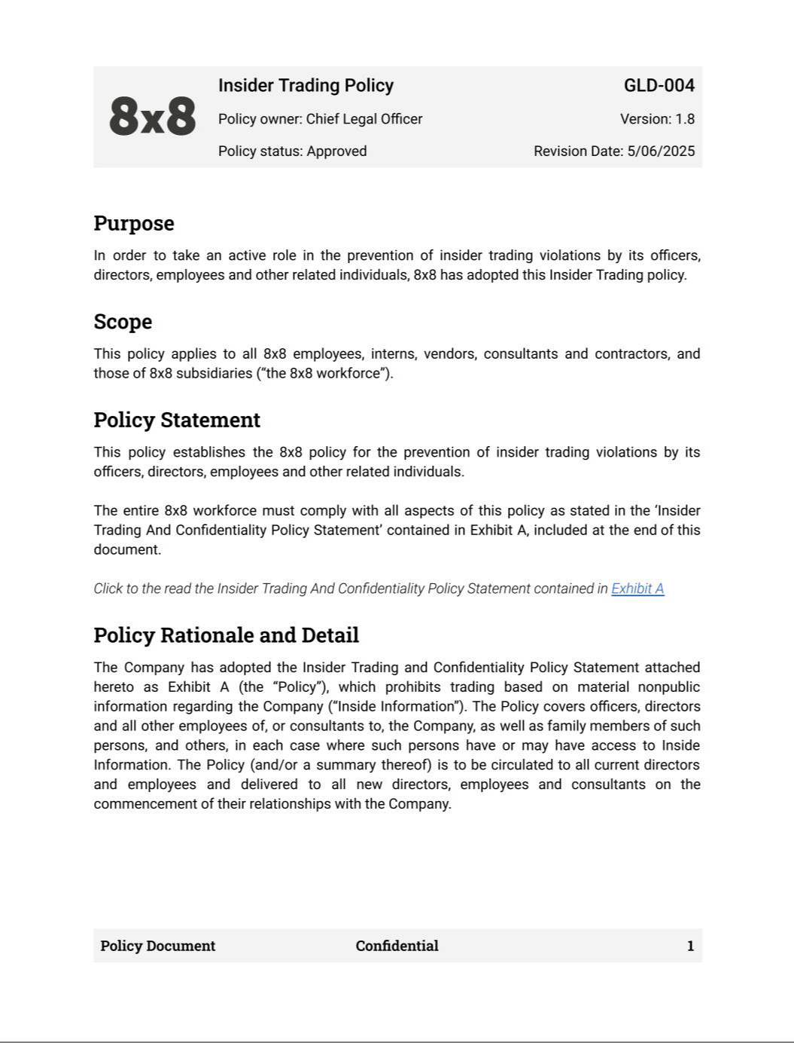

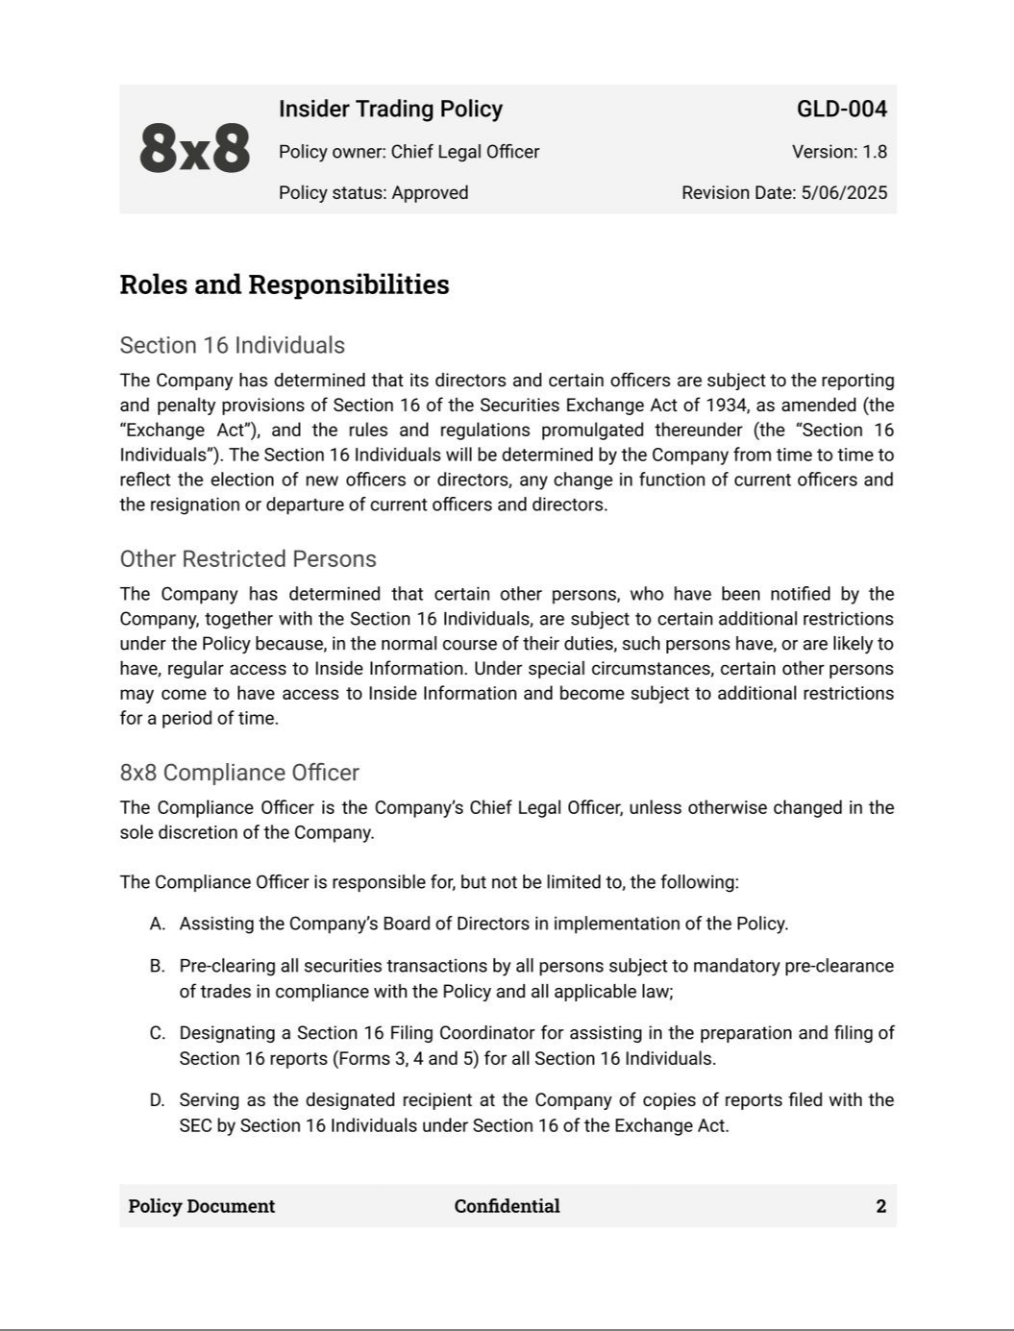

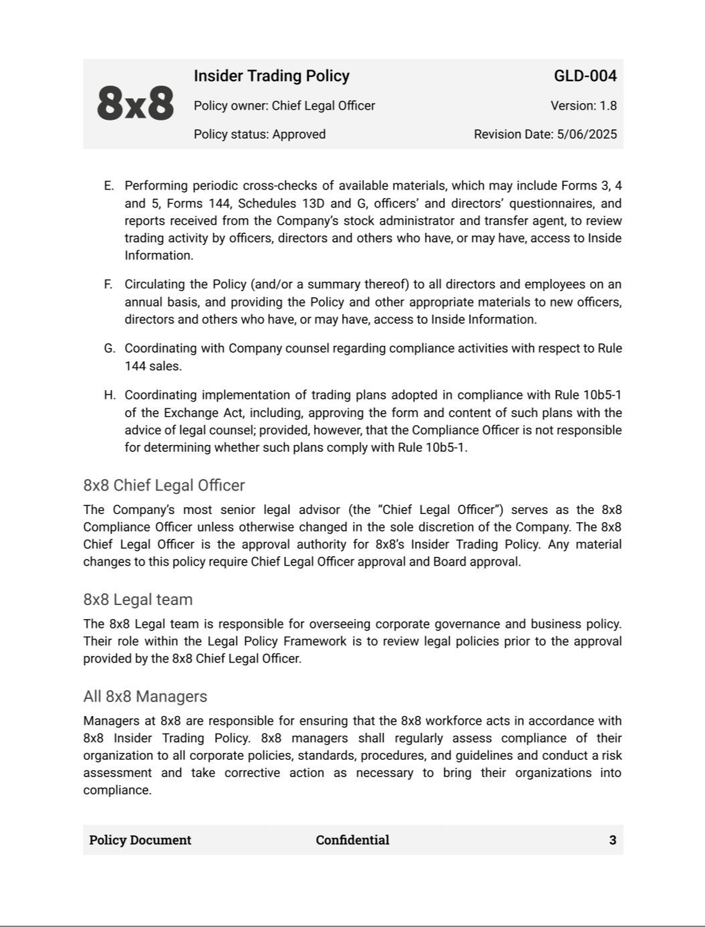

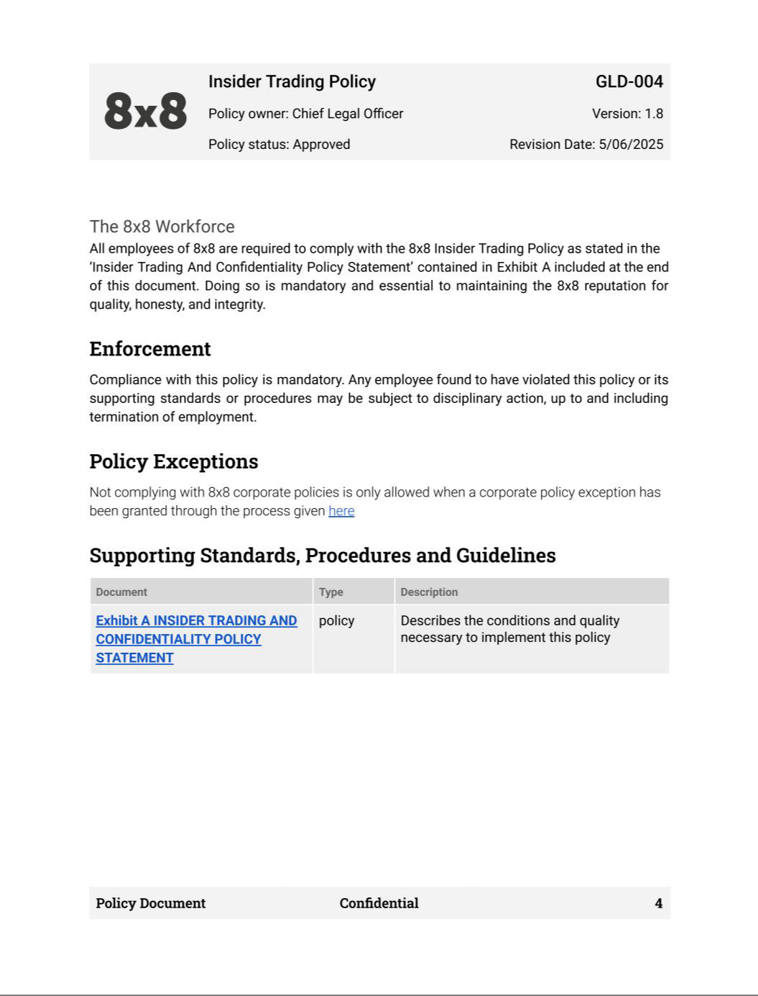

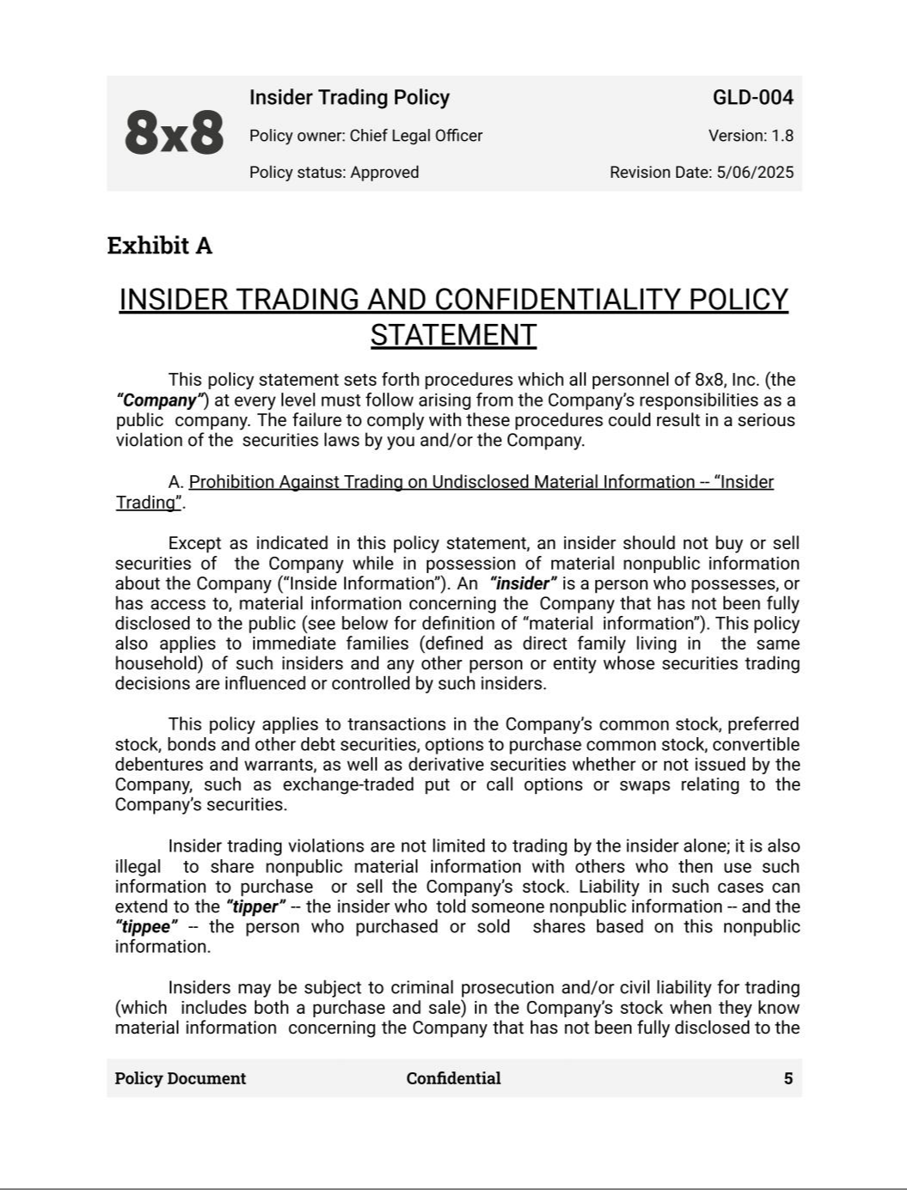

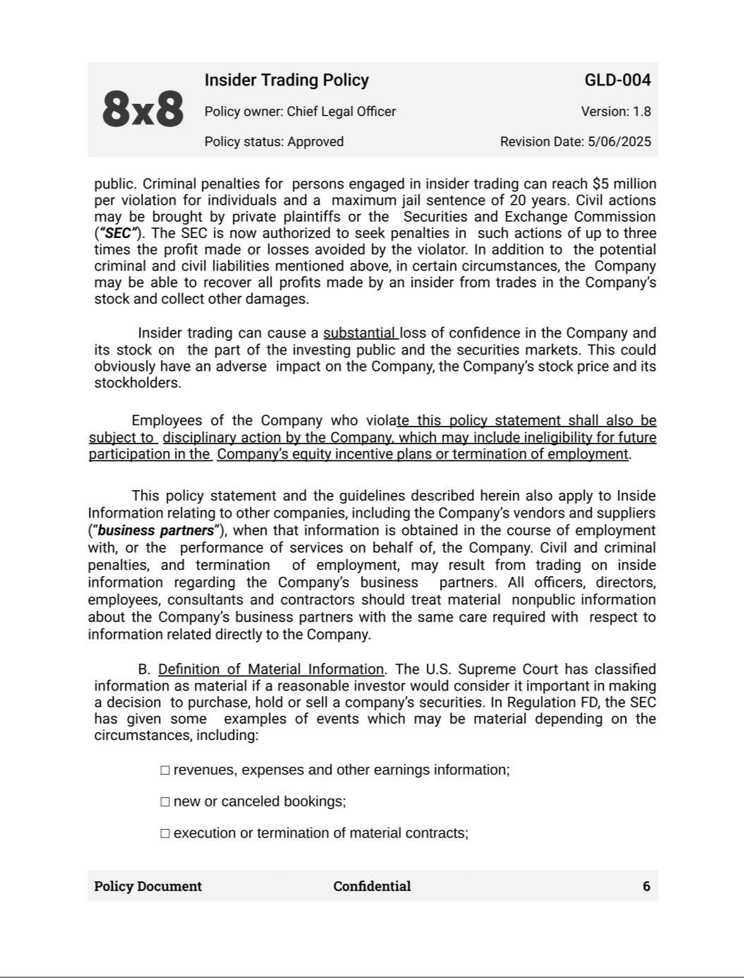

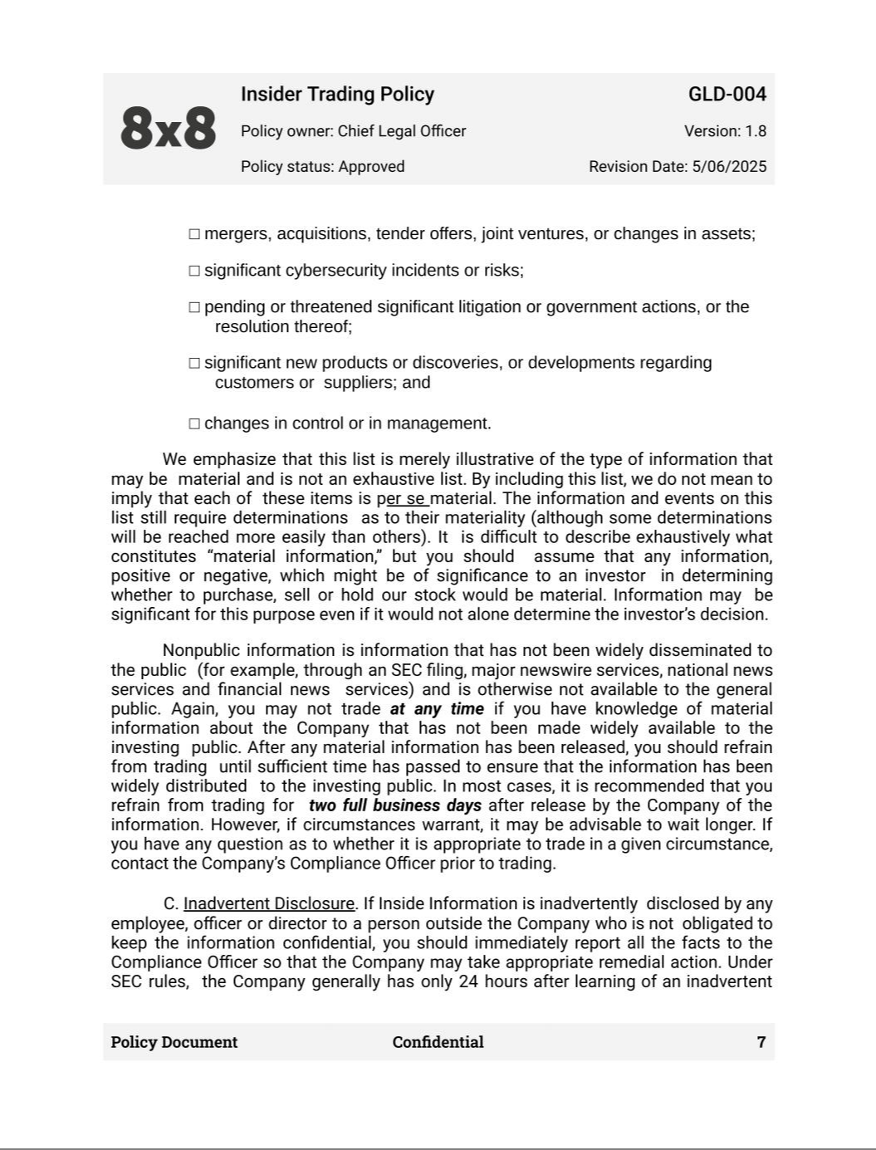

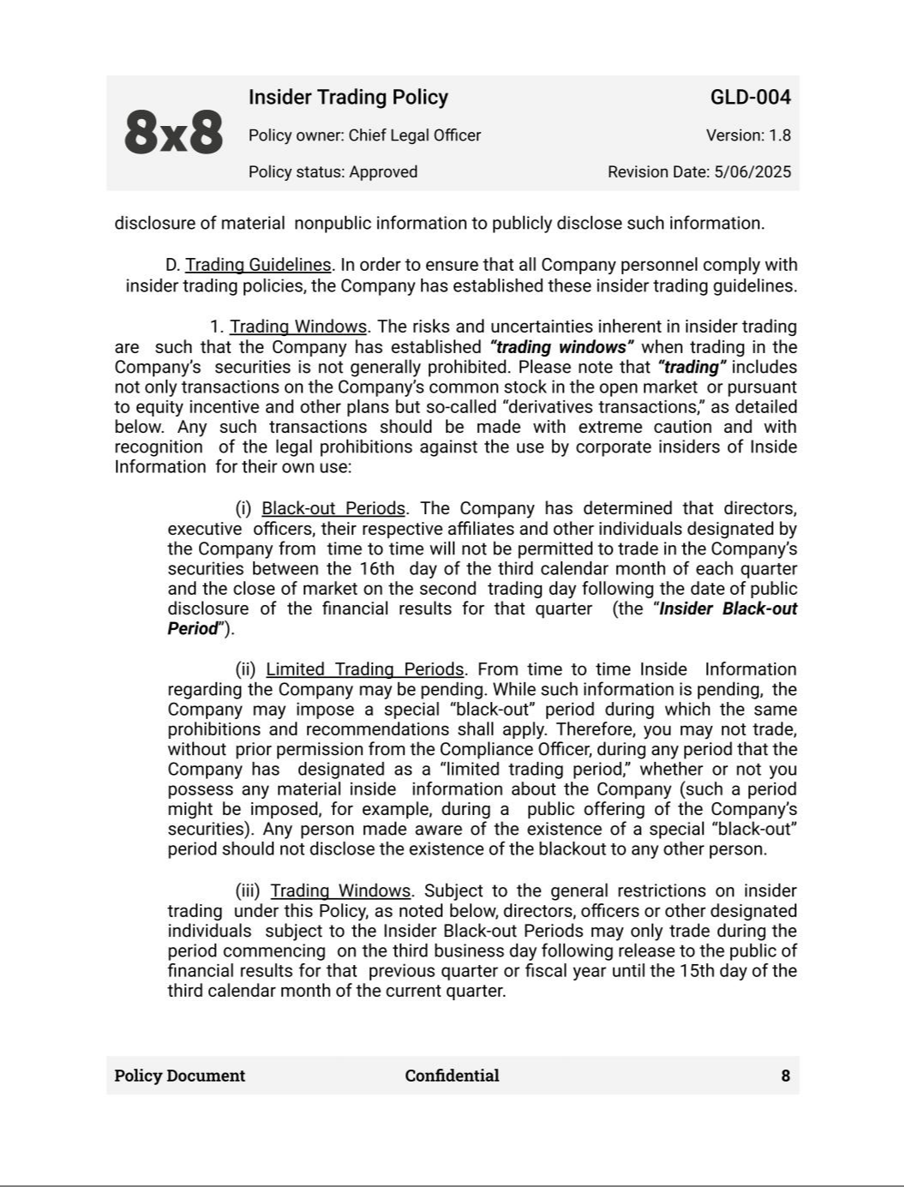

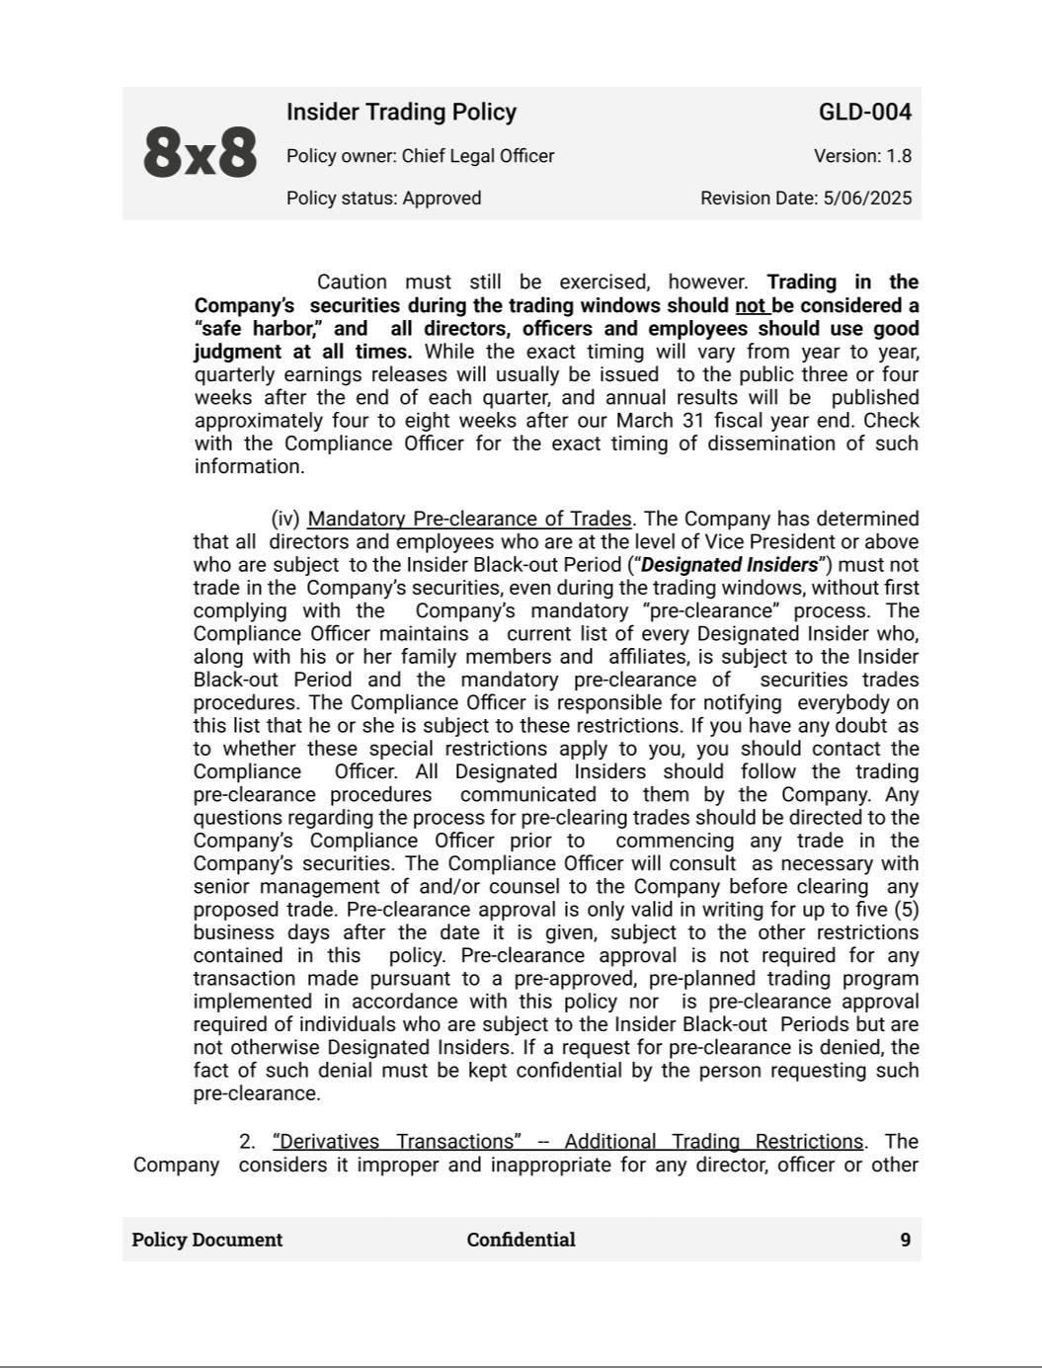

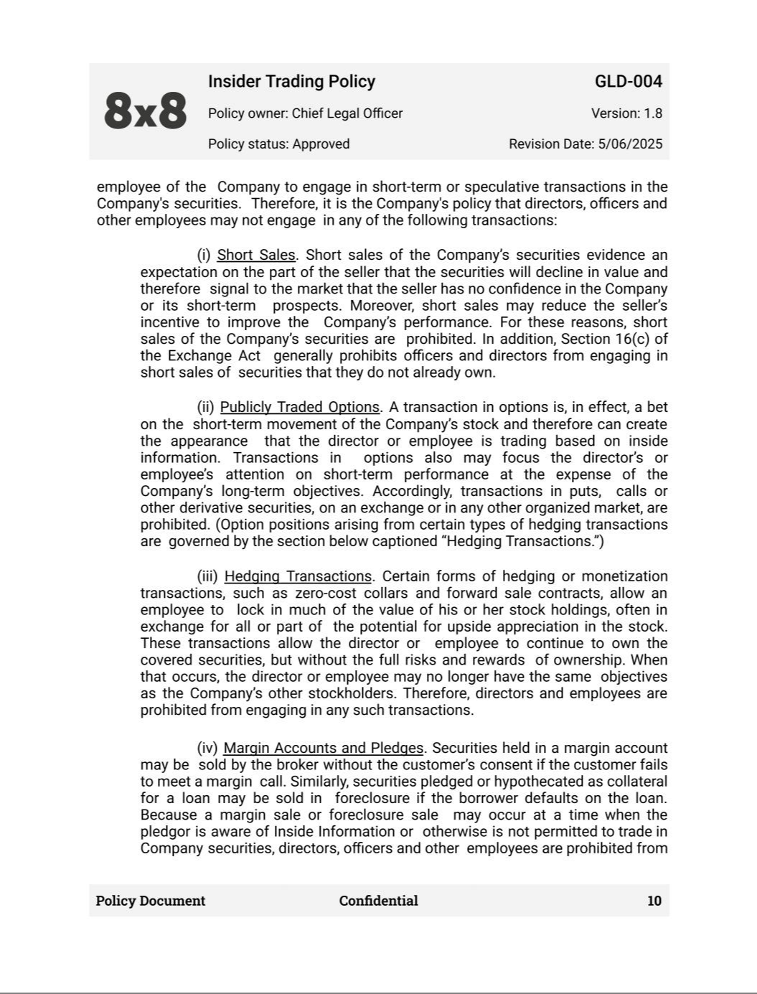

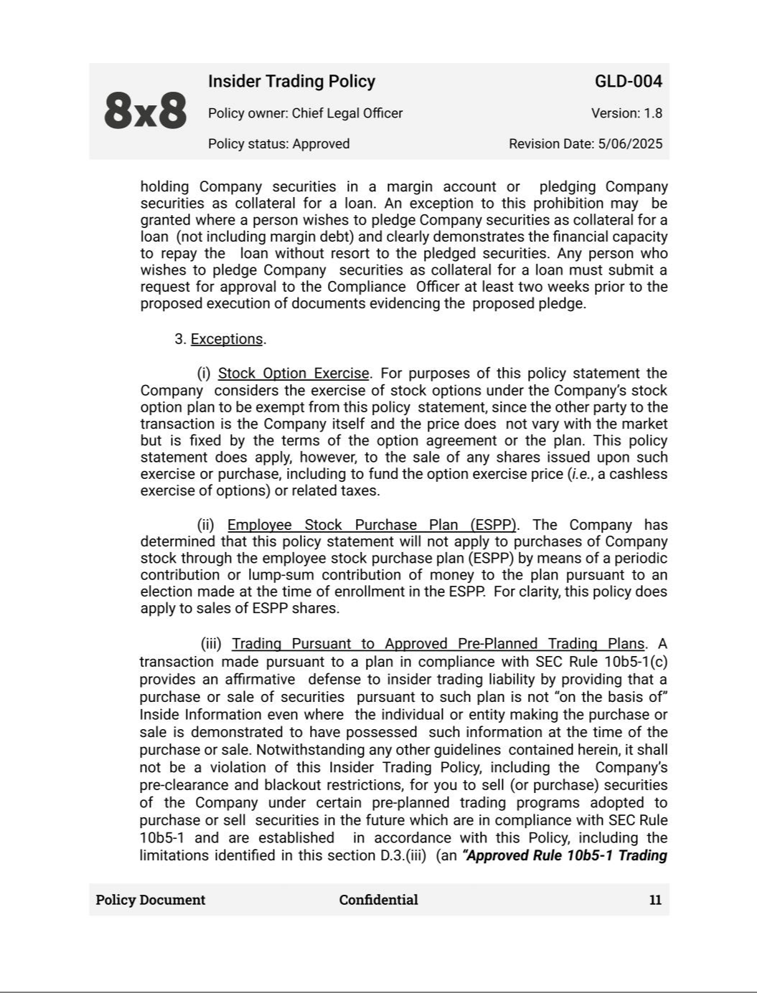

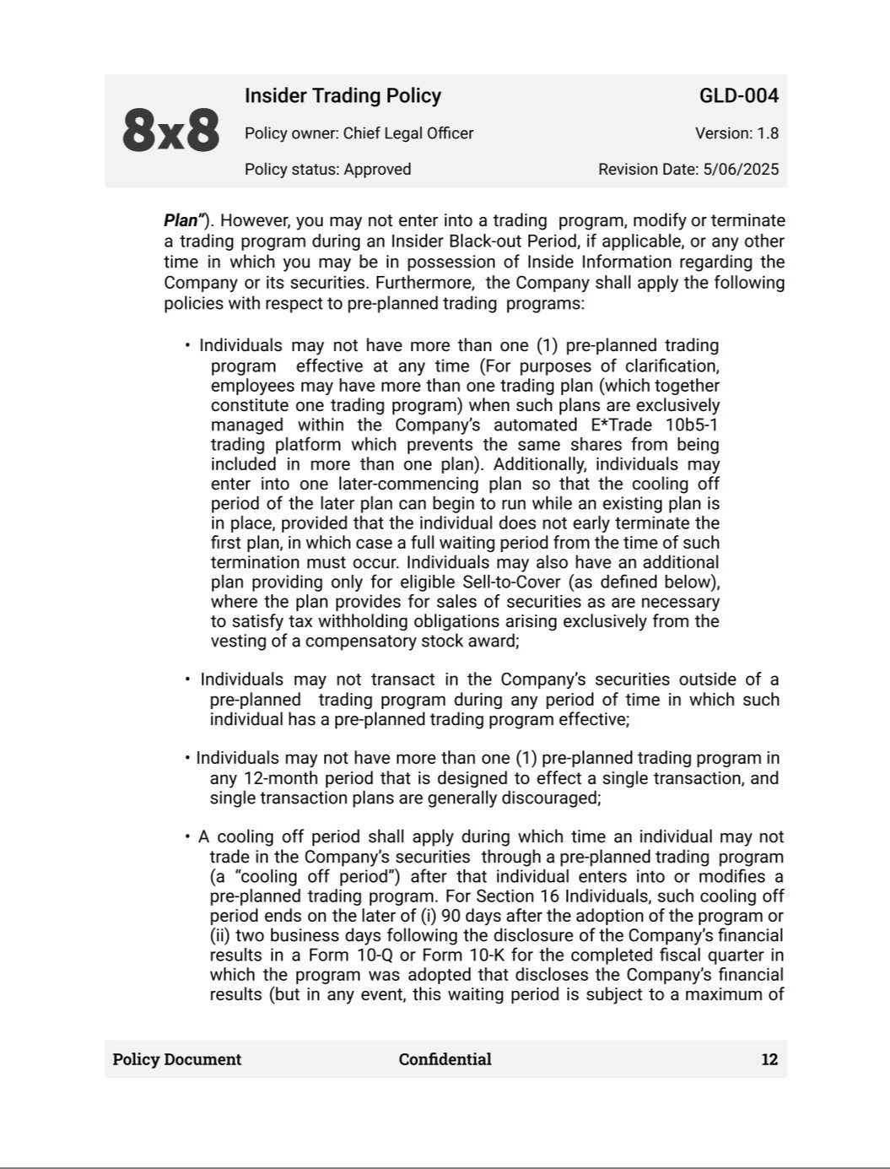

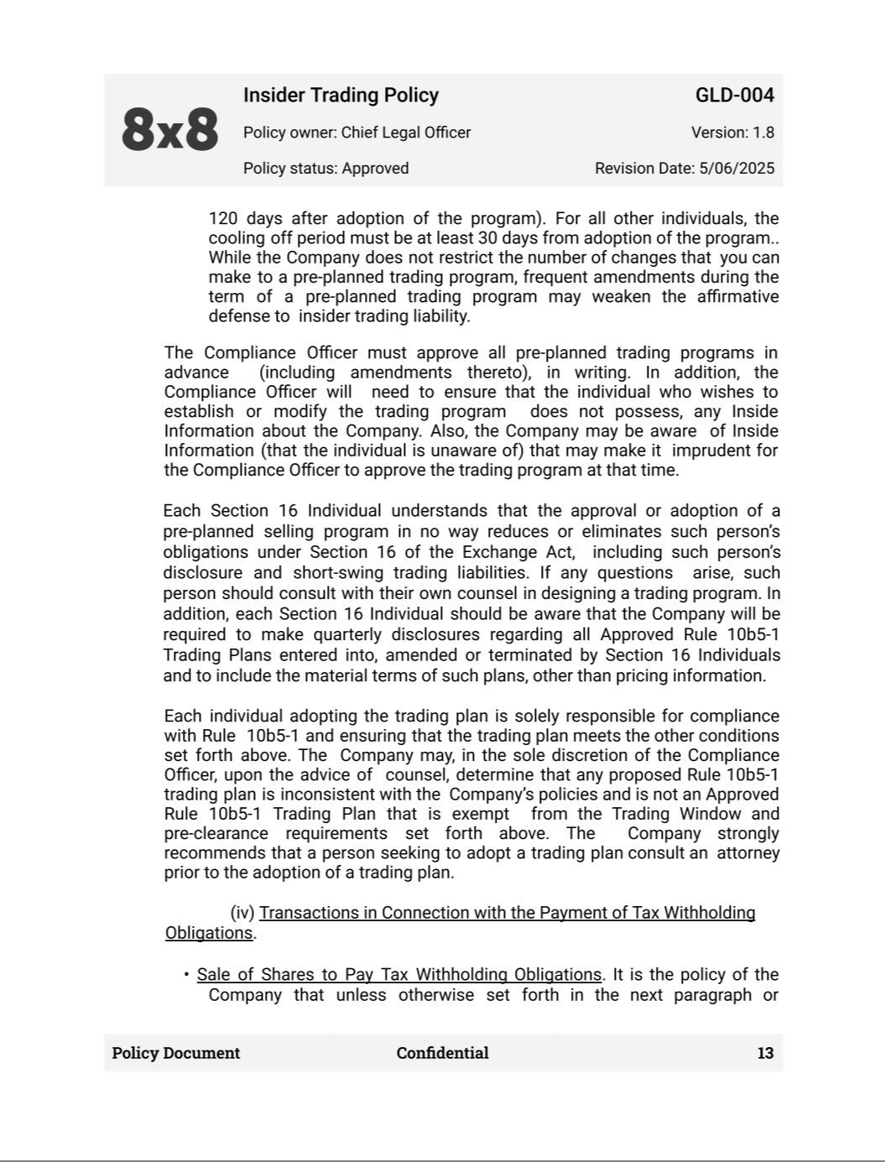

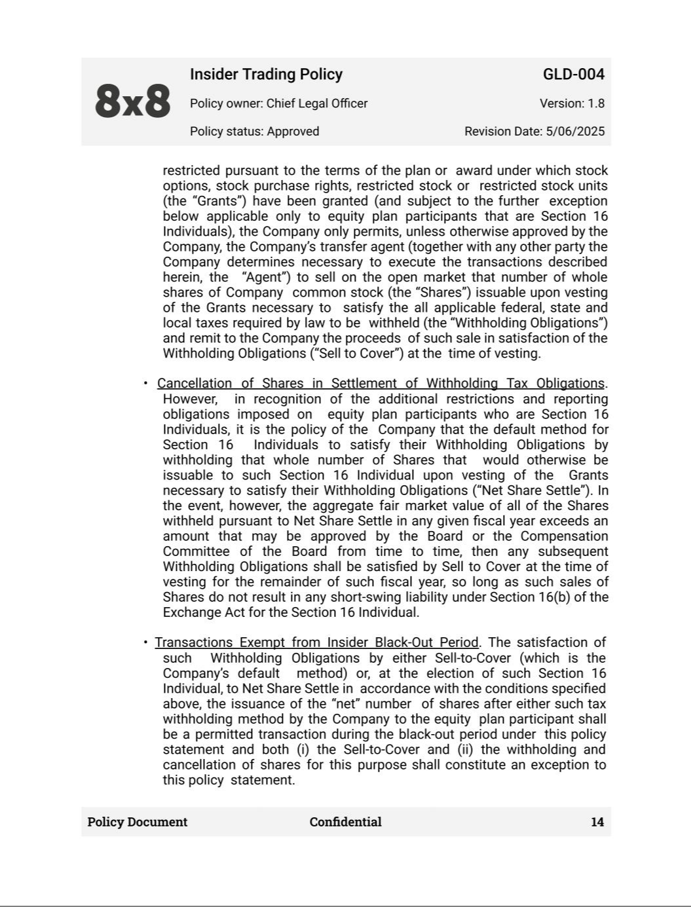

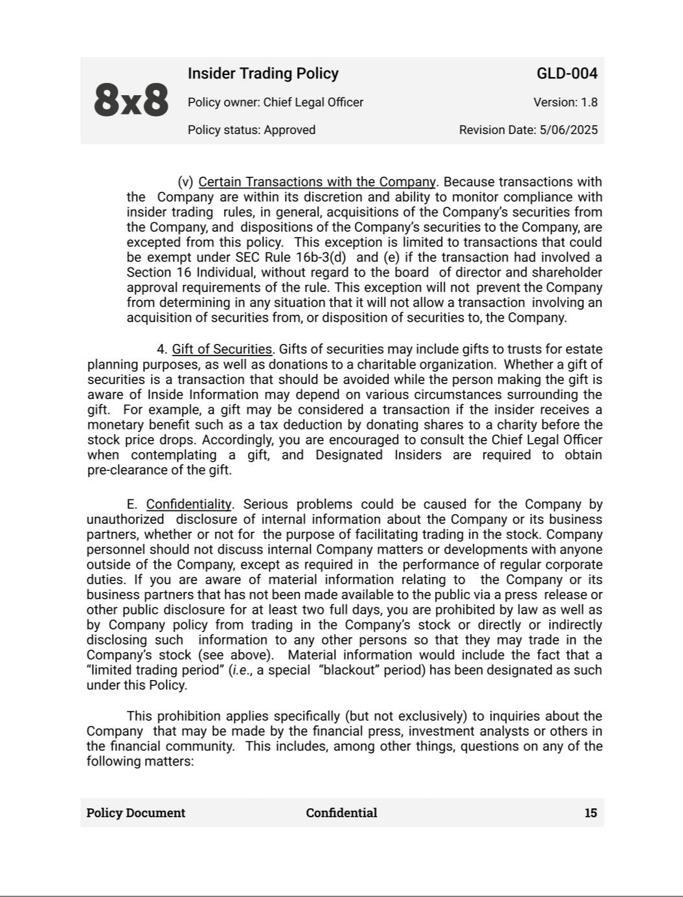

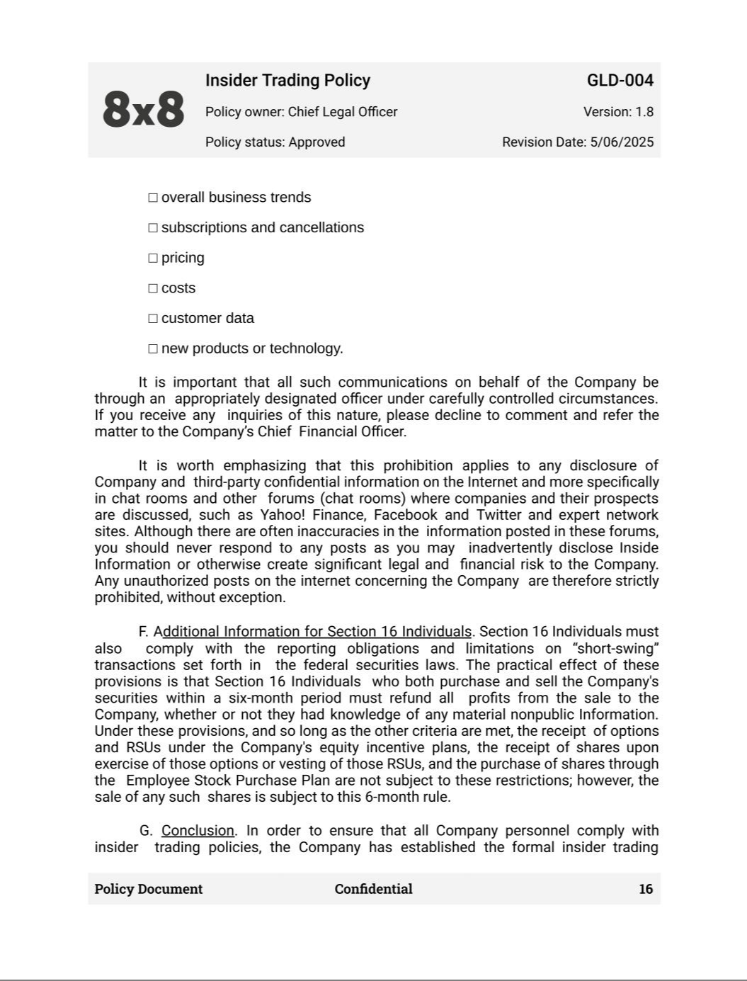

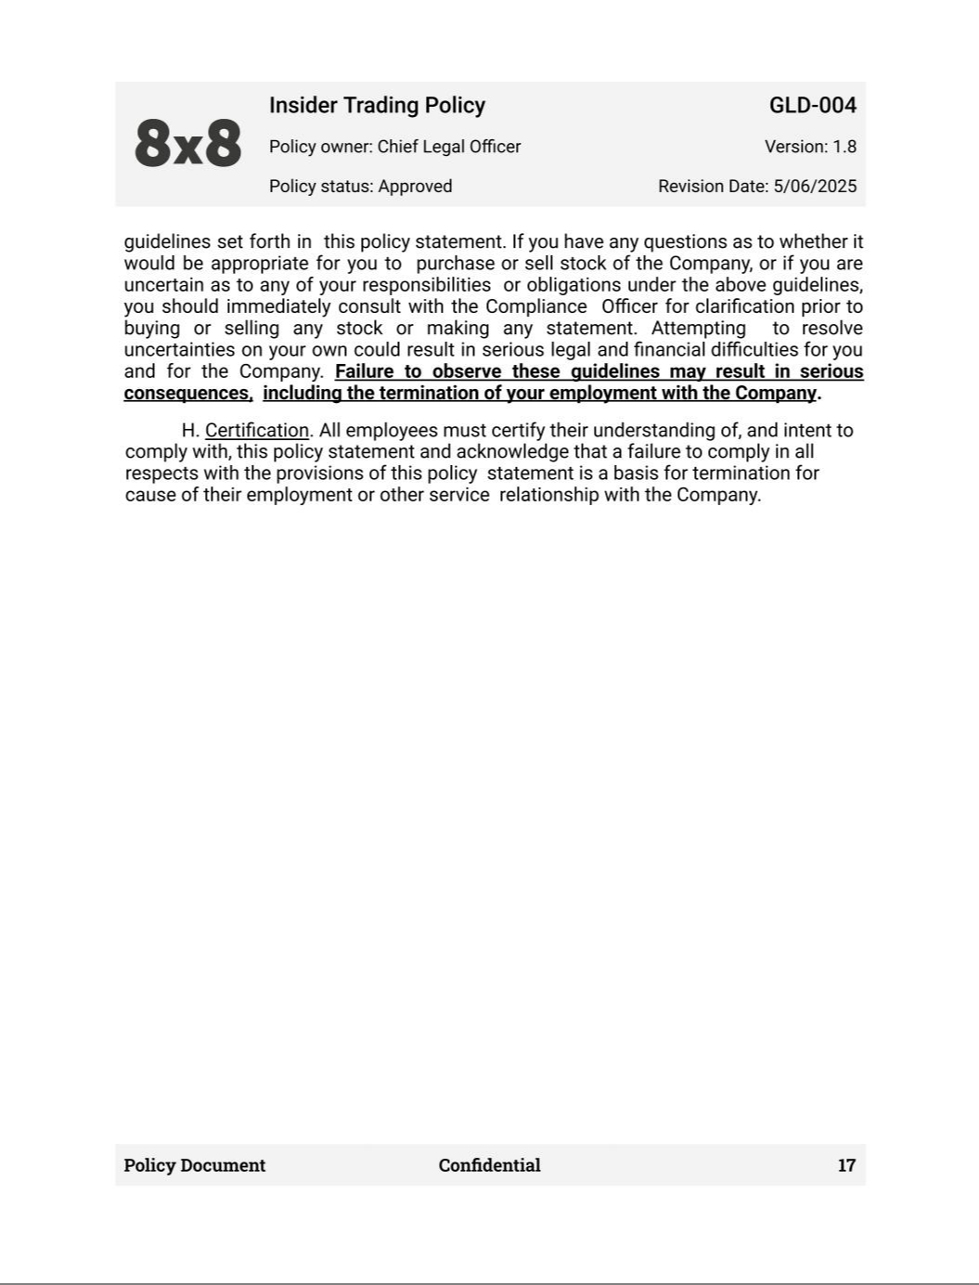

Exhibit 21.1


SUBSIDIARIES OF REGISTRANT

The following is a list of subsidiaries of 8x8, Inc. as of March 31, 2025, omitting subsidiaries which, considered in the aggregate, would not constitute a significant subsidiary.

Name |  | Where Incorporated
8x8 UK Limited |  | United Kingdom

Exhibit 23.1

Consent of Independent Registered Public Accounting Firm

We consent to the incorporation by reference in the Registration Statements on Form S-3 (Nos. 333-262019 and 333-262337) and Form S-8 (Nos. 333-30943, 333-15627, 333-50519, 333-66296, 333-90172, 333-118642, 333-126337, 333-137599, 333-183597, 333-189452, 333-191080, 333-196275, 333-198012, 333-199795, 333-204583, 333-206029, 333-212163, 333-213032, 333-218472, 333-221290, 333-225388, 333-226879, 333-231670, 333-233458, 333-238572, 333-249757, 333-251489, 333-262510, 333-266171, 333-272218, 333-276829, 333-281756, and 333-284709) of 8x8, Inc. (the “Company”), of our report dated May 22, 2025, relating to the consolidated financial statements of the Company and the effectiveness of internal control over financial reporting of the Company, appearing in this Annual Report on Form 10-K of the Company for the year ended March 31, 2025.

/s/ Moss Adams LLP

Campbell, California

May 22, 2025

Exhibit 31.1

CERTIFICATION PURSUANT TO

RULES 13a-14(a) AND 15d-14(a) UNDER THE SECURITIES EXCHANGE ACT OF 1934

AS ADOPTED PURSUANT TO

SECTION 302 OF THE SARBANES-OXLEY ACT OF 2002

I, Samuel Wilson, certify that:

- I have reviewed this annual report on Form 10-K of 8x8, Inc.;

- Based on my knowledge, this report does not contain any untrue statement of a material fact or omit to state a material fact necessary to make the statements made, in light of the circumstances under which such statements were made, not misleading with respect to the period covered by this report;

- Based on my knowledge, the financial statements, and other financial information included in this report, fairly present in all material respects the financial condition, results of operations and cash flows of the registrant as of, and for, the periods presented in this report;

- The registrant's other certifying officer and I are responsible for establishing and maintaining disclosure controls and procedures (as defined in Exchange Act Rules 13a-15(e) and 15d-15(e)) and internal control over financial reporting (as defined in Exchange Act Rules 13a-15(f) and 15d-15(f)) for the registrant and have:

  - Designed such disclosure controls and procedures, or caused such disclosure controls and procedures to be designed under our supervision, to ensure that material information relating to the registrant, including its consolidated subsidiaries, is made known to us by others within those entities, particularly during the period in which this report is being prepared;

  - Designed such internal control over financial reporting, or caused such internal control over financial reporting to be designed under our supervision, to provide reasonable assurance regarding the reliability of financial reporting and the preparation of financial statements for external purposes in accordance with generally accepted accounting principles;

  - Evaluated the effectiveness of the registrant's disclosure controls and procedures and presented in this report our conclusions about the effectiveness of the disclosure controls and procedures as of the end of the period covered by this report based on such evaluation; and

  - Disclosed in this report any change in the registrant's internal control over financial reporting that occurred during the registrant's most recent fiscal quarter (the registrant's fourth fiscal quarter in the case of an annual report) that has materially affected, or is reasonably likely to materially affect, the registrant's internal control over financial reporting; and

- The registrant's other certifying officer and I have disclosed, based on our most recent evaluation of internal control over financial reporting, to the registrant's auditors and the audit committee of the registrant's board of directors (or persons performing the equivalent functions):

  - All significant deficiencies and material weaknesses in the design or operation of internal control over financial reporting which are reasonably likely to adversely affect the registrant's ability to record, process, summarize and report financial information; and

  - Any fraud, whether or not material, that involves management or other employees who have a significant role in the registrant's internal control over financial reporting.

May 22, 2025

/s/ Samuel Wilson

Samuel Wilson

Chief Executive Officer

Exhibit 31.2

CERTIFICATION PURSUANT TO

RULES 13a-14(a) AND 15d-14(a) UNDER THE SECURITIES EXCHANGE ACT OF 1934

AS ADOPTED PURSUANT TO

SECTION 302 OF THE SARBANES-OXLEY ACT OF 2002

I, Kevin Kraus, certify that:

- I have reviewed this annual report on Form 10-K of 8x8, Inc.;

- Based on my knowledge, this report does not contain any untrue statement of a material fact or omit to state a material fact necessary to make the statements made, in light of the circumstances under which such statements were made, not misleading with respect to the period covered by this report;

- Based on my knowledge, the financial statements, and other financial information included in this report, fairly present in all material respects the financial condition, results of operations and cash flows of the registrant as of, and for, the periods presented in this report;

- The registrant's other certifying officer and I are responsible for establishing and maintaining disclosure controls and procedures (as defined in Exchange Act Rules 13a-15(e) and 15d-15(e)) and internal control over financial reporting (as defined in Exchange Act Rules 13a-15(f) and 15d-15(f)) for the registrant and have:

  - Designed such disclosure controls and procedures, or caused such disclosure controls and procedures to be designed under our supervision, to ensure that material information relating to the registrant, including its consolidated subsidiaries, is made known to us by others within those entities, particularly during the period in which this report is being prepared;

  - Designed such internal control over financial reporting, or caused such internal control over financial reporting to be designed under our supervision, to provide reasonable assurance regarding the reliability of financial reporting and the preparation of financial statements for external purposes in accordance with generally accepted accounting principles;

  - Evaluated the effectiveness of the registrant's disclosure controls and procedures and presented in this report our conclusions about the effectiveness of the disclosure controls and procedures as of the end of the period covered by this report based on such evaluation; and

  - Disclosed in this report any change in the registrant's internal control over financial reporting that occurred during the registrant's most recent fiscal quarter (the registrant's fourth fiscal quarter in the case of an annual report) that has materially affected, or is reasonably likely to materially affect, the registrant's internal control over financial reporting; and

- The registrant's other certifying officer and I have disclosed, based on our most recent evaluation of internal control over financial reporting, to the registrant's auditors and the audit committee of the registrant's board of directors (or persons performing the equivalent functions):

  - All significant deficiencies and material weaknesses in the design or operation of internal control over financial reporting which are reasonably likely to adversely affect the registrant's ability to record, process, summarize and report financial information; and

  - Any fraud, whether or not material, that involves management or other employees who have a significant role in the registrant's internal control over financial reporting.

May 22, 2025

/s/ Kevin Kraus

Kevin Kraus

Chief Financial Officer

Exhibit 32.1

CERTIFICATION PURSUANT TO

18 U.S. C. SECTION 1350,

AS ADOPTED PURSUANT TO

SECTION 906 OF THE SARBANES-OXLEY ACT OF 2002

In connection with the Annual Report on Form 10-K of 8x8, Inc. (the "Company") for the year ended March 31, 2025, as filed with the Securities and Exchange Commission on the date hereof (the "Report"), I, Samuel Wilson, Chief Executive Officer of the Company, hereby certify, pursuant to 18 U.S.C. Section 1350, as adopted pursuant to Section 906 of the Sarbanes-Oxley Act of 2002, that:

- The Report fully complies with the requirements of Section 13(a) or 15(d) of the Securities Exchange Act of 1934; and

- The information contained in the Report fairly presents, in all material respects, the financial condition and results of operations of the Company.

/s/ Samuel Wilson

Samuel Wilson

Chief Executive Officer

May 22, 2025

This certification accompanies this Report pursuant to §906 of the Sarbanes-Oxley Act of 2002 and shall not, except to the extent required by the Sarbanes-Oxley Act of 2002, or otherwise required, be deemed filed by the Company for purposes of §18 of the Securities Exchange Act of 1934, as amended.

Exhibit 32.2

CERTIFICATION PURSUANT TO

18 U.S. C. SECTION 1350,

AS ADOPTED PURSUANT TO

SECTION 906 OF THE SARBANES-OXLEY ACT OF 2002

In connection with the Annual Report on Form 10-K of 8x8, Inc. (the "Company") for the year ended March 31, 2025, as filed with the Securities and Exchange Commission on the date hereof (the "Report"), I, Kevin Kraus, Chief Financial Officer of the Company, hereby certify, pursuant to 18 U.S.C. Section 1350, as adopted pursuant to Section 906 of the Sarbanes-Oxley Act of 2002, that:

- The Report fully complies with the requirements of Section 13(a) or 15(d) of the Securities Exchange Act of 1934; and

- The information contained in the Report fairly presents, in all material respects, the financial condition and results of operations of the Company.

/s/ Kevin Kraus

Kevin Kraus

Chief Financial Officer

May 22, 2025

This certification accompanies this Report pursuant to §906 of the Sarbanes-Oxley Act of 2002 and shall not, except to the extent required by the Sarbanes-Oxley Act of 2002, or otherwise required, be deemed filed by the Company for purposes of §18 of the Securities Exchange Act of 1934, as amended.

