Table of Contents
UNITED STATES
SECURITIES AND EXCHANGE COMMISSION
Washington, D.C. 20549
 |  |  | FORM |  |  | 10-Q
☒ QUARTERLY REPORT PURSUANT TO SECTION 13 OR 15(d) OF THE SECURITIES EXCHANGE ACT OF 1934
For the quarterly period ended September 30, 2026
or
☐ TRANSITION REPORT PURSUANT TO SECTION 13 OR 15(d) OF THE SECURITIES EXCHANGE ACT OF 1934
For the transition period from ________to _________
Commission file number: 001-38312
_________________

8x8, INC.
(Exact name of Registrant as Specified in its Charter)
_________________
Delaware |  |  |  |  |  | 77-0142404
(State or Other Jurisdiction of Incorporation or Organization) |  |  |  |  |  | (I.R.S. Employer Identification Number)
675 Creekside Way
Campbell, CA 95008
(Address of principal executive offices)
(408) 727-1885
(Registrant's telephone number, including area code)
_________________
Securities registered pursuant to Section 12(b) of the Act:
Title of each class |  |  | Trading Symbol |  |  | Name of each exchange on which registered
COMMON STOCK, PAR VALUE $0.001 PER SHARE |  |  | EGHT |  |  | Nasdaq Global Select Market
Indicate by check mark whether the registrant (1) has filed all reports required to be filed by Section 13 or 15 (d) of the Securities Exchange Act of 1934 during the preceding 12 months (or for such shorter period that the registrant was required to file reports), and (2) has been subject to such filing requirements for the past 90 days. ☒ Yes ☐ No
Indicate by check mark whether the registrant has submitted electronically every Interactive Data File required to be submitted pursuant to Rule 405 of Regulation S-T (§232.405 of this chapter) during the preceding 12 months (or for such shorter period that the registrant was required to submit such files). Yes ☒ No ☐
Indicate by check mark whether the registrant is a large accelerated filer, an accelerated filer, a non-accelerated filer, a smaller reporting company or an emerging growth company. See the definitions of "large accelerated filer," "accelerated filer," "smaller reporting company" and "emerging growth company" in Rule 12b-2 of the Exchange Act.
 |  |  | Large accelerated filer |  |  | ☐ |  |  |  |  |  | Accelerated filer |  |  | ☒
 |  |  | Non-accelerated filer |  |  | ☐ |  |  |  |  |  | Smaller reporting company |  |  | ☐
 |  |  |  |  |  |  |  |  |  |  |  | Emerging growth company |  |  | ☐
If an emerging growth company, indicate by check mark if the registrant has elected not to use the extended transition period for complying with any new or revised financial accounting standards provided pursuant to Section 13(a) of the Exchange Act. ☐
Indicate by check mark whether the registrant is a shell company (as defined in Rule 12b-2 of the Exchange Act). Yes ☐ No ☒
The number of shares of the Registrant's Common Stock outstanding as of October 30, 2026 was 145,897,920.

Table of Contents
8X8, INC.
INDEX TO QUARTERLY REPORT ON FORM 10-Q
FOR THE QUARTER ENDED SEPTEMBER 30, 2026
 |  |  | Page
Forward-Looking Statements and Risk Factors |  |  | 2
PART I. FINANCIAL INFORMATION |  |  | 3
Item 1. Financial Statements (unaudited): |  |  | 3
Condensed Consolidated Balance Sheets |  |  | 3
Condensed Consolidated Statements of Operations and Comprehensive Income (Loss) |  |  | 4
Condensed Consolidated Statements of Stockholders' Equity |  |  | 5
Condensed Consolidated Statements of Cash Flows |  |  | 6
Notes to Unaudited Condensed Consolidated Financial Statements |  |  | 7
Item 2. Management's Discussion and Analysis of Financial Condition and Results of Operations |  |  | 22
Item 3. Quantitative and Qualitative Disclosures About Market Risk |  |  | 33
Item 4. Controls and Procedures |  |  | 33
PART II. OTHER INFORMATION |  |  | 34
Item 1. Legal Proceedings |  |  | 34
Item 1A. Risk Factors |  |  | 34
Item 2. Unregistered Sales of Equity Securities and Use of Proceeds |  |  | 35
Item 3. Defaults Upon Senior Securities |  |  | 35
Item 4. Mine Safety Disclosures |  |  | 35
Item 5. Other Information |  |  | 35
Item 6. Exhibits |  |  | 36
Signature |  |  | 37

1
Table of Contents
Forward-Looking Statements and Risk Factors
Statements contained in this quarterly report on Form 10-Q, or this "Quarterly Report", regarding our expectations, beliefs, estimates, intentions or strategies are “forward-looking statements” within the meaning of the Private Securities Litigation Reform Act of 1995, Section 27A of the Securities Act of 1933 (the "Securities Act"), and Section 21E of the Securities Exchange Act of 1934 (the "Exchange Act"), in each case, as amended from time to time. Any statements contained herein that are not statements of historical fact may be deemed to be forward-looking statements. For example, words such as "may," "will," "should," "estimates," "predicts," "potential," "continue," "strategy," "believes," "anticipates," "plans," "expects," "intends," “opportunity,” and similar expressions are intended to identify forward-looking statements.
Forward-looking statements contained in this Quarterly Report include, but are not limited to, statements about: our future financial performance, including revenue, margins, and operating expenses; trends in our business and the technology industry; the sufficiency of our cash, cash equivalents, and operating cash flows to meet our liquidity needs; our ability to service and refinance our debt; our market position, opportunity, and growth strategy; our ability to compete successfully; our product strategy, innovation efforts and evolving artificial intelligence ("AI") capabilities; our ability to operate under evolving macroeconomic conditions, including geopolitical instability, tariffs, inflationary pressures, increased interest rates, supply chain disruptions, decreased economic output, and currency volatility; our ability to attract and retain customers; our ability to expand into new markets and internationally; our ability to manage growth and future expenses; and the impact of recent accounting pronouncements on our consolidated financial statements.
Forward-looking statements may appear throughout this Quarterly Report, including in the section entitled: “Management’s Discussion and Analysis of Financial Condition and Results of Operations” (Part I, Item 2). We describe risks and uncertainties that could impact forward-looking statements or cause actual results and events to differ materially in the section entitled “Risk Factors” (Part II, Item 1A) of this Quarterly Report and in the sections entitled “Risk Factors,” “Management’s Discussion and Analysis of Financial Condition and Results of Operations,” and “Quantitative and Qualitative Disclosures About Market Risk” (Part I, Item 1A and Part II, Items 7 and 7A, respectively) of our Annual Report on Form 10-K for the fiscal year ended March 31, 2026, as filed with the Securities and Exchange Commission (the “SEC”) on May 22, 2026 (the “Form 10-K”). All forward-looking statements included in this Quarterly Report are based on information available to us on the date hereof, and we assume no obligation to update any such forward-looking statements. Readers are urged to carefully review and consider the various disclosures made in this Quarterly Report, which attempt to advise interested parties of the risks and factors that may affect our business, financial condition, results of operations and prospects.

Our fiscal year ends on March 31 of each calendar year. Each reference to a fiscal year in this Quarterly Report refers to the fiscal year ended March 31 of the calendar year indicated (for example, fiscal 2027 refers to the fiscal year ending March 31, 2027). Unless the context requires otherwise, references to "we," "us," "our," "8x8," and the "Company" refer to 8x8, Inc. and its consolidated subsidiaries. All dollar amounts within this Quarterly Report are in thousands of United States Dollars ("Dollars") unless otherwise noted.

2
Table of Contents
PART I. FINANCIAL INFORMATION

ITEM 1. Financial Statements

8X8, INC.
CONDENSED CONSOLIDATED BALANCE SHEETS
(Unaudited, in thousands, except per share amounts)

 |  |  | September 30, 2026 |  |  |  |  |  | March 31, 2026
ASSETS
Current assets:
Cash and cash equivalents |  |  | $ | 101,708 |  |  |  |  | $ | 93,260
Restricted cash |  |  | 893 |  |  |  |  |  | 1,702
Accounts receivable, net |  |  | 61,956 |  |  |  |  |  | 57,004
Deferred contract acquisition costs |  |  | 21,896 |  |  |  |  |  | 25,193
Other current assets |  |  | 32,314 |  |  |  |  |  | 32,650
Total current assets |  |  | 218,767 |  |  |  |  |  | 209,809
Property and equipment, net |  |  | 42,963 |  |  |  |  |  | 45,821
Operating lease, right-of-use assets |  |  | 24,329 |  |  |  |  |  | 26,672
Intangible assets, net |  |  | 50,689 |  |  |  |  |  | 57,589
Goodwill |  |  | 276,777 |  |  |  |  |  | 276,372
Deferred contract acquisition costs, non-current |  |  | 32,973 |  |  |  |  |  | 34,562
Other assets, non-current |  |  | 11,397 |  |  |  |  |  | 11,996
Total assets |  |  | $ | 657,895 |  |  |  |  | $ | 662,821
LIABILITIES AND STOCKHOLDERS' EQUITY
Current liabilities:
Accounts payable |  |  | $ | 31,555 |  |  |  |  | $ | 36,714
Accrued and other liabilities |  |  | 73,917 |  |  |  |  |  | 69,867
Operating lease liabilities |  |  | 10,904 |  |  |  |  |  | 10,357
Deferred revenue |  |  | 38,789 |  |  |  |  |  | 36,699
Term loan, current |  |  | 107,326 |  |  |  |  |  | 39,218
Total current liabilities |  |  | 262,491 |  |  |  |  |  | 192,855
Operating lease liabilities, non-current |  |  | 37,422 |  |  |  |  |  | 39,100
Deferred revenue, non-current |  |  | 149 |  |  |  |  |  | 181
Convertible senior notes, non-current |  |  | 200,382 |  |  |  |  |  | 199,830
Term loan, non-current |  |  | — |  |  |  |  |  | 82,431
Other liabilities, non-current |  |  | 1,454 |  |  |  |  |  | 1,815
Total liabilities |  |  | 501,898 |  |  |  |  |  | 516,212
Commitments and contingencies (Note 7)
Stockholders' equity:
Preferred stock: $0.001 par value, 5,000 shares authorized, none issued and outstanding as of September 30, 2026 and March 31, 2026 |  |  | — |  |  |  |  |  | —
Common stock: $0.001 par value, 300,000 shares authorized, 145,860 shares and 141,164 shares issued and outstanding as of September 30, 2026 and March 31, 2026, respectively |  |  | 146 |  |  |  |  |  | 141
Additional paid-in capital |  |  | 1,046,108 |  |  |  |  |  | 1,038,745
Accumulated other comprehensive loss |  |  | (6,372) |  |  |  |  |  | (6,204)
Accumulated deficit |  |  | (883,885) |  |  |  |  |  | (886,073)
Total stockholders' equity |  |  | 155,997 |  |  |  |  |  | 146,609
Total liabilities and stockholders' equity |  |  | $ | 657,895 |  |  |  |  | $ | 662,821

The accompanying notes are an integral part of these unaudited condensed consolidated financial statements.
3
Table of Contents
8X8, INC.
CONDENSED CONSOLIDATED STATEMENTS OF OPERATIONS AND COMPREHENSIVE INCOME (LOSS)
(Unaudited, in thousands, except per share amounts)
 |  |  | Three Months Ended September 30, |  |  |  |  |  |  |  |  |  |  |  | Six Months Ended September 30,
 |  |  | 2026 |  |  |  |  |  | 2025 |  |  |  |  |  | 2026 |  |  |  |  |  | 2025
Service revenue |  |  | $ | 187,784 |  |  |  |  | $ | 179,094 |  |  |  |  | $ | 373,130 |  |  |  |  | $ | 355,402
Other revenue |  |  | 4,217 |  |  |  |  |  | 5,001 |  |  |  |  |  | 9,041 |  |  |  |  |  | 10,054
Total revenue |  |  | 192,001 |  |  |  |  |  | 184,095 |  |  |  |  |  | 382,171 |  |  |  |  |  | 365,456
Cost of service revenue |  |  | 71,093 |  |  |  |  |  | 57,699 |  |  |  |  |  | 138,728 |  |  |  |  |  | 111,521
Cost of other revenue |  |  | 6,344 |  |  |  |  |  | 7,056 |  |  |  |  |  | 12,508 |  |  |  |  |  | 14,155
Total cost of revenue |  |  | 77,437 |  |  |  |  |  | 64,755 |  |  |  |  |  | 151,236 |  |  |  |  |  | 125,676
Gross profit |  |  | 114,564 |  |  |  |  |  | 119,340 |  |  |  |  |  | 230,935 |  |  |  |  |  | 239,780
Operating expenses:
Research and development |  |  | 27,570 |  |  |  |  |  | 27,918 |  |  |  |  |  | 55,976 |  |  |  |  |  | 56,282
Sales and marketing |  |  | 56,146 |  |  |  |  |  | 63,835 |  |  |  |  |  | 114,896 |  |  |  |  |  | 132,019
General and administrative |  |  | 20,983 |  |  |  |  |  | 22,238 |  |  |  |  |  | 45,819 |  |  |  |  |  | 45,565
Impairment of long-lived assets |  |  | 2,933 |  |  |  |  |  | — |  |  |  |  |  | 2,933 |  |  |  |  |  | —
Total operating expenses |  |  | 107,632 |  |  |  |  |  | 113,991 |  |  |  |  |  | 219,624 |  |  |  |  |  | 233,866
Income from operations |  |  | 6,932 |  |  |  |  |  | 5,349 |  |  |  |  |  | 11,311 |  |  |  |  |  | 5,914
Interest expense |  |  | (4,207) |  |  |  |  |  | (4,842) |  |  |  |  |  | (8,386) |  |  |  |  |  | (8,810)
Other income (expense), net |  |  | 1,107 |  |  |  |  |  | 468 |  |  |  |  |  | 699 |  |  |  |  |  | 832
Income (loss) before provision for income taxes |  |  | 3,832 |  |  |  |  |  | 975 |  |  |  |  |  | 3,624 |  |  |  |  |  | (2,064)
Provision for income taxes |  |  | 444 |  |  |  |  |  | 208 |  |  |  |  |  | 1,436 |  |  |  |  |  | 1,484
Net income (loss) |  |  | $ | 3,388 |  |  |  |  | $ | 767 |  |  |  |  | $ | 2,188 |  |  |  |  | $ | (3,548)
Net income (loss) per share:
Basic |  |  | $ | 0.02 |  |  |  |  | $ | 0.01 |  |  |  |  | $ | 0.02 |  |  |  |  | $ | (0.03)
Diluted |  |  | $ | 0.02 |  |  |  |  | $ | 0.01 |  |  |  |  | $ | 0.01 |  |  |  |  | $ | (0.03)
Weighted average number of shares:
Basic |  |  | 144,929 |  |  |  |  |  | 136,970 |  |  |  |  |  | 143,459 |  |  |  |  |  | 135,895
Diluted |  |  | 146,349 |  |  |  |  |  | 139,522 |  |  |  |  |  | 145,958 |  |  |  |  |  | 135,895
Comprehensive income (loss)
Net income (loss) |  |  | $ | 3,388 |  |  |  |  | $ | 767 |  |  |  |  | $ | 2,188 |  |  |  |  | $ | (3,548)
Foreign currency translation adjustment |  |  | (267) |  |  |  |  |  | (1,826) |  |  |  |  |  | (168) |  |  |  |  |  | 4,432
Comprehensive income (loss) |  |  | $ | 3,121 |  |  |  |  | $ | (1,059) |  |  |  |  | $ | 2,020 |  |  |  |  | $ | 884

The accompanying notes are an integral part of these unaudited condensed consolidated financial statements.
4
Table of Contents
8X8, INC.
CONDENSED CONSOLIDATED STATEMENTS OF STOCKHOLDERS' EQUITY
(Unaudited, in thousands)
 |  |  | Common Stock |  |  |  |  |  |  |  |  |  |  |  | Additional Paid-in Capital |  |  |  |  |  | Accumulated Other Comprehensive Loss |  |  |  |  |  | Accumulated Deficit |  |  |  |  |  | Total
 |  |  | Shares |  |  |  |  |  | Amount
Balance at March 31, 2026 |  |  | 141,164 |  |  |  |  |  | $ | 141 |  |  |  |  | $ | 1,038,745 |  |  |  |  | $ | (6,204) |  |  |  |  | $ | (886,073) |  |  |  |  | $ | 146,609
Issuance of common stock under stock plans |  |  | 3,654 |  |  |  |  |  | 4 |  |  |  |  |  | (4) |  |  |  |  |  | — |  |  |  |  |  | — |  |  |  |  |  | —
Common shares withheld for settlement of taxes in connection with equity-based compensation |  |  | (848) |  |  |  |  |  | (1) |  |  |  |  |  | (1,683) |  |  |  |  |  | — |  |  |  |  |  | — |  |  |  |  |  | (1,684)
Stock-based compensation expense |  |  | — |  |  |  |  |  | — |  |  |  |  |  | 3,993 |  |  |  |  |  | — |  |  |  |  |  | — |  |  |  |  |  | 3,993
Foreign currency translation adjustment |  |  | — |  |  |  |  |  | — |  |  |  |  |  | — |  |  |  |  |  | 99 |  |  |  |  |  | — |  |  |  |  |  | 99
Net loss |  |  | — |  |  |  |  |  | — |  |  |  |  |  | — |  |  |  |  |  | — |  |  |  |  |  | (1,200) |  |  |  |  |  | (1,200)
Balance at June 30, 2026 |  |  | 143,970 |  |  |  |  |  | $ | 144 |  |  |  |  | $ | 1,041,051 |  |  |  |  | $ | (6,105) |  |  |  |  | $ | (887,273) |  |  |  |  | $ | 147,817
Issuance of common stock under stock plans |  |  | 1,280 |  |  |  |  |  | 1 |  |  |  |  |  | (1) |  |  |  |  |  | — |  |  |  |  |  | — |  |  |  |  |  | —
Common shares withheld for settlement of taxes in connection with equity-based compensation |  |  | (141) |  |  |  |  |  | — |  |  |  |  |  | (264) |  |  |  |  |  | — |  |  |  |  |  | — |  |  |  |  |  | (264)
ESPP share issuance |  |  | 751 |  |  |  |  |  | 1 |  |  |  |  |  | 1,162 |  |  |  |  |  | — |  |  |  |  |  | — |  |  |  |  |  | 1,163
Stock-based compensation expense |  |  | — |  |  |  |  |  | — |  |  |  |  |  | 4,160 |  |  |  |  |  | — |  |  |  |  |  | — |  |  |  |  |  | 4,160
Foreign currency translation adjustment |  |  | — |  |  |  |  |  | — |  |  |  |  |  | — |  |  |  |  |  | (267) |  |  |  |  |  | — |  |  |  |  |  | (267)
Net income |  |  | — |  |  |  |  |  | — |  |  |  |  |  | — |  |  |  |  |  | — |  |  |  |  |  | 3,388 |  |  |  |  |  | 3,388
Balance at September 30, 2026 |  |  | 145,860 |  |  |  |  |  | $ | 146 |  |  |  |  | $ | 1,046,108 |  |  |  |  | $ | (6,372) |  |  |  |  | $ | (883,885) |  |  |  |  | $ | 155,997
 |  |  | Common Stock |  |  |  |  |  |  |  |  |  |  |  | Additional Paid-in Capital |  |  |  |  |  | Accumulated Other Comprehensive Loss |  |  |  |  |  | Accumulated Deficit |  |  |  |  |  | Total
 |  |  | Shares |  |  |  |  |  | Amount
Balance at March 31, 2025 |  |  | 134,355 |  |  |  |  |  | $ | 134 |  |  |  |  | $ | 1,018,902 |  |  |  |  | $ | (9,111) |  |  |  |  | $ | (887,721) |  |  |  |  | $ | 122,204
Issuance of common stock under stock plans |  |  | 2,692 |  |  |  |  |  | 3 |  |  |  |  |  | (3) |  |  |  |  |  | — |  |  |  |  |  | — |  |  |  |  |  | —
Common shares withheld for settlement of taxes in connection with equity-based compensation |  |  | (300) |  |  |  |  |  | — |  |  |  |  |  | (489) |  |  |  |  |  | — |  |  |  |  |  | — |  |  |  |  |  | (489)
Repurchase of common stock |  |  | (1,000) |  |  |  |  |  | (1) |  |  |  |  |  | (1,847) |  |  |  |  |  | — |  |  |  |  |  | — |  |  |  |  |  | (1,848)
Stock-based compensation expense |  |  | — |  |  |  |  |  | — |  |  |  |  |  | 6,380 |  |  |  |  |  | — |  |  |  |  |  | — |  |  |  |  |  | 6,380
Foreign currency translation adjustment |  |  | — |  |  |  |  |  | — |  |  |  |  |  | — |  |  |  |  |  | 6,258 |  |  |  |  |  | — |  |  |  |  |  | 6,258
Net loss |  |  | — |  |  |  |  |  | — |  |  |  |  |  | — |  |  |  |  |  | — |  |  |  |  |  | (4,315) |  |  |  |  |  | (4,315)
Balance at June 30, 2025 |  |  | 135,747 |  |  |  |  |  | $ | 136 |  |  |  |  | $ | 1,022,943 |  |  |  |  | $ | (2,853) |  |  |  |  | $ | (892,036) |  |  |  |  | $ | 128,190
Issuance of common stock under stock plans |  |  | 2,231 |  |  |  |  |  | 2 |  |  |  |  |  | (2) |  |  |  |  |  | — |  |  |  |  |  | — |  |  |  |  |  | —
Common shares withheld for settlement of taxes in connection with equity-based compensation |  |  | (226) |  |  |  |  |  | — |  |  |  |  |  | (479) |  |  |  |  |  | — |  |  |  |  |  | — |  |  |  |  |  | (479)
ESPP share issuance |  |  | 817 |  |  |  |  |  | 1 |  |  |  |  |  | 1,227 |  |  |  |  |  | — |  |  |  |  |  | — |  |  |  |  |  | 1,228
Stock-based compensation expense |  |  | — |  |  |  |  |  | — |  |  |  |  |  | 5,282 |  |  |  |  |  | — |  |  |  |  |  | — |  |  |  |  |  | 5,282
Foreign currency translation adjustment |  |  | — |  |  |  |  |  | — |  |  |  |  |  | — |  |  |  |  |  | (1,826) |  |  |  |  |  | — |  |  |  |  |  | (1,826)
Net income |  |  | — |  |  |  |  |  | — |  |  |  |  |  | — |  |  |  |  |  | — |  |  |  |  |  | 767 |  |  |  |  |  | 767
Balance at September 30, 2025 |  |  | 138,569 |  |  |  |  |  | $ | 139 |  |  |  |  | $ | 1,028,971 |  |  |  |  | $ | (4,679) |  |  |  |  | $ | (891,269) |  |  |  |  | $ | 133,162

The accompanying notes are an integral part of these unaudited condensed consolidated financial statements.
5
Table of Contents
8X8, INC.
CONDENSED CONSOLIDATED STATEMENTS OF CASH FLOWS
(Unaudited, in thousands)
 |  |  | Six Months Ended September 30,
 |  |  | 2026 |  |  |  |  |  | 2025
Cash flows from operating activities:
Net income (loss) |  |  | $ | 2,188 |  |  |  |  | $ | (3,548)
Adjustments to reconcile net income (loss) to net cash provided by operating activities:
Depreciation |  |  | 2,753 |  |  |  |  |  | 3,391
Amortization of intangible assets |  |  | 6,923 |  |  |  |  |  | 7,003
Amortization of capitalized internal-use software costs |  |  | 5,682 |  |  |  |  |  | 5,685
Amortization of debt discount and issuance costs |  |  | 684 |  |  |  |  |  | 698
Amortization of deferred contract acquisition costs |  |  | 13,747 |  |  |  |  |  | 17,402
Allowance for credit losses |  |  | 413 |  |  |  |  |  | 375
Operating lease expense, net of accretion |  |  | 5,031 |  |  |  |  |  | 5,529
Impairment of long-lived assets |  |  | 2,933 |  |  |  |  |  | —
Stock-based compensation expense |  |  | 8,281 |  |  |  |  |  | 11,715
Loss on debt extinguishment |  |  | 44 |  |  |  |  |  | 127
(Gain) loss on remeasurement of warrants |  |  | 4 |  |  |  |  |  | (246)
Other |  |  | (321) |  |  |  |  |  | (402)
Changes in assets and liabilities:
Accounts receivable, net |  |  | (5,549) |  |  |  |  |  | (16,392)
Deferred contract acquisition costs |  |  | (8,775) |  |  |  |  |  | (8,407)
Other current and non-current assets |  |  | (4,790) |  |  |  |  |  | (1,332)
Accounts payable and accrued liabilities |  |  | (1,152) |  |  |  |  |  | (6,053)
Deferred revenue |  |  | 1,997 |  |  |  |  |  | 5,163
Net cash provided by operating activities |  |  | 30,093 |  |  |  |  |  | 20,708
Cash flows from investing activities:
Purchases of property and equipment |  |  | (1,287) |  |  |  |  |  | (1,519)
Capitalized internal-use software costs |  |  | (4,084) |  |  |  |  |  | (7,140)
Payments for other investing activities |  |  | (229) |  |  |  |  |  | —
Net cash used in investing activities |  |  | (5,600) |  |  |  |  |  | (8,659)
Cash flows from financing activities:
Proceeds from issuance of common stock under employee stock plans |  |  | 1,163 |  |  |  |  |  | 1,228
Repurchase of common stock |  |  | — |  |  |  |  |  | (1,848)
Payments for debt issuance and amendment costs |  |  | — |  |  |  |  |  | (70)
Repayment of principal on term loan |  |  | (14,500) |  |  |  |  |  | (25,000)
Other financing activities |  |  | (2,798) |  |  |  |  |  | (969)
Net cash used in financing activities |  |  | (16,135) |  |  |  |  |  | (26,659)
Effect of exchange rate changes on cash |  |  | (719) |  |  |  |  |  | 1,970
Net increase (decrease) in cash, cash equivalents and restricted cash |  |  | 7,639 |  |  |  |  |  | (12,640)
Cash, cash equivalents and restricted cash, beginning of year |  |  | 94,962 |  |  |  |  |  | 89,324
Cash, cash equivalents and restricted cash, end of period |  |  | $ | 102,601 |  |  |  |  | $ | 76,684
Supplemental disclosures of cash flow information:
Interest paid |  |  | $ | 7,679 |  |  |  |  | $ | 9,038
Income taxes paid |  |  | $ | 1,026 |  |  |  |  | $ | 1,373
Payables and accruals for property and equipment |  |  | $ | 143 |  |  |  |  | $ | 108

The accompanying notes are an integral part of these unaudited condensed consolidated financial statements.
6
Table of Contents
8X8, INC.
NOTES TO CONDENSED CONSOLIDATED FINANCIAL STATEMENTS — UNAUDITED

1. The Company and Significant Accounting Policies
The Company
8x8, Inc. ("8x8" or the "Company") was incorporated in California in February 1987 and was reincorporated in Delaware in December 1996. The Company trades under the symbol "EGHT" on the Nasdaq Global Select Market.
The Company is a leading Software-as-a-Service ("SaaS") provider of contact center, voice, video, chat, and enterprise-class API solutions powered by one global cloud communications platform. 8x8 empowers workforces worldwide by connecting individuals and teams, so they can collaborate faster and work smarter from anywhere. 8x8 provides real-time business analytics and intelligence, giving its customers unique insights across all interactions and channels on its platform, so they can support a distributed and hybrid working model while delighting their end-customers and accelerating their business. A majority of all revenue is generated from communication services subscriptions and platform usage. The Company also generates revenue from sales of hardware and professional services, which are complementary to the delivery of its integrated technology platform.
Basis of Presentation and Consolidation
The accompanying condensed consolidated financial statements are unaudited and have been prepared in accordance with U.S. generally accepted accounting principles ("U.S. GAAP") and regulations of the Securities and Exchange Commission ("SEC") regarding interim financial reporting. Accordingly, certain information and disclosures normally included in the Company's annual consolidated financial statements prepared in accordance with U.S. GAAP have been condensed or omitted. These condensed consolidated financial statements should be read in conjunction with the Company's audited consolidated financial statements as of and for the fiscal year ended March 31, 2026 and notes thereto included in the Form 10-K.
The unaudited condensed consolidated financial statements include the accounts of the Company and its wholly owned subsidiaries. All material intercompany accounts and transactions have been eliminated in consolidation. The Company conducts its operations through one operating and reportable segment.
In the opinion of the Company's management, these condensed consolidated financial statements reflect all adjustments (consisting only of normal recurring adjustments) considered necessary for a fair statement of the Company's financial position, results of operations and cash flows for the periods presented. The results of operations for the interim periods presented are not necessarily indicative of the results to be expected for any subsequent quarter or for the entire year ending March 31, 2027.
Use of Estimates
The preparation of the condensed consolidated financial statements in conformity with U.S. GAAP requires management to make estimates and assumptions that affect the reported amounts of assets, liabilities and equity, disclosure of contingent assets and liabilities at the date of the condensed consolidated financial statements, and the reported amounts of revenues and expenses during the reporting period. On an ongoing basis, the Company evaluates its estimates, including, but not limited to, those related to revenue recognition, current expected credit losses, returns reserve for expected cancellations, fair value of and/or potential impairment of goodwill and value and useful life of long-lived assets (including intangible assets and right-of-use assets), capitalized internal-use software costs, benefit period for deferred contract acquisition costs, stock-based compensation, incremental borrowing rate used to calculate operating lease liabilities, convertible senior notes fair value, litigation, and other contingencies. The Company bases its estimates on known facts and circumstances, historical experience, and various other assumptions. Actual results could differ from those estimates under different assumptions or conditions.
Significant Accounting Policies
There have been no material changes from the significant accounting policies previously disclosed in Part II, Item 8 of the Form 10-K, except for the following:
Net Income (Loss) Per Share
Basic net income (loss) per share is computed by dividing net income (loss) available to stockholders (numerator) by the weighted average number of vested, unrestricted shares of common stock outstanding during the period (denominator). Diluted net income per share is computed on the basis of the weighted average number of shares of common stock, plus the effect of dilutive potential shares of common stock outstanding during the period. Dilutive potential shares of common stock from stock options, shares under the Amended and Restated 1996 Employee Stock Purchase Plan (the "ESPP"), Restricted Stock Units ("RSUs"), Performance Stock Units ("PSUs") and warrants are computed using the treasury stock method. PSUs subject to performance conditions are treated as contingently issuable shares and are included in diluted weighted average shares outstanding based on the number of shares that would be issuable if the end of the reporting period were the end of the contingency period, assuming the result would be dilutive. The treasury stock method is then applied to determine the net incremental dilutive shares from PSUs.

7
Table of Contents
Potential shares of common stock attributable to the Company's convertible senior notes due 2028 (the "2028 Notes") as discussed below in Note 8, Convertible Senior Notes and Term Loan, are evaluated using the if-converted method, which requires testing both cash and share settlement assumptions and applying the more dilutive result. For periods where a net loss was recognized, basic and diluted net loss per share are the same, as the effect of potential shares of common stock would be anti-dilutive.
The Company corrected immaterial prior period amounts within its net income (loss) per share disclosures to reflect the following:
•The Company revised its anti-dilutive shares disclosure for the three and six months ended September 30, 2025 to reflect the following: (i) approximately 28.2 million shares issuable upon conversion of the 2028 Notes, which are anti-dilutive under the if-converted method for all periods presented; (ii) PSU shares updated to reflect only contingently issuable shares based on period-end performance; and (iii) additional RSU and PSU shares that were not previously included in the anti-dilutive table despite the Company being in a net loss position for that period. These revisions resulted in an immaterial correction to the anti-dilutive shares disclosure with no impact on basic or diluted net income (loss) per share in the condensed consolidated financial statements for any period presented.
•The Company revised its computation of diluted weighted average shares outstanding for the three months ended September 30, 2025 to include PSUs as contingently issuable shares based on the number of shares that would be issuable if the end of the reporting period were the end of the contingency period, rather than the number of shares deemed probable of vesting. This resulted in an immaterial correction to diluted weighted average shares outstanding for the period presented, with no impact on basic or diluted net income (loss) per share in the condensed consolidated financial statements. See Note 11, Net Income (Loss) Per Share, for further details.
Recently Adopted Accounting Pronouncements
In November 2024, the FASB issued ASU 2024-04, Debt - Debt with Conversion and Other Options (Subtopic 470-20): Induced Conversions of Convertible Debt Instruments, which clarifies whether the induced conversion guidance can be applied to the settlement of a convertible debt instrument that does not require the issuance of equity securities upon conversion. This update is effective for annual reporting periods beginning after December 15, 2025, and interim reporting periods within those annual reporting periods. The Company has adopted ASU 2024-04 on a prospective basis during the three months ended June 30, 2026, and this ASU did not have a material impact on the condensed consolidated financial statements.
In July 2025, the FASB issued ASU 2025-05, Financial Instruments - Credit Losses (Topic 326): Measurement of Credit Losses for Accounts Receivable and Contract Assets, providing a practical expedient to calculating current expected credit loss by assuming that the current conditions as of the balance sheet date will not change for the remaining life of the asset. This expedient can only be applied to current accounts receivable and current contract assets. This update is effective for annual reporting periods beginning after December 15, 2025, and interim periods within those annual reporting periods, and this update is applied prospectively. The Company has elected the expedient and adopted ASU 2025-05 on a prospective basis during the three months ended June 30, 2026. This ASU did not have a material impact on the condensed consolidated financial statements.
Recently Issued Not Yet Adopted Accounting Pronouncements
In November 2024, the FASB issued ASU 2024-03, Income Statement - Reporting Comprehensive Income - Expense Disaggregation Disclosures (Subtopic 220-40): Disaggregation of Income Statement Expenses, and issued subsequent amendments to the implementation guidance (including ASU 2025-01), which requires companies to disclose additional information about specific expense categories in the notes to financial statements. This guidance will be effective for the Company's annual disclosures beginning for the fiscal year ending March 31, 2028 and for interim period disclosures beginning in the fiscal year ending March 31, 2029. The Company is currently evaluating the impact this guidance will have on the disclosures in its condensed consolidated financial statements and accompanying notes.
In September 2025, the FASB issued ASU 2025-06, Intangibles - Goodwill and Other - Internal-Use Software (Subtopic 350-40): Targeted Improvements to the Accounting for Internal-Use Software, which updates the accounting model by replacing the project stage approach with a probable-to-complete threshold, relocates website development guidance into Subtopic 350-40, and requires enhanced disclosures for capitalized software costs. This guidance will be effective for the Company's interim and annual disclosures beginning for the fiscal year ending March 31, 2029. The Company is currently evaluating the impact this guidance will have on its condensed consolidated financial statements and accompanying notes.
In December 2025, the FASB issued ASU 2025-11, Interim Reporting (Topic 270): Narrow-Scope Improvements, which clarifies interim disclosure requirements and adds a principle requiring disclosure of events since the end of the last annual reporting period that have a material impact on the entity. The ASU is effective for the Company’s interim disclosures beginning in the fiscal year ending March 31, 2029, with early adoption permitted, and is not expected to have a material impact on the Company’s condensed consolidated financial statements.
There have been no other recent accounting pronouncements, changes in accounting pronouncements or recently adopted accounting guidance during the six months ended September 30, 2026 that are of significance or potential significance to the Company.

8
Table of Contents
2. Segment and Revenue Information
Segment Information
The Company operates in and reports its results in a single operating and reportable segment offering SaaS solutions through the Company's Platform for Customer Experience ("CX"), which delivers unified communications-as-a-service ("UCaaS"), contact center-as-a-service ("CCaaS"), and communications platform-as-a-service ("CPaaS"). The Company derives revenue in the United States, United Kingdom, Singapore, and other international geographical locations from service revenue and other revenue, and manages the business activities on a consolidated basis.
The Company's Chief Executive Officer ("CEO"), who reviews operating results to make decisions about allocating resources and assessing performance for the entire Company, has been identified as the chief operating decision maker ("CODM"). The CEO manages and reviews financial information presented on a consolidated basis and uses consolidated net income (loss) for purposes of making operating decisions, evaluating operating expenses, assessing financial performance and the allocation of resources. The CODM does not assess segment performance or make decisions using asset or liability information. The consolidated financial information provided to the CODM, including significant expenses, is presented in a manner consistent with the information already disclosed in the accompanying condensed consolidated financial statements and the notes thereto.
Disaggregation of Revenue
The Company believes that the nature, amount, timing, and uncertainty of its revenue and cash flows are most appropriately depicted by (i) geographic region and (ii) type of revenue or service provided. Revenue is disaggregated between subscription and platform usage, as these categories reflect key differences in economic characteristics, including recurring, over-time subscription revenue and variable, usage-based revenue driven by customer consumption.
The following table sets forth the revenue geographic information based on the billing address of customers for each period (in thousands):
 |  |  | Three Months Ended September 30, |  |  |  |  |  |  |  |  |  |  |  | Six Months Ended September 30,
 |  |  | 2026 |  |  |  |  |  | 2025 |  |  |  |  |  | 2026 |  |  |  |  |  | 2025
United States |  |  | $ | 103,495 |  |  |  |  | $ | 113,938 |  |  |  |  | $ | 209,296 |  |  |  |  | $ | 228,092
United Kingdom |  |  | 33,225 |  |  |  |  |  | 32,636 |  |  |  |  |  | 66,545 |  |  |  |  |  | 64,901
Singapore1 |  |  | 27,585 |  |  |  |  |  | 11,206 |  |  |  |  |  | 43,521 |  |  |  |  |  | 16,964
Other International2 |  |  | 27,696 |  |  |  |  |  | 26,315 |  |  |  |  |  | 62,809 |  |  |  |  |  | 55,499
Total revenue |  |  | $ | 192,001 |  |  |  |  | $ | 184,095 |  |  |  |  | $ | 382,171 |  |  |  |  | $ | 365,456
Service revenue consists of communication services subscriptions and platform usage revenue and related fees from the Company's UCaaS, CCaaS and CPaaS offerings. Subscription, platform usage, and other revenue were as follows (in thousands):
 |  |  | Three Months Ended September 30, |  |  |  |  |  |  |  |  |  |  |  | Six Months Ended September 30,
 |  |  | 2026 |  |  |  |  |  | 2025 |  |  |  |  |  | 2026 |  |  |  |  |  | 2025
Service revenue
Subscription revenue |  |  | $ | 135,396 |  |  |  |  | $ | 144,379 |  |  |  |  | $ | 272,825 |  |  |  |  | $ | 291,300
Platform usage revenue |  |  | 52,388 |  |  |  |  |  | 34,715 |  |  |  |  |  | 100,305 |  |  |  |  |  | 64,102
Total service revenue |  |  | 187,784 |  |  |  |  |  | 179,094 |  |  |  |  |  | 373,130 |  |  |  |  |  | 355,402
Other revenue |  |  | 4,217 |  |  |  |  |  | 5,001 |  |  |  |  |  | 9,041 |  |  |  |  |  | 10,054
Total revenue |  |  | $ | 192,001 |  |  |  |  | $ | 184,095 |  |  |  |  | $ | 382,171 |  |  |  |  | $ | 365,456
1 Revenue from customers in Singapore exceeded 10% of total revenue for the three and six months ended September 30, 2026. Prior period amounts, previously included in "Other International" have been reclassified to conform to the current period presentation.
2 No individual country within "Other International" represented 10% or more of the Company’s total revenue for the three and six months ended September 30, 2026 and 2025.
9
Table of Contents
Contract Balances
The following table provides amounts of contract assets and deferred revenue from contracts with customers (in thousands):
 |  |  | September 30, 2026 |  |  |  |  |  | March 31, 2026
Contract assets, current (component of Other current assets) |  |  | $ | 4,996 |  |  |  |  | $ | 6,113
Contract assets, non-current (component of Other non-current assets) |  |  | 5,423 |  |  |  |  |  | 6,356
Deferred revenue, current |  |  | 38,789 |  |  |  |  |  | 36,699
Deferred revenue, non-current |  |  | 149 |  |  |  |  |  | 181
Contract assets are recorded for contract consideration not yet invoiced but for which the performance obligations are completed. Contract assets, net of allowances for credit losses, are included in other current assets or other assets in the Company's condensed consolidated balance sheets, depending on whether their reduction will be recognized during the succeeding twelve-month period or beyond. The allowance applied to the Company's contract assets as of September 30, 2026 and March 31, 2026 and the activity in this account, including the current-period provision for expected credit losses for the six months ended September 30, 2026, was not material. As of March 31, 2025, contract assets, current and non-current were $7.0 million and $7.3 million, respectively.
The change in contract assets was primarily driven by billing of amounts previously recognized as revenue, net of new contract assets recognized during the period, resulting in a net decrease in the contract asset balance. The change in deferred revenue was primarily driven by new non-monthly invoices billed during the period exceeding the recognition of subscription and professional services revenue on previously invoiced non-monthly contracts. As of March 31, 2025, deferred revenue, current and non-current, was $37.8 million and $0.7 million, respectively. During the six months ended September 30, 2026 and September 30, 2025, the Company recognized revenue of approximately $29.7 million and $28.5 million that was included in deferred revenue at the beginning of the fiscal year, respectively.
Remaining Performance Obligations
The Company's subscription terms typically range from one year to five years. Contract revenue from the remaining performance obligations that had not yet been recognized as of September 30, 2026 was approximately $610.0 million. This amount excludes contracts with an original expected length of less than one year. The Company expects to recognize revenue on approximately 87% of the remaining performance obligations over the next 24 months, including approximately 64% of the remaining performance obligations estimated to be recognized within 12 months, and approximately 13% estimated to be recognized over the remainder of the subscription period.
Deferred Contract Acquisition Costs
Deferred sales commissions are considered incremental and recoverable costs of acquiring customer contracts. Amortization of deferred contract acquisition costs for the three months ended September 30, 2026 and 2025 was approximately $6.7 million and $8.4 million, respectively, and $13.7 million and $17.4 million during the six months ended September 30, 2026 and 2025, respectively. There were no material write-offs during the six months ended September 30, 2026 and 2025.
The following table provides amounts of deferred contract acquisition costs from contracts with customers (in thousands):
 |  |  | September 30, 2026 |  |  |  |  |  | March 31, 2026
Deferred contract acquisition costs |  |  | $ | 21,896 |  |  |  |  | $ | 25,193
Deferred contract acquisition costs, non-current |  |  | 32,973 |  |  |  |  |  | 34,562

10
Table of Contents
3. Fair Value Measurements
Cash, cash equivalents, and restricted cash were as follows (in thousands):
 |  |  |  |  |  | As of September 30, 2026
 |  |  |  |  |  | Fair Value |  |  |  |  |  | Cash and Cash Equivalents |  |  |  |  |  | Restricted Cash (Current)
Cash |  |  |  |  |  | $ | 81,931 |  |  |  |  | $ | 81,038 |  |  |  |  | $ | 893
Level 1:
Money market funds |  |  |  |  |  | 20,670 |  |  |  |  |  | 20,670 |  |  |  |  |  | —
Total assets |  |  |  |  |  | $ | 102,601 |  |  |  |  | $ | 101,708 |  |  |  |  | $ | 893
 |  |  |  |  |  | As of March 31, 2026
 |  |  |  |  |  | Fair Value |  |  |  |  |  | Cash and Cash Equivalents |  |  |  |  |  | Restricted Cash (Current)
Cash |  |  |  |  |  | $ | 74,645 |  |  |  |  | $ | 72,943 |  |  |  |  | $ | 1,702
Level 1:
Money market funds |  |  |  |  |  | 20,317 |  |  |  |  |  | 20,317 |  |  |  |  |  | —
Total assets |  |  |  |  |  | $ | 94,962 |  |  |  |  | $ | 93,260 |  |  |  |  | $ | 1,702
As of September 30, 2025, cash, cash equivalents and restricted cash of $76.7 million included $75.9 million and $0.8 million of cash and cash equivalents and restricted cash, respectively.
To support its current operations, the Company considers all highly liquid investments with an original maturity of three months or less to be cash equivalents. The restricted cash component is related to accrued holdbacks for business combinations.
The Company uses the Black-Scholes option-pricing valuation model to value its detachable warrants from inception and at each reporting period. During the three months ended September 30, 2026, the Company used historical volatility to determine the fair value of the warrants liability due to the low options trading volume and moneyness assessment as of September 30, 2026. Changes in the fair values of the detachable warrants liability are recorded as a gain (loss) on warrants remeasurement within other income (expense), net in the condensed consolidated statements of operations and comprehensive income (loss).
The following table presents additional information about valuation techniques and inputs used for the detachable warrants (see Note 8, Convertible Senior Notes and Term Loan) that are measured at fair value and categorized within Level 3 as of September 30, 2026 and March 31, 2026 (dollars in thousands):
 |  |  | September 30, 2026 |  |  |  |  |  | March 31, 2026
Estimated fair value of detachable warrants |  |  | $ | 236 |  |  |  |  | $ | 233
Unobservable inputs:
Stock volatility |  |  | 80.0 |  | % |  |  |  | 78.8 |  | %
Risk-free rate |  |  | 4.5 |  | % |  |  |  | 3.7 |  | %
Expected term |  |  | 0.8 years |  |  |  |  |  | 1.3 years
As of September 30, 2026 and March 31, 2026, the estimated fair value of the Company’s convertible senior notes due in 2028 was $195.5 million and $187.7 million, respectively (see Note 8, Convertible Senior Notes and Term Loan). The fair value of the convertible senior notes was determined based on the closing price of the notes on the last trading day of the reporting period, and is classified as Level 2 in the fair value hierarchy due to limited trading activity of the debt instruments. As of September 30, 2026 and March 31, 2026, the carrying value of the Company’s 2024 Term Loan approximates its estimated fair value.

11
Table of Contents
4. Financial Statement Components
Accounts receivable, net consisted of the following (in thousands):
 |  |  | September 30, 2026 |  |  |  |  |  | March 31, 2026
Trade accounts receivable |  |  | $ | 60,377 |  |  |  |  | $ | 51,191
Unbilled trade accounts receivable |  |  | 5,706 |  |  |  |  |  | 10,663
Less: allowance for credit losses |  |  | (1,223) |  |  |  |  |  | (1,253)
Less: allowance for sales reserves |  |  | (2,904) |  |  |  |  |  | (3,597)
Total accounts receivable, net |  |  | $ | 61,956 |  |  |  |  | $ | 57,004
Allowances for credit losses and sales reserves consisted of the following (in thousands):
 |  |  | Six Months Ended September 30, 2026 |  |  |  |  |  |  |  |  |  |  |  | Year Ended March 31, 2026
 |  |  | Credit Losses |  |  |  |  |  | Sales Reserves |  |  |  |  |  | Credit Losses |  |  |  |  |  | Sales Reserves
Beginning balance |  |  | $ | (1,253) |  |  |  |  | $ | (3,597) |  |  |  |  | $ | (1,898) |  |  |  |  | $ | (4,233)
(Reserve) provision |  |  | (543) |  |  |  |  |  | (3,222) |  |  |  |  |  | (548) |  |  |  |  |  | (8,110)
Write-offs (recoveries) |  |  | 573 |  |  |  |  |  | 3,915 |  |  |  |  |  | 1,193 |  |  |  |  |  | 8,746
Ending balance |  |  | $ | (1,223) |  |  |  |  | $ | (2,904) |  |  |  |  | $ | (1,253) |  |  |  |  | $ | (3,597)
As of September 30, 2026 and March 31, 2026, no customer accounted for more than 10% of accounts receivable. For the three and six months ended September 30, 2026 and 2025, no customer accounted for more than 10% of revenue.
Property and equipment, net, by geography consisted of the following (in thousands):
 |  |  | September 30, 2026 |  |  |  |  |  | March 31, 2026
United States |  |  | $ | 39,238 |  |  |  |  | $ | 42,441
International |  |  | 3,725 |  |  |  |  |  | 3,380
Total property and equipment, net |  |  | $ | 42,963 |  |  |  |  | $ | 45,821
Other current assets consisted of the following (in thousands):
 |  |  | September 30, 2026 |  |  |  |  |  | March 31, 2026
Prepaid expense |  |  | $ | 24,945 |  |  |  |  | $ | 23,556
Contract assets |  |  | 4,996 |  |  |  |  |  | 6,113
Other current assets |  |  | 2,373 |  |  |  |  |  | 2,981
Total other current assets |  |  | $ | 32,314 |  |  |  |  | $ | 32,650
Accrued and other liabilities consisted of the following (in thousands):
 |  |  | September 30, 2026 |  |  |  |  |  | March 31, 2026
Accrued compensation |  |  | $ | 21,499 |  |  |  |  | $ | 21,649
Accrued taxes |  |  | 25,787 |  |  |  |  |  | 23,238
Other accrued liabilities |  |  | 26,631 |  |  |  |  |  | 24,980
Total accrued and other liabilities |  |  | $ | 73,917 |  |  |  |  | $ | 69,867
Other income (expense), net consisted of the following (in thousands):
 |  |  | Three Months Ended September 30, |  |  |  |  |  |  |  |  |  |  |  | Six Months Ended September 30,
 |  |  | 2026 |  |  |  |  |  | 2025 |  |  |  |  |  | 2026 |  |  |  |  |  | 2025
Loss on debt extinguishment |  |  | $ | — |  |  |  |  | $ | (46) |  |  |  |  | $ | (44) |  |  |  |  | $ | (127)
Gain (loss) on warrants remeasurement |  |  | (75) |  |  |  |  |  | 37 |  |  |  |  |  | (4) |  |  |  |  |  | 246
Interest income |  |  | 554 |  |  |  |  |  | 453 |  |  |  |  |  | 1,021 |  |  |  |  |  | 929
Other income (expense) |  |  | 628 |  |  |  |  |  | 24 |  |  |  |  |  | (274) |  |  |  |  |  | (216)
Other income (expense), net |  |  | $ | 1,107 |  |  |  |  | $ | 468 |  |  |  |  | $ | 699 |  |  |  |  | $ | 832

12
Table of Contents
5. Intangible Assets and Goodwill
The carrying value of intangible assets consisted of the following (in thousands):
 |  |  | September 30, 2026 |  |  |  |  |  |  |  |  |  |  |  |  |  |  |  |  |  |  |  |  |  |  |  | March 31, 2026
 |  |  | Weighted Average Remaining Useful Life (in years) |  |  |  |  |  | Gross  Carrying  Amount |  |  |  |  |  | Accumulated  Amortization |  |  |  |  |  | Net Carrying  Amount |  |  |  |  |  | Gross  Carrying  Amount |  |  |  |  |  | Accumulated  Amortization |  |  |  |  |  | Net Carrying  Amount
Customer relationships |  |  | 4.3 |  |  |  |  |  | $ | 106,347 |  |  |  |  | $ | (58,462) |  |  |  |  | $ | 47,885 |  |  |  |  | $ | 106,342 |  |  |  |  | $ | (52,673) |  |  |  |  | $ | 53,669
Developed technology |  |  | 2.4 |  |  |  |  |  | 50,078 |  |  |  |  |  | (47,274) |  |  |  |  |  | 2,804 |  |  |  |  |  | 50,063 |  |  |  |  |  | (46,177) |  |  |  |  |  | 3,886
Trade names and domains |  |  | 0.0 |  |  |  |  |  | 672 |  |  |  |  |  | (672) |  |  |  |  |  | — |  |  |  |  |  | 671 |  |  |  |  |  | (637) |  |  |  |  |  | 34
Total acquired identifiable intangible assets |  |  |  |  |  |  |  |  | $ | 157,097 |  |  |  |  | $ | (106,408) |  |  |  |  | $ | 50,689 |  |  |  |  | $ | 157,076 |  |  |  |  | $ | (99,487) |  |  |  |  | $ | 57,589
At September 30, 2026, annual amortization of intangible assets, based upon existing intangible assets and current useful lives, is estimated to be the following (in thousands):
Remainder of fiscal 2027 |  |  | $ | 6,167
2028 |  |  | 12,326
2029 |  |  | 12,148
2030 |  |  | 11,135
2031 |  |  | 8,913
Total |  |  | $ | 50,689
The following table provides a summary of the changes in the carrying amounts of goodwill (in thousands):
Balance as of March 31, 2026 |  |  | $ | 276,372
Foreign currency translation |  |  | 405
Balance as of September 30, 2026 |  |  | $ | 276,777

6. Leases
The components of lease expense were as follows (in thousands):
 |  |  | Three Months Ended September 30, |  |  |  |  |  |  |  |  |  |  |  | Six Months Ended September 30,
 |  |  | 2026 |  |  |  |  |  | 2025 |  |  |  |  |  | 2026 |  |  |  |  |  | 2025
Operating lease expense |  |  | $ | 2,436 |  |  |  |  | $ | 2,675 |  |  |  |  | $ | 5,031 |  |  |  |  | $ | 5,529
Variable lease expense |  |  | $ | 1,049 |  |  |  |  | $ | 965 |  |  |  |  | $ | 2,171 |  |  |  |  | $ | 1,915
The supplemental cash flow information related to leases was as follows (in thousands):
 |  |  | Three Months Ended September 30, |  |  |  |  |  |  |  |  |  |  |  | Six Months Ended September 30,
 |  |  | 2026 |  |  |  |  |  | 2025 |  |  |  |  |  | 2026 |  |  |  |  |  | 2025
Cash outflows from operating leases |  |  | $ | 3,214 |  |  |  |  | $ | 3,438 |  |  |  |  | $ | 6,408 |  |  |  |  | $ | 6,940
Right-of-use assets obtained in exchange for operating lease obligations |  |  | $ | 792 |  |  |  |  | $ | — |  |  |  |  | $ | 4,258 |  |  |  |  | $ | —
Short-term lease expense was immaterial during the six months ended September 30, 2026 and 2025.
The following table presents supplemental lease information:
 |  |  | September 30, 2026 |  |  |  |  |  | March 31, 2026
Weighted average remaining lease term |  |  | 4.1 years |  |  |  |  |  | 4.5 years
Weighted average discount rate |  |  | 4.7% |  |  |  |  |  | 4.6%
13
Table of Contents
The following table presents the maturity of lease liabilities under the Company's noncancelable operating leases as of September 30, 2026 (in thousands):
Remainder of fiscal 2027 |  |  | $ | 6,466
2028 |  |  | 12,600
2029 |  |  | 12,584
2030 |  |  | 12,178
2031 |  |  | 9,128
Thereafter |  |  | 47
Total lease payments |  |  | 53,003
Less: imputed interest |  |  | (4,677)
Present value of lease liabilities |  |  | $ | 48,326
Operating lease liabilities |  |  | 10,904
Operating lease liabilities, non-current |  |  | $ | 37,422
During the three and six months ended September 30, 2026, the Company renewed lease agreements of existing international office space in the United Kingdom over a five-year term. During the six months ended September 30, 2026, the Company recognized a right-of-use asset and lease liability of $4.3 million and $4.1 million, respectively, on the condensed consolidated balance sheets.
During the three months ended September 30, 2026, management committed to the cessation of use of approximately 21% of leased space at the Company’s headquarters located at 675 Creekside Way, Campbell, CA (the “Company’s Headquarters”). The Company ceased use of the space on August 7, 2026, and plans to continue to hold this space available for sublease.
The Company reviewed the recoverability of the related right-of-use asset during the three months ended September 30, 2026, and determined the change in the intended use of this location represented an impairment indicator, as this event indicated the carrying value of the right-of-use asset may not be recoverable. In connection with the partial cease-use of the Company’s Headquarters, the Company recorded an impairment charge of $2.9 million, because the carrying amount of the right-of-use asset related to the lease exceeded its fair value based on the Company’s estimate of future discounted cash flows under the income approach. The fair value represented a Level 3 measurement and utilized certain unobservable inputs which required significant judgment and estimates, including estimated sublease income, temporary idling periods, discount rates, free rent periods, and sublease terms based on the Company’s experience and assessment of existing market conditions.
The estimation of sublease income is subject to uncertainty due to various factors, including market conditions, demand for the commercial real estate market and the Company’s Headquarters, the future financial stability of potential subtenants, market rent and any related free rent periods. Temporary idling periods are difficult to predict accurately and may arise due to unforeseen circumstances, such as the availability of new tenants, economic downturns, or changes in commercial real estate market conditions. The estimated discount rate of 6.6% is influenced by various factors, including prevailing interest rates, collateralization, and the remaining lease term. The Level 3 fair value measurement was determined by discounting estimated future sublease cash flows, which reflect estimated sublease income, temporary idling periods, and free rent periods, at the estimated discount rate.
During the three and six months ended September 30, 2026, the non-cash charge of $2.9 million was recorded as an impairment of long-lived assets on the condensed consolidated statements of operations and comprehensive income (loss). No impairment charges were recorded during the three and six months ended September 30, 2025.

14
Table of Contents
7. Commitments and Contingencies
Indemnifications
In the normal course of business, the Company may agree to indemnify other parties, including customers, lessors, and parties to other transactions with the Company with respect to certain matters, such as breaches of representations or covenants or intellectual property infringement or other claims made by third parties. These agreements may limit the time within which an indemnification claim can be made and the amount of the claim. In addition, the Company has entered into indemnification agreements with its officers and directors.
It is not possible to determine the maximum potential amount of the Company's exposure under these indemnification agreements due to the limited history of prior indemnification claims and the unique facts and circumstances involved in each particular agreement. Historically, payments made by the Company under these agreements have not had a material impact on the Company's operating results, financial position, or cash flows. Under some of these agreements, however, the Company's potential indemnification liability might not have a contractual limit.
Operating Leases
The Company's lease obligations consist of the Company's principal facility and various leased facilities under operating lease agreements. See Note 6, Leases, for more information on the Company's leases and the future minimum lease payments.
Purchase Obligations
The Company's purchase obligations include contracts with third-party customer support vendors and third-party network service providers. These contracts include minimum monthly commitments and the requirements to maintain the service level for several months.
During the six months ended September 30, 2026, the Company entered into a $74.0 million noncancelable five-year hosting service contract with a cloud service provider. Under this agreement, $2.0 million has been paid as of September 30, 2026, $6.1 million remains due during fiscal 2027, $13.9 million will be due during fiscal 2028, $15.8 million will be due during fiscal 2029 and $36.2 million will be due for the remaining contractual term.
During the fiscal year ended March 31, 2026, the Company increased its noncancelable three-year hosting service contract commitment from $24.1 million to $54.0 million. Under this agreement, $3.4 million remains due in fiscal 2027 and $10.0 million will be due in fiscal 2028.
Legal Proceedings
The Company may be involved in various claims, lawsuits, investigations, and other legal proceedings, all in various phases, including intellectual property, commercial, regulatory compliance, securities, and employment matters that arise in the normal course of business. The Company determines whether an estimated loss from a contingency should be accrued by assessing whether a loss is deemed probable and can be reasonably estimated. The Company regularly evaluates current information to determine whether any accruals should be adjusted and whether new accruals are required. Actual claims could settle or be adjudicated against the Company in the future for materially different amounts than the Company has accrued due to the inherently unpredictable nature of litigation. Legal costs are expensed as incurred.
The Company believes it has recorded adequate provisions for any such lawsuits and claims and proceedings as of September 30, 2026. The Company believes that damage amounts claimed in these matters are not meaningful indicators of potential liability. Some of the matters pending against the Company involve potential compensatory, punitive, or treble damage claims or sanctions that, if granted, could require the Company to pay damages or make other expenditures in amounts that could have a material adverse effect on its condensed consolidated financial statements. Given the inherent uncertainties of litigation, the ultimate outcome of the ongoing matters described herein cannot be predicted, and the Company believes it has valid defenses with respect to the legal matters pending against it. Nevertheless, the condensed consolidated financial statements could be materially adversely affected in a particular period by the resolution of one or more of these contingencies.
Federal, State and Local Taxes and Surcharges
From time to time, the Company has received inquiries from a number of federal, state and local taxing agencies with respect to the remittance of sales, use, telecommunications, excise, and income taxes. Several jurisdictions currently are conducting tax audits of the Company's records, all in various phases. The Company collects and/or accrues amounts for all taxes and surcharges that it believes are required. The amounts that have been remitted have historically been within the accruals established by the Company. The Company conducts periodic reviews of the taxability of its services with respect to sales, use, telecommunications or other similar indirect taxes and adjusts its accrual when facts relating to specific exposures warrant such adjustment. A similar review was performed on the taxability of services provided by Fuze, Inc., and it was determined that certain services may be subject to sales, use, telecommunications or other similar indirect taxes in certain jurisdictions. Accordingly, the Company recorded contingent indirect tax liabilities. Based on such assessments, as of September 30, 2026 and March 31, 2026, the Company had accrued contingent indirect tax liabilities of $9.7 million and $9.4 million, respectively.

15
Table of Contents
8. Convertible Senior Notes and Term Loan
Components of the convertible senior notes and term loan were as follows (in thousands):
 |  |  | September 30, 2026 |  |  |  |  |  |  |  |  |  |  |  |  |  |  |  |  |  | March 31, 2026
 |  |  | 2024 Term Loan |  |  |  |  |  | 2028 Notes |  |  |  |  |  | Total |  |  |  |  |  | 2024 Term Loan |  |  |  |  |  | 2028 Notes |  |  |  |  |  | Total
Principal |  |  | $ | 107,500 |  |  |  |  | $ | 201,914 |  |  |  |  | $ | 309,414 |  |  |  |  | $ | 122,000 |  |  |  |  | $ | 201,914 |  |  |  |  | $ | 323,914
Unamortized debt discount and issuance costs |  |  | (174) |  |  |  |  |  | (1,532) |  |  |  |  |  | (1,706) |  |  |  |  |  | (351) |  |  |  |  |  | (2,084) |  |  |  |  |  | (2,435)
Net carrying amount |  |  | $ | 107,326 |  |  |  |  | $ | 200,382 |  |  |  |  | $ | 307,708 |  |  |  |  | $ | 121,649 |  |  |  |  | $ | 199,830 |  |  |  |  | $ | 321,479
Current portion of long-term debt |  |  | 107,326 |  |  |  |  |  | — |  |  |  |  |  | 107,326 |  |  |  |  |  | 39,218 |  |  |  |  |  | — |  |  |  |  |  | 39,218
Non-current portion of long-term debt |  |  | $ | — |  |  |  |  | $ | 200,382 |  |  |  |  | $ | 200,382 |  |  |  |  | $ | 82,431 |  |  |  |  | $ | 199,830 |  |  |  |  | $ | 282,261
Components of interest expense were as follows (in thousands):
 |  |  | Three Months Ended September 30, 2026 |  |  |  |  |  |  |  |  |  |  |  |  |  |  |  |  |  | Three Months Ended September 30, 2025
 |  |  | 2024 Term Loan |  |  |  |  |  | 2028 Notes |  |  |  |  |  | Total |  |  |  |  |  | 2024 Term Loan |  |  |  |  |  | 2028 Notes |  |  |  |  |  | Total
Contractual interest expense |  |  | $ | 1,834 |  |  |  |  | $ | 2,019 |  |  |  |  | $ | 3,853 |  |  |  |  | $ | 2,461 |  |  |  |  | $ | 2,019 |  |  |  |  | $ | 4,480
Amortization of debt discount and issuance costs1 |  |  | 64 |  |  |  |  |  | 290 |  |  |  |  |  | 354 |  |  |  |  |  | 84 |  |  |  |  |  | 278 |  |  |  |  |  | 362
Total debt interest2 |  |  | $ | 1,898 |  |  |  |  | $ | 2,309 |  |  |  |  | $ | 4,207 |  |  |  |  | $ | 2,545 |  |  |  |  | $ | 2,297 |  |  |  |  | $ | 4,842
 |  |  | Six Months Ended September 30, 2026 |  |  |  |  |  |  |  |  |  |  |  |  |  |  |  |  |  | Six Months Ended September 30, 2025
 |  |  | 2024 Term Loan |  |  |  |  |  | 2028 Notes |  |  |  |  |  | Total |  |  |  |  |  | 2024 Term Loan |  |  |  |  |  | 2028 Notes |  |  |  |  |  | Total
Contractual interest expense |  |  | $ | 3,664 |  |  |  |  | $ | 4,038 |  |  |  |  | $ | 7,702 |  |  |  |  | $ | 5,000 |  |  |  |  | $ | 4,038 |  |  |  |  | $ | 9,038
Amortization of debt discount and issuance costs1 |  |  | 133 |  |  |  |  |  | 551 |  |  |  |  |  | 684 |  |  |  |  |  | 171 |  |  |  |  |  | 527 |  |  |  |  |  | 698
Total debt interest2 |  |  | $ | 3,797 |  |  |  |  | $ | 4,589 |  |  |  |  | $ | 8,386 |  |  |  |  | $ | 5,171 |  |  |  |  | $ | 4,565 |  |  |  |  | $ | 9,736
The 2024 Term Loan (as defined below) is the Company’s senior secured obligation and ranks senior in right of payment to any of the Company’s indebtedness. The 2028 Notes are the Company’s senior unsecured obligation but rank junior in right of payment to any of the Company’s secured indebtedness to the extent of such security.
2024 Delayed Draw Term Loan
On July 11, 2024, the Company entered into a new term loan credit agreement with Wells Fargo Bank, National Association, as administrative agent, and the lenders thereto (the “2024 Credit Agreement”). The 2024 Credit Agreement establishes a delayed draw term loan facility in an aggregate principal amount of up to $200.0 million maturing on August 15, 2027.
On August 5, 2024, the Company drew upon the entire facility of $200.0 million under the delayed draw term loan facility (the "2024 Term Loan") and used the proceeds of the 2024 Term Loan and cash on hand of approximately $29.0 million to repay in full the $225.0 million of outstanding principal amount and accrued interest of the 2022 Term Loan (defined below) and the fees incurred in connection with the repayment (the "Repayment"). For additional information, refer to the "2022 Term Loan and Warrants" section below.

1 Amount represents the non-cash amortization of debt discount and issuance costs associated with the Company's debt instruments. These costs are amortized to interest expense over the respective terms of the debt using the effective interest method.
2 Total debt interest expense excludes the impact of capitalized interest related to property and equipment from general borrowing costs during the six months ended September 30, 2025.
16
Table of Contents
The 2024 Term Loan bears interest at an annual rate equal to the Term Standard Overnight Financing Rate (the "Term SOFR"), plus a margin of either 2.50%, 2.75% or 3.00%, based on the consolidated total net leverage ratio of the Company and its subsidiaries. The initial margin was 3.00% for the fiscal quarter ending September 30, 2024 and remained 3.00% as of September 30, 2026. The Company has the option to pay interest monthly, quarterly, or semi-annually. During the three months ended September 30, 2026, the Company elected monthly interest payment terms, resulting in contractual interest expense of $1.8 million. As of September 30, 2026, the debt issuance costs were amortized to interest expense over the term of the 2024 Term Loan at an effective interest rate of 8.61%.
Under the terms of the 2024 Credit Agreement, the Company has the right to prepay the 2024 Term Loan at any time without any premium or penalty. On April 10, 2026, the Company prepaid $14.5 million of quarterly principal payments due under the 2024 Term Loan. The Company completed three principal repayments of the 2024 Term Loan during fiscal 2026 for a total of $30.0 million in aggregate principal amount.
As of September 30, 2026, the scheduled minimum principal repayments are $25.0 million in fiscal 2027 (consisting of $12.5 million on each of December 31, 2026 and March 31, 2027) and $82.5 million in fiscal 2028 (consisting of $12.5 million on June 30, 2027 and $70.0 million due upon maturity on August 15, 2027). As of September 30, 2026, the Company has paid $22.5 million, $37.5 million, $22.5 million, and $10.0 million of the originally scheduled principal repayments due in fiscal 2025, 2026, 2027, and 2028 respectively, and the remaining principal amount of the 2024 Term Loan after the payments is $107.5 million.
On October 9, 2026, the Company paid the $12.5 million short-term principal payment due December 2026 under the 2024 Term Loan, reducing the remaining principal balance to $95.0 million. The Company has $12.5 million of mandatory principal payments remaining due for fiscal 2027, and the next quarterly payment is due on March 31, 2027. See Note 12, Subsequent Events, for more information.
On July 29, 2025, the Company executed the First Amendment (the "Amendment") to the 2024 Credit Agreement. The Amendment is designed to provide additional financial flexibility and support future strategic initiatives. Under the terms of the 2024 Credit Agreement, the Company may prepay the 2024 Term Loan at any time without incurring a premium or penalty. The Amendment also modified, among other things, the requirements to meet certain financial ratio tests in connection with permitted acquisitions and an adjustment to maintain the existing consolidated total net leverage ratio (a measure of total debt relative to Adjusted Cash EBITDA) at its current level for the duration of the 2024 Credit Agreement. In connection with the Amendment, the Company prepaid $10.0 million of the remaining long-term principal payment due in August 2027 under the 2024 Term Loan. This prepayment did not adjust the scheduled quarterly principal payments.
These short-term principal debt repayments are accounted for as partial debt extinguishment transactions. The carrying value of the 2024 Term Loan, including the unamortized debt discount and issuance costs, was derecognized. The difference between the cash consideration paid to partially extinguish the 2024 Term Loan and the carrying value of the 2024 Term Loan was recognized as a loss on debt extinguishment within other income (expense), net, in the condensed consolidated statements of operations and comprehensive income (loss). See Note 4, Financial Statement Components, for further details.
The obligations under the 2024 Credit Agreement are guaranteed by the Company’s wholly-owned subsidiaries, subject to certain customary exceptions, and secured by a perfected security interest in substantially all of the Company’s tangible and intangible assets, as well as substantially all of the tangible and intangible assets of the guarantors.
Mandatory prepayments of the 2024 Term Loan are required to be made upon the occurrence of certain events, including, without limitation, (i) sales of certain assets, (ii) receipt of certain casualty and condemnation awards proceeds, and (iii) the incurrence of non-permitted indebtedness, subject to certain thresholds and reinvestment rights. Voluntary prepayments are permitted at any time without premium or penalty, subject to certain customary break funding payments.
The 2024 Credit Agreement contains a consolidated interest coverage ratio financial covenant, a maximum consolidated total net leverage ratio financial covenant and a maximum consolidated secured leverage ratio financial covenant, and contains affirmative and negative covenants customary for transactions of this type, including limitations with respect to share repurchases, indebtedness, liens, investments, dividends, disposition of assets, change in business, and transactions with affiliates. As of September 30, 2026, the Company was in compliance with all covenants set forth in the 2024 Credit Agreement.
2022 Term Loan and Warrants
The Company entered into a senior secured term loan facility (the “2022 Term Loan”) under a term loan credit agreement (the “2022 Credit Agreement”) on August 3, 2022 with Wilmington Savings Fund Society, FSB, as administrative agent, and certain affiliates of Francisco Partners ("FP"). On August 5, 2024, the Company repaid the full outstanding principal amount and accrued interest of the 2022 Term Loan using the proceeds of the 2024 Term Loan and cash on hand.
In connection with the 2022 Credit Agreement, the Company issued detachable warrants (the “Warrants”) to affiliates of FP to purchase an aggregate of 3.1 million shares of the Company’s common stock with a five-year term and an exercise price of $7.15 per share (subject to adjustment) that represents a 27.5% premium over the closing price per share of the Company’s common stock on August 3, 2022. The Warrants are classified as liabilities as the Warrants contain certain terms that could result in cash settlement as a result of events outside of the Company’s control. Accordingly, the Company recognizes the Warrants as liabilities at fair value initially and adjusts the Warrants to fair value at each reporting period.
17
Table of Contents
The Warrants remain outstanding, with no change in terms in connection with the repayment of the 2022 Term Loan or issuance of the 2024 Term Loan. As of September 30, 2026 and March 31, 2026, the fair value of the Warrants was $0.2 million and $0.2 million, respectively, and was recorded within accrued and other liabilities as of September 30, 2026 and other liabilities, non-current as of March 31, 2026 on the condensed consolidated balance sheets. The subsequent changes in fair value were recorded through other income (expense), net in the Company’s condensed consolidated statements of operations and comprehensive income (loss). See Note 3, Fair Value Measurements, for further details.
2028 Notes
As of September 30, 2026 and March 31, 2026, the Company had $201.9 million aggregate principal amount of 4.00% 2028 Notes, with debt issuance costs of approximately $5.6 million, of which 50% was paid in the form of shares of the Company's common stock. The 2028 Notes are senior obligations of the Company that accrue interest, payable semi-annually in arrears on February 1 and August 1 of each year. The 2028 Notes will mature on February 1, 2028, unless earlier converted, redeemed or repurchased. The initial conversion rate is 139.8064 shares of the Company’s common stock per $1,000 principal amount of the 2028 Notes (equivalent to an initial conversion price of approximately $7.15 per share), subject to customary adjustments. Upon conversion of the 2028 Notes, the Company may elect to satisfy the conversion obligation with cash, shares of the Company’s common stock, or a combination of cash and shares of the Company’s stock. As of September 30, 2026, the Company was in compliance with all covenants set forth in the indenture governing the 2028 Notes. The debt discount and debt issuance costs are amortized to interest expense over the term of the 2028 Notes at an effective interest rate of 4.7%.

9. Stock-Based Compensation and Stockholders' Equity
Common Stock Reserved for Future Issuance
Shares of common stock reserved for future issuance related to outstanding equity awards and employee equity incentive plans as of September 30, 2026 were as follows (in thousands):
 |  |  | Shares of Common Stock Reserved
Restricted and performance stock units outstanding |  |  | 16,048
Shares available under the 2017 Plan |  |  | 1,596
Shares available under the 2022 Plan |  |  | 13,117
Shares available for future issuance under the ESPP |  |  | 3,674
Total shares of common stock reserved |  |  | 34,435
2022 Equity Incentive Plan
On August 3, 2026, stockholders of the Company approved an amendment to the Amended and Restated 2022 Equity Incentive Plan (the "2022 Plan"), which increased the number of shares of the Company's common stock reserved for future issuance by 8.3 million shares.
2017 New Employee Inducement Incentive Plan
On July 29, 2026, the Board of Directors approved an amendment to the Amended and Restated 2017 New Employee Inducement Incentive Plan (the "2017 Plan"), which increased the number of shares of the Company's common stock reserved for future issuance by 1.2 million shares. Subsequent to the end of the quarter, the Board of Directors approved an amendment increasing the number of shares reserved for future issuance by 1.2 million shares. See Note 12, Subsequent Events, for further details.
Stock-Based Compensation
The following table presents stock-based compensation expense (in thousands):
 |  |  | Three Months Ended September 30, |  |  |  |  |  |  |  |  |  |  |  | Six Months Ended September 30,
 |  |  | 2026 |  |  |  |  |  | 2025 |  |  |  |  |  | 2026 |  |  |  |  |  | 2025
Cost of service revenue |  |  | $ | 211 |  |  |  |  | $ | 218 |  |  |  |  | $ | 385 |  |  |  |  | $ | 490
Cost of other revenue |  |  | 78 |  |  |  |  |  | 89 |  |  |  |  |  | 157 |  |  |  |  |  | 227
Research and development |  |  | 884 |  |  |  |  |  | 1,132 |  |  |  |  |  | 1,822 |  |  |  |  |  | 2,522
Sales and marketing |  |  | 1,335 |  |  |  |  |  | 1,786 |  |  |  |  |  | 2,506 |  |  |  |  |  | 3,785
General and administrative |  |  | 1,718 |  |  |  |  |  | 2,138 |  |  |  |  |  | 3,411 |  |  |  |  |  | 4,691
Total |  |  | $ | 4,226 |  |  |  |  | $ | 5,363 |  |  |  |  | $ | 8,281 |  |  |  |  | $ | 11,715
18
Table of Contents
The Company accounts for stock-based compensation through the measurement and recognition of compensation expense for share-based payment awards made to employees, directors or consultants over the related requisite service period, including restricted stock, RSUs and PSUs, qualified performance-based awards, and stock grants (all issuable under the Company's equity incentive plans).
As of September 30, 2026, unrecognized stock-based compensation expense by award type and their expected weighted-average recognition periods are summarized as follows (in thousands, except years):
 |  |  | RSU |  |  |  |  |  | PSU |  |  |  |  |  | ESPP
Unrecognized stock-based compensation expense |  |  | $ | 20,827 |  |  |  |  | $ | 2,585 |  |  |  |  | $ | 1,331
Weighted-average amortization period |  |  | 2.1 years |  |  |  |  |  | 1.1 years |  |  |  |  |  | 0.8 years
Restricted Stock Units
The following table presents the RSU activity (shares in thousands):
RSUs |  |  | Number of Shares |  |  |  |  |  | Weighted Average Grant Date Fair Value |  |  |  |  |  | Weighted Average Remaining Contractual Term (in Years)
Balance as of March 31, 2026 |  |  | 9,791 |  |  |  |  |  | $ | 2.00 |  |  |  |  | 0.86
Granted |  |  | 7,772 |  |  |  |  |  | 2.22
Vested and released |  |  | (4,130) |  |  |  |  |  | 2.06
Forfeited |  |  | (1,213) |  |  |  |  |  | 2.08
Balance as of September 30, 2026 |  |  | 12,220 |  |  |  |  |  | $ | 2.11 |  |  |  |  | 1.17
Performance Stock Units
Market-Based PSUs
Market-based PSUs are granted to certain employees, including executive officers, with vesting that is contingent on a combination of stock performance and continued service. These awards are eligible to be earned over a period of one year to four years based on Total Shareholder Return ("TSR"), relative to specified market indices, or the achievement of specific pre-established absolute stock price hurdles.
The grant date fair value of market-based PSUs is determined using a Monte Carlo simulation model. Stock-based compensation expense is recognized over the requisite service period, regardless of whether the market condition is ultimately achieved. During the three and six months ended September 30, 2026 and 2025, the Company determined that the market conditions were not achieved and therefore no shares have been earned.
Performance-Based PSUs
Performance-based PSUs are granted to certain employees, including executive officers, with vesting based on the achievement of specific financial or operational goals, such as revenue growth or cash flow from operations ("CFFO"). The grant date fair value of performance-based PSUs is valued based on the Company’s stock price at the grant date. Stock-based compensation expense is recognized over the requisite service period based on the number of units expected to vest, which is reassessed during each reporting period based on the Company’s evaluation of the probability of achieving the applicable performance conditions.
The Company determined that the CFFO and revenue targets for the performance period were probable of being achieved and recognized $0.7 million and $1.1 million of related compensation expense for the three and six months ended September 30, 2026, respectively. The Company recognized $0.6 million and $0.9 million of related stock-based compensation expense for the three and six months ended September 30, 2025, respectively.
19
Table of Contents
The following table presents the PSU activity (shares in thousands):
PSUs |  |  | Number of Shares |  |  |  |  |  | Weighted Average Grant Date Fair Value |  |  |  |  |  | Weighted Average Remaining Contractual Term (in Years)
Balance as of March 31, 2026 |  |  | 3,549 |  |  |  |  |  | $ | 2.48 |  |  |  |  | 0.65
Granted1 |  |  | 1,356 |  |  |  |  |  | 2.27
Vested and released |  |  | (938) |  |  |  |  |  | 1.90
Forfeited |  |  | (139) |  |  |  |  |  | 2.56
Balance as of September 30, 2026 |  |  | 3,828 |  |  |  |  |  | $ | 2.55 |  |  |  |  | 1.14
Share Repurchase Program
In May 2017, the Company's board of directors authorized the Company to purchase $25.0 million of its common stock from time to time under the 2017 Repurchase Plan (the "2017 Repurchase Plan"). The 2017 Repurchase Plan expires when the maximum purchase amount is reached, or upon the earlier revocation or termination by the Company's board of directors. During the six months ended September 30, 2025, the Company repurchased 1.0 million shares of common stock in the open market for approximately $1.8 million at an average price of $1.83 per share. The total purchase price of the common stock repurchased and retired was reflected as a reduction to the condensed consolidated stockholders' equity during the repurchase period. The remaining amount of common stock available for repurchase under the 2017 Repurchase Plan as of September 30, 2026 was approximately $5.2 million. During the six months ended September 30, 2026, the Company did not repurchase any shares of common stock under the 2017 Repurchase Plan.

10. Income Taxes
The Company's effective tax rate was 11.6% and 21.3% for the three months ended September 30, 2026 and 2025, respectively, and 39.6% and (71.9)% for the six months ended September 30, 2026 and 2025, respectively. The difference between the effective tax rate and the U.S. federal statutory rate was primarily due to the full valuation allowance that the Company maintains against its U.S. deferred tax assets after adjusting for the impact of certain provisions under the One Big Beautiful Bill Act (the "OBBBA"), current tax liabilities of profitable foreign subsidiaries subject to different local income tax rates, and state taxes in the United States. The effective tax rate is calculated by dividing the provision for income taxes by the income (loss) before provision for income taxes.

11. Net Income (Loss) Per Share
The following is a reconciliation of the weighted average number of common shares outstanding used in calculating basic and diluted net income (loss) per share (in thousands, except per share data):
 |  |  | Three Months Ended September 30, |  |  |  |  |  |  |  |  |  |  |  | Six Months Ended September 30,
 |  |  | 2026 |  |  |  |  |  | 2025 |  |  |  |  |  | 2026 |  |  |  |  |  | 2025
Net income (loss) |  |  | $ | 3,388 |  |  |  |  | $ | 767 |  |  |  |  | $ | 2,188 |  |  |  |  | $ | (3,548)
Weighted average common shares outstanding - basic |  |  | 144,929 |  |  |  |  |  | 136,970 |  |  |  |  |  | 143,459 |  |  |  |  |  | 135,895
Weighted average common shares outstanding - diluted |  |  | 146,349 |  |  |  |  |  | 139,522 |  |  |  |  |  | 145,958 |  |  |  |  |  | 135,895
Net income (loss) per share - basic |  |  | $ | 0.02 |  |  |  |  | $ | 0.01 |  |  |  |  | $ | 0.02 |  |  |  |  | $ | (0.03)
Net income (loss) per share - diluted |  |  | $ | 0.02 |  |  |  |  | $ | 0.01 |  |  |  |  | $ | 0.01 |  |  |  |  | $ | (0.03)
For the periods presented where the Company was in a loss position, basic net loss per share is equivalent to diluted net loss per share as the inclusion of all potential dilutive shares would have had an anti-dilutive effect.
1 Represents performance-based PSUs granted based on the achievement of specific financial or operational goals, such as revenue growth or CFFO.
20
Table of Contents
The following potentially dilutive weighted-average common shares were excluded from the calculation of diluted earnings per share because their inclusion would have been anti-dilutive (shares in thousands):
 |  |  | Three Months Ended September 30, |  |  |  |  |  |  |  |  |  |  |  | Six Months Ended September 30,
 |  |  | 2026 |  |  |  |  |  | 2025 |  |  |  |  |  | 2026 |  |  |  |  |  | 2025
Stock options |  |  | 13 |  |  |  |  |  | 49 |  |  |  |  |  | 14 |  |  |  |  |  | 85
Restricted stock units and Performance stock units |  |  | 5,959 |  |  |  |  |  | 2,704 |  |  |  |  |  | 4,263 |  |  |  |  |  | 12,677
Potential shares attributable to the ESPP |  |  | 975 |  |  |  |  |  | 1,229 |  |  |  |  |  | 591 |  |  |  |  |  | 1,584
Warrants to purchase common stock |  |  | 3,100 |  |  |  |  |  | 3,100 |  |  |  |  |  | 3,100 |  |  |  |  |  | 3,100
Convertible senior notes |  |  | 28,229 |  |  |  |  |  | 28,229 |  |  |  |  |  | 28,229 |  |  |  |  |  | 28,229
Total anti-dilutive shares |  |  | 38,276 |  |  |  |  |  | 35,311 |  |  |  |  |  | 36,197 |  |  |  |  |  | 45,675
The Company used the if-converted method for calculating any potential dilutive effect of its convertible senior notes for the three and six months ended September 30, 2026 and 2025. Under this method, the Company calculates diluted earnings per share under both the cash and share settlement assumptions to determine which is more dilutive. If share settlement is more dilutive, the Company calculates diluted earnings per share, assuming that all of the convertible senior notes were converted solely into shares of common stock at the beginning of the reporting period. The potential impact upon the conversion of the convertible senior notes was excluded from the calculation of diluted net income (loss) per share for the three and six months ended September 30, 2026 and 2025 because the effect would have been anti-dilutive.

12. Subsequent Events
2024 Term Loan Prepayment
Under the terms of the 2024 Credit Agreement, the Company has the right to prepay the 2024 Term Loan at any time without any premium or penalty. On October 9, 2026, the Company prepaid $12.5 million of quarterly principal payments due under the 2024 Term Loan. This short-term principal debt repayment is accounted for as a partial debt extinguishment transaction. As a result, any associated unamortized debt discount and issuance costs of the 2024 Term Loan will be recognized within other income (expense), net, in the condensed consolidated statements of operations and comprehensive income (loss) for the three months ended December 31, 2026. The remaining principal amount of the 2024 Term Loan after the repayment is $95.0 million. The next quarterly payment is due on March 31, 2027.
Amendment to 2017 Plan
On October 21, 2026, the Board of Directors approved an amendment to the 2017 Plan, which increased the number of shares of the Company's common stock reserved for future issuance by 1.2 million shares.

21
Table of Contents
ITEM 2. Management's Discussion and Analysis of Financial Condition and Results of Operations

The following discussion and analysis of our financial condition and results of operations should be read in conjunction with our condensed consolidated financial statements and related notes appearing elsewhere in this Quarterly Report. As discussed in the section entitled “Forward-Looking Statements and Risk Factors,” the following discussion and analysis contain forward-looking statements that involve risks and uncertainties, as well as assumptions that, if they never materialize or prove incorrect, could cause our results to differ materially from those expressed or implied by such forward-looking statements. Factors that could cause or contribute to these differences include, but are not limited to, those discussed below and elsewhere in this Quarterly Report, and those set forth under the section entitled "Risk Factors" in the Form 10-K for the fiscal year ended March 31, 2026.
Overview
8x8, Inc. is a global provider of integrated customer experience and business communications solutions, purpose-built to unify customer and employee engagement across the enterprise. Our 8x8 Platform for CX combines contact center, business communications, and application programmable interfaces ("APIs") for communications into a single, secure system powered by artificial intelligence ("AI") that delivers seamless, data-driven interactions. Designed for agility and scale, our platform helps businesses eliminate silos, improve operational efficiency, and turn every conversation into actionable intelligence. By aligning technology with measurable outcomes, we empower organizations to transform how they connect, serve, and grow from first interactions to lasting relationships.
We serve a broad customer base, from small businesses to large global enterprises across every major industry. We reach customers through a combination of direct sales and an expanding global network of channel partners. To serve diverse organizations of all sizes, we invest in retaining and growing customers across segments through a service model that scales from AI-powered support for smaller accounts to dedicated customer success resources for our most complex enterprise relationships.
We generate service revenue from subscriptions to our UCaaS and CCaaS offerings, as well as usage of our platform. Our service subscription plans are sold on a per-user basis and are structured with increasing levels of functionality, based on the specific communication needs and customer engagement profile of each user. Platform usage revenue is revenue recognized from sales of products on an as-used basis and includes the use of our communications APIs, digital and voice AI interactions, and telephony minutes. Platform usage revenue increased by 51% in the second quarter of fiscal 2027 compared to the second quarter of fiscal 2026, driven by an increase in the use of communication APIs in the Asia-Pacific region, reflecting expanded customer adoption of our usage-based offerings. This growth was partially offset by a decrease in subscription revenue related to customer churn and down-sell, reflecting a continued shift in revenue mix from subscription-based to usage-based offerings.
We generate other revenue from professional services and the sale of office phones and other hardware equipment. We define a “customer” as one or more legal entities to which we provide services pursuant to a single contractual arrangement. In some cases, we may have multiple billing relationships with a single customer (for example, where we establish separate billing accounts for a parent company and each of its subsidiaries).
Macroeconomic and Other Factors
We are subject to risks and exposures, including those caused by adverse economic conditions. Macroeconomic conditions that could adversely affect our business include geopolitical instability, tariffs, inflationary pressures, increased interest rates, supply chain disruptions, decreased economic output, and currency volatility. We continuously monitor the impacts of these factors, as well as the overall global economy and geopolitical landscape, on our business and financial results.
While the implications of macroeconomic events on our business, results of operations, and overall financial position remain uncertain, we expect that difficult economic conditions could negatively impact our business in future periods. For example, our installed base includes small businesses, which tend to be disproportionately affected by macroeconomic headwinds. International revenue grew from approximately 38% of total revenue in the second quarter of fiscal 2026 to approximately 46% in the second quarter of fiscal 2027, increasing our exposure to foreign currency fluctuations. However, a significant portion of our international operating expenses is denominated in the same currencies as our international revenue, which partially mitigates the impact of currency movements on profitability. We also continue to monitor the pace of AI adoption across our customer base, which represents both an evolving competitive dynamic and a direct driver of demand for our platform capabilities and usage-based revenue.

22
Table of Contents
Summary and Outlook
In the second quarter of fiscal 2027, we delivered the following financial results:
Three Months Ended
•Service revenue increased 4.9% to $187.8 million, compared to $179.1 million in the second quarter of fiscal 2026.
•Gross margin was 59.7%, compared to 64.8% in the second quarter of fiscal 2026.
•Operating income was $6.9 million, compared to $5.3 million in the second quarter of fiscal 2026.
•Net income was $3.4 million, compared to net income of $0.8 million in the second quarter of fiscal 2026.
•Cash provided by operating activities was $13.1 million, compared to $8.8 million in the second quarter of fiscal 2026.
Six Months Ended
•Service revenue increased 5.0% to $373.1 million, compared to $355.4 million in the six months ended September 30, 2025.
•Gross margin was 60.4%, compared to 65.6% in the six months ended September 30, 2025.
•Operating income was $11.3 million, compared to $5.9 million in the six months ended September 30, 2025.
•Net income was $2.2 million, compared to net loss of $3.5 million in the six months ended September 30, 2025.
•Cash provided by operating activities was $30.1 million, compared to $20.7 million in the six months ended September 30, 2025.
As part of our objectives to grow our revenue and increase profitability and cash flow, we are focused on retaining our existing customers and driving multi-product adoption within our installed base, as well as expanding our base with new customers. We believe that continued innovation is a critical factor in attracting and retaining our customers and is an important variable in achieving sustainable growth. We are committed to continuing our investment in research and development to deliver innovation across our Platform for CX, expand our ecosystem of integrated third-party applications, and maintain the high platform availability that our customers require.
This fiscal year our focus involves the following: (i) strengthening our partner-first go-to-market strategy and growing our community of value-added resellers and technology partners as a means to expand distribution, especially in international regions; (ii) improving customer retention while continuing to expand the features and functionality of our Platform for CX; (iii) driving multi-product adoption within our installed base by increasing the use of our agentic AI solutions and communication APIs; and (iv) increasing the efficiency of our operations through process improvements, automation, and self-service. We are embracing the use of AI internally to accelerate innovation and the introduction of new products, improve our sales productivity and conversion rates, increase the efficiency and security of our global network infrastructure, and simplify our back-office operations.
Our investment in research and development has enabled us to introduce new products like 8x8 Engage and 8x8 AI Studio, add capabilities that allow our customers to enhance their employee and customer experiences, and expand integrations within our Technology Partner Ecosystem. We also invested in our global network infrastructure to ensure continued high availability, enhance security, and lower the cost to deliver our services. Our combined investments in our platform and process improvements allow us to deliver tightly integrated solutions around the world that prioritize ease-of-use, out-of-the-box functionality, and rapid deployment. We expect the costs of delivering our communication services and communication APIs, both in total dollars and as a percentage of service revenue, to vary with the amount of service revenue and the mix of subscription and usage revenue within service revenue.
To improve our sales efficiency over time, we are investing in marketing programs to drive awareness for our solutions, training programs and tools to increase productivity in our direct sales, and partner enablement solutions to drive increased cross-sell and new business. We are also devoting resources to expand our community of value-added resellers, who provide implementation services and Tier 1 customer support in addition to sales capacity.
We continue to monitor factors that could have an impact on customer buying behavior and demand, including technological changes in AI-related developments, macroeconomic conditions, the competitive environment, contract duration, churn, upsell and down-sell, renewals, and payment terms, all of which have caused variability in our results and may continue to do so in the future.

23
Table of Contents
Key GAAP Operating Results
To assess the success of our strategies to achieve growth and increase our cash flow, our management reviews our financial performance as presented in our condensed consolidated financial statements, including trends in service revenue, gross profit margin, income from operations, net income (loss), and cash flow generated by operations in absolute dollars and as a percentage of total revenue as presented in the following table:
 |  |  | Fiscal 2027 |  |  |  |  |  |  |  |  |  |  |  | Fiscal 2026
 |  |  | Three Months Ended |  |  |  |  |  |  |  |  |  |  |  | Three Months Ended
(In thousands, except percentages) |  |  | September 30, 2026 |  |  |  |  |  | June 30, 2026 |  |  |  |  |  | March 31, 2026 |  |  |  |  |  | December 31, 2025 |  |  |  |  |  | September 30, 2025 |  |  |  |  |  | June 30, 2025
Service revenue |  |  | $ | 187,784 |  |  |  |  | $ | 185,346 |  |  |  |  | $ | 180,175 |  |  |  |  | $ | 179,682 |  |  |  |  | $ | 179,094 |  |  |  |  | $ | 176,308
% of Total Revenue |  |  | 97.8 |  | % |  |  |  | 97.5 |  | % |  |  |  | 97.3 |  | % |  |  |  | 97.1 |  | % |  |  |  | 97.3 |  | % |  |  |  | 97.2 |  | %
Gross profit |  |  | $ | 114,564 |  |  |  |  | $ | 116,371 |  |  |  |  | $ | 117,053 |  |  |  |  | $ | 118,216 |  |  |  |  | $ | 119,340 |  |  |  |  | $ | 120,440
% of Total Revenue |  |  | 59.7 |  | % |  |  |  | 61.2 |  | % |  |  |  | 63.2 |  | % |  |  |  | 63.9 |  | % |  |  |  | 64.8 |  | % |  |  |  | 66.4 |  | %
Income from operations |  |  | $ | 6,932 |  |  |  |  | $ | 4,379 |  |  |  |  | $ | 3,330 |  |  |  |  | $ | 9,694 |  |  |  |  | $ | 5,349 |  |  |  |  | $ | 565
% of Total Revenue |  |  | 3.6 |  | % |  |  |  | 2.3 |  | % |  |  |  | 1.8 |  | % |  |  |  | 5.2 |  | % |  |  |  | 2.9 |  | % |  |  |  | 0.3 |  | %
Net income (loss) |  |  | $ | 3,388 |  |  |  |  | $ | (1,200) |  |  |  |  | $ | 106 |  |  |  |  | $ | 5,090 |  |  |  |  | $ | 767 |  |  |  |  | $ | (4,315)
% of Total Revenue |  |  | 1.8 |  | % |  |  |  | (0.6) |  | % |  |  |  | 0.1 |  | % |  |  |  | 2.8 |  | % |  |  |  | 0.4 |  | % |  |  |  | (2.4) |  | %
Net cash provided by operating activities |  |  | $ | 13,059 |  |  |  |  | $ | 17,034 |  |  |  |  | $ | 14,386 |  |  |  |  | $ | 20,692 |  |  |  |  | $ | 8,835 |  |  |  |  | $ | 11,873

Components of Results of Operations
Service Revenue
Service revenue consists of communication services subscriptions, platform usage revenue, and related fees from our UCaaS, CCaaS and CPaaS offerings. We plan to increase service revenue through a combination of new customer acquisition, cross-selling of additional products to existing customers, including new products resulting from our increased investment in innovation, AI, geographic expansion of our customer base outside the United States, innovation in our products and technologies, and strategic acquisitions of technologies and businesses.
Other Revenue
Other revenue consists of revenue from professional services, primarily in support of deployment of our solutions and platform, and revenue from sales and rentals of IP telephones in conjunction with our cloud telephony service. Other revenue is dependent on the number of customers who choose to purchase or rent IP telephone hardware in conjunction with our service instead of using the solution on their cell phone, computer, or other compatible device, and/or choose to engage our professional services organization for implementation and deployment of our cloud services.
Cost of Service Revenue
Cost of service revenue consists primarily of costs associated with network operations and related personnel, technology licenses, amortization of intangible assets and capitalized internal use software, other communication origination and termination services provided by third-party carriers, outsourced customer service call center operations, and other costs such as customer service costs and technical support costs. We allocate overhead costs, such as information technology and facilities, to cost of service revenue, as well as to each of the operating expense categories, generally based on relative headcount. Our information technology costs include costs for information technology infrastructure and personnel. Facilities costs primarily consist of office leases and related expenses.

24
Table of Contents
Cost of Other Revenue
Cost of other revenue consists primarily of costs associated with the purchase and shipping and handling of IP telephone hardware, as well as scheduling, personnel costs, and other expenditures incurred in connection with the professional services associated with the deployment and implementation of our products, and allocated information technology and facilities costs.
Research and Development
Research and development expenses consist primarily of personnel and related costs, stock-based compensation, third-party development, software and equipment costs necessary to conduct our product, platform development and engineering efforts, as well as allocated information technology and facilities costs.
Sales and Marketing
Sales and marketing expenses consist primarily of personnel and related costs, stock-based compensation, sales commissions, including those to the channel, trade shows, advertising and other marketing, demand generation, and promotional expenses, as well as allocated information technology and facilities costs.
General and Administrative
General and administrative expenses consist primarily of personnel and related costs, professional services fees, corporate administrative costs, tax and regulatory fees, stock-based compensation and allocated information technology and facilities costs.
Impairment of Long-Lived Assets
Impairment of long-lived assets consists of non-cash impairment charges for right-of-use assets. During the second quarter of fiscal 2027, we partially ceased use of the Company's Headquarters. We reviewed the recoverability of the related right-of-use asset and determined this event represented an impairment indicator, because it indicated the carrying value of the right-of-use asset may not be recoverable. In connection with the partial cease-use of the Company’s Headquarters, we recorded an impairment charge of $2.9 million, as the carrying amount of the right-of-use asset exceeded its fair value based on our estimate of future discounted cash flows related to the leased facility. During the three and six months ended September 30, 2026, the non-cash charge of $2.9 million was recorded as an impairment of long-lived assets on the condensed consolidated statements of operations and comprehensive income (loss). See Note 6, Leases, for further details.
Interest Expense
Interest expense consists primarily of interest expense related to our term loan and convertible notes, and amortization of debt discount and issuance costs.
Other Income (Expense), Net
Other income (expense), net, consists primarily of losses on debt extinguishment, gains or losses on warrant remeasurement, interest income, gains or losses on foreign exchange transactions, as well as other income.
Provision for Income Taxes
Provision for income taxes consists primarily of foreign income taxes and state taxes in the United States. As we expand the scale of our international business activities, any changes in the United States and foreign taxation of such activities may increase our overall provision for income taxes in the future. We have a valuation allowance for our U.S. deferred tax assets, including federal and state net operating loss carryforwards. We expect to maintain this valuation allowance until it becomes more likely than not that the benefit of our federal and state deferred tax assets will be realized by way of expected future taxable income in the United States.

25
Table of Contents
Results of Operations
Revenue
Service revenue
 |  |  | Three Months Ended September 30, |  |  |  |  |  |  |  |  |  |  |  |  |  |  |  |  |  |  |  |  |  |  |  | Six Months Ended September 30,
(In thousands, except percentages) |  |  | 2026 |  |  |  |  |  | 2025 |  |  |  |  |  | Change |  |  |  |  |  |  |  |  |  |  |  | 2026 |  |  |  |  |  | 2025 |  |  |  |  |  | Change
Service revenue |  |  | $ | 187,784 |  |  |  |  | $ | 179,094 |  |  |  |  | $ | 8,690 |  |  |  |  | 4.9 |  | % |  |  |  | $ | 373,130 |  |  |  |  | $ | 355,402 |  |  |  |  | $ | 17,728 |  |  |  |  | 5.0 |  | %
Percentage of total revenue |  |  | 97.8 |  | % |  |  |  | 97.3 |  | % |  |  |  |  |  |  |  |  |  |  |  |  |  |  |  | 97.6 |  | % |  |  |  | 97.2 |  | %
Three Months Ended
Service revenue increased by $8.7 million, or 4.9%, for the three months ended September 30, 2026, compared to the three months ended September 30, 2025. This change was primarily due to an increase of $17.7 million in platform usage revenue driven by an increase in the use of communication APIs in the Asia-Pacific region, reflecting expanded customer adoption of our usage-based offerings. This increase was partially offset by a decrease in subscription revenue of $9.0 million related to customer churn and down-sell.
Six Months Ended
Service revenue increased by $17.7 million, or 5.0%, for the six months ended September 30, 2026, compared to the six months ended September 30, 2025. This change was primarily due to an increase of $36.2 million in platform usage revenue driven by an increase in the use of communication APIs in the Asia-Pacific region, reflecting expanded customer adoption of our usage-based offerings. This increase was partially offset by a decrease in subscription revenue of $18.5 million related to customer churn and down-sell.
Other revenue
 |  |  | Three Months Ended September 30, |  |  |  |  |  |  |  |  |  |  |  |  |  |  |  |  |  |  |  |  |  |  |  | Six Months Ended September 30,
(In thousands, except percentages) |  |  | 2026 |  |  |  |  |  | 2025 |  |  |  |  |  | Change |  |  |  |  |  |  |  |  |  |  |  | 2026 |  |  |  |  |  | 2025 |  |  |  |  |  | Change
Other revenue |  |  | $ | 4,217 |  |  |  |  | $ | 5,001 |  |  |  |  | $ | (784) |  |  |  |  | (15.7) |  | % |  |  |  | $ | 9,041 |  |  |  |  | $ | 10,054 |  |  |  |  | $ | (1,013) |  |  |  |  | (10.1) |  | %
Percentage of total revenue |  |  | 2.2 |  | % |  |  |  | 2.7 |  | % |  |  |  |  |  |  |  |  |  |  |  |  |  |  |  | 2.4 |  | % |  |  |  | 2.8 |  | %
Three Months Ended
Other revenue decreased by $0.8 million, or 15.7%, for the three months ended September 30, 2026, compared to the three months ended September 30, 2025, primarily due to a decrease in professional service revenue of $0.8 million.
Six Months Ended
Other revenue decreased by $1.0 million, or 10.1%, for the six months ended September 30, 2026, compared to the six months ended September 30, 2025, due to a decrease in professional service revenue of $1.5 million, partially offset by an increase in product revenue of $0.5 million.
Cost of Revenue
Cost of service revenue
 |  |  | Three Months Ended September 30, |  |  |  |  |  |  |  |  |  |  |  |  |  |  |  |  |  |  |  |  |  |  |  | Six Months Ended September 30,
(In thousands, except percentages) |  |  | 2026 |  |  |  |  |  | 2025 |  |  |  |  |  | Change |  |  |  |  |  |  |  |  |  |  |  | 2026 |  |  |  |  |  | 2025 |  |  |  |  |  | Change
Cost of service revenue |  |  | $ | 71,093 |  |  |  |  | $ | 57,699 |  |  |  |  | $ | 13,394 |  |  |  |  | 23.2 |  | % |  |  |  | $ | 138,728 |  |  |  |  | $ | 111,521 |  |  |  |  | $ | 27,207 |  |  |  |  | 24.4 |  | %
Percentage of service revenue |  |  | 37.9 |  | % |  |  |  | 32.2 |  | % |  |  |  |  |  |  |  |  |  |  |  |  |  |  |  | 37.2 |  | % |  |  |  | 31.4 |  | %
26
Table of Contents
Three Months Ended
Cost of service revenue increased by $13.4 million, or 23.2%, for the three months ended September 30, 2026, compared to the three months ended September 30, 2025, primarily due to an increase of $14.3 million in network and carrier service provider costs to deliver our platform usage services and support our capacity needs. This increase was partially offset by decreases of $0.7 million in depreciation and amortization of intangible assets and $0.2 million in amortization of capitalized software.
Six Months Ended
Cost of service revenue increased by $27.2 million, or 24.4%, for the six months ended September 30, 2026, compared to the six months ended September 30, 2025, primarily due to an increase of $30.5 million in network and carrier service provider costs to deliver our platform usage services and support our capacity needs. This increase was partially offset by decreases of $1.8 million in salaries, benefits and consulting costs, $1.0 million in depreciation and amortization of intangible assets, and $0.5 million in amortization of capitalized software.
Cost of other revenue
 |  |  | Three Months Ended September 30, |  |  |  |  |  |  |  |  |  |  |  |  |  |  |  |  |  |  |  |  |  |  |  | Six Months Ended September 30,
(In thousands, except percentages) |  |  | 2026 |  |  |  |  |  | 2025 |  |  |  |  |  | Change |  |  |  |  |  |  |  |  |  |  |  | 2026 |  |  |  |  |  | 2025 |  |  |  |  |  | Change
Cost of other revenue |  |  | $ | 6,344 |  |  |  |  | $ | 7,056 |  |  |  |  | $ | (712) |  |  |  |  | (10.1) |  | % |  |  |  | $ | 12,508 |  |  |  |  | $ | 14,155 |  |  |  |  | $ | (1,647) |  |  |  |  | (11.6) |  | %
Percentage of other revenue |  |  | 150.4 |  | % |  |  |  | 141.1 |  | % |  |  |  |  |  |  |  |  |  |  |  |  |  |  |  | 138.3 |  | % |  |  |  | 140.8 |  | %
Three Months Ended
Cost of other revenue decreased by $0.7 million, or 10.1%, for the three months ended September 30, 2026, compared to the three months ended September 30, 2025, primarily due to decreases in salaries, benefits, and consulting costs to deliver our professional services.
Six Months Ended
Cost of other revenue decreased by $1.6 million, or 11.6%, for the six months ended September 30, 2026, compared to the six months ended September 30, 2025, primarily due to decreases in salaries, benefits, and consulting costs to deliver our professional services.
Gross Profit
 |  |  | Three Months Ended September 30, |  |  |  |  |  |  |  |  |  |  |  |  |  |  |  |  |  |  |  |  |  |  |  | Six Months Ended September 30,
(In thousands, except percentages) |  |  | 2026 |  |  |  |  |  | 2025 |  |  |  |  |  | Change |  |  |  |  |  |  |  |  |  |  |  | 2026 |  |  |  |  |  | 2025 |  |  |  |  |  | Change
Gross profit |  |  | $ | 114,564 |  |  |  |  | $ | 119,340 |  |  |  |  | $ | (4,776) |  |  |  |  | (4.0) |  | % |  |  |  | $ | 230,935 |  |  |  |  | $ | 239,780 |  |  |  |  | $ | (8,845) |  |  |  |  | (3.7) |  | %
Percentage of total revenue |  |  | 59.7 |  | % |  |  |  | 64.8 |  | % |  |  |  |  |  |  |  |  |  |  |  |  |  |  |  | 60.4 |  | % |  |  |  | 65.6 |  | %
Three Months Ended
Gross profit decreased by $4.8 million, or 4.0%, for the three months ended September 30, 2026, compared to the three months ended September 30, 2025, driven by the shift in revenue mix toward usage-based offerings, as growth in cost of service revenue outpaced service revenue growth. Generally, usage-based offerings generate higher network and carrier service provider costs per dollar of revenue relative to our subscription-based offerings, resulting in lower gross margin.
Six Months Ended
Gross profit decreased by $8.8 million, or 3.7%, for the six months ended September 30, 2026, compared to the six months ended September 30, 2025, driven by the shift in revenue mix toward usage-based offerings, as growth in cost of service revenue outpaced service revenue growth. Generally, usage-based offerings generate higher network and carrier service provider costs per dollar of revenue relative to our subscription-based offerings, resulting in lower gross margin.
27
Table of Contents
Research and development
 |  |  | Three Months Ended September 30, |  |  |  |  |  |  |  |  |  |  |  |  |  |  |  |  |  |  |  |  |  |  |  | Six Months Ended September 30,
(In thousands, except percentages) |  |  | 2026 |  |  |  |  |  | 2025 |  |  |  |  |  | Change |  |  |  |  |  |  |  |  |  |  |  | 2026 |  |  |  |  |  | 2025 |  |  |  |  |  | Change
Research and development |  |  | $ | 27,570 |  |  |  |  | $ | 27,918 |  |  |  |  | $ | (348) |  |  |  |  | (1.2) |  | % |  |  |  | $ | 55,976 |  |  |  |  | $ | 56,282 |  |  |  |  | $ | (306) |  |  |  |  | (0.5) |  | %
Percentage of total revenue |  |  | 14.4 |  | % |  |  |  | 15.2 |  | % |  |  |  |  |  |  |  |  |  |  |  |  |  |  |  | 14.6 |  | % |  |  |  | 15.4 |  | %
Three Months Ended
Research and development expenses decreased by $0.3 million, or 1.2%, for the three months ended September 30, 2026, compared to the three months ended September 30, 2025, primarily due to decreases of $2.7 million in combined salaries, benefits, and consulting costs necessary to conduct our product, platform development and engineering efforts and $0.3 million in stock-based compensation. These decreases were partially offset by lower capitalization of internally-developed software of $1.2 million, an increase of $1.2 million in other costs necessary to conduct our research and development activities, and a $0.3 million increase in amortization of intangible assets.
Six Months Ended
Research and development expenses decreased by $0.3 million, or 0.5%, for the six months ended September 30, 2026, compared to the six months ended September 30, 2025, primarily due to decreases of $5.2 million in combined salaries, benefits, and consulting costs necessary to conduct our product, platform development and engineering efforts and $0.8 million in stock-based compensation. These decreases were partially offset by lower capitalization of internally-developed software and an increase in other costs necessary to conduct our research and development activities of $4.5 million, a $0.6 million increase in amortization of capitalized software placed into service in prior periods, and a $0.6 million increase in amortization of intangible assets.
Sales and marketing
 |  |  | Three Months Ended September 30, |  |  |  |  |  |  |  |  |  |  |  |  |  |  |  |  |  |  |  |  |  |  |  | Six Months Ended September 30,
(In thousands, except percentages) |  |  | 2026 |  |  |  |  |  | 2025 |  |  |  |  |  | Change |  |  |  |  |  |  |  |  |  |  |  | 2026 |  |  |  |  |  | 2025 |  |  |  |  |  | Change
Sales and marketing |  |  | $ | 56,146 |  |  |  |  | $ | 63,835 |  |  |  |  | $ | (7,689) |  |  |  |  | (12.0) |  | % |  |  |  | $ | 114,896 |  |  |  |  | $ | 132,019 |  |  |  |  | $ | (17,123) |  |  |  |  | (13.0) |  | %
Percentage of total revenue |  |  | 29.2 |  | % |  |  |  | 34.7 |  | % |  |  |  |  |  |  |  |  |  |  |  |  |  |  |  | 30.1 |  | % |  |  |  | 36.1 |  | %
Three Months Ended
Sales and marketing expenses decreased by $7.7 million, or 12.0%, for the three months ended September 30, 2026, compared to the three months ended September 30, 2025, primarily due to decreases of $3.7 million in salaries, benefits, and consulting costs, $2.5 million in channel commissions and amortization of deferred contract acquisition costs, $1.1 million in paid media and other marketing services costs, and $0.4 million in stock-based compensation expense.
Six Months Ended
Sales and marketing expenses decreased by $17.1 million, or 13.0%, for the six months ended September 30, 2026, compared to the six months ended September 30, 2025, primarily due to decreases of $7.8 million in salaries, benefits, and consulting costs, $6.0 million in channel commissions and amortization of deferred contract acquisition costs, $2.0 million in paid media and other marketing services costs, and $1.3 million in stock-based compensation expense.
General and administrative
 |  |  | Three Months Ended September 30, |  |  |  |  |  |  |  |  |  |  |  |  |  |  |  |  |  |  |  |  |  |  |  | Six Months Ended September 30,
(In thousands, except percentages) |  |  | 2026 |  |  |  |  |  | 2025 |  |  |  |  |  | Change |  |  |  |  |  |  |  |  |  |  |  | 2026 |  |  |  |  |  | 2025 |  |  |  |  |  | Change
General and administrative |  |  | $ | 20,983 |  |  |  |  | $ | 22,238 |  |  |  |  | $ | (1,255) |  |  |  |  | (5.6) |  | % |  |  |  | $ | 45,819 |  |  |  |  | $ | 45,565 |  |  |  |  | $ | 254 |  |  |  |  | 0.6 |  | %
Percentage of total revenue |  |  | 10.9 |  | % |  |  |  | 12.1 |  | % |  |  |  |  |  |  |  |  |  |  |  |  |  |  |  | 12.0 |  | % |  |  |  | 12.5 |  | %
28
Table of Contents
Three Months Ended
General and administrative expenses decreased by $1.3 million, or 5.6%, for the three months ended September 30, 2026, compared to the three months ended September 30, 2025, primarily due to decreases of $0.8 million in transaction-related and general corporate costs, $0.7 million in personnel and consulting costs, and $0.4 million in stock-based compensation. These decreases were partially offset by increases of $0.4 million in legal and regulatory costs and $0.2 million in facilities costs.
Six Months Ended
General and administrative expenses increased by $0.3 million, or 0.6%, for the six months ended September 30, 2026, compared to the six months ended September 30, 2025, primarily due to increases of $1.7 million in transaction-related and general corporate costs and $0.2 million in facilities costs. These increases were partially offset by decreases of $1.3 million in stock-based compensation and $0.3 million in personnel and consulting costs.
Impairment of long-lived assets
 |  |  | Three Months Ended September 30, |  |  |  |  |  |  |  |  |  |  |  |  |  |  |  |  |  |  |  |  |  |  |  | Six Months Ended September 30,
(In thousands, except percentages) |  |  | 2026 |  |  |  |  |  | 2025 |  |  |  |  |  | Change |  |  |  |  |  |  |  |  |  |  |  | 2026 |  |  |  |  |  | 2025 |  |  |  |  |  | Change
Impairment of long-lived assets |  |  | $ | 2,933 |  |  |  |  | $ | — |  |  |  |  | $ | 2,933 |  |  |  |  | N/M |  |  |  |  |  | $ | 2,933 |  |  |  |  | $ | — |  |  |  |  | $ | 2,933 |  |  |  |  | N/M
Percentage of total revenue |  |  | 1.5 |  | % |  |  |  | — |  | % |  |  |  |  |  |  |  |  |  |  |  |  |  |  |  | 0.8 |  | % |  |  |  | — |  | %
Three and Six Months Ended
Impairment of long-lived assets increased by $2.9 million for the three and six months ended September 30, 2026, compared to the three and six months ended September 30, 2025. During the second quarter of fiscal 2027, we partially ceased use of office space at the Company's Headquarters. We reviewed the recoverability of the related right-of-use asset and determined this event represented an impairment indicator, because it indicated the carrying value of the right-of-use asset may not be recoverable. In connection with the partial cease-use of the Company's Headquarters, we recorded an impairment charge of $2.9 million, as the carrying amount of the right-of-use asset exceeded its fair value based on our estimate of future discounted cash flows related to the leased facility. During the three and six months ended September 30, 2026, the non-cash charge of $2.9 million was recorded as an impairment of long-lived assets on the condensed consolidated statements of operations and comprehensive income (loss).
Interest expense
 |  |  | Three Months Ended September 30, |  |  |  |  |  |  |  |  |  |  |  |  |  |  |  |  |  |  |  |  |  |  |  | Six Months Ended September 30,
(In thousands, except percentages) |  |  | 2026 |  |  |  |  |  | 2025 |  |  |  |  |  | Change |  |  |  |  |  |  |  |  |  |  |  | 2026 |  |  |  |  |  | 2025 |  |  |  |  |  | Change
Interest expense |  |  | $ | (4,207) |  |  |  |  | $ | (4,842) |  |  |  |  | $ | 635 |  |  |  |  | (13.1) |  | % |  |  |  | $ | (8,386) |  |  |  |  | $ | (8,810) |  |  |  |  | $ | 424 |  |  |  |  | (4.8) |  | %
Percentage of total revenue |  |  | (2.2) |  | % |  |  |  | (2.6) |  | % |  |  |  |  |  |  |  |  |  |  |  |  |  |  |  | (2.2) |  | % |  |  |  | (2.4) |  | %
Three Months Ended
Interest expense decreased by $0.6 million, or 13.1%, for the three months ended September 30, 2026, compared to the three months ended September 30, 2025, primarily from reduced debt interest due to a lower interest rate and principal balance on the 2024 Term Loan. See Note 8, Convertible Senior Notes and Term Loan, for further details.
Six Months Ended
Interest expense decreased by $0.4 million, or 4.8%, for the six months ended September 30, 2026, compared to the six months ended September 30, 2025, primarily due to reduced debt interest resulting from a lower interest rate and principal balance on the 2024 Term Loan. This decrease was partially offset by lower capitalized interest related to property and equipment from general borrowing costs recorded in fiscal 2026.
29
Table of Contents
Other income (expense), net
 |  |  | Three Months Ended September 30, |  |  |  |  |  |  |  |  |  |  |  |  |  |  |  |  |  |  |  |  |  |  |  | Six Months Ended September 30,
(In thousands, except percentages) |  |  | 2026 |  |  |  |  |  | 2025 |  |  |  |  |  | Change |  |  |  |  |  |  |  |  |  |  |  | 2026 |  |  |  |  |  | 2025 |  |  |  |  |  | Change
Other income (expense), net |  |  | $ | 1,107 |  |  |  |  | $ | 468 |  |  |  |  | $ | 639 |  |  |  |  | 136.5 |  | % |  |  |  | $ | 699 |  |  |  |  | $ | 832 |  |  |  |  | $ | (133) |  |  |  |  | (16.0) |  | %
Percentage of total revenue |  |  | 0.6 |  | % |  |  |  | 0.3 |  | % |  |  |  |  |  |  |  |  |  |  |  |  |  |  |  | 0.2 |  | % |  |  |  | 0.2 |  | %
Three Months Ended
Other income (expense) increased by $0.6 million during the three months ended September 30, 2026, compared to the three months ended September 30, 2025, primarily due to increases of $0.5 million in miscellaneous other income and $0.1 million in foreign exchange gains.
Six Months Ended
Other income (expense) decreased by $0.1 million during the six months ended September 30, 2026, compared to the six months ended September 30, 2025, primarily due to an increase of $0.6 million in foreign exchange losses and a reduced gain of $0.2 million on the remeasurement of the Warrants issued in connection with the 2022 Term Loan. These decreases in other income (expense) were partially offset by increases of $0.6 million in miscellaneous other income and $0.1 million in interest income.
Provision for income taxes
 |  |  | Three Months Ended September 30, |  |  |  |  |  |  |  |  |  |  |  |  |  |  |  |  |  |  |  |  |  |  |  | Six Months Ended September 30,
(In thousands, except percentages) |  |  | 2026 |  |  |  |  |  | 2025 |  |  |  |  |  | Change |  |  |  |  |  |  |  |  |  |  |  | 2026 |  |  |  |  |  | 2025 |  |  |  |  |  | Change
Provision for income taxes |  |  | $ | 444 |  |  |  |  | $ | 208 |  |  |  |  | $ | 236 |  |  |  |  | 113.5 |  | % |  |  |  | $ | 1,436 |  |  |  |  | $ | 1,484 |  |  |  |  | $ | (48) |  |  |  |  | (3.2) |  | %
Percentage of total revenue |  |  | 0.2 |  | % |  |  |  | 0.1 |  | % |  |  |  |  |  |  |  |  |  |  |  |  |  |  |  | 0.4 |  | % |  |  |  | 0.4 |  | %
Three Months Ended
Provision for income taxes increased by $0.2 million for the three months ended September 30, 2026, compared to the three months ended September 30, 2025, primarily due to increases of $0.4 million in foreign tax expense and $0.2 million in federal tax expense, which were partially offset by a $0.4 million reduction in unrecognized tax benefit.
Six Months Ended
Provision for income taxes was relatively flat for the six months ended September 30, 2026, compared to the six months ended September 30, 2025, due to increases of $0.3 million in foreign tax expense and $0.1 million in federal tax expense, which were partially offset by a $0.4 million reduction in unrecognized tax benefit.

Liquidity and Capital Resources
We believe that our existing cash, cash equivalents and our anticipated cash flows from operations will be sufficient to meet our working capital, expenditure, and contractual obligation requirements for a minimum of the next twelve months and the foreseeable future. Although we believe we have adequate sources of liquidity for at least the next twelve months and the foreseeable future, the success of our operations, the global economic outlook, and the pace of growth in our markets could impact our business and liquidity.
As of September 30, 2026, the remaining $107.5 million outstanding principal balance of the 2024 Term Loan has been classified as a current liability on our condensed consolidated balance sheets, as the final maturity date is August 15, 2027, which falls within twelve months of the balance sheet date. Management has evaluated our liquidity position and concluded that our existing cash and cash equivalents, together with anticipated cash flows from operations, are sufficient to repay the 2024 Term Loan at maturity. We are pursuing debt refinancing options for all debt instruments prior to their maturity.
30
Table of Contents
Cash and Cash Equivalents
The following is a summary of our cash and cash equivalents (in thousands):
 |  |  | September 30, 2026 |  |  |  |  |  | March 31, 2026
Cash and cash equivalents |  |  | $ | 101,708 |  |  |  |  | $ | 93,260
Restricted cash, current1 |  |  | 893 |  |  |  |  |  | 1,702
Total |  |  | $ | 102,601 |  |  |  |  | $ | 94,962
Our primary requirements for liquidity and working capital include delivery of our various products to customers, research and development, sales and marketing activities, principal and interest payments on our outstanding debt and other general corporate needs. Historically, these cash requirements have been met from cash provided by operating activities and our cash and cash equivalents balances. Our current capital deployment strategy for fiscal 2027 is to maintain sufficient liquidity to fund our operations and growth initiatives, including planned software development activities, and to pay down our outstanding debt.
As of September 30, 2026, we are not party to any off-balance sheet arrangements that have had or are reasonably likely to have a current or future material effect on our financial condition, results of operations, liquidity, capital expenditures, or capital resources. Significant cash requirements for the fiscal year include our operating lease obligations, principal and interest payments related to our debt obligations, and operating and capital purchase commitments. For information regarding our expected cash requirements and timing of payments related to leases and noncancelable purchase commitments, see Note 6, Leases, and Note 7, Commitments and Contingencies, respectively, to the condensed consolidated financial statements. Additionally, refer to Note 8, Convertible Senior Notes and Term Loan, to the condensed consolidated financial statements for more information related to our debt obligations.
Our outstanding 2024 Term Loan allows for voluntary prepayments. In order to reduce future cash interest payments, as well as future amounts due at maturity or upon redemption, we may, from time to time, make prepayments. We evaluate opportunities for stock repurchases, and may utilize cash and cash equivalents to repurchase shares under the 2017 Repurchase Plan. During the six months ended September 30, 2025, we repurchased 1.0 million shares of common stock in the open market for approximately $1.8 million at an average price of $1.83 per share. For more information, see Note 9, Stock-Based Compensation and Stockholders' Equity.
As of September 30, 2026, our 2028 Notes were trading at a discount to their principal amount. We may seek to retire, refinance or purchase our outstanding debt through open-market purchases, privately negotiated transactions or otherwise, which may have an impact on our liquidity requirements. Any such transactions will be dependent upon several factors, including our liquidity requirements, contractual restrictions, prevailing market conditions, and other factors. Whether or not we engage in any such transactions will be determined at our discretion. For historical debt payments, see Note 8, Convertible Senior Notes and Term Loan.
Cash Flows
The following is a summary of our cash flows provided by (used in) operating, investing and financing activities (in thousands):
 |  |  | Six Months Ended September 30,
 |  |  | 2026 |  |  |  |  |  | 2025
Net cash provided by operating activities |  |  | $ | 30,093 |  |  |  |  | $ | 20,708
Net cash used in investing activities |  |  | (5,600) |  |  |  |  |  | (8,659)
Net cash used in financing activities |  |  | (16,135) |  |  |  |  |  | (26,659)
Effect of exchange rate changes on cash |  |  | (719) |  |  |  |  |  | 1,970
Net increase (decrease) in cash, cash equivalents and restricted cash |  |  | $ | 7,639 |  |  |  |  | $ | (12,640)
Cash provided by operating activities increased by $9.4 million to $30.1 million for the six months ended September 30, 2026, primarily driven by an increase in cash collected from customers and a decrease in cash paid to vendors, employees and interest on outstanding debt. Cash used in investing activities decreased by $3.1 million to $5.6 million for the six months ended September 30, 2026, primarily due to decreases in capitalized internal-use software costs and purchases of property and equipment. Cash used in financing activities decreased by $10.5 million to $16.1 million for the six months ended September 30, 2026, mainly due to a decrease in the repayment of principal on the 2024 Term Loan and no common stock repurchases for such period, partially offset by an increase in payments for other financing activities.
Debt Obligations
See Note 8, Convertible Senior Notes and Term Loan, in the unaudited condensed consolidated financial statements included elsewhere in this Quarterly Report for information regarding our debt obligations.
1 Restricted cash is related to accrued holdbacks for business combinations.
31
Table of Contents
2024 Delayed Draw Term Loan
On July 11, 2024, we entered into a new term loan credit agreement with Wells Fargo Bank, National Association, as administrative agent, and the lenders thereto (the “2024 Credit Agreement”). The 2024 Credit Agreement establishes a delayed draw term loan facility in an aggregate principal amount of up to $200.0 million maturing on August 15, 2027.
On August 5, 2024, we drew upon the entire facility of $200.0 million under the delayed draw term loan facility (the "2024 Term Loan") and used the proceeds of the 2024 Term Loan and cash on hand of approximately $29.0 million to repay in full the $225.0 million of outstanding principal amount and accrued interest of the 2022 Term Loan and the fees incurred in connection with the Repayment.
The 2024 Term Loan bears interest at an annual rate equal to the Term SOFR, plus a margin of either 2.50%, 2.75% or 3.00% based on the consolidated total net leverage ratio of the Company and its subsidiaries. The initial margin was 3.00% for the fiscal quarter ending September 30, 2024 and remained 3.00% as of September 30, 2026. We have the option to pay interest monthly, quarterly, or semi-annually. During the three months ended September 30, 2026, we elected monthly interest payment terms which resulted in cash payments of $1.8 million. For the three months ending December 31, 2026, we have elected monthly interest payment terms, which will result in cash payments of approximately $1.7 million. As of September 30, 2026, the debt issuance costs were amortized to interest expense over the term of the 2024 Term Loan at an effective interest rate of 8.61%.
Under the terms of the 2024 Credit Agreement, we have the right to prepay the 2024 Term Loan at any time without any premium or penalty. We completed three principal repayments of the 2024 Term Loan during fiscal 2026 for a total of $30.0 million in aggregate principal amount. We completed one principal repayment of the 2024 Term Loan during the six months ended September 30, 2026 for $14.5 million in aggregate principal amount.
As of September 30, 2026, the scheduled minimum principal repayments are $25.0 million in fiscal 2027 (consisting of $12.5 million on each of December 31, 2026 and March 31, 2027) and $82.5 million in fiscal 2028 (consisting of $12.5 million on June 30, 2027 and $70.0 million due upon maturity on August 15, 2027). As of September 30, 2026, we have paid $22.5 million, $37.5 million, $22.5 million, and $10.0 million of the originally scheduled principal repayments due in fiscal 2025, 2026, 2027, and 2028 respectively, and the remaining principal amount of the 2024 Term Loan after the payments is $107.5 million.
On October 9, 2026, we paid the $12.5 million short-term principal payment due December 2026 under the 2024 Term Loan, reducing the remaining principal balance to $95.0 million. We have $12.5 million of mandatory principal payments remaining due for fiscal 2027, and the next quarterly payment is due on March 31, 2027. See Note 12, Subsequent Events, for more information.
Material Cash Requirements and Other Obligations

As of March 31, 2026, our material cash requirements and other obligations were $69.6 million. During the fiscal year ended March 31, 2026, we increased our noncancelable three-year hosting service contract commitment from $24.1 million to $54.0 million. Under this agreement, $3.4 million remains due in fiscal 2027 and $10.0 million will be due in fiscal 2028.
During the six months ended September 30, 2026, we entered into a $74.0 million noncancelable five-year hosting service contract with a cloud service provider. Under this agreement, $2.0 million has been paid as of September 30, 2026, $6.1 million remains due during fiscal 2027, $13.9 million will be due during fiscal 2028, $15.8 million will be due during fiscal 2029 and $36.2 million will be due for the remaining contractual term. For information regarding our material cash requirements and other obligations, see Item 7, "Management's Discussion and Analysis" in the Form 10-K.
During the six months ended September 30, 2026, we reduced the 2024 Term Loan contractual principal by $14.5 million to $107.5 million. See Note 8, Convertible Senior Notes and Term Loan, for further details.

32
Table of Contents
Critical Accounting Policies and Estimates
The discussion and analysis of our financial condition and results of operations are based upon our condensed consolidated financial statements, which have been prepared in accordance with accounting principles generally accepted in the United States. The preparation of these financial statements requires us to make estimates and judgments that affect the reported amounts of assets, liabilities, revenue and expenses, and related disclosures of assets and liabilities. On an ongoing basis, we evaluate our critical accounting policies and estimates. We base our estimates on historical experience and on various other assumptions that we believe to be reasonable under the circumstances, the results of which form the basis for making judgments about the carrying values of assets and liabilities that are not readily apparent from other sources. Actual results may differ from these estimates under different assumptions or conditions.
Our condensed consolidated financial statements are prepared in accordance with U.S. generally accepted accounting principles ("U.S. GAAP"). See Note 1, The Company and Significant Accounting Policies, in the notes to the unaudited condensed consolidated financial statements included in this Quarterly Report, which describes the significant accounting policies and methods used in the preparation of our condensed consolidated financial statements. There have been no significant changes during the six months ended September 30, 2026 to our critical accounting policies and estimates previously disclosed in the Form 10-K.

ITEM 3. Quantitative and Qualitative Disclosures About Market Risk
There have been no material changes in our exposures to market risk since March 31, 2026. For details on the Company’s interest rate and foreign currency exchange risks, see “Quantitative and Qualitative Disclosures About Market Risk” in Part II, Item 7A of the Form 10-K.

ITEM 4. Controls and Procedures
Evaluation of Disclosure Controls and Procedures
Our management, with the participation of our Chief Executive Officer ("CEO") and Chief Financial Officer ("CFO"), has evaluated the effectiveness of our disclosure controls and procedures (as defined in Rules 13a-15(e) and 15d-15(e) under the Securities Exchange Act of 1934, as amended) as of September 30, 2026. Based on this evaluation, our CEO and CFO concluded that, as of September 30, 2026, our disclosure controls and procedures were effective at a reasonable assurance level to ensure that information required to be disclosed by us in the reports that we file or submit under the Exchange Act is recorded, processed, summarized, and reported within the time periods specified in the SEC’s rules and forms.
Changes in Internal Control Over Financial Reporting
During the three months ended September 30, 2026, there was no change in our internal control over financial reporting that has materially affected, or is reasonably likely to materially affect, our internal control over financial reporting.
Limitations on the Effectiveness of Controls
Our management, including the CEO and CFO, does not expect that our disclosure controls or internal control over financial reporting will prevent all errors and all fraud. A control system, no matter how well designed and operated, can provide only reasonable, not absolute, assurance that the control system's objectives will be met. Further, the design of a control system must reflect the fact that there are resource constraints, and the benefits of controls must be considered relative to their costs. Because of the inherent limitations in all control systems, no evaluation of controls can provide absolute assurance that all control issues and instances of fraud, if any, have been detected.

33
Table of Contents
PART II. OTHER INFORMATION

ITEM 1. Legal Proceedings
Information with respect to this item may be found in Note 7, Commitments and Contingencies, under the heading “Legal Proceedings” in the Notes to Unaudited Condensed Consolidated Financial Statements included in this Quarterly Report, which is incorporated by reference in response to this item.

ITEM 1A. Risk Factors
Investing in our securities involves risk. Prior to making a decision about investing in our securities, you should carefully consider the risk factors related to our business and operations described in Part I, Item 1A of the Form 10-K under the heading “Risk Factors,” together with all of the other information contained or incorporated by reference in this Quarterly Report. Additional risks and uncertainties not presently known to us or that we currently deem immaterial may also affect our operations.
Except as set forth below, there have been no material changes to the risk factors previously disclosed in our Annual Report on Form 10-K for the fiscal year ended March 31, 2026.
Refinancing our 2024 Term Loan and our 2028 Notes before their maturities is likely to be more expensive than our current interest expense and we may not be able to refinance such debt on acceptable terms, or at all, and the concentration of those maturities within a short period could materially and adversely affect our liquidity and financial condition.
Our 2024 Term Loan matures on August 15, 2027 and our 2028 Notes mature on February 1, 2028. As of September 30, 2026, $107.5 million of principal was outstanding under the 2024 Term Loan, all of which is classified as a current liability on our balance sheet, and $201.9 million aggregate principal amount of the 2028 Notes was outstanding. Following a $12.5 million principal payment on October 9, 2026, $95.0 million remains outstanding under the 2024 Term Loan. Accordingly, based on principal currently outstanding, approximately $297 million of indebtedness is scheduled to mature between March 2027 and February 2028, including approximately $272 million that matures within a period of approximately six months beginning in August 2027. As of September 30, 2026, our cash and cash equivalents balance was $101.7 million, before giving effect to the October 2026 principal payment. Barring an increase in the price per share of our common stock such that the 2028 Notes would be convertible into shares, we do not expect that our cash, cash equivalents and anticipated cash flows from operations will be sufficient to repay both instruments at maturity without a refinancing or other capital-raising transaction.
We are pursuing a refinancing of our debt structure, including the 2024 Term Loan and the 2028 Notes. There can be no assurance that we will be able to complete a refinancing on acceptable terms, on our anticipated timeline, or at all. Our ability to do so will depend on factors, many of which are outside our control, including conditions in the credit and capital markets, interest rates, our operating performance and credit profile, the trading price of our common stock and of the 2028 Notes, and the willingness of lenders and investors to extend credit to companies in our industry and of our size. Any refinancing is likely to be at a higher interest rate than our existing debt, may contain more restrictive covenants, may require additional collateral or guarantees, or may include equity or equity-linked securities, which could dilute our existing stockholders. Repurchasing or exchanging the 2028 Notes before maturity may also require us to pay a premium or incur other costs, and could result in a loss on extinguishment of debt or induced conversion expense.
If we are unable to refinance the 2024 Term Loan before its maturity, we intend to repay it with cash on hand and cash generated from operations, which would substantially reduce our liquidity and the funds available for operations, investment and other corporate purposes, and would leave us dependent on a subsequent transaction to repay the 2028 Notes in February 2028. If we are unable to refinance or repay our indebtedness as it matures, we could default under the 2024 Credit Agreement or the indenture governing the 2028 Notes, which could result in acceleration of that indebtedness and cross-defaults under our other agreements. Management evaluates our ability to continue as a going concern in each interim and annual reporting period, considering conditions and events within one year after the financial statements are issued. If a refinancing has not been completed, the 2028 Notes maturity is expected to fall within that period beginning with our report for the quarter ending December 31, 2026. Accordingly, management will be required to evaluate whether that maturity raises substantial doubt about our ability to continue as a going concern, and any such conclusion or related disclosure could adversely affect our stock price, our relationships with customers, partners and suppliers, and our ability to complete a refinancing on acceptable terms.

34
Table of Contents
ITEM 2. Unregistered Sales of Equity Securities and Use of Proceeds
(a) Unregistered Sales of Equity Securities
None.
(b) Use of Proceeds from Registered Securities
None.
(c) Issuer Purchases of Equity Securities
None.

ITEM 3. Defaults Upon Senior Securities
None.

ITEM 4. Mine Safety Disclosures
Not applicable.

ITEM 5. Other Information
None of the Company's directors and officers (as defined in Rule 16a-1(f) under the Exchange Act) adopted or terminated a Rule 10b5-1 trading arrangement (as defined in Item 408(c) of Regulation S-K) during the three months ended September 30, 2026, except as noted below:
Kevin Kraus, our Chief Financial Officer and a Section 16 officer, adopted a Rule 10b5-1 Trading Plan on August 24, 2026, intended to satisfy the affirmative defense of Rule 10b5-1(c) under the Exchange Act. Mr. Kraus’s Rule 10b5-1 Trading Plan provides for the potential sale of up to 24,000 shares of the Company’s common stock, plus an additional number of shares that Mr. Kraus may receive in connection with his participation in the ESPP. The exact number of these additional shares can only be determined upon the future purchase of shares under the ESPP. The plan is scheduled to expire on November 23, 2027.
Our officers (as defined in Rule 16a-1(f) under the Exchange Act) have entered into sell-to-cover arrangements, which constitute non-Rule 10b5-1 trading arrangements (as defined in Item 408(c) of Regulation S-K), authorizing the pre-arranged sale of shares to satisfy tax withholding obligations of the Company arising exclusively from the vesting of RSUs and PSUs, as applicable, and the related issuance of shares. Any sale of shares under these arrangements will occur only if (i) the aggregate value of all of the shares withheld by the Company to satisfy such tax withholding obligations in the given fiscal year has reached a certain threshold, and (ii) the sale does not result in any short-swing liability under Section 16(b) of the Exchange Act. The amount of shares to be sold under these arrangements may vary and will be dependent on the trading price of the Company’s common stock at the time of the vesting of the RSUs and PSUs, as applicable. Each of these arrangements lasts until the final vesting date of the applicable RSUs or PSUs, or each officer’s earlier termination of employment.

35
Table of Contents
ITEM 6. Exhibits
 |  |  |  |  |  | Incorporated by Reference
Exhibit Number |  |  | Exhibit Description |  |  | Company Form |  |  | Filing Date |  |  | Exhibit Number |  |  | Filed Herewith
3.1 |  |  | Certificate of Amendment to the Restated Certificate of Incorporation of 8x8, Inc., dated as of July 12, 2022 |  |  | 8-K |  |  | 7/13/2022 |  |  | 3.1
3.2 |  |  | Amended and Restated By-Laws of 8x8, Inc. |  |  | 8-K |  |  | 7/28/2015 |  |  | 3.2
10.1 |  |  | 8x8, Inc. Amended and Restated 2022 Equity Incentive Plan |  |  | 10-Q |  |  | 8/5/2026 |  |  | 10.1
10.2 |  |  | 8x8, Inc. Amended and Restated 2017 New Employee Inducement Incentive Plan |  |  |  |  |  |  |  |  |  |  |  | X
31.1 |  |  | Certification of Chief Executive Officer of the Registrant pursuant to Rule 13a-14 |  |  |  |  |  |  |  |  |  |  |  | X
31.2 |  |  | Certification of Chief Financial Officer of the Registrant pursuant to Rule 13a-14 |  |  |  |  |  |  |  |  |  |  |  | X
32.1 |  |  | Certification of Chief Executive Officer of the Registrant pursuant to 18 U.S.C. 1350, as adopted pursuant to Section 906 of the Sarbanes-Oxley Act of 2002 |  |  |  |  |  |  |  |  |  |  |  | X
32.2 |  |  | Certification of Chief Financial Officer of the Registrant pursuant to 18 U.S.C. 1350, as adopted pursuant to Section 906 of the Sarbanes-Oxley Act of 2002 |  |  |  |  |  |  |  |  |  |  |  | X
101.INS |  |  | Inline XBRL Instance Document - the instance document does not appear in the Interactive Data File because its XBRL tags are embedded within the Inline XBRL document. |  |  |  |  |  |  |  |  |  |  |  | X
101.SCH |  |  | Inline XBRL Taxonomy Schema Document |  |  |  |  |  |  |  |  |  |  |  | X
101.CAL |  |  | Inline XBRL Taxonomy Calculation Linkbase Document |  |  |  |  |  |  |  |  |  |  |  | X
101.DEF |  |  | Inline XBRL Taxonomy Definition Linkbase Document |  |  |  |  |  |  |  |  |  |  |  | X
101.LAB |  |  | Inline XBRL Taxonomy Labels Linkbase Document |  |  |  |  |  |  |  |  |  |  |  | X
101.PRE |  |  | Inline XBRL Taxonomy Presentation Linkbase Document |  |  |  |  |  |  |  |  |  |  |  | X
104 |  |  | Cover Page Interactive Data File (formatted as Inline XBRL and contained in Exhibit 101) |  |  |  |  |  |  |  |  |  |  |  | X

36
Table of Contents
SIGNATURES
Pursuant to the requirements of Section 13 or 15(d) of the Securities Exchange Act of 1934, the Registrant, 8x8, Inc., a Delaware corporation, has duly caused this Quarterly Report on Form 10-Q to be signed on its behalf by the undersigned, thereunto duly authorized, in the City of Campbell, State of California, on November 5, 2026.
8x8, Inc.
/s/ Colleen Martin-Garcia
Colleen Martin-Garcia
Chief Accounting Officer
(Principal Accounting Officer and Duly Authorized Officer)
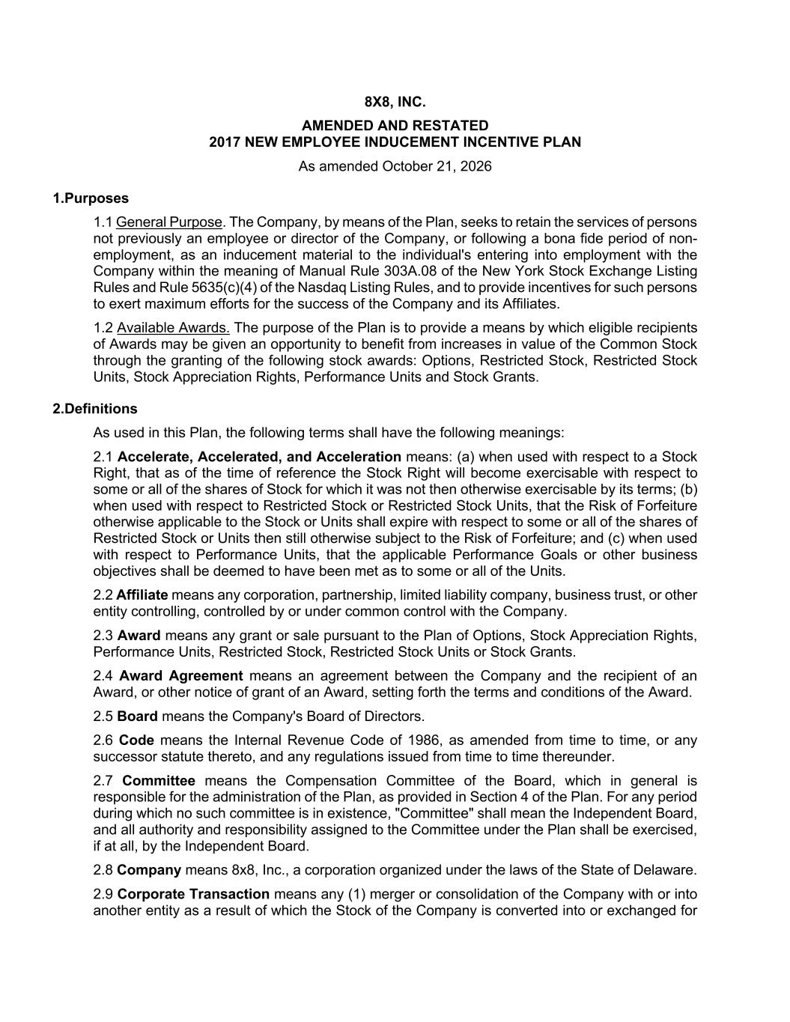
37
8X8, INC. AMENDED AND RESTATED 2017 NEW EMPLOYEE INDUCEMENT INCENTIVE PLAN As amended October 21, 2026 1.Purposes 1.1 General Purpose. The Company, by means of the Plan, seeks to retain the services of persons not previously an employee or director of the Company, or following a bona fide period of non- employment, as an inducement material to the individual's entering into employment with the Company within the meaning of Manual Rule 303A.08 of the New York Stock Exchange Listing Rules and Rule 5635(c)(4) of the Nasdaq Listing Rules, and to provide incentives for such persons to exert maximum efforts for the success of the Company and its Affiliates. 1.2 Available Awards. The purpose of the Plan is to provide a means by which eligible recipients of Awards may be given an opportunity to benefit from increases in value of the Common Stock through the granting of the following stock awards: Options, Restricted Stock, Restricted Stock Units, Stock Appreciation Rights, Performance Units and Stock Grants. 2.Definitions As used in this Plan, the following terms shall have the following meanings: 2.1 Accelerate, Accelerated, and Acceleration means: (a) when used with respect to a Stock Right, that as of the time of reference the Stock Right will become exercisable with respect to some or all of the shares of Stock for which it was not then otherwise exercisable by its terms; (b) when used with respect to Restricted Stock or Restricted Stock Units, that the Risk of Forfeiture otherwise applicable to the Stock or Units shall expire with respect to some or all of the shares of Restricted Stock or Units then still otherwise subject to the Risk of Forfeiture; and (c) when used with respect to Performance Units, that the applicable Performance Goals or other business objectives shall be deemed to have been met as to some or all of the Units. 2.2 Affiliate means any corporation, partnership, limited liability company, business trust, or other entity controlling, controlled by or under common control with the Company. 2.3 Award means any grant or sale pursuant to the Plan of Options, Stock Appreciation Rights, Performance Units, Restricted Stock, Restricted Stock Units or Stock Grants. 2.4 Award Agreement means an agreement between the Company and the recipient of an Award, or other notice of grant of an Award, setting forth the terms and conditions of the Award. 2.5 Board means the Company's Board of Directors. 2.6 Code means the Internal Revenue Code of 1986, as amended from time to time, or any successor statute thereto, and any regulations issued from time to time thereunder. 2.7 Committee means the Compensation Committee of the Board, which in general is responsible for the administration of the Plan, as provided in Section 4 of the Plan. For any period during which no such committee is in existence, "Committee" shall mean the Independent Board, and all authority and responsibility assigned to the Committee under the Plan shall be exercised, if at all, by the Independent Board. 2.8 Company means 8x8, Inc., a corporation organized under the laws of the State of Delaware. 2.9 Corporate Transaction means any (1) merger or consolidation of the Company with or into another entity as a result of which the Stock of the Company is converted into or exchanged for

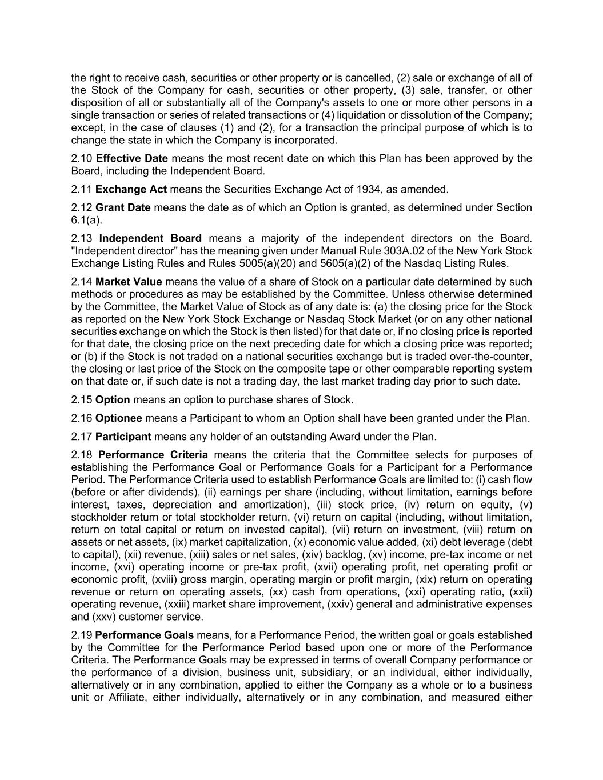
the right to receive cash, securities or other property or is cancelled, (2) sale or exchange of all of the Stock of the Company for cash, securities or other property, (3) sale, transfer, or other disposition of all or substantially all of the Company's assets to one or more other persons in a single transaction or series of related transactions or (4) liquidation or dissolution of the Company; except, in the case of clauses (1) and (2), for a transaction the principal purpose of which is to change the state in which the Company is incorporated. 2.10 Effective Date means the most recent date on which this Plan has been approved by the Board, including the Independent Board. 2.11 Exchange Act means the Securities Exchange Act of 1934, as amended. 2.12 Grant Date means the date as of which an Option is granted, as determined under Section 6.1(a). 2.13 Independent Board means a majority of the independent directors on the Board. "Independent director" has the meaning given under Manual Rule 303A.02 of the New York Stock Exchange Listing Rules and Rules 5005(a)(20) and 5605(a)(2) of the Nasdaq Listing Rules. 2.14 Market Value means the value of a share of Stock on a particular date determined by such methods or procedures as may be established by the Committee. Unless otherwise determined by the Committee, the Market Value of Stock as of any date is: (a) the closing price for the Stock as reported on the New York Stock Exchange or Nasdaq Stock Market (or on any other national securities exchange on which the Stock is then listed) for that date or, if no closing price is reported for that date, the closing price on the next preceding date for which a closing price was reported; or (b) if the Stock is not traded on a national securities exchange but is traded over-the-counter, the closing or last price of the Stock on the composite tape or other comparable reporting system on that date or, if such date is not a trading day, the last market trading day prior to such date. 2.15 Option means an option to purchase shares of Stock. 2.16 Optionee means a Participant to whom an Option shall have been granted under the Plan. 2.17 Participant means any holder of an outstanding Award under the Plan. 2.18 Performance Criteria means the criteria that the Committee selects for purposes of establishing the Performance Goal or Performance Goals for a Participant for a Performance Period. The Performance Criteria used to establish Performance Goals are limited to: (i) cash flow (before or after dividends), (ii) earnings per share (including, without limitation, earnings before interest, taxes, depreciation and amortization), (iii) stock price, (iv) return on equity, (v) stockholder return or total stockholder return, (vi) return on capital (including, without limitation, return on total capital or return on invested capital), (vii) return on investment, (viii) return on assets or net assets, (ix) market capitalization, (x) economic value added, (xi) debt leverage (debt to capital), (xii) revenue, (xiii) sales or net sales, (xiv) backlog, (xv) income, pre-tax income or net income, (xvi) operating income or pre-tax profit, (xvii) operating profit, net operating profit or economic profit, (xviii) gross margin, operating margin or profit margin, (xix) return on operating revenue or return on operating assets, (xx) cash from operations, (xxi) operating ratio, (xxii) operating revenue, (xxiii) market share improvement, (xxiv) general and administrative expenses and (xxv) customer service. 2.19 Performance Goals means, for a Performance Period, the written goal or goals established by the Committee for the Performance Period based upon one or more of the Performance Criteria. The Performance Goals may be expressed in terms of overall Company performance or the performance of a division, business unit, subsidiary, or an individual, either individually, alternatively or in any combination, applied to either the Company as a whole or to a business unit or Affiliate, either individually, alternatively or in any combination, and measured either

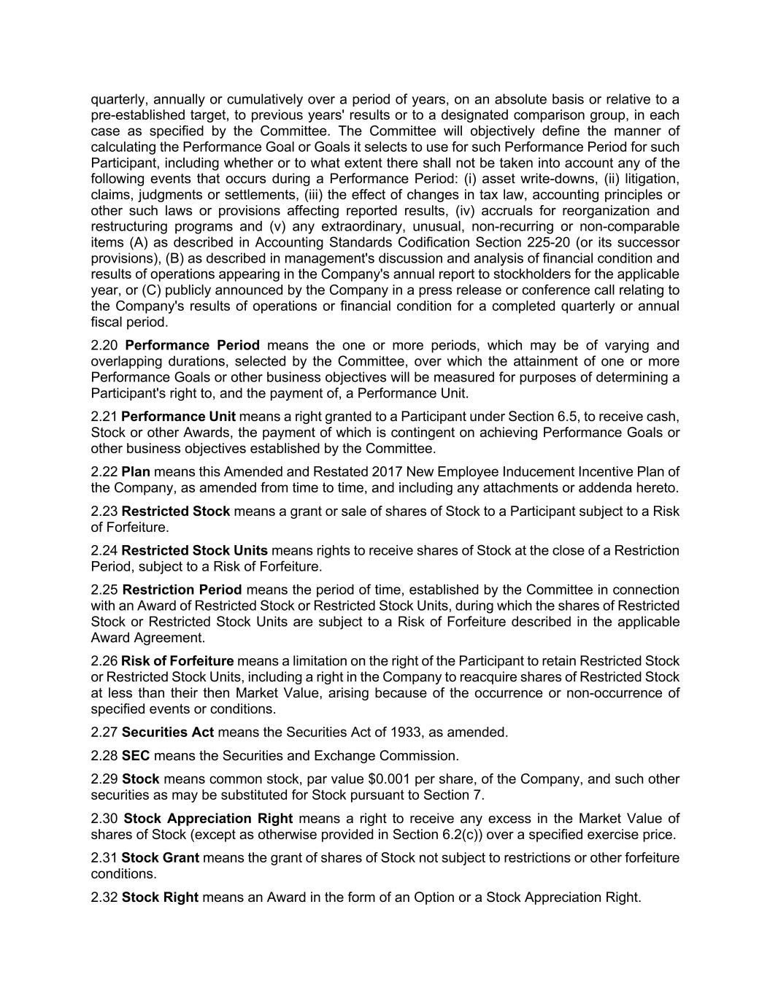
quarterly, annually or cumulatively over a period of years, on an absolute basis or relative to a pre-established target, to previous years' results or to a designated comparison group, in each case as specified by the Committee. The Committee will objectively define the manner of calculating the Performance Goal or Goals it selects to use for such Performance Period for such Participant, including whether or to what extent there shall not be taken into account any of the following events that occurs during a Performance Period: (i) asset write-downs, (ii) litigation, claims, judgments or settlements, (iii) the effect of changes in tax law, accounting principles or other such laws or provisions affecting reported results, (iv) accruals for reorganization and restructuring programs and (v) any extraordinary, unusual, non-recurring or non-comparable items (A) as described in Accounting Standards Codification Section 225-20 (or its successor provisions), (B) as described in management's discussion and analysis of financial condition and results of operations appearing in the Company's annual report to stockholders for the applicable year, or (C) publicly announced by the Company in a press release or conference call relating to the Company's results of operations or financial condition for a completed quarterly or annual fiscal period. 2.20 Performance Period means the one or more periods, which may be of varying and overlapping durations, selected by the Committee, over which the attainment of one or more Performance Goals or other business objectives will be measured for purposes of determining a Participant's right to, and the payment of, a Performance Unit. 2.21 Performance Unit means a right granted to a Participant under Section 6.5, to receive cash, Stock or other Awards, the payment of which is contingent on achieving Performance Goals or other business objectives established by the Committee. 2.22 Plan means this Amended and Restated 2017 New Employee Inducement Incentive Plan of the Company, as amended from time to time, and including any attachments or addenda hereto. 2.23 Restricted Stock means a grant or sale of shares of Stock to a Participant subject to a Risk of Forfeiture. 2.24 Restricted Stock Units means rights to receive shares of Stock at the close of a Restriction Period, subject to a Risk of Forfeiture. 2.25 Restriction Period means the period of time, established by the Committee in connection with an Award of Restricted Stock or Restricted Stock Units, during which the shares of Restricted Stock or Restricted Stock Units are subject to a Risk of Forfeiture described in the applicable Award Agreement. 2.26 Risk of Forfeiture means a limitation on the right of the Participant to retain Restricted Stock or Restricted Stock Units, including a right in the Company to reacquire shares of Restricted Stock at less than their then Market Value, arising because of the occurrence or non-occurrence of specified events or conditions. 2.27 Securities Act means the Securities Act of 1933, as amended. 2.28 SEC means the Securities and Exchange Commission. 2.29 Stock means common stock, par value $0.001 per share, of the Company, and such other securities as may be substituted for Stock pursuant to Section 7. 2.30 Stock Appreciation Right means a right to receive any excess in the Market Value of shares of Stock (except as otherwise provided in Section 6.2(c)) over a specified exercise price. 2.31 Stock Grant means the grant of shares of Stock not subject to restrictions or other forfeiture conditions. 2.32 Stock Right means an Award in the form of an Option or a Stock Appreciation Right.

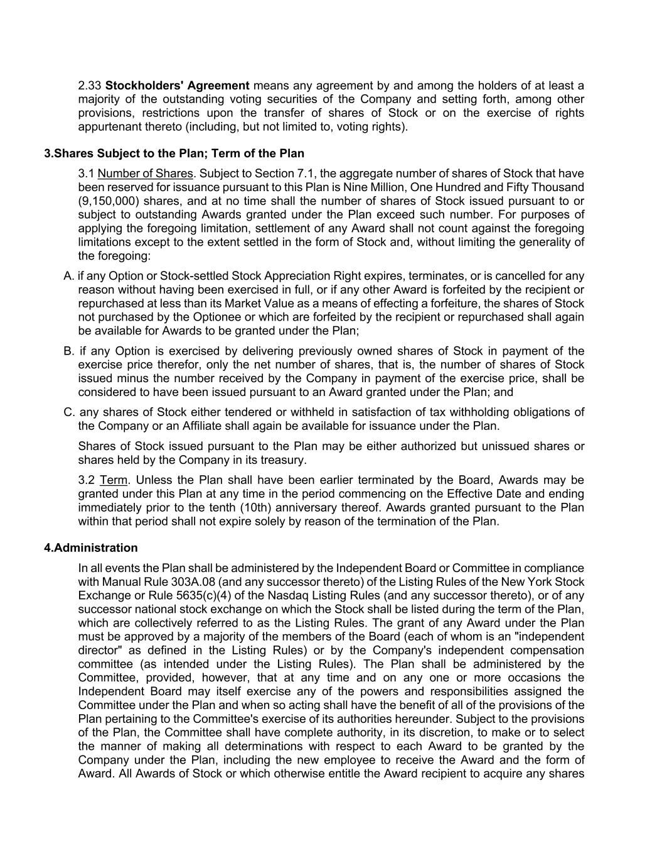
2.33 Stockholders' Agreement means any agreement by and among the holders of at least a majority of the outstanding voting securities of the Company and setting forth, among other provisions, restrictions upon the transfer of shares of Stock or on the exercise of rights appurtenant thereto (including, but not limited to, voting rights). 3.Shares Subject to the Plan; Term of the Plan 3.1 Number of Shares. Subject to Section 7.1, the aggregate number of shares of Stock that have been reserved for issuance pursuant to this Plan is Nine Million, One Hundred and Fifty Thousand (9,150,000) shares, and at no time shall the number of shares of Stock issued pursuant to or subject to outstanding Awards granted under the Plan exceed such number. For purposes of applying the foregoing limitation, settlement of any Award shall not count against the foregoing limitations except to the extent settled in the form of Stock and, without limiting the generality of the foregoing: A. if any Option or Stock-settled Stock Appreciation Right expires, terminates, or is cancelled for any reason without having been exercised in full, or if any other Award is forfeited by the recipient or repurchased at less than its Market Value as a means of effecting a forfeiture, the shares of Stock not purchased by the Optionee or which are forfeited by the recipient or repurchased shall again be available for Awards to be granted under the Plan; B. if any Option is exercised by delivering previously owned shares of Stock in payment of the exercise price therefor, only the net number of shares, that is, the number of shares of Stock issued minus the number received by the Company in payment of the exercise price, shall be considered to have been issued pursuant to an Award granted under the Plan; and C. any shares of Stock either tendered or withheld in satisfaction of tax withholding obligations of the Company or an Affiliate shall again be available for issuance under the Plan. Shares of Stock issued pursuant to the Plan may be either authorized but unissued shares or shares held by the Company in its treasury. 3.2 Term. Unless the Plan shall have been earlier terminated by the Board, Awards may be granted under this Plan at any time in the period commencing on the Effective Date and ending immediately prior to the tenth (10th) anniversary thereof. Awards granted pursuant to the Plan within that period shall not expire solely by reason of the termination of the Plan. 4.Administration In all events the Plan shall be administered by the Independent Board or Committee in compliance with Manual Rule 303A.08 (and any successor thereto) of the Listing Rules of the New York Stock Exchange or Rule 5635(c)(4) of the Nasdaq Listing Rules (and any successor thereto), or of any successor national stock exchange on which the Stock shall be listed during the term of the Plan, which are collectively referred to as the Listing Rules. The grant of any Award under the Plan must be approved by a majority of the members of the Board (each of whom is an "independent director" as defined in the Listing Rules) or by the Company's independent compensation committee (as intended under the Listing Rules). The Plan shall be administered by the Committee, provided, however, that at any time and on any one or more occasions the Independent Board may itself exercise any of the powers and responsibilities assigned the Committee under the Plan and when so acting shall have the benefit of all of the provisions of the Plan pertaining to the Committee's exercise of its authorities hereunder. Subject to the provisions of the Plan, the Committee shall have complete authority, in its discretion, to make or to select the manner of making all determinations with respect to each Award to be granted by the Company under the Plan, including the new employee to receive the Award and the form of Award. All Awards of Stock or which otherwise entitle the Award recipient to acquire any shares

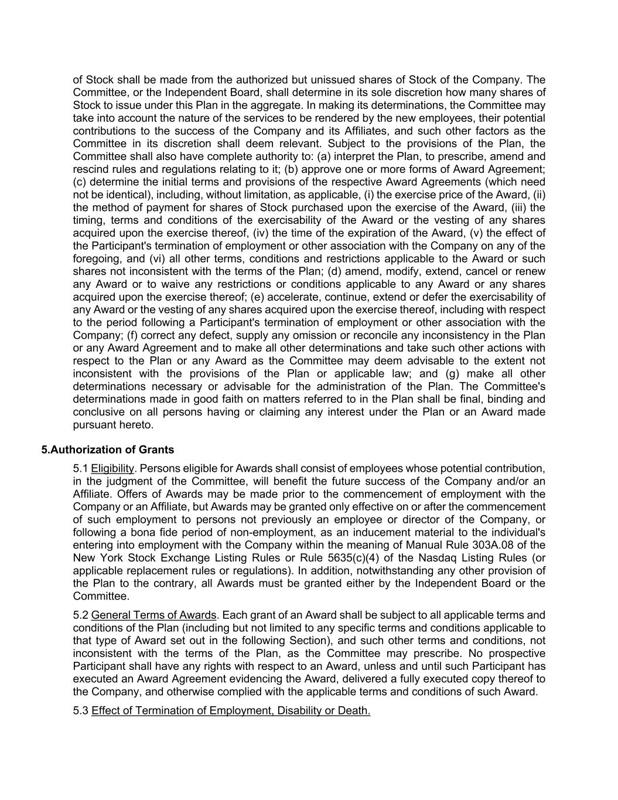
of Stock shall be made from the authorized but unissued shares of Stock of the Company. The Committee, or the Independent Board, shall determine in its sole discretion how many shares of Stock to issue under this Plan in the aggregate. In making its determinations, the Committee may take into account the nature of the services to be rendered by the new employees, their potential contributions to the success of the Company and its Affiliates, and such other factors as the Committee in its discretion shall deem relevant. Subject to the provisions of the Plan, the Committee shall also have complete authority to: (a) interpret the Plan, to prescribe, amend and rescind rules and regulations relating to it; (b) approve one or more forms of Award Agreement; (c) determine the initial terms and provisions of the respective Award Agreements (which need not be identical), including, without limitation, as applicable, (i) the exercise price of the Award, (ii) the method of payment for shares of Stock purchased upon the exercise of the Award, (iii) the timing, terms and conditions of the exercisability of the Award or the vesting of any shares acquired upon the exercise thereof, (iv) the time of the expiration of the Award, (v) the effect of the Participant's termination of employment or other association with the Company on any of the foregoing, and (vi) all other terms, conditions and restrictions applicable to the Award or such shares not inconsistent with the terms of the Plan; (d) amend, modify, extend, cancel or renew any Award or to waive any restrictions or conditions applicable to any Award or any shares acquired upon the exercise thereof; (e) accelerate, continue, extend or defer the exercisability of any Award or the vesting of any shares acquired upon the exercise thereof, including with respect to the period following a Participant's termination of employment or other association with the Company; (f) correct any defect, supply any omission or reconcile any inconsistency in the Plan or any Award Agreement and to make all other determinations and take such other actions with respect to the Plan or any Award as the Committee may deem advisable to the extent not inconsistent with the provisions of the Plan or applicable law; and (g) make all other determinations necessary or advisable for the administration of the Plan. The Committee's determinations made in good faith on matters referred to in the Plan shall be final, binding and conclusive on all persons having or claiming any interest under the Plan or an Award made pursuant hereto. 5.Authorization of Grants 5.1 Eligibility. Persons eligible for Awards shall consist of employees whose potential contribution, in the judgment of the Committee, will benefit the future success of the Company and/or an Affiliate. Offers of Awards may be made prior to the commencement of employment with the Company or an Affiliate, but Awards may be granted only effective on or after the commencement of such employment to persons not previously an employee or director of the Company, or following a bona fide period of non-employment, as an inducement material to the individual's entering into employment with the Company within the meaning of Manual Rule 303A.08 of the New York Stock Exchange Listing Rules or Rule 5635(c)(4) of the Nasdaq Listing Rules (or applicable replacement rules or regulations). In addition, notwithstanding any other provision of the Plan to the contrary, all Awards must be granted either by the Independent Board or the Committee. 5.2 General Terms of Awards. Each grant of an Award shall be subject to all applicable terms and conditions of the Plan (including but not limited to any specific terms and conditions applicable to that type of Award set out in the following Section), and such other terms and conditions, not inconsistent with the terms of the Plan, as the Committee may prescribe. No prospective Participant shall have any rights with respect to an Award, unless and until such Participant has executed an Award Agreement evidencing the Award, delivered a fully executed copy thereof to the Company, and otherwise complied with the applicable terms and conditions of such Award. 5.3 Effect of Termination of Employment, Disability or Death.

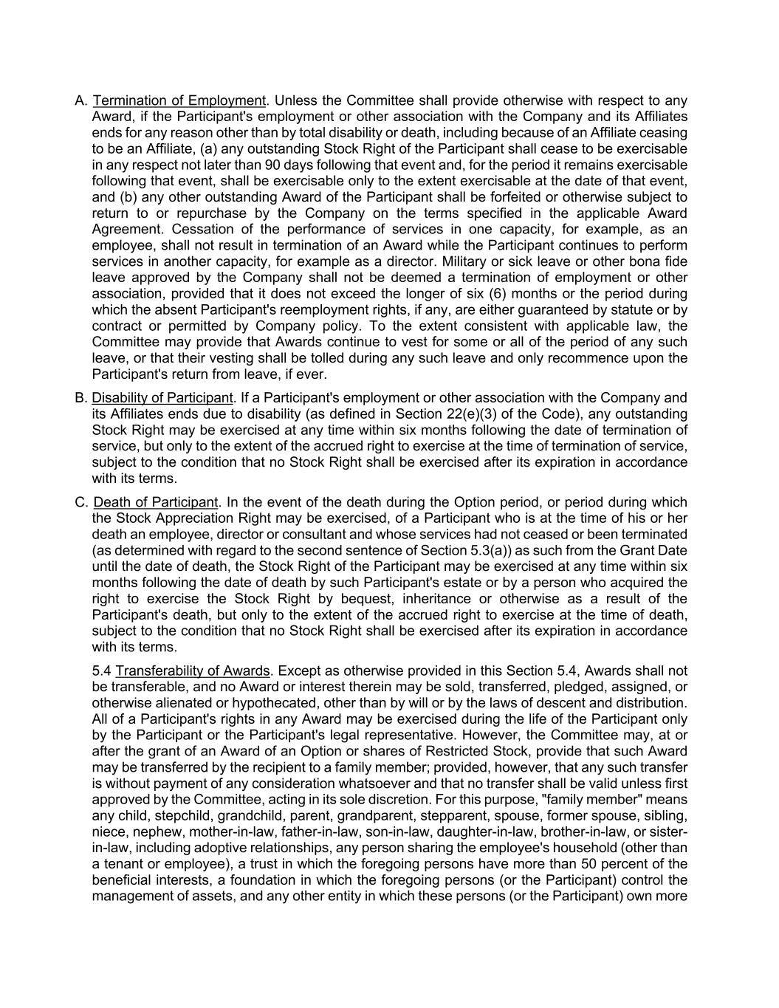
A. Termination of Employment. Unless the Committee shall provide otherwise with respect to any Award, if the Participant's employment or other association with the Company and its Affiliates ends for any reason other than by total disability or death, including because of an Affiliate ceasing to be an Affiliate, (a) any outstanding Stock Right of the Participant shall cease to be exercisable in any respect not later than 90 days following that event and, for the period it remains exercisable following that event, shall be exercisable only to the extent exercisable at the date of that event, and (b) any other outstanding Award of the Participant shall be forfeited or otherwise subject to return to or repurchase by the Company on the terms specified in the applicable Award Agreement. Cessation of the performance of services in one capacity, for example, as an employee, shall not result in termination of an Award while the Participant continues to perform services in another capacity, for example as a director. Military or sick leave or other bona fide leave approved by the Company shall not be deemed a termination of employment or other association, provided that it does not exceed the longer of six (6) months or the period during which the absent Participant's reemployment rights, if any, are either guaranteed by statute or by contract or permitted by Company policy. To the extent consistent with applicable law, the Committee may provide that Awards continue to vest for some or all of the period of any such leave, or that their vesting shall be tolled during any such leave and only recommence upon the Participant's return from leave, if ever. B. Disability of Participant. If a Participant's employment or other association with the Company and its Affiliates ends due to disability (as defined in Section 22(e)(3) of the Code), any outstanding Stock Right may be exercised at any time within six months following the date of termination of service, but only to the extent of the accrued right to exercise at the time of termination of service, subject to the condition that no Stock Right shall be exercised after its expiration in accordance with its terms. C. Death of Participant. In the event of the death during the Option period, or period during which the Stock Appreciation Right may be exercised, of a Participant who is at the time of his or her death an employee, director or consultant and whose services had not ceased or been terminated (as determined with regard to the second sentence of Section 5.3(a)) as such from the Grant Date until the date of death, the Stock Right of the Participant may be exercised at any time within six months following the date of death by such Participant's estate or by a person who acquired the right to exercise the Stock Right by bequest, inheritance or otherwise as a result of the Participant's death, but only to the extent of the accrued right to exercise at the time of death, subject to the condition that no Stock Right shall be exercised after its expiration in accordance with its terms. 5.4 Transferability of Awards. Except as otherwise provided in this Section 5.4, Awards shall not be transferable, and no Award or interest therein may be sold, transferred, pledged, assigned, or otherwise alienated or hypothecated, other than by will or by the laws of descent and distribution. All of a Participant's rights in any Award may be exercised during the life of the Participant only by the Participant or the Participant's legal representative. However, the Committee may, at or after the grant of an Award of an Option or shares of Restricted Stock, provide that such Award may be transferred by the recipient to a family member; provided, however, that any such transfer is without payment of any consideration whatsoever and that no transfer shall be valid unless first approved by the Committee, acting in its sole discretion. For this purpose, "family member" means any child, stepchild, grandchild, parent, grandparent, stepparent, spouse, former spouse, sibling, niece, nephew, mother-in-law, father-in-law, son-in-law, daughter-in-law, brother-in-law, or sister- in-law, including adoptive relationships, any person sharing the employee's household (other than a tenant or employee), a trust in which the foregoing persons have more than 50 percent of the beneficial interests, a foundation in which the foregoing persons (or the Participant) control the management of assets, and any other entity in which these persons (or the Participant) own more

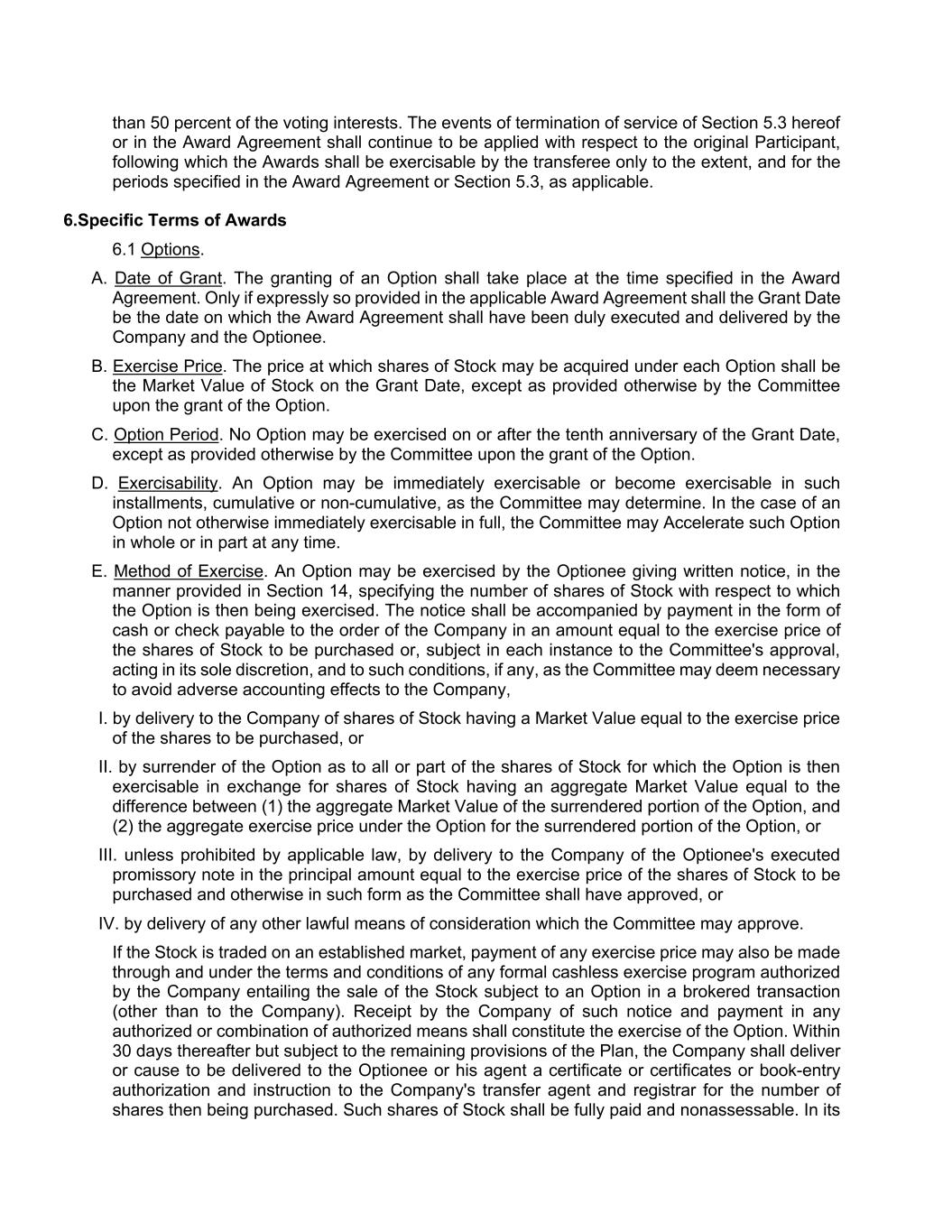
than 50 percent of the voting interests. The events of termination of service of Section 5.3 hereof or in the Award Agreement shall continue to be applied with respect to the original Participant, following which the Awards shall be exercisable by the transferee only to the extent, and for the periods specified in the Award Agreement or Section 5.3, as applicable. 6.Specific Terms of Awards 6.1 Options. A. Date of Grant. The granting of an Option shall take place at the time specified in the Award Agreement. Only if expressly so provided in the applicable Award Agreement shall the Grant Date be the date on which the Award Agreement shall have been duly executed and delivered by the Company and the Optionee. B. Exercise Price. The price at which shares of Stock may be acquired under each Option shall be the Market Value of Stock on the Grant Date, except as provided otherwise by the Committee upon the grant of the Option. C. Option Period. No Option may be exercised on or after the tenth anniversary of the Grant Date, except as provided otherwise by the Committee upon the grant of the Option. D. Exercisability. An Option may be immediately exercisable or become exercisable in such installments, cumulative or non-cumulative, as the Committee may determine. In the case of an Option not otherwise immediately exercisable in full, the Committee may Accelerate such Option in whole or in part at any time. E. Method of Exercise. An Option may be exercised by the Optionee giving written notice, in the manner provided in Section 14, specifying the number of shares of Stock with respect to which the Option is then being exercised. The notice shall be accompanied by payment in the form of cash or check payable to the order of the Company in an amount equal to the exercise price of the shares of Stock to be purchased or, subject in each instance to the Committee's approval, acting in its sole discretion, and to such conditions, if any, as the Committee may deem necessary to avoid adverse accounting effects to the Company, I. by delivery to the Company of shares of Stock having a Market Value equal to the exercise price of the shares to be purchased, or II. by surrender of the Option as to all or part of the shares of Stock for which the Option is then exercisable in exchange for shares of Stock having an aggregate Market Value equal to the difference between (1) the aggregate Market Value of the surrendered portion of the Option, and (2) the aggregate exercise price under the Option for the surrendered portion of the Option, or III. unless prohibited by applicable law, by delivery to the Company of the Optionee's executed promissory note in the principal amount equal to the exercise price of the shares of Stock to be purchased and otherwise in such form as the Committee shall have approved, or IV. by delivery of any other lawful means of consideration which the Committee may approve. If the Stock is traded on an established market, payment of any exercise price may also be made through and under the terms and conditions of any formal cashless exercise program authorized by the Company entailing the sale of the Stock subject to an Option in a brokered transaction (other than to the Company). Receipt by the Company of such notice and payment in any authorized or combination of authorized means shall constitute the exercise of the Option. Within 30 days thereafter but subject to the remaining provisions of the Plan, the Company shall deliver or cause to be delivered to the Optionee or his agent a certificate or certificates or book-entry authorization and instruction to the Company's transfer agent and registrar for the number of shares then being purchased. Such shares of Stock shall be fully paid and nonassessable. In its

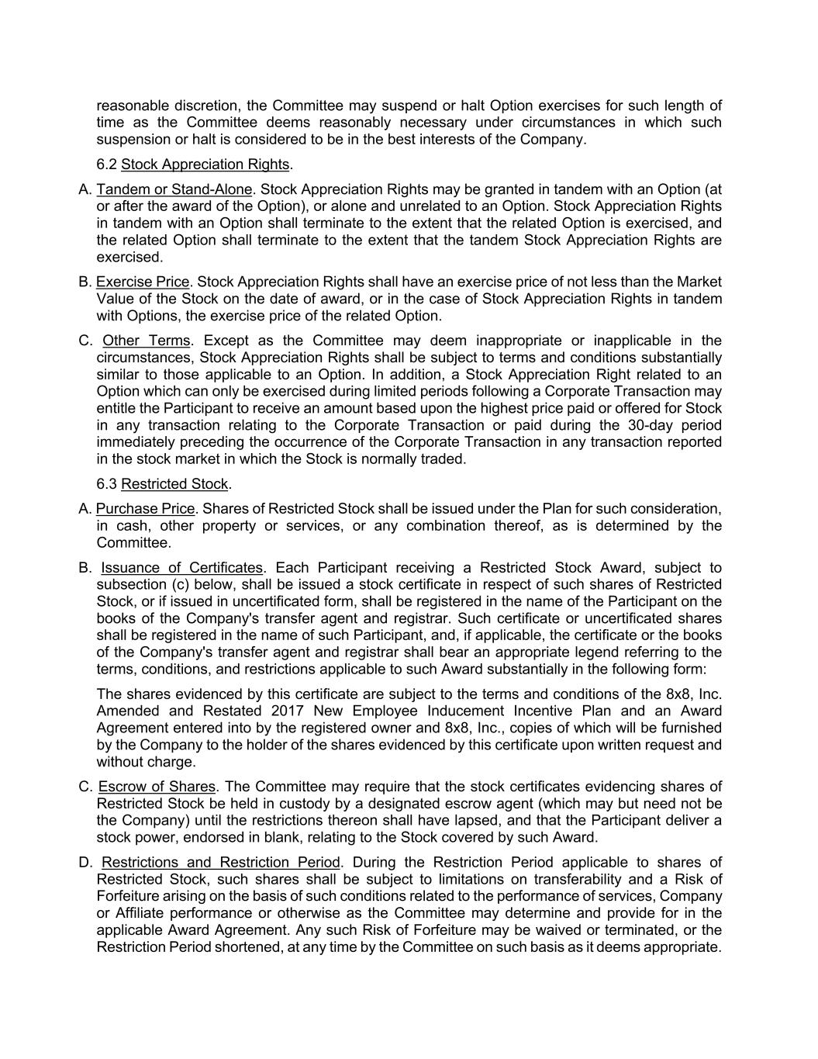
reasonable discretion, the Committee may suspend or halt Option exercises for such length of time as the Committee deems reasonably necessary under circumstances in which such suspension or halt is considered to be in the best interests of the Company. 6.2 Stock Appreciation Rights. A. Tandem or Stand-Alone. Stock Appreciation Rights may be granted in tandem with an Option (at or after the award of the Option), or alone and unrelated to an Option. Stock Appreciation Rights in tandem with an Option shall terminate to the extent that the related Option is exercised, and the related Option shall terminate to the extent that the tandem Stock Appreciation Rights are exercised. B. Exercise Price. Stock Appreciation Rights shall have an exercise price of not less than the Market Value of the Stock on the date of award, or in the case of Stock Appreciation Rights in tandem with Options, the exercise price of the related Option. C. Other Terms. Except as the Committee may deem inappropriate or inapplicable in the circumstances, Stock Appreciation Rights shall be subject to terms and conditions substantially similar to those applicable to an Option. In addition, a Stock Appreciation Right related to an Option which can only be exercised during limited periods following a Corporate Transaction may entitle the Participant to receive an amount based upon the highest price paid or offered for Stock in any transaction relating to the Corporate Transaction or paid during the 30-day period immediately preceding the occurrence of the Corporate Transaction in any transaction reported in the stock market in which the Stock is normally traded. 6.3 Restricted Stock. A. Purchase Price. Shares of Restricted Stock shall be issued under the Plan for such consideration, in cash, other property or services, or any combination thereof, as is determined by the Committee. B. Issuance of Certificates. Each Participant receiving a Restricted Stock Award, subject to subsection (c) below, shall be issued a stock certificate in respect of such shares of Restricted Stock, or if issued in uncertificated form, shall be registered in the name of the Participant on the books of the Company's transfer agent and registrar. Such certificate or uncertificated shares shall be registered in the name of such Participant, and, if applicable, the certificate or the books of the Company's transfer agent and registrar shall bear an appropriate legend referring to the terms, conditions, and restrictions applicable to such Award substantially in the following form: The shares evidenced by this certificate are subject to the terms and conditions of the 8x8, Inc. Amended and Restated 2017 New Employee Inducement Incentive Plan and an Award Agreement entered into by the registered owner and 8x8, Inc., copies of which will be furnished by the Company to the holder of the shares evidenced by this certificate upon written request and without charge. C. Escrow of Shares. The Committee may require that the stock certificates evidencing shares of Restricted Stock be held in custody by a designated escrow agent (which may but need not be the Company) until the restrictions thereon shall have lapsed, and that the Participant deliver a stock power, endorsed in blank, relating to the Stock covered by such Award. D. Restrictions and Restriction Period. During the Restriction Period applicable to shares of Restricted Stock, such shares shall be subject to limitations on transferability and a Risk of Forfeiture arising on the basis of such conditions related to the performance of services, Company or Affiliate performance or otherwise as the Committee may determine and provide for in the applicable Award Agreement. Any such Risk of Forfeiture may be waived or terminated, or the Restriction Period shortened, at any time by the Committee on such basis as it deems appropriate.

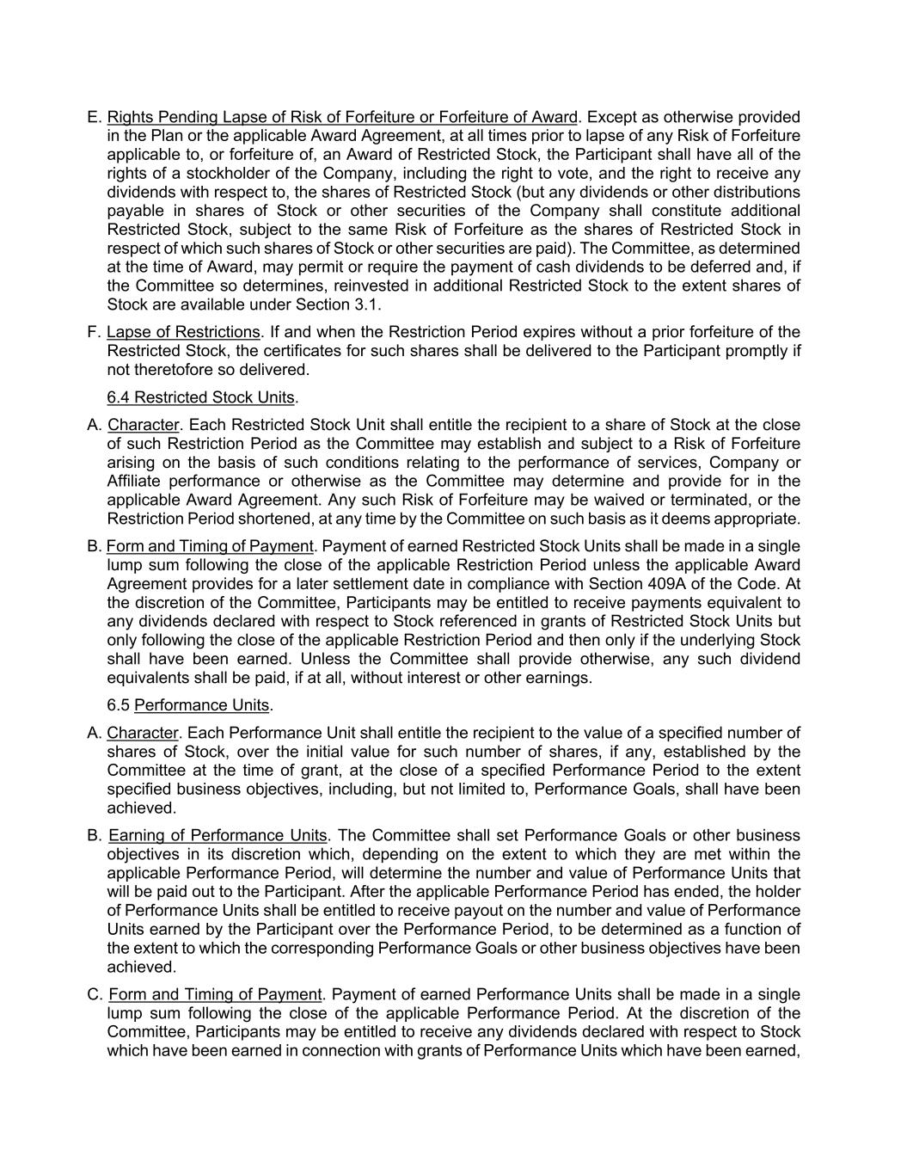
E. Rights Pending Lapse of Risk of Forfeiture or Forfeiture of Award. Except as otherwise provided in the Plan or the applicable Award Agreement, at all times prior to lapse of any Risk of Forfeiture applicable to, or forfeiture of, an Award of Restricted Stock, the Participant shall have all of the rights of a stockholder of the Company, including the right to vote, and the right to receive any dividends with respect to, the shares of Restricted Stock (but any dividends or other distributions payable in shares of Stock or other securities of the Company shall constitute additional Restricted Stock, subject to the same Risk of Forfeiture as the shares of Restricted Stock in respect of which such shares of Stock or other securities are paid). The Committee, as determined at the time of Award, may permit or require the payment of cash dividends to be deferred and, if the Committee so determines, reinvested in additional Restricted Stock to the extent shares of Stock are available under Section 3.1. F. Lapse of Restrictions. If and when the Restriction Period expires without a prior forfeiture of the Restricted Stock, the certificates for such shares shall be delivered to the Participant promptly if not theretofore so delivered. 6.4 Restricted Stock Units. A. Character. Each Restricted Stock Unit shall entitle the recipient to a share of Stock at the close of such Restriction Period as the Committee may establish and subject to a Risk of Forfeiture arising on the basis of such conditions relating to the performance of services, Company or Affiliate performance or otherwise as the Committee may determine and provide for in the applicable Award Agreement. Any such Risk of Forfeiture may be waived or terminated, or the Restriction Period shortened, at any time by the Committee on such basis as it deems appropriate. B. Form and Timing of Payment. Payment of earned Restricted Stock Units shall be made in a single lump sum following the close of the applicable Restriction Period unless the applicable Award Agreement provides for a later settlement date in compliance with Section 409A of the Code. At the discretion of the Committee, Participants may be entitled to receive payments equivalent to any dividends declared with respect to Stock referenced in grants of Restricted Stock Units but only following the close of the applicable Restriction Period and then only if the underlying Stock shall have been earned. Unless the Committee shall provide otherwise, any such dividend equivalents shall be paid, if at all, without interest or other earnings. 6.5 Performance Units. A. Character. Each Performance Unit shall entitle the recipient to the value of a specified number of shares of Stock, over the initial value for such number of shares, if any, established by the Committee at the time of grant, at the close of a specified Performance Period to the extent specified business objectives, including, but not limited to, Performance Goals, shall have been achieved. B. Earning of Performance Units. The Committee shall set Performance Goals or other business objectives in its discretion which, depending on the extent to which they are met within the applicable Performance Period, will determine the number and value of Performance Units that will be paid out to the Participant. After the applicable Performance Period has ended, the holder of Performance Units shall be entitled to receive payout on the number and value of Performance Units earned by the Participant over the Performance Period, to be determined as a function of the extent to which the corresponding Performance Goals or other business objectives have been achieved. C. Form and Timing of Payment. Payment of earned Performance Units shall be made in a single lump sum following the close of the applicable Performance Period. At the discretion of the Committee, Participants may be entitled to receive any dividends declared with respect to Stock which have been earned in connection with grants of Performance Units which have been earned,

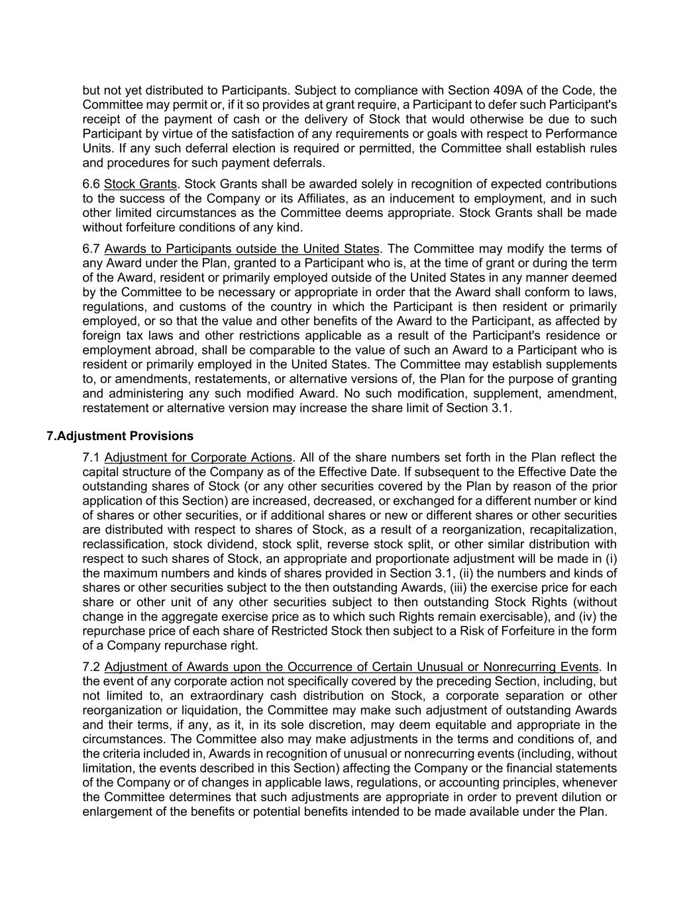
but not yet distributed to Participants. Subject to compliance with Section 409A of the Code, the Committee may permit or, if it so provides at grant require, a Participant to defer such Participant's receipt of the payment of cash or the delivery of Stock that would otherwise be due to such Participant by virtue of the satisfaction of any requirements or goals with respect to Performance Units. If any such deferral election is required or permitted, the Committee shall establish rules and procedures for such payment deferrals. 6.6 Stock Grants. Stock Grants shall be awarded solely in recognition of expected contributions to the success of the Company or its Affiliates, as an inducement to employment, and in such other limited circumstances as the Committee deems appropriate. Stock Grants shall be made without forfeiture conditions of any kind. 6.7 Awards to Participants outside the United States. The Committee may modify the terms of any Award under the Plan, granted to a Participant who is, at the time of grant or during the term of the Award, resident or primarily employed outside of the United States in any manner deemed by the Committee to be necessary or appropriate in order that the Award shall conform to laws, regulations, and customs of the country in which the Participant is then resident or primarily employed, or so that the value and other benefits of the Award to the Participant, as affected by foreign tax laws and other restrictions applicable as a result of the Participant's residence or employment abroad, shall be comparable to the value of such an Award to a Participant who is resident or primarily employed in the United States. The Committee may establish supplements to, or amendments, restatements, or alternative versions of, the Plan for the purpose of granting and administering any such modified Award. No such modification, supplement, amendment, restatement or alternative version may increase the share limit of Section 3.1. 7.Adjustment Provisions 7.1 Adjustment for Corporate Actions. All of the share numbers set forth in the Plan reflect the capital structure of the Company as of the Effective Date. If subsequent to the Effective Date the outstanding shares of Stock (or any other securities covered by the Plan by reason of the prior application of this Section) are increased, decreased, or exchanged for a different number or kind of shares or other securities, or if additional shares or new or different shares or other securities are distributed with respect to shares of Stock, as a result of a reorganization, recapitalization, reclassification, stock dividend, stock split, reverse stock split, or other similar distribution with respect to such shares of Stock, an appropriate and proportionate adjustment will be made in (i) the maximum numbers and kinds of shares provided in Section 3.1, (ii) the numbers and kinds of shares or other securities subject to the then outstanding Awards, (iii) the exercise price for each share or other unit of any other securities subject to then outstanding Stock Rights (without change in the aggregate exercise price as to which such Rights remain exercisable), and (iv) the repurchase price of each share of Restricted Stock then subject to a Risk of Forfeiture in the form of a Company repurchase right. 7.2 Adjustment of Awards upon the Occurrence of Certain Unusual or Nonrecurring Events. In the event of any corporate action not specifically covered by the preceding Section, including, but not limited to, an extraordinary cash distribution on Stock, a corporate separation or other reorganization or liquidation, the Committee may make such adjustment of outstanding Awards and their terms, if any, as it, in its sole discretion, may deem equitable and appropriate in the circumstances. The Committee also may make adjustments in the terms and conditions of, and the criteria included in, Awards in recognition of unusual or nonrecurring events (including, without limitation, the events described in this Section) affecting the Company or the financial statements of the Company or of changes in applicable laws, regulations, or accounting principles, whenever the Committee determines that such adjustments are appropriate in order to prevent dilution or enlargement of the benefits or potential benefits intended to be made available under the Plan.

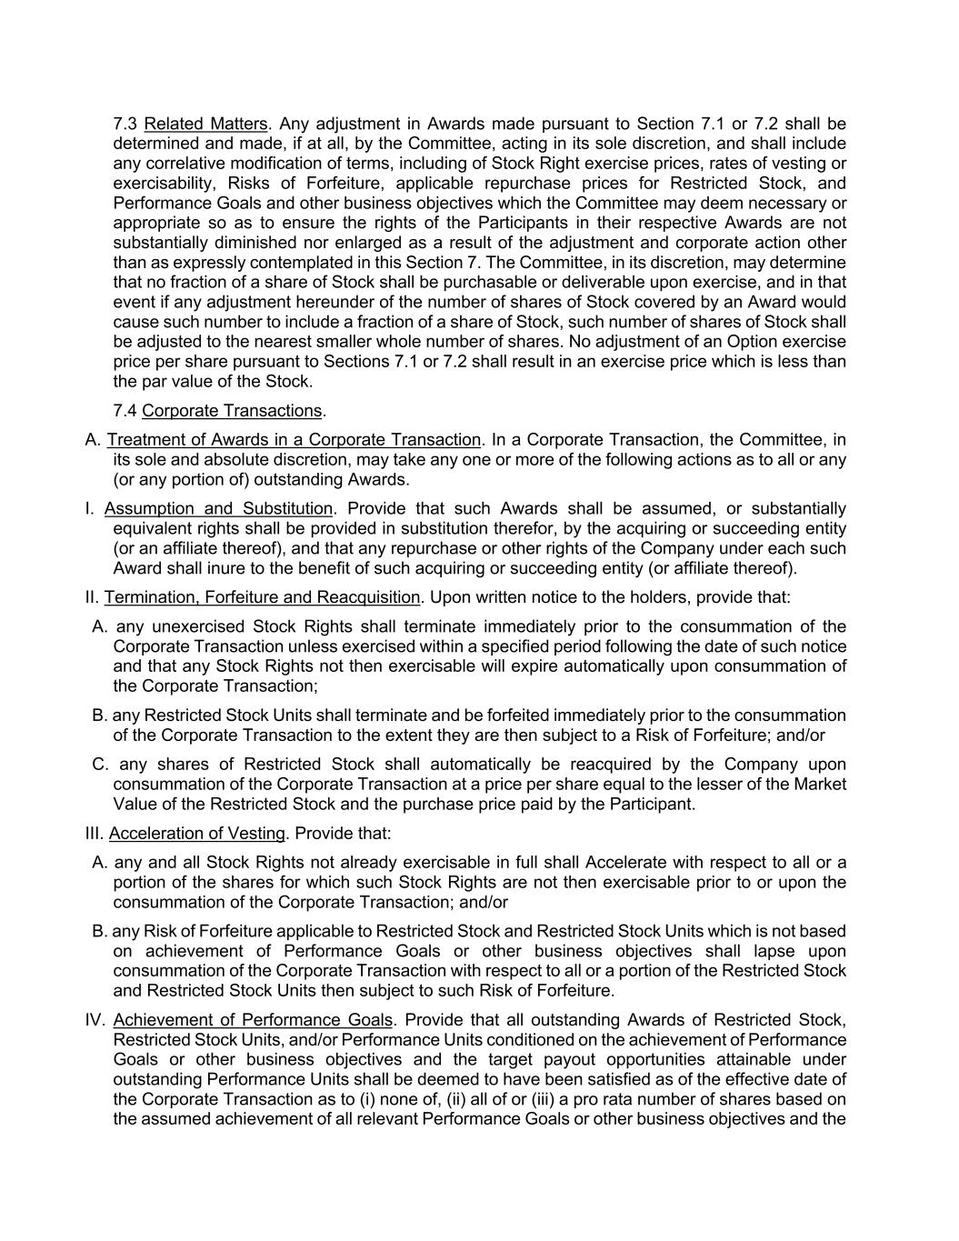
7.3 Related Matters. Any adjustment in Awards made pursuant to Section 7.1 or 7.2 shall be determined and made, if at all, by the Committee, acting in its sole discretion, and shall include any correlative modification of terms, including of Stock Right exercise prices, rates of vesting or exercisability, Risks of Forfeiture, applicable repurchase prices for Restricted Stock, and Performance Goals and other business objectives which the Committee may deem necessary or appropriate so as to ensure the rights of the Participants in their respective Awards are not substantially diminished nor enlarged as a result of the adjustment and corporate action other than as expressly contemplated in this Section 7. The Committee, in its discretion, may determine that no fraction of a share of Stock shall be purchasable or deliverable upon exercise, and in that event if any adjustment hereunder of the number of shares of Stock covered by an Award would cause such number to include a fraction of a share of Stock, such number of shares of Stock shall be adjusted to the nearest smaller whole number of shares. No adjustment of an Option exercise price per share pursuant to Sections 7.1 or 7.2 shall result in an exercise price which is less than the par value of the Stock. 7.4 Corporate Transactions. A. Treatment of Awards in a Corporate Transaction. In a Corporate Transaction, the Committee, in its sole and absolute discretion, may take any one or more of the following actions as to all or any (or any portion of) outstanding Awards. I. Assumption and Substitution. Provide that such Awards shall be assumed, or substantially equivalent rights shall be provided in substitution therefor, by the acquiring or succeeding entity (or an affiliate thereof), and that any repurchase or other rights of the Company under each such Award shall inure to the benefit of such acquiring or succeeding entity (or affiliate thereof). II. Termination, Forfeiture and Reacquisition. Upon written notice to the holders, provide that: A. any unexercised Stock Rights shall terminate immediately prior to the consummation of the Corporate Transaction unless exercised within a specified period following the date of such notice and that any Stock Rights not then exercisable will expire automatically upon consummation of the Corporate Transaction; B. any Restricted Stock Units shall terminate and be forfeited immediately prior to the consummation of the Corporate Transaction to the extent they are then subject to a Risk of Forfeiture; and/or C. any shares of Restricted Stock shall automatically be reacquired by the Company upon consummation of the Corporate Transaction at a price per share equal to the lesser of the Market Value of the Restricted Stock and the purchase price paid by the Participant. III. Acceleration of Vesting. Provide that: A. any and all Stock Rights not already exercisable in full shall Accelerate with respect to all or a portion of the shares for which such Stock Rights are not then exercisable prior to or upon the consummation of the Corporate Transaction; and/or B. any Risk of Forfeiture applicable to Restricted Stock and Restricted Stock Units which is not based on achievement of Performance Goals or other business objectives shall lapse upon consummation of the Corporate Transaction with respect to all or a portion of the Restricted Stock and Restricted Stock Units then subject to such Risk of Forfeiture. IV. Achievement of Performance Goals. Provide that all outstanding Awards of Restricted Stock, Restricted Stock Units, and/or Performance Units conditioned on the achievement of Performance Goals or other business objectives and the target payout opportunities attainable under outstanding Performance Units shall be deemed to have been satisfied as of the effective date of the Corporate Transaction as to (i) none of, (ii) all of or (iii) a pro rata number of shares based on the assumed achievement of all relevant Performance Goals or other business objectives and the

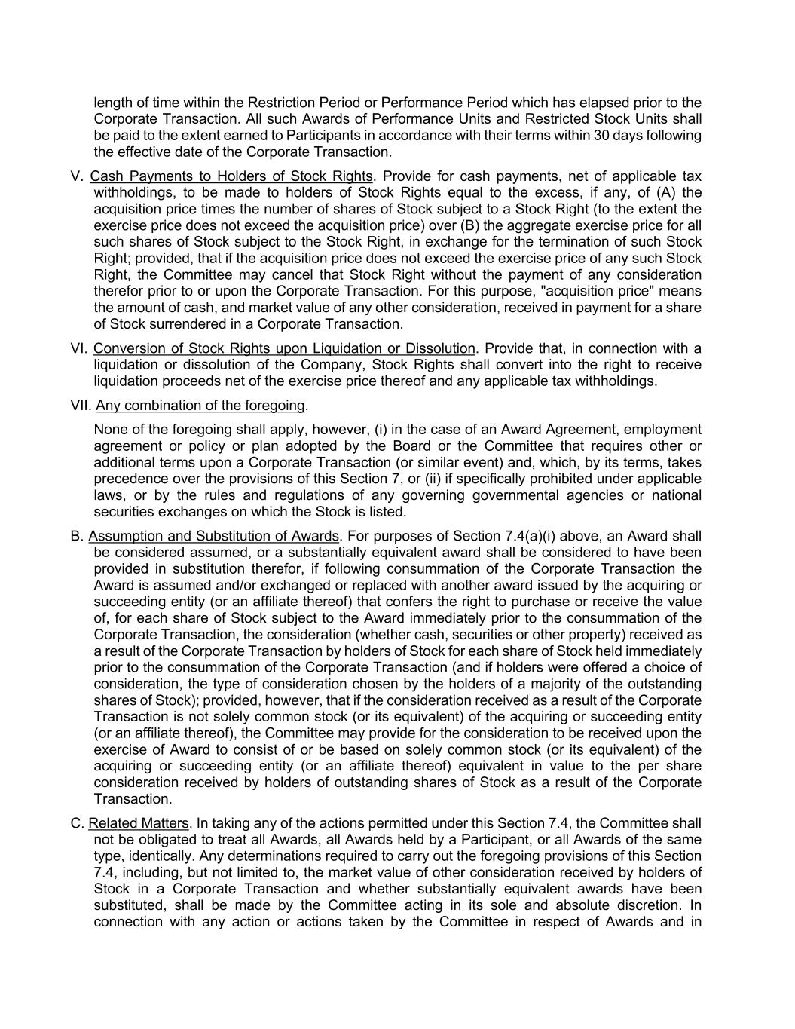
length of time within the Restriction Period or Performance Period which has elapsed prior to the Corporate Transaction. All such Awards of Performance Units and Restricted Stock Units shall be paid to the extent earned to Participants in accordance with their terms within 30 days following the effective date of the Corporate Transaction. V. Cash Payments to Holders of Stock Rights. Provide for cash payments, net of applicable tax withholdings, to be made to holders of Stock Rights equal to the excess, if any, of (A) the acquisition price times the number of shares of Stock subject to a Stock Right (to the extent the exercise price does not exceed the acquisition price) over (B) the aggregate exercise price for all such shares of Stock subject to the Stock Right, in exchange for the termination of such Stock Right; provided, that if the acquisition price does not exceed the exercise price of any such Stock Right, the Committee may cancel that Stock Right without the payment of any consideration therefor prior to or upon the Corporate Transaction. For this purpose, "acquisition price" means the amount of cash, and market value of any other consideration, received in payment for a share of Stock surrendered in a Corporate Transaction. VI. Conversion of Stock Rights upon Liquidation or Dissolution. Provide that, in connection with a liquidation or dissolution of the Company, Stock Rights shall convert into the right to receive liquidation proceeds net of the exercise price thereof and any applicable tax withholdings. VII. Any combination of the foregoing. None of the foregoing shall apply, however, (i) in the case of an Award Agreement, employment agreement or policy or plan adopted by the Board or the Committee that requires other or additional terms upon a Corporate Transaction (or similar event) and, which, by its terms, takes precedence over the provisions of this Section 7, or (ii) if specifically prohibited under applicable laws, or by the rules and regulations of any governing governmental agencies or national securities exchanges on which the Stock is listed. B. Assumption and Substitution of Awards. For purposes of Section 7.4(a)(i) above, an Award shall be considered assumed, or a substantially equivalent award shall be considered to have been provided in substitution therefor, if following consummation of the Corporate Transaction the Award is assumed and/or exchanged or replaced with another award issued by the acquiring or succeeding entity (or an affiliate thereof) that confers the right to purchase or receive the value of, for each share of Stock subject to the Award immediately prior to the consummation of the Corporate Transaction, the consideration (whether cash, securities or other property) received as a result of the Corporate Transaction by holders of Stock for each share of Stock held immediately prior to the consummation of the Corporate Transaction (and if holders were offered a choice of consideration, the type of consideration chosen by the holders of a majority of the outstanding shares of Stock); provided, however, that if the consideration received as a result of the Corporate Transaction is not solely common stock (or its equivalent) of the acquiring or succeeding entity (or an affiliate thereof), the Committee may provide for the consideration to be received upon the exercise of Award to consist of or be based on solely common stock (or its equivalent) of the acquiring or succeeding entity (or an affiliate thereof) equivalent in value to the per share consideration received by holders of outstanding shares of Stock as a result of the Corporate Transaction. C. Related Matters. In taking any of the actions permitted under this Section 7.4, the Committee shall not be obligated to treat all Awards, all Awards held by a Participant, or all Awards of the same type, identically. Any determinations required to carry out the foregoing provisions of this Section 7.4, including, but not limited to, the market value of other consideration received by holders of Stock in a Corporate Transaction and whether substantially equivalent awards have been substituted, shall be made by the Committee acting in its sole and absolute discretion. In connection with any action or actions taken by the Committee in respect of Awards and in

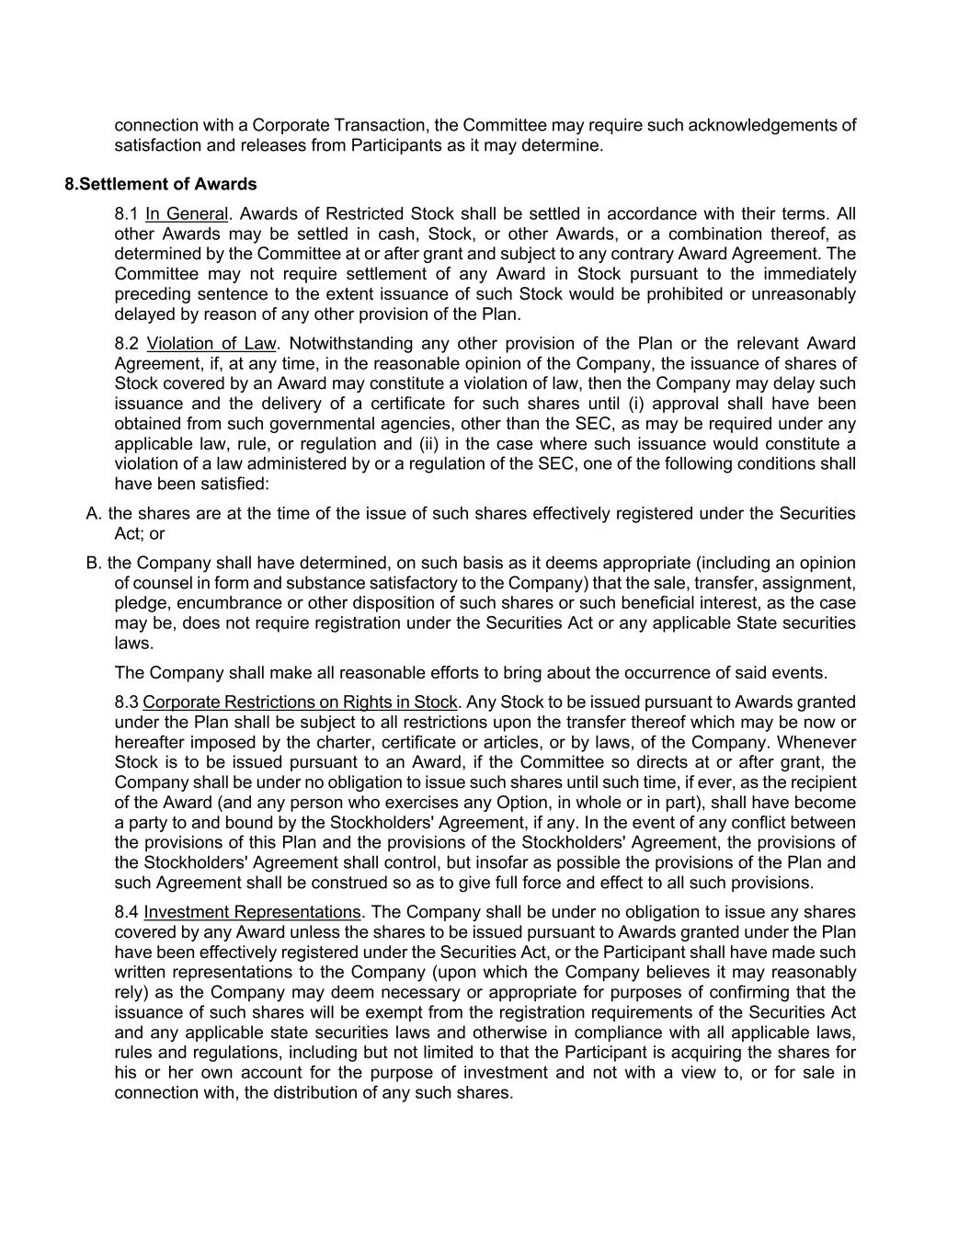
connection with a Corporate Transaction, the Committee may require such acknowledgements of satisfaction and releases from Participants as it may determine. 8.Settlement of Awards 8.1 In General. Awards of Restricted Stock shall be settled in accordance with their terms. All other Awards may be settled in cash, Stock, or other Awards, or a combination thereof, as determined by the Committee at or after grant and subject to any contrary Award Agreement. The Committee may not require settlement of any Award in Stock pursuant to the immediately preceding sentence to the extent issuance of such Stock would be prohibited or unreasonably delayed by reason of any other provision of the Plan. 8.2 Violation of Law. Notwithstanding any other provision of the Plan or the relevant Award Agreement, if, at any time, in the reasonable opinion of the Company, the issuance of shares of Stock covered by an Award may constitute a violation of law, then the Company may delay such issuance and the delivery of a certificate for such shares until (i) approval shall have been obtained from such governmental agencies, other than the SEC, as may be required under any applicable law, rule, or regulation and (ii) in the case where such issuance would constitute a violation of a law administered by or a regulation of the SEC, one of the following conditions shall have been satisfied: A. the shares are at the time of the issue of such shares effectively registered under the Securities Act; or B. the Company shall have determined, on such basis as it deems appropriate (including an opinion of counsel in form and substance satisfactory to the Company) that the sale, transfer, assignment, pledge, encumbrance or other disposition of such shares or such beneficial interest, as the case may be, does not require registration under the Securities Act or any applicable State securities laws. The Company shall make all reasonable efforts to bring about the occurrence of said events. 8.3 Corporate Restrictions on Rights in Stock. Any Stock to be issued pursuant to Awards granted under the Plan shall be subject to all restrictions upon the transfer thereof which may be now or hereafter imposed by the charter, certificate or articles, or by laws, of the Company. Whenever Stock is to be issued pursuant to an Award, if the Committee so directs at or after grant, the Company shall be under no obligation to issue such shares until such time, if ever, as the recipient of the Award (and any person who exercises any Option, in whole or in part), shall have become a party to and bound by the Stockholders' Agreement, if any. In the event of any conflict between the provisions of this Plan and the provisions of the Stockholders' Agreement, the provisions of the Stockholders' Agreement shall control, but insofar as possible the provisions of the Plan and such Agreement shall be construed so as to give full force and effect to all such provisions. 8.4 Investment Representations. The Company shall be under no obligation to issue any shares covered by any Award unless the shares to be issued pursuant to Awards granted under the Plan have been effectively registered under the Securities Act, or the Participant shall have made such written representations to the Company (upon which the Company believes it may reasonably rely) as the Company may deem necessary or appropriate for purposes of confirming that the issuance of such shares will be exempt from the registration requirements of the Securities Act and any applicable state securities laws and otherwise in compliance with all applicable laws, rules and regulations, including but not limited to that the Participant is acquiring the shares for his or her own account for the purpose of investment and not with a view to, or for sale in connection with, the distribution of any such shares.

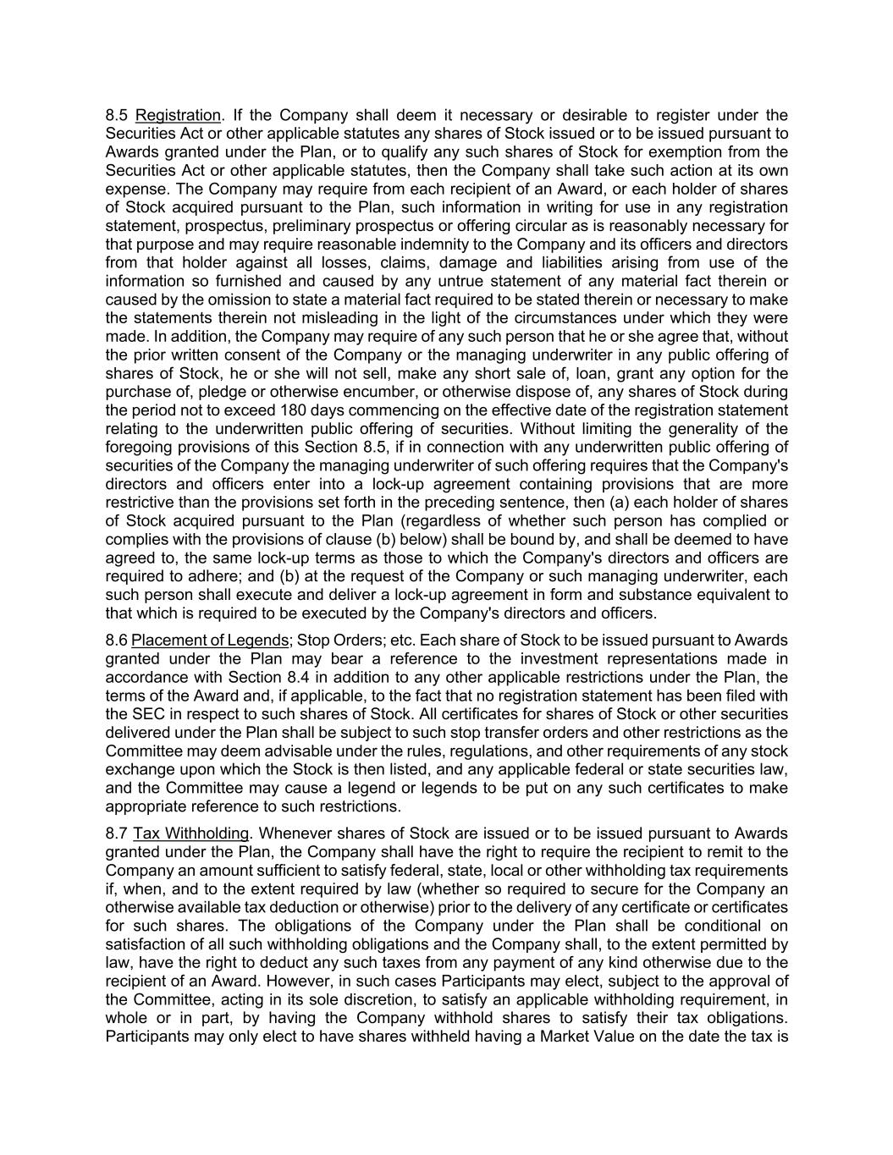
8.5 Registration. If the Company shall deem it necessary or desirable to register under the Securities Act or other applicable statutes any shares of Stock issued or to be issued pursuant to Awards granted under the Plan, or to qualify any such shares of Stock for exemption from the Securities Act or other applicable statutes, then the Company shall take such action at its own expense. The Company may require from each recipient of an Award, or each holder of shares of Stock acquired pursuant to the Plan, such information in writing for use in any registration statement, prospectus, preliminary prospectus or offering circular as is reasonably necessary for that purpose and may require reasonable indemnity to the Company and its officers and directors from that holder against all losses, claims, damage and liabilities arising from use of the information so furnished and caused by any untrue statement of any material fact therein or caused by the omission to state a material fact required to be stated therein or necessary to make the statements therein not misleading in the light of the circumstances under which they were made. In addition, the Company may require of any such person that he or she agree that, without the prior written consent of the Company or the managing underwriter in any public offering of shares of Stock, he or she will not sell, make any short sale of, loan, grant any option for the purchase of, pledge or otherwise encumber, or otherwise dispose of, any shares of Stock during the period not to exceed 180 days commencing on the effective date of the registration statement relating to the underwritten public offering of securities. Without limiting the generality of the foregoing provisions of this Section 8.5, if in connection with any underwritten public offering of securities of the Company the managing underwriter of such offering requires that the Company's directors and officers enter into a lock-up agreement containing provisions that are more restrictive than the provisions set forth in the preceding sentence, then (a) each holder of shares of Stock acquired pursuant to the Plan (regardless of whether such person has complied or complies with the provisions of clause (b) below) shall be bound by, and shall be deemed to have agreed to, the same lock-up terms as those to which the Company's directors and officers are required to adhere; and (b) at the request of the Company or such managing underwriter, each such person shall execute and deliver a lock-up agreement in form and substance equivalent to that which is required to be executed by the Company's directors and officers. 8.6 Placement of Legends; Stop Orders; etc. Each share of Stock to be issued pursuant to Awards granted under the Plan may bear a reference to the investment representations made in accordance with Section 8.4 in addition to any other applicable restrictions under the Plan, the terms of the Award and, if applicable, to the fact that no registration statement has been filed with the SEC in respect to such shares of Stock. All certificates for shares of Stock or other securities delivered under the Plan shall be subject to such stop transfer orders and other restrictions as the Committee may deem advisable under the rules, regulations, and other requirements of any stock exchange upon which the Stock is then listed, and any applicable federal or state securities law, and the Committee may cause a legend or legends to be put on any such certificates to make appropriate reference to such restrictions. 8.7 Tax Withholding. Whenever shares of Stock are issued or to be issued pursuant to Awards granted under the Plan, the Company shall have the right to require the recipient to remit to the Company an amount sufficient to satisfy federal, state, local or other withholding tax requirements if, when, and to the extent required by law (whether so required to secure for the Company an otherwise available tax deduction or otherwise) prior to the delivery of any certificate or certificates for such shares. The obligations of the Company under the Plan shall be conditional on satisfaction of all such withholding obligations and the Company shall, to the extent permitted by law, have the right to deduct any such taxes from any payment of any kind otherwise due to the recipient of an Award. However, in such cases Participants may elect, subject to the approval of the Committee, acting in its sole discretion, to satisfy an applicable withholding requirement, in whole or in part, by having the Company withhold shares to satisfy their tax obligations. Participants may only elect to have shares withheld having a Market Value on the date the tax is

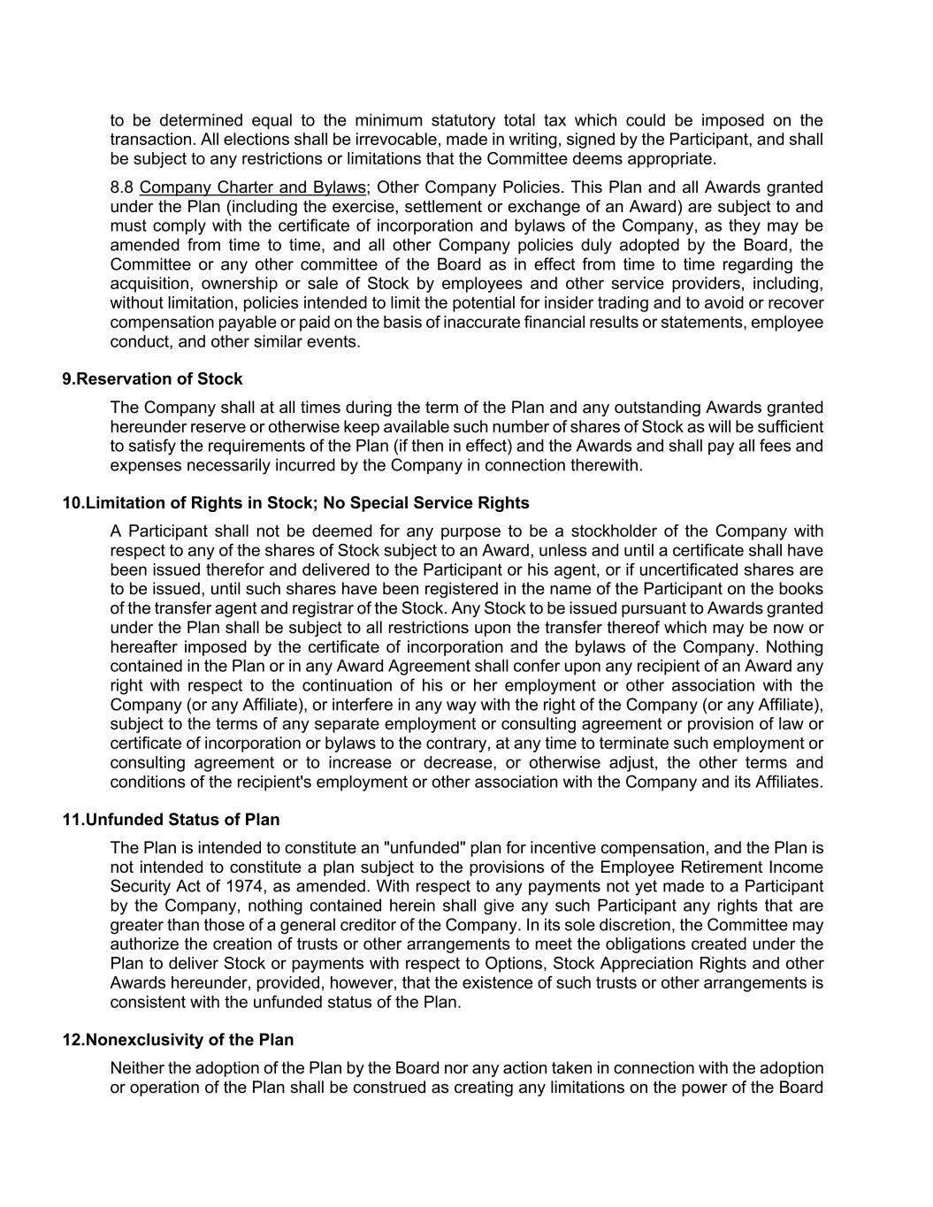
to be determined equal to the minimum statutory total tax which could be imposed on the transaction. All elections shall be irrevocable, made in writing, signed by the Participant, and shall be subject to any restrictions or limitations that the Committee deems appropriate. 8.8 Company Charter and Bylaws; Other Company Policies. This Plan and all Awards granted under the Plan (including the exercise, settlement or exchange of an Award) are subject to and must comply with the certificate of incorporation and bylaws of the Company, as they may be amended from time to time, and all other Company policies duly adopted by the Board, the Committee or any other committee of the Board as in effect from time to time regarding the acquisition, ownership or sale of Stock by employees and other service providers, including, without limitation, policies intended to limit the potential for insider trading and to avoid or recover compensation payable or paid on the basis of inaccurate financial results or statements, employee conduct, and other similar events. 9.Reservation of Stock The Company shall at all times during the term of the Plan and any outstanding Awards granted hereunder reserve or otherwise keep available such number of shares of Stock as will be sufficient to satisfy the requirements of the Plan (if then in effect) and the Awards and shall pay all fees and expenses necessarily incurred by the Company in connection therewith. 10.Limitation of Rights in Stock; No Special Service Rights A Participant shall not be deemed for any purpose to be a stockholder of the Company with respect to any of the shares of Stock subject to an Award, unless and until a certificate shall have been issued therefor and delivered to the Participant or his agent, or if uncertificated shares are to be issued, until such shares have been registered in the name of the Participant on the books of the transfer agent and registrar of the Stock. Any Stock to be issued pursuant to Awards granted under the Plan shall be subject to all restrictions upon the transfer thereof which may be now or hereafter imposed by the certificate of incorporation and the bylaws of the Company. Nothing contained in the Plan or in any Award Agreement shall confer upon any recipient of an Award any right with respect to the continuation of his or her employment or other association with the Company (or any Affiliate), or interfere in any way with the right of the Company (or any Affiliate), subject to the terms of any separate employment or consulting agreement or provision of law or certificate of incorporation or bylaws to the contrary, at any time to terminate such employment or consulting agreement or to increase or decrease, or otherwise adjust, the other terms and conditions of the recipient's employment or other association with the Company and its Affiliates. 11.Unfunded Status of Plan The Plan is intended to constitute an "unfunded" plan for incentive compensation, and the Plan is not intended to constitute a plan subject to the provisions of the Employee Retirement Income Security Act of 1974, as amended. With respect to any payments not yet made to a Participant by the Company, nothing contained herein shall give any such Participant any rights that are greater than those of a general creditor of the Company. In its sole discretion, the Committee may authorize the creation of trusts or other arrangements to meet the obligations created under the Plan to deliver Stock or payments with respect to Options, Stock Appreciation Rights and other Awards hereunder, provided, however, that the existence of such trusts or other arrangements is consistent with the unfunded status of the Plan. 12.Nonexclusivity of the Plan Neither the adoption of the Plan by the Board nor any action taken in connection with the adoption or operation of the Plan shall be construed as creating any limitations on the power of the Board

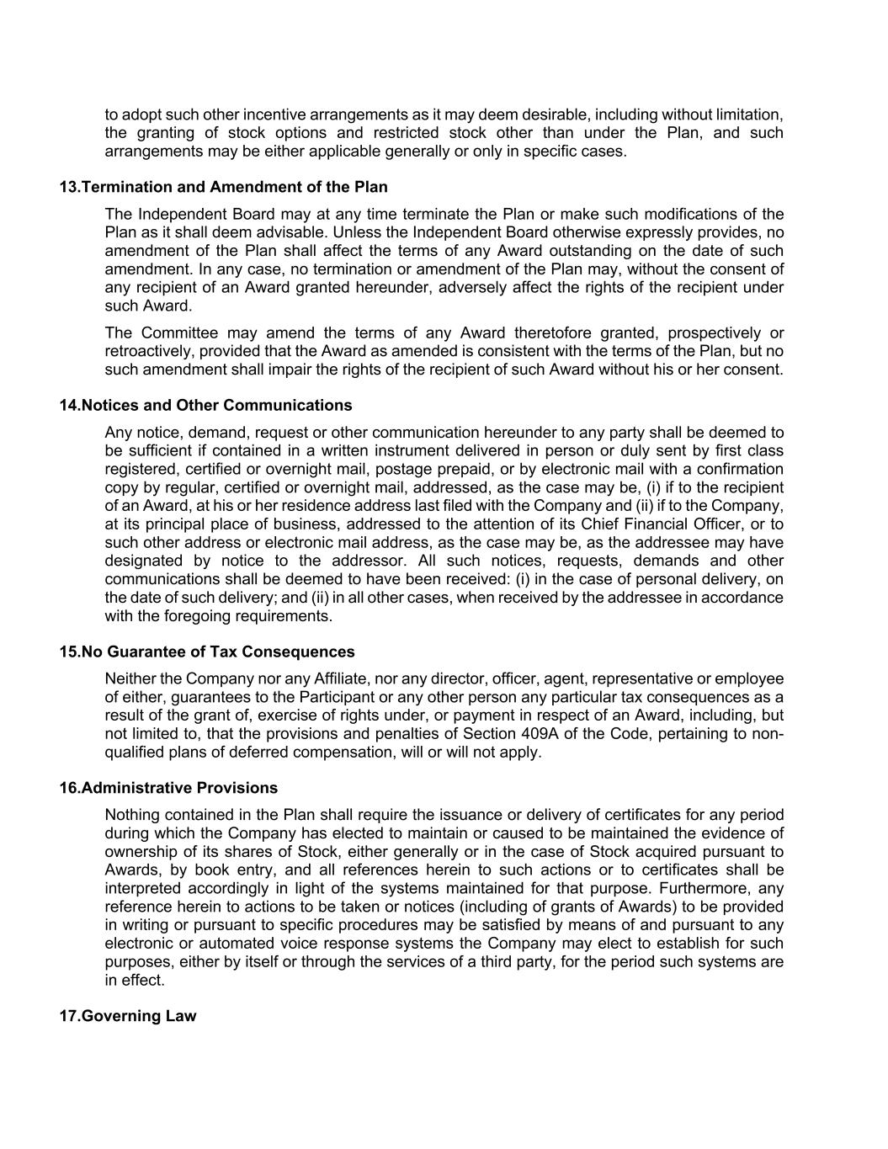
to adopt such other incentive arrangements as it may deem desirable, including without limitation, the granting of stock options and restricted stock other than under the Plan, and such arrangements may be either applicable generally or only in specific cases. 13.Termination and Amendment of the Plan The Independent Board may at any time terminate the Plan or make such modifications of the Plan as it shall deem advisable. Unless the Independent Board otherwise expressly provides, no amendment of the Plan shall affect the terms of any Award outstanding on the date of such amendment. In any case, no termination or amendment of the Plan may, without the consent of any recipient of an Award granted hereunder, adversely affect the rights of the recipient under such Award. The Committee may amend the terms of any Award theretofore granted, prospectively or retroactively, provided that the Award as amended is consistent with the terms of the Plan, but no such amendment shall impair the rights of the recipient of such Award without his or her consent. 14.Notices and Other Communications Any notice, demand, request or other communication hereunder to any party shall be deemed to be sufficient if contained in a written instrument delivered in person or duly sent by first class registered, certified or overnight mail, postage prepaid, or by electronic mail with a confirmation copy by regular, certified or overnight mail, addressed, as the case may be, (i) if to the recipient of an Award, at his or her residence address last filed with the Company and (ii) if to the Company, at its principal place of business, addressed to the attention of its Chief Financial Officer, or to such other address or electronic mail address, as the case may be, as the addressee may have designated by notice to the addressor. All such notices, requests, demands and other communications shall be deemed to have been received: (i) in the case of personal delivery, on the date of such delivery; and (ii) in all other cases, when received by the addressee in accordance with the foregoing requirements. 15.No Guarantee of Tax Consequences Neither the Company nor any Affiliate, nor any director, officer, agent, representative or employee of either, guarantees to the Participant or any other person any particular tax consequences as a result of the grant of, exercise of rights under, or payment in respect of an Award, including, but not limited to, that the provisions and penalties of Section 409A of the Code, pertaining to non- qualified plans of deferred compensation, will or will not apply. 16.Administrative Provisions Nothing contained in the Plan shall require the issuance or delivery of certificates for any period during which the Company has elected to maintain or caused to be maintained the evidence of ownership of its shares of Stock, either generally or in the case of Stock acquired pursuant to Awards, by book entry, and all references herein to such actions or to certificates shall be interpreted accordingly in light of the systems maintained for that purpose. Furthermore, any reference herein to actions to be taken or notices (including of grants of Awards) to be provided in writing or pursuant to specific procedures may be satisfied by means of and pursuant to any electronic or automated voice response systems the Company may elect to establish for such purposes, either by itself or through the services of a third party, for the period such systems are in effect. 17.Governing Law

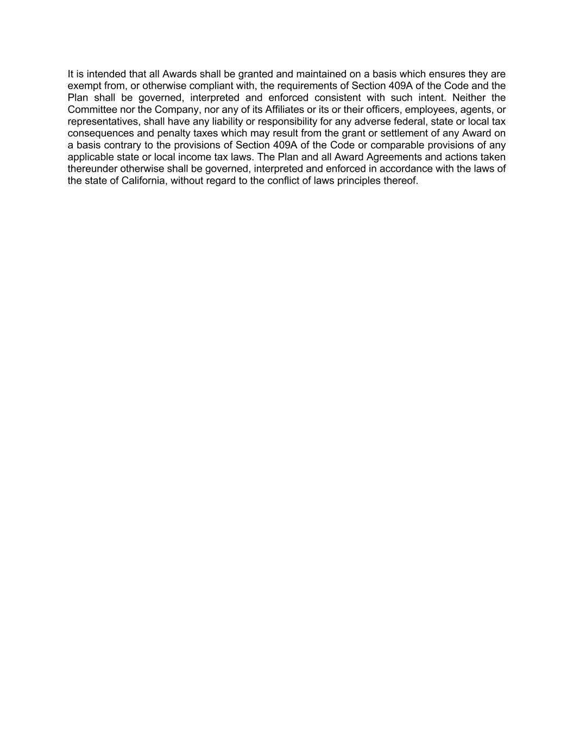
It is intended that all Awards shall be granted and maintained on a basis which ensures they are exempt from, or otherwise compliant with, the requirements of Section 409A of the Code and the Plan shall be governed, interpreted and enforced consistent with such intent. Neither the Committee nor the Company, nor any of its Affiliates or its or their officers, employees, agents, or representatives, shall have any liability or responsibility for any adverse federal, state or local tax consequences and penalty taxes which may result from the grant or settlement of any Award on a basis contrary to the provisions of Section 409A of the Code or comparable provisions of any applicable state or local income tax laws. The Plan and all Award Agreements and actions taken thereunder otherwise shall be governed, interpreted and enforced in accordance with the laws of the state of California, without regard to the conflict of laws principles thereof.

Exhibit 31.1
CERTIFICATION PURSUANT TO
RULES 13a-14(a) AND 15d-14(a) UNDER THE SECURITIES EXCHANGE ACT OF 1934
AS ADOPTED PURSUANT TO
SECTION 302 OF THE SARBANES-OXLEY ACT OF 2002
I, Samuel Wilson, certify that:
1.I have reviewed this quarterly report on Form 10-Q of 8x8, Inc.;
2.Based on my knowledge, this report does not contain any untrue statement of a material fact or omit to state a material fact necessary to make the statements made, in light of the circumstances under which such statements were made, not misleading with respect to the period covered by this report;
3.Based on my knowledge, the financial statements, and other financial information included in this report, fairly present in all material respects the financial condition, results of operations and cash flows of the registrant as of, and for, the periods presented in this report;
4.The registrant's other certifying officer and I are responsible for establishing and maintaining disclosure controls and procedures (as defined in Exchange Act Rules 13a-15(e) and 15d-15(e)) and internal control over financial reporting (as defined in Exchange Act Rules 13a-15(f) and 15d-15(f)) for the registrant and have:
a.Designed such disclosure controls and procedures, or caused such disclosure controls and procedures to be designed under our supervision, to ensure that material information relating to the registrant, including its consolidated subsidiaries, is made known to us by others within those entities, particularly during the period in which this report is being prepared;
b.Designed such internal control over financial reporting, or caused such internal control over financial reporting to be designed under our supervision, to provide reasonable assurance regarding the reliability of financial reporting and the preparation of financial statements for external purposes in accordance with generally accepted accounting principles;
c.Evaluated the effectiveness of the registrant's disclosure controls and procedures and presented in this report our conclusions about the effectiveness of the disclosure controls and procedures as of the end of the period covered by this report based on such evaluation; and
d.Disclosed in this report any change in the registrant's internal control over financial reporting that occurred during the registrant's most recent fiscal quarter (the registrant's fourth fiscal quarter in the case of an annual report) that has materially affected, or is reasonably likely to materially affect, the registrant's internal control over financial reporting; and
5.The registrant's other certifying officer and I have disclosed, based on our most recent evaluation of internal control over financial reporting, to the registrant's auditors and the audit committee of the registrant's board of directors (or persons performing the equivalent functions):
a.All significant deficiencies and material weaknesses in the design or operation of internal control over financial reporting which are reasonably likely to adversely affect the registrant's ability to record, process, summarize and report financial information; and
b.Any fraud, whether or not material, that involves management or other employees who have a significant role in the registrant's internal control over financial reporting.
November 5, 2026
/s/ Samuel Wilson
Samuel Wilson
Chief Executive Officer

Exhibit 31.2
CERTIFICATION PURSUANT TO
RULES 13a-14(a) AND 15d-14(a) UNDER THE SECURITIES EXCHANGE ACT OF 1934
AS ADOPTED PURSUANT TO
SECTION 302 OF THE SARBANES-OXLEY ACT OF 2002
I, Kevin Kraus, certify that:
1.I have reviewed this quarterly report on Form 10-Q of 8x8, Inc.;
2.Based on my knowledge, this report does not contain any untrue statement of a material fact or omit to state a material fact necessary to make the statements made, in light of the circumstances under which such statements were made, not misleading with respect to the period covered by this report;
3.Based on my knowledge, the financial statements, and other financial information included in this report, fairly present in all material respects the financial condition, results of operations and cash flows of the registrant as of, and for, the periods presented in this report;
4.The registrant's other certifying officer and I are responsible for establishing and maintaining disclosure controls and procedures (as defined in Exchange Act Rules 13a-15(e) and 15d-15(e)) and internal control over financial reporting (as defined in Exchange Act Rules 13a-15(f) and 15d-15(f)) for the registrant and have:
a.Designed such disclosure controls and procedures, or caused such disclosure controls and procedures to be designed under our supervision, to ensure that material information relating to the registrant, including its consolidated subsidiaries, is made known to us by others within those entities, particularly during the period in which this report is being prepared;
b.Designed such internal control over financial reporting, or caused such internal control over financial reporting to be designed under our supervision, to provide reasonable assurance regarding the reliability of financial reporting and the preparation of financial statements for external purposes in accordance with generally accepted accounting principles;
c.Evaluated the effectiveness of the registrant's disclosure controls and procedures and presented in this report our conclusions about the effectiveness of the disclosure controls and procedures as of the end of the period covered by this report based on such evaluation; and
d.Disclosed in this report any change in the registrant's internal control over financial reporting that occurred during the registrant's most recent fiscal quarter (the registrant's fourth fiscal quarter in the case of an annual report) that has materially affected, or is reasonably likely to materially affect, the registrant's internal control over financial reporting; and
5.The registrant's other certifying officer and I have disclosed, based on our most recent evaluation of internal control over financial reporting, to the registrant's auditors and the audit committee of the registrant's board of directors (or persons performing the equivalent functions):
a.All significant deficiencies and material weaknesses in the design or operation of internal control over financial reporting which are reasonably likely to adversely affect the registrant's ability to record, process, summarize and report financial information; and
b.Any fraud, whether or not material, that involves management or other employees who have a significant role in the registrant's internal control over financial reporting.
November 5, 2026
/s/ Kevin Kraus
Kevin Kraus
Chief Financial Officer

Exhibit 32.1
CERTIFICATION PURSUANT TO
18 U.S. C. SECTION 1350,
AS ADOPTED PURSUANT TO
SECTION 906 OF THE SARBANES-OXLEY ACT OF 2002
In connection with the Quarterly Report on Form 10-Q of 8x8, Inc. (the "Company") for the period ended September 30, 2026, as filed with the Securities and Exchange Commission on the date hereof (the "Report"), I, Samuel Wilson, Chief Executive Officer of the Company, hereby certify, pursuant to 18 U.S.C. Section 1350, as adopted pursuant to Section 906 of the Sarbanes-Oxley Act of 2002, that:
1.The Report fully complies with the requirements of Section 13(a) or 15(d) of the Securities Exchange Act of 1934; and
2.The information contained in the Report fairly presents, in all material respects, the financial condition and results of operations of the Company.
/s/ Samuel Wilson
Samuel Wilson
Chief Executive Officer
November 5, 2026
This certification accompanies this Report pursuant to §906 of the Sarbanes-Oxley Act of 2002 and shall not, except to the extent required by the Sarbanes-Oxley Act of 2002, or otherwise required, be deemed filed by the Company for purposes of §18 of the Securities Exchange Act of 1934, as amended.

Exhibit 32.2
CERTIFICATION PURSUANT TO
18 U.S. C. SECTION 1350,
AS ADOPTED PURSUANT TO
SECTION 906 OF THE SARBANES-OXLEY ACT OF 2002
In connection with the Quarterly Report on Form 10-Q of 8x8, Inc. (the "Company") for the period ended September 30, 2026, as filed with the Securities and Exchange Commission on the date hereof (the "Report"), I, Kevin Kraus, Chief Financial Officer of the Company, hereby certify, pursuant to 18 U.S.C. Section 1350, as adopted pursuant to Section 906 of the Sarbanes-Oxley Act of 2002, that:
1.The Report fully complies with the requirements of Section 13(a) or 15(d) of the Securities Exchange Act of 1934; and
2.The information contained in the Report fairly presents, in all material respects, the financial condition and results of operations of the Company.
/s/ Kevin Kraus
Kevin Kraus
Chief Financial Officer
November 5, 2026
This certification accompanies this Report pursuant to §906 of the Sarbanes-Oxley Act of 2002 and shall not, except to the extent required by the Sarbanes-Oxley Act of 2002, or otherwise required, be deemed filed by the Company for purposes of §18 of the Securities Exchange Act of 1934, as amended.

