As filed with the Securities and Exchange Commission on August 11, 2026
Registration No. 333- _____
UNITED STATES
SECURITIES AND EXCHANGE COMMISSION
Washington, D.C. 20549
 |  |  | FORM |  |  | S-8
REGISTRATION STATEMENT
UNDER
THE SECURITIES ACT OF 1933
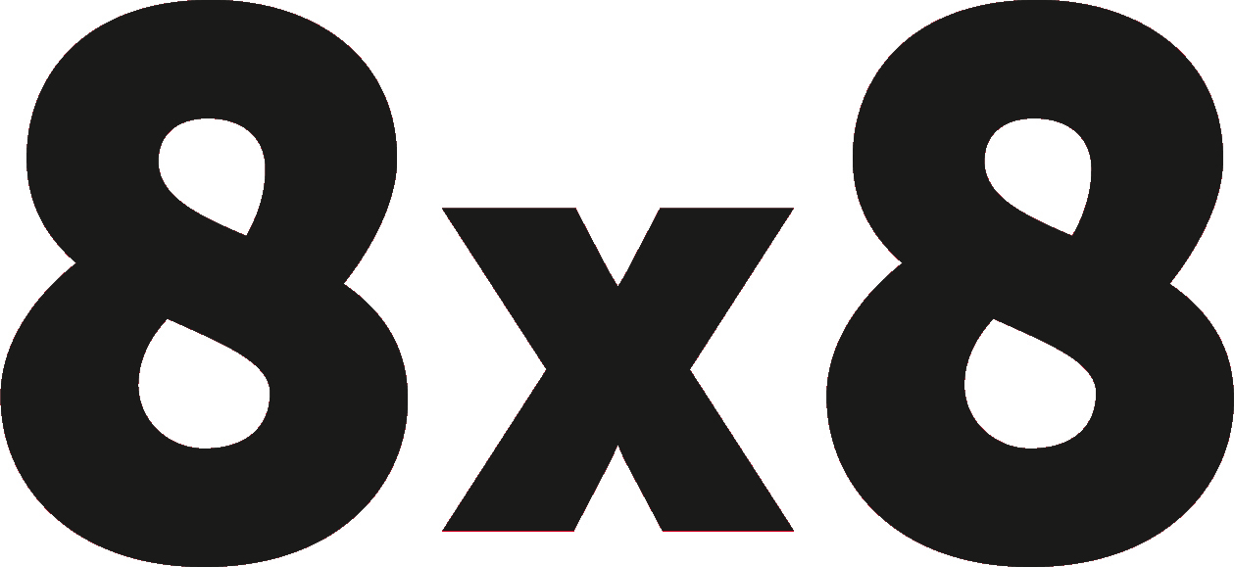
8x8, INC.
(Exact name of Registrant as Specified in its Charter)
Delaware |  |  |  |  |  | 77-0142404
(State or Other Jurisdiction of Incorporation or Organization) |  |  |  |  |  | (I.R.S. Employer Identification Number)
675 Creekside Way
Campbell, CA 95008
(Address of principal executive offices)
(408) 727-1885
(Registrant's telephone number, including area code)
8x8, Inc. Amended and Restated 2022 Equity Incentive Plan
8x8, Inc. Amended and Restated 2017 New Employee Inducement Incentive Plan

(Full Title of the Plans)

Laurence Denny
Secretary and Chief Legal Officer
8x8, Inc.
675 Creekside Way
Campbell, CA 95008
(Name and Address of Agent For Service)
(408) 727-1885
(Telephone Number, Including Area Code, of Agent For Service)

Indicate by check mark whether the registrant is a large accelerated filer, an accelerated filer, a non-accelerated filer, a smaller reporting company or an emerging growth company. See the definitions of “large accelerated filer,” “accelerated filer,” “smaller reporting company” and “emerging growth company” in Rule 12b-2 of the Exchange Act.

 |  |  | Large accelerated filer |  |  | ☐ |  |  |  |  |  | Accelerated filer |  |  | ☒
 |  |  | Non-accelerated filer |  |  | ☐ |  |  |  |  |  | Smaller reporting company |  |  | ☐
 |  |  |  |  |  |  |  |  |  |  |  | Emerging growth company |  |  | ☐
If an emerging growth company, indicate by check mark if the registrant has elected not to use the extended transition period for complying with any new or revised financial accounting standards provided pursuant to Section 7(a)(2)(B) of the Securities Act. ☐

INFORMATION REQUIRED PURSUANT
TO GENERAL INSTRUCTION E TO FORM S-8
Explanatory Note
This Registration Statement on Form S-8 (this "Registration Statement") is being filed by 8x8, Inc. (the “Registrant”) to register (i) an additional 8,338,000 shares of its common stock, $0.001 par value per share (the “Common Stock”), under the Registrant’s Amended and Restated 2022 Equity Incentive Plan (the “2022 Plan”), pursuant to an amendment to the 2022 Plan authorized and approved by the stockholders of the Registrant on August 3, 2026 and (ii) up to an additional 1,200,000 shares of Common Stock under the Registrant's Amended and Restated 2017 New Employee Inducement Incentive Plan.
This Registration Statement hereby incorporates by reference the contents of the Registrant’s applicable previous registration statements on Form S-8 filed with the Securities and Exchange Commission (the "SEC") (File Nos. 333-221290, 333-225388, 333-251489, 333-262510, 333-266171, 333-272218, 333-276829, 333-281756, 333-284709, and 333-289224). Collectively, all prior registration statements referenced above are referred to herein as the “Prior Registration Statements.”
This Registration Statement relates to securities of the same class as that to which the Prior Registration Statements relate and is submitted in accordance with Instruction E to Form S-8 regarding the registration of additional securities. Accordingly, the contents of the Prior Registration Statements are incorporated herein by reference and made part of this Registration Statement, except as amended hereby.
PART II
INFORMATION REQUIRED IN THE REGISTRATION STATEMENT
Item 3. Incorporation of Documents by Reference.
The following documents filed by the Registrant with the SEC are hereby incorporated by reference in this Registration Statement:
1.The Registrant’s Annual Report on Form 10-K for the fiscal year ended March 31, 2026, filed with the SEC on May 22, 2026, including the portions of the Registrant’s proxy statement for the 2026 annual meeting of stockholders, filed with the SEC on June 24, 2026, incorporated by reference in Part III of the 2026 Annual Report on Form 10-K;
2.The Registrant’s Current Reports on Form 8-K filed with the SEC on May 19, 2026, June 23, 2026, July 30, 2026, August 3, 2026, August 4, 2026 and August 6, 2026 (on Form 8-K/A) (but not any Item 2.02 or Exhibit 99.1 of such filings, which were furnished under applicable SEC rules rather than filed);
3.The Registrant's Quarterly Report on Form 10-Q for the quarter ended June 30, 2026, filed with the SEC on August 5, 2026; and
4.The description of the Registrant’s capital stock filed as Exhibit 4.1 to its Annual Report on Form 10-K for the fiscal year ended March 31, 2026, filed with the SEC on May 22, 2026.

In addition, all documents filed by the Registrant with the SEC pursuant to Sections 13(a), 13(c), 14 and 15(d) of the Securities Exchange Act of 1934, as amended, subsequent to the date of this Registration Statement and prior to the filing of a post-effective amendment, which indicates that all securities offered have been sold or which deregisters all of such securities then remaining unsold, are deemed to be incorporated by reference in this Registration Statement and to be a part hereof from the respective dates of filing of such documents. Any statement contained in this Registration Statement or in a document incorporated by reference shall be deemed modified or superseded to the extent that a statement contained in any subsequently filed document which also is or is deemed to be incorporated by reference herein or therein modifies or supersedes such statement. Any statement so modified or superseded shall not be deemed to constitute a part hereof, except as so modified or superseded.
Item 8. Exhibits.
 |  |  |  |  |  | Incorporated by Reference
Exhibit Number |  |  | Exhibit Description |  |  | Company Form |  |  | Filing Date |  |  | Exhibit Number |  |  | Filed Herewith
5.1 |  |  | Opinion of Skadden, Arps, Slate, Meagher & Flom LLP |  |  |  |  |  |  |  |  |  |  |  | X
10.1 |  |  | 8x8, Inc. Amended and Restated 2022 Equity Incentive Plan |  |  | 10-Q |  |  | 8/5/2026 |  |  | 10.1
10.2 |  |  | 8x8, Inc. Amended and Restated 2017 New Employee Inducement Incentive Plan |  |  | 10-Q |  |  | 8/5/2026 |  |  | 10.2
23.1 |  |  | Consent of Skadden, Arps, Slate, Meagher and Flom (included in Exhibit 5.1) |  |  |  |  |  |  |  |  |  |  |  | X
23.2 |  |  | Consent of Independent Registered Public Accounting Firm |  |  |  |  |  |  |  |  |  |  |  | X
23.3 |  |  | Consent of Independent Registered Public Accounting Firm |  |  |  |  |  |  |  |  |  |  |  | X
24.1 |  |  | Power of Attorney (included in signature page to this Registration Statement) |  |  |  |  |  |  |  |  |  |  |  | X
107 |  |  | Calculation of Filing Fee Table |  |  |  |  |  |  |  |  |  |  |  | X

- 2 -

SIGNATURES
Pursuant to the requirements of the Securities Act of 1933, as amended, the Registrant certifies that it has reasonable grounds to believe that it meets all of the requirements for filing on Form S-8 and has duly caused this Registration Statement to be signed on its behalf by the undersigned, thereunto duly authorized, in the city of Campbell, State of California, on the 11th day of August 2026.
8x8, Inc.
By: /s/ Samuel Wilson
Samuel Wilson
Chief Executive Officer

- 3 -

POWER OF ATTORNEY
KNOW ALL PERSONS BY THESE PRESENTS, that each person whose signature appears below hereby constitutes and appoints Samuel Wilson, Laurence Denny and Kevin Kraus, and each one of them, acting individually and without the other, as his or her true and lawful attorney-in-fact and agent, each with full power of substitution, for him and in his or her name, place and stead in any and all capacities, to sign any and all amendments to this Registration Statement (including post-effective amendments), and to file the same, with exhibits thereto and other documents in connection therewith, with the Securities and Exchange Commission, granting unto said attorneys-in-fact and agents, full power and authority to do and perform each and every act and thing requisite and necessary to be done, as fully to all intents and purposes as he or she might or could do in person, hereby ratifying and confirming all that each of said attorneys-in-fact or his substitute or substitutes may do or cause to be done by virtue hereof.
Pursuant to the requirements of the Securities Act of 1933, as amended, this Registration Statement has been signed by the following persons in the capacities and on the dates indicated.
Signature |  |  | Title |  |  | Date
/s/ Samuel Wilson  Samuel Wilson |  |  | Chief Executive Officer and Director  (Principal Executive Officer and Director) |  |  | August 11, 2026
/s/ Kevin Kraus  Kevin Kraus |  |  | Chief Financial Officer  (Principal Financial Officer) |  |  | August 11, 2026
/s/ Colleen Martin-Garcia  Colleen Martin-Garcia |  |  | Chief Accounting Officer  (Principal Accounting Officer) |  |  | August 11, 2026
/s/ Jaswinder Pal Singh  Jaswinder Pal Singh |  |  | Chairman and Director |  |  | August 11, 2026
/s/ Monique Bonner  Monique Bonner |  |  | Director |  |  | August 11, 2026
/s/ Andrew Burton  Andrew Burton |  |  | Director |  |  | August 11, 2026
/s/ Todd Ford  Todd Ford |  |  | Director |  |  | August 11, 2026
/s/ Alison Gleeson  Alison Gleeson |  |  | Director |  |  | August 11, 2026
/s/ John Pagliuca  John Pagliuca |  |  | Director |  |  | August 11, 2026
/s/ Elizabeth Theophille  Elizabeth Theophille |  |  | Director |  |  | August 11, 2026

- 4 -

CALCULATION OF FILING FEE TABLE
Form S-8
8x8, Inc.
Table 1 – Newly Registered Securities
Security Type |  |  | Security Class Title |  |  | Fee Calculation Rule |  |  | Amount Registered(1) |  |  | Proposed Maximum Offering Price Per Share |  |  | Maximum Aggregate Offering Price |  |  | Fee Rate |  |  | Amount of Registration Fee
Equity |  |  | Equity—Common |  |  | Other |  |  | 8,338,000(2) |  |  | $2.28(4) |  |  | $ | 19,010,640 |  | 0.0001381 |  |  | $ | 2,625.37
Equity |  |  | Equity—Common |  |  | Other |  |  | 1,200,000(3) |  |  | $2.28(4) |  |  | $ | 2,736,000 |  | 0.0001381 |  |  | $ | 377.84
Total Offering Amounts |  |  |  |  |  |  |  |  |  |  |  |  |  |  | $ | 21,746,640 |  |  |  |  | $ | 3,003.21
Total Fee Offsets |  |  |  |  |  |  |  |  |  |  |  |  |  |  |  |  |  |  |  |  | $ | —
Net Fee Due |  |  |  |  |  |  |  |  |  |  |  |  |  |  |  |  |  |  |  |  | $ | 3,003.21
(1) In addition, pursuant to Rule 416(a) under the Securities Act of 1933, as amended (the “Securities Act”), this Registration Statement also covers an indeterminate number of shares of common stock, par value $0.001 per share (“Common Stock”), of 8x8, Inc. (the “Registrant”) that may be offered or issued by reason of stock splits, stock dividends or similar transactions.
(2) Represents shares of Common Stock added to the 8x8, Inc. Amended and Restated 2022 Equity Incentive Plan (the “2022 Plan”) pursuant to an amendment to the 2022 Plan authorized and approved by the stockholders of the Registrant on August 3, 2026.
(3) Represents shares of Common Stock added to the 8x8, Inc. Amended and Restated 2017 New Employee Inducement Incentive Plan (the “2017 Plan”) pursuant to an amendment to the 2017 Plan authorized and approved by the Board of Directors of the Registrant on July 29, 2026.
(4) Estimated solely for purposes of calculating the amount of the registration fee pursuant to Rule 457(c) and (h) under the Securities Act. The computation is based upon the average of the high and low prices per share of the Registrant’s Common Stock as reported on the Nasdaq on August 6, 2026.
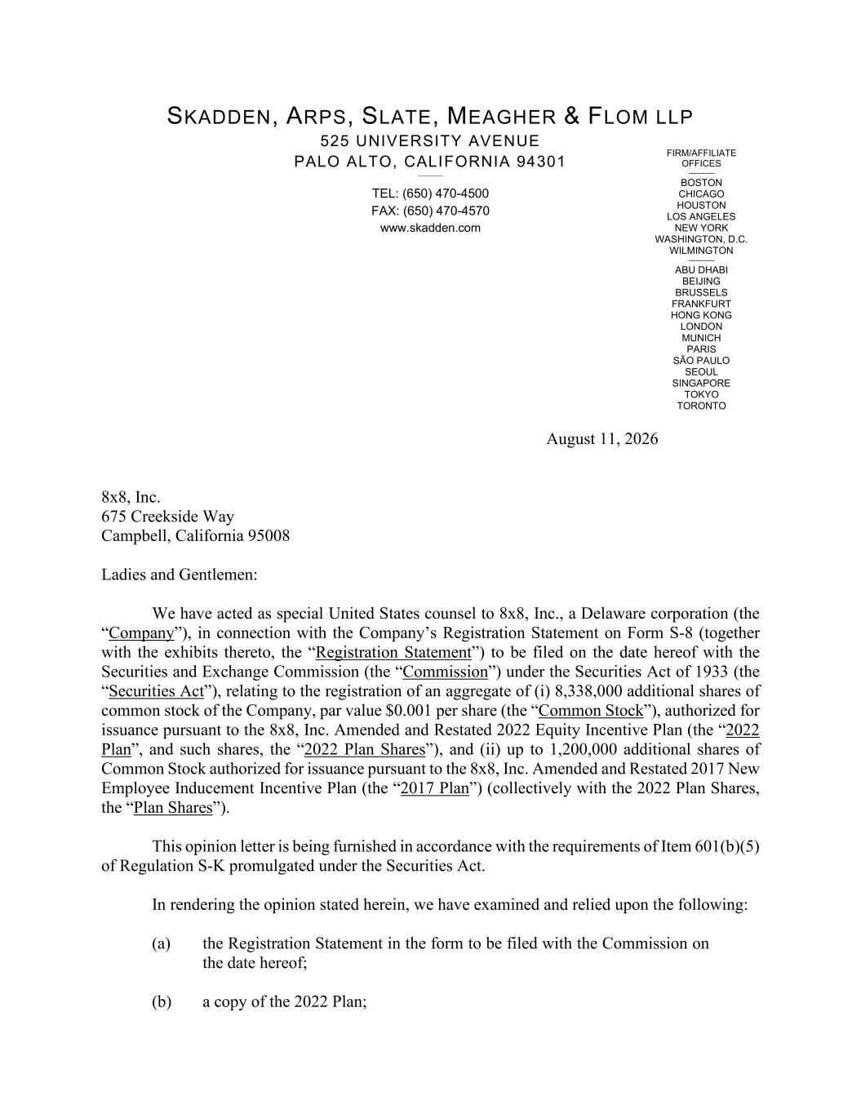

FIRM/AFFILIATE OFFICES ----------- BOSTON CHICAGO HOUSTON LOS ANGELES NEW YORK WASHINGTON, D.C. WILMINGTON ----------- ABU DHABI BEIJING BRUSSELS FRANKFURT HONG KONG LONDON MUNICH PARIS SÃO PAULO SEOUL SINGAPORE TOKYO TORONTO SKADDEN, ARPS, SLATE, MEAGHER & FLOM LLP 525 UNIVERSITY AVENUE PALO ALTO, CALIFORNIA 94301 ________ TEL: (650) 470-4500 FAX: (650) 470-4570 www.skadden.com August 11, 2026 8x8, Inc. 675 Creekside Way Campbell, California 95008 Ladies and Gentlemen: We have acted as special United States counsel to 8x8, Inc., a Delaware corporation (the “Company”), in connection with the Company’s Registration Statement on Form S-8 (together with the exhibits thereto, the “Registration Statement”) to be filed on the date hereof with the Securities and Exchange Commission (the “Commission”) under the Securities Act of 1933 (the “Securities Act”), relating to the registration of an aggregate of (i) 8,338,000 additional shares of common stock of the Company, par value $0.001 per share (the “Common Stock”), authorized for issuance pursuant to the 8x8, Inc. Amended and Restated 2022 Equity Incentive Plan (the “2022 Plan”, and such shares, the “2022 Plan Shares”), and (ii) up to 1,200,000 additional shares of Common Stock authorized for issuance pursuant to the 8x8, Inc. Amended and Restated 2017 New Employee Inducement Incentive Plan (the “2017 Plan”) (collectively with the 2022 Plan Shares, the “Plan Shares”). This opinion letter is being furnished in accordance with the requirements of Item 601(b)(5) of Regulation S-K promulgated under the Securities Act. In rendering the opinion stated herein, we have examined and relied upon the following: (a) the Registration Statement in the form to be filed with the Commission on the date hereof; (b) a copy of the 2022 Plan;

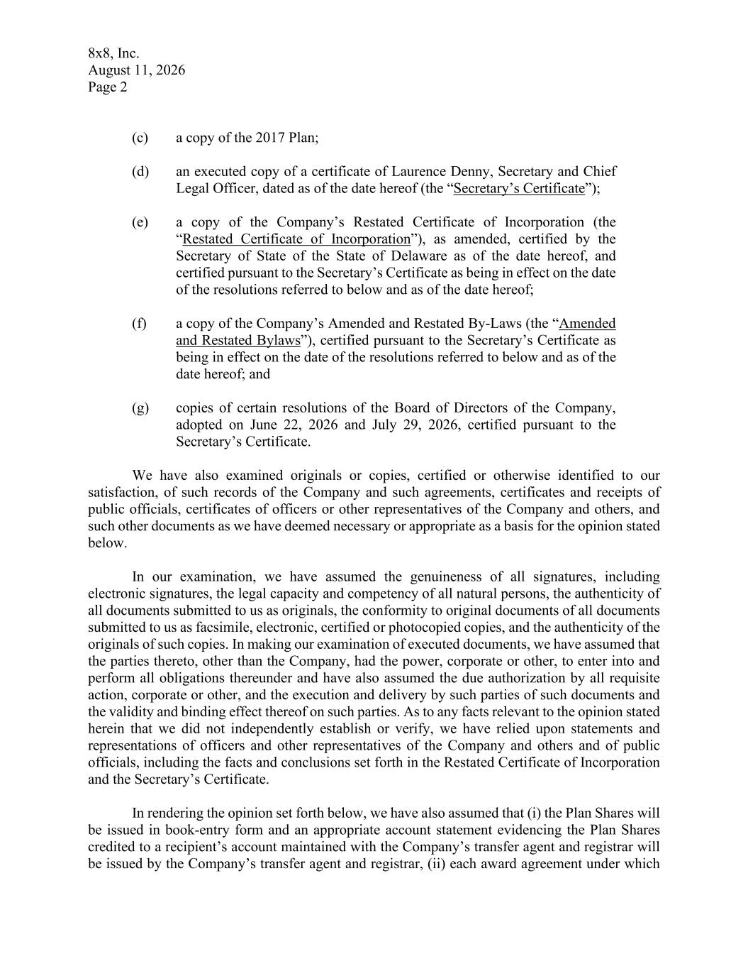
8x8, Inc. August 11, 2026 Page 2 (c) a copy of the 2017 Plan; (d) an executed copy of a certificate of Laurence Denny, Secretary and Chief Legal Officer, dated as of the date hereof (the “Secretary’s Certificate”); (e) a copy of the Company’s Restated Certificate of Incorporation (the “Restated Certificate of Incorporation”), as amended, certified by the Secretary of State of the State of Delaware as of the date hereof, and certified pursuant to the Secretary’s Certificate as being in effect on the date of the resolutions referred to below and as of the date hereof; (f) a copy of the Company’s Amended and Restated By-Laws (the “Amended and Restated Bylaws”), certified pursuant to the Secretary’s Certificate as being in effect on the date of the resolutions referred to below and as of the date hereof; and (g) copies of certain resolutions of the Board of Directors of the Company, adopted on June 22, 2026 and July 29, 2026, certified pursuant to the Secretary’s Certificate. We have also examined originals or copies, certified or otherwise identified to our satisfaction, of such records of the Company and such agreements, certificates and receipts of public officials, certificates of officers or other representatives of the Company and others, and such other documents as we have deemed necessary or appropriate as a basis for the opinion stated below. In our examination, we have assumed the genuineness of all signatures, including electronic signatures, the legal capacity and competency of all natural persons, the authenticity of all documents submitted to us as originals, the conformity to original documents of all documents submitted to us as facsimile, electronic, certified or photocopied copies, and the authenticity of the originals of such copies. In making our examination of executed documents, we have assumed that the parties thereto, other than the Company, had the power, corporate or other, to enter into and perform all obligations thereunder and have also assumed the due authorization by all requisite action, corporate or other, and the execution and delivery by such parties of such documents and the validity and binding effect thereof on such parties. As to any facts relevant to the opinion stated herein that we did not independently establish or verify, we have relied upon statements and representations of officers and other representatives of the Company and others and of public officials, including the facts and conclusions set forth in the Restated Certificate of Incorporation and the Secretary’s Certificate. In rendering the opinion set forth below, we have also assumed that (i) the Plan Shares will be issued in book-entry form and an appropriate account statement evidencing the Plan Shares credited to a recipient’s account maintained with the Company’s transfer agent and registrar will be issued by the Company’s transfer agent and registrar, (ii) each award agreement under which

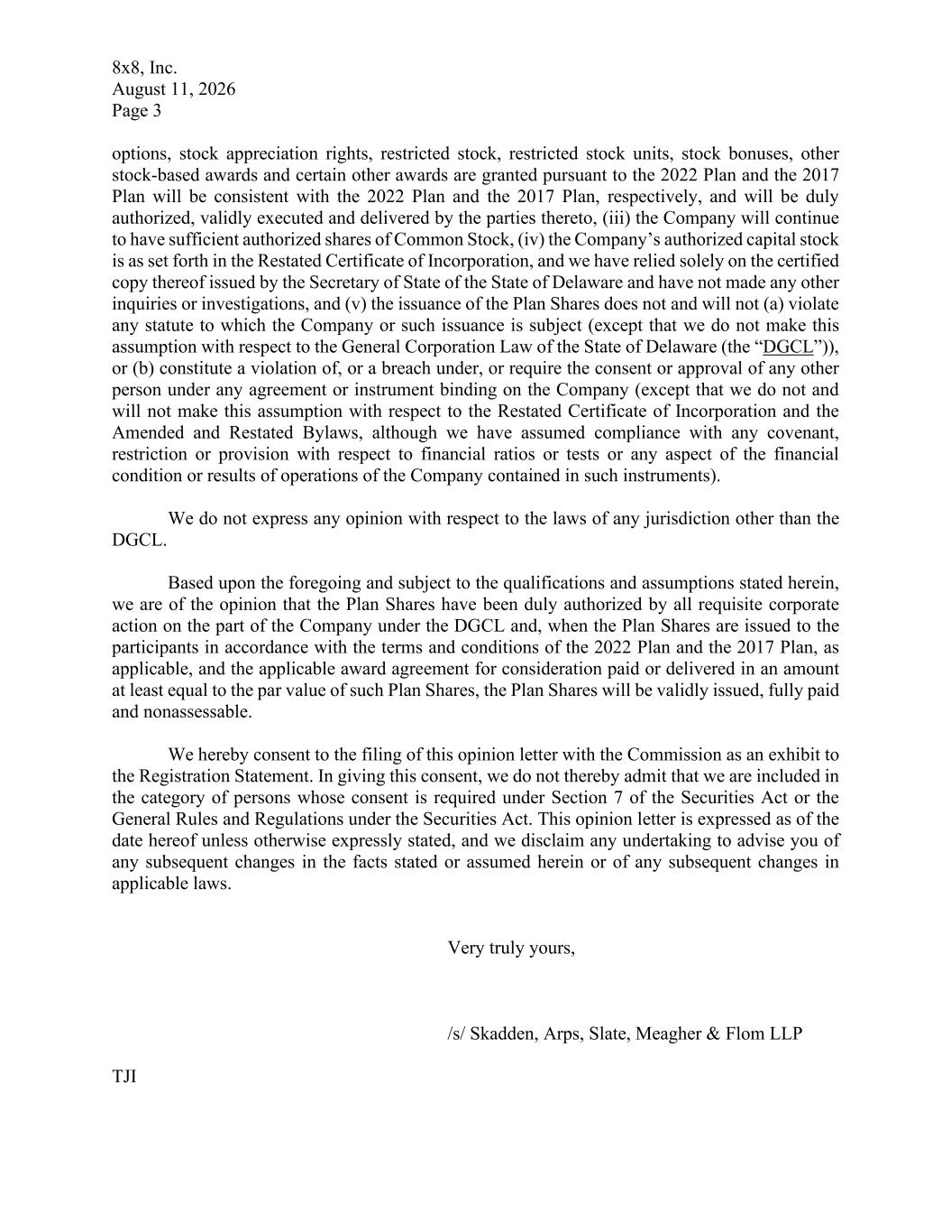
8x8, Inc. August 11, 2026 Page 3 options, stock appreciation rights, restricted stock, restricted stock units, stock bonuses, other stock-based awards and certain other awards are granted pursuant to the 2022 Plan and the 2017 Plan will be consistent with the 2022 Plan and the 2017 Plan, respectively, and will be duly authorized, validly executed and delivered by the parties thereto, (iii) the Company will continue to have sufficient authorized shares of Common Stock, (iv) the Company’s authorized capital stock is as set forth in the Restated Certificate of Incorporation, and we have relied solely on the certified copy thereof issued by the Secretary of State of the State of Delaware and have not made any other inquiries or investigations, and (v) the issuance of the Plan Shares does not and will not (a) violate any statute to which the Company or such issuance is subject (except that we do not make this assumption with respect to the General Corporation Law of the State of Delaware (the “DGCL”)), or (b) constitute a violation of, or a breach under, or require the consent or approval of any other person under any agreement or instrument binding on the Company (except that we do not and will not make this assumption with respect to the Restated Certificate of Incorporation and the Amended and Restated Bylaws, although we have assumed compliance with any covenant, restriction or provision with respect to financial ratios or tests or any aspect of the financial condition or results of operations of the Company contained in such instruments). We do not express any opinion with respect to the laws of any jurisdiction other than the DGCL. Based upon the foregoing and subject to the qualifications and assumptions stated herein, we are of the opinion that the Plan Shares have been duly authorized by all requisite corporate action on the part of the Company under the DGCL and, when the Plan Shares are issued to the participants in accordance with the terms and conditions of the 2022 Plan and the 2017 Plan, as applicable, and the applicable award agreement for consideration paid or delivered in an amount at least equal to the par value of such Plan Shares, the Plan Shares will be validly issued, fully paid and nonassessable. We hereby consent to the filing of this opinion letter with the Commission as an exhibit to the Registration Statement. In giving this consent, we do not thereby admit that we are included in the category of persons whose consent is required under Section 7 of the Securities Act or the General Rules and Regulations under the Securities Act. This opinion letter is expressed as of the date hereof unless otherwise expressly stated, and we disclaim any undertaking to advise you of any subsequent changes in the facts stated or assumed herein or of any subsequent changes in applicable laws. Very truly yours, /s/ Skadden, Arps, Slate, Meagher & Flom LLP TJI

Consent of Independent Registered Public Accounting Firm
We have issued our reports dated May 22, 2026 with respect to the consolidated financial statements and internal control over financial reporting of 8x8, Inc. included in the Annual Report on Form 10-K for the year ended March 31, 2026, which are incorporated by reference in this Registration Statement. We consent to the incorporation by reference of the aforementioned reports in this Registration Statement.

/s/ Grant Thornton LLP
Bellevue, Washington
August 11, 2026

Consent of Independent Registered Public Accounting Firm
We consent to the incorporation by reference in this Registration Statement on Form S-8 of 8x8, Inc. (the “Company”) of our report dated May 22, 2025, relating to the Company’s consolidated financial statements as of March 31, 2025, and for the years ended March 31, 2025 and 2024, appearing in the Annual Report on Form 10-K of the Company for the year ended March 31, 2026, filed with the Securities and Exchange Commission.

/s/ Baker Tilly US, LLP
San Jose, California
August 11, 2026

