Table of Contents
UNITED STATES
SECURITIES AND EXCHANGE COMMISSION
Washington, D.C. 20549
 |  |  | FORM |  |  | 10-Q
☒ QUARTERLY REPORT PURSUANT TO SECTION 13 OR 15(d) OF THE SECURITIES EXCHANGE ACT OF 1934
For the quarterly period ended December 31, 2023
or
☐ TRANSITION REPORT PURSUANT TO SECTION 13 OR 15(d) OF THE SECURITIES EXCHANGE ACT OF 1934
For the transition period from ________to _________
Commission file number: 001-38312
_________________

8x8, INC.
(Exact name of Registrant as Specified in its Charter)
_________________
Delaware |  |  |  |  |  | 77-0142404
(State or Other Jurisdiction of Incorporation or Organization) |  |  |  |  |  | (I.R.S. Employer Identification Number)
675 Creekside Way
Campbell, CA 95008
(Address of principal executive offices)
(408) 727-1885
(Registrant's telephone number, including area code)
_________________
Securities registered pursuant to Section 12(b) of the Act:
Title of each class |  |  | Trading Symbol |  |  | Name of each exchange on which registered
COMMON STOCK, PAR VALUE $0.001 PER SHARE |  |  | EGHT |  |  | Nasdaq Global Select Market
Indicate by check mark whether the registrant (1) has filed all reports required to be filed by Section 13 or 15 (d) of the Securities Exchange Act of 1934 during the preceding 12 months (or for such shorter period that the registrant was required to file reports), and (2) has been subject to such filing requirements for the past 90 days. ☒ Yes ☐ No
Indicate by check mark whether the registrant has submitted electronically every Interactive Data File required to be submitted pursuant to Rule 405 of Regulation S-T (§232.405 of this chapter) during the preceding 12 months (or for such shorter period that the registrant was required to submit such files). Yes ☒ No ☐
Indicate by check mark whether the registrant is a large accelerated filer, an accelerated filer, a non-accelerated filer, a smaller reporting company or an emerging growth company. See the definitions of "large accelerated filer," "accelerated filer," "smaller reporting company" and "emerging growth company" in Rule 12b-2 of the Exchange Act.
 |  |  | Large accelerated filer |  |  | ☐ |  |  |  |  |  | Accelerated filer |  |  | ☒
 |  |  | Non-accelerated filer |  |  | ☐ |  |  |  |  |  | Smaller reporting company |  |  | ☐
 |  |  |  |  |  |  |  |  |  |  |  | Emerging growth company |  |  | ☐
If an emerging growth company, indicate by check mark if the registrant has elected not to use the extended transition period for complying with any new or revised financial accounting standards provided pursuant to Section 13(a) of the Exchange Act. ☐
Indicate by check mark whether the registrant is a shell company (as defined in Rule 12b-2 of the Exchange Act). Yes ☐ No ☒
The number of shares of the Registrant's Common Stock outstanding as of January 24, 2024 was 123,421,417.

Table of Contents
8X8, INC.
INDEX TO QUARTERLY REPORT ON FORM 10-Q
FOR THE QUARTER ENDED DECEMBER 31, 2023
 |  |  | Page
Forward-Looking Statements and Risk Factors |  |  | 2
PART I. FINANCIAL INFORMATION |  |  | 3
Item 1. Financial Statements (unaudited): |  |  | 3
Condensed Consolidated Balance Sheets |  |  | 3
Condensed Consolidated Statements of Operations |  |  | 4
Condensed Consolidated Statements of Comprehensive Loss |  |  | 5
Condensed Consolidated Statements of Stockholders' Equity |  |  | 6
Condensed Consolidated Statements of Cash Flows |  |  | 8
Notes to Unaudited Condensed Consolidated Financial Statements |  |  | 10
Item 2. Management's Discussion and Analysis of Financial Condition and Results of Operations |  |  | 19
Item 3. Quantitative and Qualitative Disclosures About Market Risk |  |  | 28
Item 4. Controls and Procedures |  |  | 29
PART II. OTHER INFORMATION |  |  | 30
Item 1. Legal Proceedings |  |  | 30
Item 1A. Risk Factors |  |  | 30
Item 2. Unregistered Sales of Equity Securities and Use of Proceeds |  |  | 30
Item 3. Defaults Upon Senior Securities |  |  | 30
Item 4. Mine Safety Disclosures |  |  | 30
Item 5. Other Information |  |  | 30
Item 6. Exhibits |  |  | 30
Signature |  |  | 31

1
Table of Contents
Forward-Looking Statements and Risk Factors
Statements contained in this quarterly report on Form 10-Q, or this "Quarterly Report," regarding our expectations, beliefs, estimates, intentions or strategies are forward-looking statements within the meaning of Section 27A of the Securities Act of 1933 (the "Securities Act") and Section 21E of the Securities Exchange Act of 1934, as amended (the "Exchange Act"). Any statements contained herein that are not statements of historical fact may be deemed to be forward-looking statements. For example, words such as "may," "will," "should," "estimates," "predicts," "potential," "continue," "strategy," "believes," "anticipates," "plans," "expects," "intends," and similar expressions are intended to identify forward-looking statements. These forward-looking statements include, but are not limited to, statements regarding: industry trends; our number of customers; service revenue; cost of service revenue; research and development expenses; reducing unit costs and improving gross profit margin, or driving sustainable growth and increasing profitability and cash flow; new debt and interest expense; hiring of employees; sales and marketing expenses; general and administrative expenses in future periods; and the impact of foreign currency exchange rate and interest rate fluctuations. You should not place undue reliance on these forward-looking statements. Actual results and trends may differ materially from historical results and those projected in any such forward-looking statements depending on a variety of factors. These factors include, but are not limited to:
•the impact of economic downturns on us and our customers;
•the impact of cost increases and general inflationary pressures, as well as supply chain shortages and disruptions, on our operating expenses;
•customer cancellations and rate of customer churn;
•ongoing volatility and conflict in the political and economic environment, including Russia’s invasion of Ukraine and any macro-economic impact that it may have;
•customer acceptance and demand for our new and existing cloud communication and collaboration services and features, including voice, contact center, video, messaging, and communication application programming interfaces;
•competitive market pressures, and any changes in the competitive dynamics of the markets in which we compete;
•the quality and reliability of our services;
•our ability to scale our business;
•customer acquisition costs;
•our reliance on a network of channel partners to provide substantial new customer demand;
•timing and extent of improvements in operating results from increased spending in marketing, sales, and research and development;
•the amount and timing of costs associated with recruiting, training, and integrating new employees and retaining existing employees;
•our reliance on infrastructure of third-party network service providers;
•risk of failure in our physical infrastructure;
•risk of defects or bugs in our software;
•risk of cybersecurity breaches;
•our ability to maintain the compatibility of our software with third-party applications and mobile platforms;
•continued compliance with industry standards and regulatory and privacy requirements, globally;
•introduction and adoption of our cloud software solutions in markets outside of the United States;
•risks that any reduction in spending may not achieve the desired result or may result in a reduction in revenue;
•risks relating to the acquisition and integration of businesses we have acquired or may acquire in the future, including most recently, Fuze, Inc.;
•risks related to the fluctuations in the value of the United States Dollar and other currencies that underlie our business transactions;
•risks related to our substantial amount of indebtedness, which could have important consequences to our business;
•potential future intellectual property infringement claims and other litigation that could adversely impact our business and operating results; and
•the current instability in the banking system, which could adversely impact our operations and operating results.
Please refer to the "Risk Factors" section of our annual report on Form 10-K for the fiscal year ended March 31, 2023 (the "Form 10-K") and subsequent Securities and Exchange Commission ("SEC") filings for additional factors that could materially affect our financial performance. All forward-looking statements included in this Quarterly Report are based on information available to us on the date hereof, and we assume no obligation to update any such forward-looking statements. Readers are urged to carefully review and consider the various disclosures made in this Quarterly Report, which attempts to advise interested parties of the risks and factors that may affect our business, financial condition, results of operations and prospects.
Our fiscal year ends on March 31 of each calendar year. Each reference to a fiscal year in this Quarterly Report refers to the fiscal year ended March 31 of the calendar year indicated (for example, fiscal 2024 refers to the fiscal year ended March 31, 2024). Unless the context requires otherwise, references to "we," "us," "our," "8x8," and the "Company" refer to 8x8, Inc. and its consolidated subsidiaries.

2
Table of Contents
PART I. FINANCIAL INFORMATION

ITEM 1. Financial Statements

8X8, INC.
CONDENSED CONSOLIDATED BALANCE SHEETS
(Unaudited, in thousands, except share and per share amounts)
 |  |  | December 31, 2023 |  |  |  |  |  | March 31, 2023
ASSETS
Current assets:
Cash and cash equivalents |  |  | $ | 168,513 |  |  |  |  | $ | 111,400
Restricted cash, current |  |  | 356 |  |  |  |  |  | 511
Short-term investments |  |  | 1,035 |  |  |  |  |  | 26,228
Accounts receivable, net of allowance for expected credit losses of $2,723 and $3,644  as of December 31, 2023 and March 31, 2023, respectively |  |  | 63,042 |  |  |  |  |  | 62,307
Deferred sales commission costs, current |  |  | 36,996 |  |  |  |  |  | 38,048
Other current assets |  |  | 32,528 |  |  |  |  |  | 34,630
Total current assets |  |  | 302,470 |  |  |  |  |  | 273,124
Property and equipment, net |  |  | 55,661 |  |  |  |  |  | 57,871
Operating lease, right-of-use assets |  |  | 38,546 |  |  |  |  |  | 52,444
Intangible assets, net |  |  | 91,816 |  |  |  |  |  | 107,112
Goodwill |  |  | 267,453 |  |  |  |  |  | 266,863
Restricted cash, non-current |  |  | 462 |  |  |  |  |  | 818
Deferred sales commission costs, non-current |  |  | 56,317 |  |  |  |  |  | 67,644
Other assets, non-current |  |  | 13,993 |  |  |  |  |  | 15,934
Total assets |  |  | $ | 826,718 |  |  |  |  | $ | 841,810
LIABILITIES AND STOCKHOLDERS' EQUITY
Current liabilities:
Accounts payable |  |  | $ | 49,493 |  |  |  |  | $ | 46,802
Accrued compensation |  |  | 20,573 |  |  |  |  |  | 29,614
Accrued taxes |  |  | 37,781 |  |  |  |  |  | 29,570
Operating lease liabilities, current |  |  | 11,763 |  |  |  |  |  | 11,504
Deferred revenue, current |  |  | 32,778 |  |  |  |  |  | 34,909
Convertible senior notes, current |  |  | 63,260 |  |  |  |  |  | 62,932
Other accrued liabilities |  |  | 14,878 |  |  |  |  |  | 14,556
Total current liabilities |  |  | 230,526 |  |  |  |  |  | 229,887
Operating lease liabilities, non-current |  |  | 59,417 |  |  |  |  |  | 65,623
Deferred revenue, non-current |  |  | 10,128 |  |  |  |  |  | 10,615
Convertible senior notes |  |  | 197,561 |  |  |  |  |  | 196,821
Term loan |  |  | 211,092 |  |  |  |  |  | 231,993
Other liabilities, non-current |  |  | 8,322 |  |  |  |  |  | 6,965
Total liabilities |  |  | 717,046 |  |  |  |  |  | 741,904
Commitments and contingencies (Note 5)
Stockholders' equity:
Preferred stock: $0.001 par value, 5,000,000 shares authorized, none issued and  outstanding as of December 31, 2023 and March 31, 2023 |  |  | — |  |  |  |  |  | —
Common stock: $0.001 par value, 300,000,000 shares authorized, 123,219,383 shares and 114,659,255 shares issued and outstanding as of December 31, 2023 and March 31, 2023, respectively |  |  | 123 |  |  |  |  |  | 115
Additional paid-in capital |  |  | 956,005 |  |  |  |  |  | 905,635
Accumulated other comprehensive loss |  |  | (9,538) |  |  |  |  |  | (12,927)
Accumulated deficit |  |  | (836,918) |  |  |  |  |  | (792,917)
Total stockholders' equity |  |  | 109,672 |  |  |  |  |  | 99,906
Total liabilities and stockholders' equity |  |  | $ | 826,718 |  |  |  |  | $ | 841,810

The accompanying notes are an integral part of these unaudited condensed consolidated financial statements.
3
Table of Contents
8X8, INC.
CONDENSED CONSOLIDATED STATEMENTS OF OPERATIONS
(Unaudited, in thousands except per share amounts)
 |  |  | Three Months Ended December 31, |  |  |  |  |  |  |  |  |  |  |  | Nine Months Ended December 31,
 |  |  | 2023 |  |  |  |  |  | 2022 |  |  |  |  |  | 2023 |  |  |  |  |  | 2022
Service revenue |  |  | $ | 175,069 |  |  |  |  | $ | 175,765 |  |  |  |  | $ | 528,089 |  |  |  |  | $ | 533,482
Other revenue |  |  | 5,937 |  |  |  |  |  | 8,635 |  |  |  |  |  | 21,203 |  |  |  |  |  | 25,927
Total revenue |  |  | 181,006 |  |  |  |  |  | 184,400 |  |  |  |  |  | 549,292 |  |  |  |  |  | 559,409
Operating expenses:
Cost of service revenue |  |  | 48,983 |  |  |  |  |  | 47,335 |  |  |  |  |  | 144,403 |  |  |  |  |  | 151,920
Cost of other revenue |  |  | 7,177 |  |  |  |  |  | 10,176 |  |  |  |  |  | 23,533 |  |  |  |  |  | 34,302
Research and development |  |  | 32,787 |  |  |  |  |  | 35,062 |  |  |  |  |  | 102,286 |  |  |  |  |  | 106,036
Sales and marketing |  |  | 66,997 |  |  |  |  |  | 79,021 |  |  |  |  |  | 204,189 |  |  |  |  |  | 243,035
General and administrative |  |  | 23,419 |  |  |  |  |  | 27,158 |  |  |  |  |  | 77,231 |  |  |  |  |  | 87,788
Impairment of long-lived assets |  |  | 11,034 |  |  |  |  |  | 3,729 |  |  |  |  |  | 11,034 |  |  |  |  |  | 6,153
Total operating expenses |  |  | 190,397 |  |  |  |  |  | 202,481 |  |  |  |  |  | 562,676 |  |  |  |  |  | 629,234
Loss from operations |  |  | (9,391) |  |  |  |  |  | (18,081) |  |  |  |  |  | (13,384) |  |  |  |  |  | (69,825)
Other (expense) income, net |  |  | (11,310) |  |  |  |  |  | (7,912) |  |  |  |  |  | (29,041) |  |  |  |  |  | 7,154
Loss before provision for income taxes |  |  | (20,701) |  |  |  |  |  | (25,993) |  |  |  |  |  | (42,425) |  |  |  |  |  | (62,671)
Provision for income taxes |  |  | 521 |  |  |  |  |  | 37 |  |  |  |  |  | 1,576 |  |  |  |  |  | 1,041
Net loss |  |  | $ | (21,222) |  |  |  |  | $ | (26,030) |  |  |  |  | $ | (44,001) |  |  |  |  | $ | (63,712)
Net loss per share:
Basic and diluted |  |  | $ | (0.17) |  |  |  |  | $ | (0.23) |  |  |  |  | $ | (0.37) |  |  |  |  | $ | (0.55)
Weighted average number of shares:
Basic and diluted |  |  | 122,556 |  |  |  |  |  | 113,201 |  |  |  |  |  | 120,042 |  |  |  |  |  | 116,298
OTHER (EXPENSE) INCOME, NET DETAILS
(Unaudited, in thousands)
 |  |  | Three Months Ended December 31, |  |  |  |  |  |  |  |  |  |  |  | Nine Months Ended December 31,
 |  |  | 2023 |  |  |  |  |  | 2022 |  |  |  |  |  | 2023 |  |  |  |  |  | 2022
Interest expense |  |  | $ | (8,878) |  |  |  |  | $ | (7,607) |  |  |  |  | $ | (26,777) |  |  |  |  | $ | (13,115)
Amortization of debt discount and issuance costs |  |  | (1,157) |  |  |  |  |  | (1,136) |  |  |  |  |  | (3,397) |  |  |  |  |  | (3,136)
Gain (loss) on warrants remeasurement |  |  | (1,297) |  |  |  |  |  | (771) |  |  |  |  |  | 1,234 |  |  |  |  |  | 522
Gain (loss) on debt extinguishment |  |  | — |  |  |  |  |  | 2,144 |  |  |  |  |  | (1,766) |  |  |  |  |  | 18,250
Gain on sale of assets |  |  | — |  |  |  |  |  | 1,757 |  |  |  |  |  | — |  |  |  |  |  | 1,826
Gain (loss) on foreign exchange |  |  | (1,841) |  |  |  |  |  | (2,616) |  |  |  |  |  | (1,080) |  |  |  |  |  | 1,984
Other income |  |  | 1,863 |  |  |  |  |  | 317 |  |  |  |  |  | 2,745 |  |  |  |  |  | 823
Other (expense) income, net |  |  | $ | (11,310) |  |  |  |  | $ | (7,912) |  |  |  |  | $ | (29,041) |  |  |  |  | $ | 7,154

The accompanying notes are an integral part of these unaudited condensed consolidated financial statements.
4
Table of Contents
8X8, INC.
CONDENSED CONSOLIDATED STATEMENTS OF COMPREHENSIVE LOSS
(Unaudited, in thousands)
 |  |  | Three Months Ended December 31, |  |  |  |  |  |  |  |  |  |  |  | Nine Months Ended December 31,
 |  |  | 2023 |  |  |  |  |  | 2022 |  |  |  |  |  | 2023 |  |  |  |  |  | 2022
Net loss |  |  | $ | (21,222) |  |  |  |  | $ | (26,030) |  |  |  |  | $ | (44,001) |  |  |  |  | $ | (63,712)
Other comprehensive income (loss), net of tax
Unrealized gain (loss) on investments in securities |  |  | (16) |  |  |  |  |  | (31) |  |  |  |  |  | 281 |  |  |  |  |  | (130)
Foreign currency translation adjustment |  |  | 5,987 |  |  |  |  |  | 10,244 |  |  |  |  |  | 3,108 |  |  |  |  |  | (6,688)
Comprehensive loss |  |  | $ | (15,251) |  |  |  |  | $ | (15,817) |  |  |  |  | $ | (40,612) |  |  |  |  | $ | (70,530)

The accompanying notes are an integral part of these unaudited condensed consolidated financial statements.
5
Table of Contents
8X8, INC.
CONDENSED CONSOLIDATED STATEMENTS OF STOCKHOLDERS' EQUITY
(Unaudited, in thousands)
 |  |  | Common Stock |  |  |  |  |  |  |  |  |  |  |  | Additional  Paid-in  Capital |  |  |  |  |  | Accumulated  Other  Comprehensive  Loss |  |  |  |  |  | Accumulated  Deficit |  |  |  |  |  | Total
 |  |  | Shares |  |  |  |  |  | Amount
Balance as of March 31, 2023 |  |  | 114,659 |  |  |  |  |  | $ | 115 |  |  |  |  | $ | 905,635 |  |  |  |  | $ | (12,927) |  |  |  |  | $ | (792,917) |  |  |  |  | $ | 99,906
Issuance of common stock under stock plans,  less withholding |  |  | 3,535 |  |  |  |  |  | 3 |  |  |  |  |  | (3) |  |  |  |  |  | — |  |  |  |  |  | — |  |  |  |  |  | —
Stock-based compensation expense |  |  | — |  |  |  |  |  | — |  |  |  |  |  | 18,559 |  |  |  |  |  | — |  |  |  |  |  | — |  |  |  |  |  | 18,559
Issuance of common stock under stock plans, less withholding, related to Fuze acquisition |  |  | 1,038 |  |  |  |  |  | 1 |  |  |  |  |  | (1) |  |  |  |  |  | — |  |  |  |  |  | — |  |  |  |  |  | —
Unrealized investment gain |  |  | — |  |  |  |  |  | — |  |  |  |  |  | — |  |  |  |  |  | 290 |  |  |  |  |  | — |  |  |  |  |  | 290
Foreign currency translation adjustment |  |  | — |  |  |  |  |  | — |  |  |  |  |  | — |  |  |  |  |  | 1,441 |  |  |  |  |  | — |  |  |  |  |  | 1,441
Net loss |  |  | — |  |  |  |  |  | — |  |  |  |  |  | — |  |  |  |  |  | — |  |  |  |  |  | (15,327) |  |  |  |  |  | (15,327)
Balance as of June 30, 2023 |  |  | 119,232 |  |  |  |  |  | $ | 119 |  |  |  |  | $ | 924,190 |  |  |  |  | $ | (11,196) |  |  |  |  | $ | (808,244) |  |  |  |  | $ | 104,869
Issuance of common stock under stock plans,  less withholding |  |  | 1,784 |  |  |  |  |  | 2 |  |  |  |  |  | (2) |  |  |  |  |  | — |  |  |  |  |  | — |  |  |  |  |  | —
ESPP share issuance |  |  | 843 |  |  |  |  |  | 1 |  |  |  |  |  | 2,365 |  |  |  |  |  |  |  |  |  |  |  |  |  |  |  |  |  | 2,366
Stock-based compensation expense |  |  | — |  |  |  |  |  | — |  |  |  |  |  | 14,940 |  |  |  |  |  | — |  |  |  |  |  | — |  |  |  |  |  | 14,940
Unrealized investment gain |  |  | — |  |  |  |  |  | — |  |  |  |  |  | — |  |  |  |  |  | 7 |  |  |  |  |  | — |  |  |  |  |  | 7
Foreign currency translation adjustment |  |  | — |  |  |  |  |  | — |  |  |  |  |  | — |  |  |  |  |  | (4,320) |  |  |  |  |  | — |  |  |  |  |  | (4,320)
Net loss |  |  | — |  |  |  |  |  | — |  |  |  |  |  | — |  |  |  |  |  | — |  |  |  |  |  | (7,452) |  |  |  |  |  | (7,452)
Balance as of September 30, 2023 |  |  | 121,859 |  |  |  |  |  | $ | 122 |  |  |  |  | $ | 941,493 |  |  |  |  | $ | (15,509) |  |  |  |  | $ | (815,696) |  |  |  |  | $ | 110,410
Issuance of common stock under stock plans,  less withholding |  |  | 1,361 |  |  |  |  |  | 1 |  |  |  |  |  | (1) |  |  |  |  |  | — |  |  |  |  |  | — |  |  |  |  |  | —
Stock-based compensation expense |  |  |  |  |  |  |  |  |  |  |  |  |  |  | 14,513 |  |  |  |  |  | — |  |  |  |  |  | — |  |  |  |  |  | 14,513
Unrealized investment loss |  |  | — |  |  |  |  |  | — |  |  |  |  |  | — |  |  |  |  |  | (16) |  |  |  |  |  | — |  |  |  |  |  | (16)
Foreign currency translation adjustment |  |  | — |  |  |  |  |  | — |  |  |  |  |  | — |  |  |  |  |  | 5,987 |  |  |  |  |  | — |  |  |  |  |  | 5,987
Net loss |  |  | — |  |  |  |  |  | — |  |  |  |  |  | — |  |  |  |  |  | — |  |  |  |  |  | (21,222) |  |  |  |  |  | (21,222)
Balance as of December 31, 2023 |  |  | 123,220 |  |  |  |  |  | $ | 123 |  |  |  |  | $ | 956,005 |  |  |  |  | $ | (9,538) |  |  |  |  | $ | (836,918) |  |  |  |  | $ | 109,672
The accompanying notes are an integral part of these unaudited condensed consolidated financial statements.
6
Table of Contents
 |  |  | Common Stock |  |  |  |  |  |  |  |  |  |  |  | Additional  Paid-in  Capital |  |  |  |  |  | Accumulated  Other  Comprehensive  Loss |  |  |  |  |  | Accumulated  Deficit |  |  |  |  |  | Total
 |  |  | Shares |  |  |  |  |  | Amount
Balance as of March 31, 2022 |  |  | 117,863 |  |  |  |  |  | $ | 118 |  |  |  |  | $ | 956,599 |  |  |  |  | $ | (7,913) |  |  |  |  | $ | (766,438) |  |  |  |  | $ | 182,366
Adjustment related to adoption of ASU 2020-06 |  |  | — |  |  |  |  |  | — |  |  |  |  |  | (92,832) |  |  |  |  |  | — |  |  |  |  |  | 46,672 |  |  |  |  |  | (46,160)
Issuance of common stock under stock plans, less withholding |  |  | 1,796 |  |  |  |  |  | 2 |  |  |  |  |  | 63 |  |  |  |  |  | — |  |  |  |  |  | — |  |  |  |  |  | 65
Stock-based compensation expense |  |  | — |  |  |  |  |  | — |  |  |  |  |  | 31,807 |  |  |  |  |  | — |  |  |  |  |  | — |  |  |  |  |  | 31,807
Unrealized investment loss |  |  | — |  |  |  |  |  | — |  |  |  |  |  | — |  |  |  |  |  | (94) |  |  |  |  |  | — |  |  |  |  |  | (94)
Foreign currency translation adjustment |  |  | — |  |  |  |  |  | — |  |  |  |  |  | (35) |  |  |  |  |  | (8,384) |  |  |  |  |  | — |  |  |  |  |  | (8,419)
Net loss |  |  | — |  |  |  |  |  | — |  |  |  |  |  | — |  |  |  |  |  | — |  |  |  |  |  | (26,043) |  |  |  |  |  | (26,043)
Balance as of June 30, 2022 |  |  | 119,659 |  |  |  |  |  | $ | 120 |  |  |  |  | $ | 895,602 |  |  |  |  | $ | (16,391) |  |  |  |  | $ | (745,809) |  |  |  |  | $ | 133,522
Issuance of common stock under stock plans,  less withholding |  |  | 1,047 |  |  |  |  |  | 1 |  |  |  |  |  | (1) |  |  |  |  |  | — |  |  |  |  |  | — |  |  |  |  |  | —
ESPP share issuance |  |  | 419 |  |  |  |  |  |  |  |  |  |  |  | 1,648 |  |  |  |  |  |  |  |  |  |  |  |  |  |  |  |  |  | 1,648
Stock-based compensation expense |  |  | — |  |  |  |  |  | — |  |  |  |  |  | 24,936 |  |  |  |  |  | — |  |  |  |  |  | — |  |  |  |  |  | 24,936
Shares repurchase |  |  | (10,695) |  |  |  |  |  | (11) |  |  |  |  |  | (60,203) |  |  |  |  |  | — |  |  |  |  |  | — |  |  |  |  |  | (60,214)
Shares issued for debt issuance |  |  | 1,015 |  |  |  |  |  | 1 |  |  |  |  |  | 5,081 |  |  |  |  |  | — |  |  |  |  |  | — |  |  |  |  |  | 5,082
Unrealized investment loss |  |  |  |  |  |  |  |  |  |  |  |  |  |  |  |  |  |  |  |  | (5) |  |  |  |  |  |  |  |  |  |  |  | (5)
Foreign currency translation adjustment |  |  | — |  |  |  |  |  | — |  |  |  |  |  | — |  |  |  |  |  | (8,548) |  |  |  |  |  | — |  |  |  |  |  | (8,548)
Net loss |  |  | — |  |  |  |  |  | — |  |  |  |  |  | — |  |  |  |  |  | — |  |  |  |  |  | (11,639) |  |  |  |  |  | (11,639)
Balance as of September 30, 2022 |  |  | 111,445 |  |  |  |  |  | $ | 111 |  |  |  |  | $ | 867,063 |  |  |  |  | $ | (24,944) |  |  |  |  | $ | (757,448) |  |  |  |  | $ | 84,782
Issuance of common stock under stock plans,  less withholding |  |  | 1,390 |  |  |  |  |  | 2 |  |  |  |  |  | (1) |  |  |  |  |  | — |  |  |  |  |  | — |  |  |  |  |  | 1
Stock-based compensation |  |  | — |  |  |  |  |  | — |  |  |  |  |  | 21,061 |  |  |  |  |  | — |  |  |  |  |  | — |  |  |  |  |  | 21,061
Unrealized investment loss |  |  | — |  |  |  |  |  | — |  |  |  |  |  | — |  |  |  |  |  | (31) |  |  |  |  |  | — |  |  |  |  |  | (31)
Foreign currency translation adjustment |  |  | — |  |  |  |  |  | — |  |  |  |  |  | — |  |  |  |  |  | 10,244 |  |  |  |  |  | — |  |  |  |  |  | 10,244
Net loss |  |  | — |  |  |  |  |  | — |  |  |  |  |  | — |  |  |  |  |  | — |  |  |  |  |  | (26,030) |  |  |  |  |  | (26,030)
Balance as of December 31, 2022 |  |  | 112,835 |  |  |  |  |  | $ | 113 |  |  |  |  | $ | 888,123 |  |  |  |  | $ | (14,731) |  |  |  |  | $ | (783,478) |  |  |  |  | $ | 90,027

The accompanying notes are an integral part of these unaudited condensed consolidated financial statements.
7
Table of Contents
8X8, INC.
CONDENSED CONSOLIDATED STATEMENTS OF CASH FLOWS
(Unaudited, in thousands)
 |  |  | Nine Months Ended December 31,
 |  |  | 2023 |  |  |  |  |  | 2022
Cash flows from operating activities:
Net loss |  |  | $ | (44,001) |  |  |  |  | $ | (63,712)
Adjustments to reconcile net loss to net cash provided by operating activities:
Depreciation |  |  | 6,133 |  |  |  |  |  | 8,056
Amortization of intangible assets |  |  | 15,296 |  |  |  |  |  | 15,954
Amortization of capitalized internal-use software costs |  |  | 14,418 |  |  |  |  |  | 16,397
Impairment of capitalized software |  |  | — |  |  |  |  |  | 3,729
Amortization of debt discount and issuance costs |  |  | 3,397 |  |  |  |  |  | 3,136
Amortization of deferred sales commission costs |  |  | 30,150 |  |  |  |  |  | 28,533
Allowance for credit losses |  |  | 1,663 |  |  |  |  |  | 1,984
Operating lease expense, net of accretion |  |  | 8,057 |  |  |  |  |  | 8,667
Impairment of right-of-use assets |  |  | 11,034 |  |  |  |  |  | 2,424
Stock-based compensation expense |  |  | 46,835 |  |  |  |  |  | 73,516
Loss (gain) on debt extinguishment |  |  | 1,766 |  |  |  |  |  | (18,250)
Gain on remeasurement of warrants |  |  | (1,234) |  |  |  |  |  | (522)
Gain on sale of assets |  |  | — |  |  |  |  |  | (1,826)
Other |  |  | (570) |  |  |  |  |  | (65)
Changes in assets and liabilities:
Accounts receivable |  |  | (2,188) |  |  |  |  |  | (236)
Deferred sales commission costs |  |  | (17,095) |  |  |  |  |  | (23,473)
Other current and non-current assets |  |  | (586) |  |  |  |  |  | 4,715
Accounts payable and accruals |  |  | (4,471) |  |  |  |  |  | (22,858)
Deferred revenue |  |  | (2,272) |  |  |  |  |  | (1,005)
Net cash provided by operating activities |  |  | 66,332 |  |  |  |  |  | 35,164
Cash flows from investing activities:
Purchases of property and equipment |  |  | (2,341) |  |  |  |  |  | (2,685)
Proceeds from sale of intangible assets |  |  | — |  |  |  |  |  | 1,000
Capitalized internal-use software costs |  |  | (10,913) |  |  |  |  |  | (6,768)
Purchases of investments |  |  | (6,174) |  |  |  |  |  | (42,899)
Sales of investments |  |  | — |  |  |  |  |  | 8,296
Maturities of investments |  |  | 31,659 |  |  |  |  |  | 44,739
Acquisition of businesses, net of cash acquired |  |  | — |  |  |  |  |  | (1,250)
Net cash provided by investing activities |  |  | 12,231 |  |  |  |  |  | 433
Cash flows from financing activities:
Proceeds from issuance of common stock under employee stock plans |  |  | 2,365 |  |  |  |  |  | 1,710
Repayment of principal on term loan |  |  | (25,000) |  |  |  |  |  | —
Net proceeds from term loan |  |  | — |  |  |  |  |  | 234,015
Repayment and exchange of convertible senior notes |  |  | — |  |  |  |  |  | (211,786)
Repurchase of common stock |  |  | — |  |  |  |  |  | (60,214)
Net cash used in financing activities |  |  | (22,635) |  |  |  |  |  | (36,275)
Effect of exchange rate changes on cash |  |  | 674 |  |  |  |  |  | (5,747)
Net increase in cash, cash equivalents and restricted cash |  |  | 56,602 |  |  |  |  |  | (6,425)
Cash, cash equivalents and restricted cash, beginning of year |  |  | 112,729 |  |  |  |  |  | 100,714
Cash, cash equivalents and restricted cash, end of year |  |  | $ | 169,331 |  |  |  |  | $ | 94,289

The accompanying notes are an integral part of these unaudited condensed consolidated financial statements.
8
Table of Contents
8X8, INC.
CONDENSED CONSOLIDATED STATEMENTS OF CASH FLOWS (continued)
(Unaudited, in thousands)
Supplemental and non-cash disclosures:
 |  |  | Nine Months Ended December 31,
 |  |  | 2023 |  |  |  |  |  | 2022
Interest paid |  |  | $ | 24,663 |  |  |  |  | $ | 9,063
Income taxes paid |  |  | 5,444 |  |  |  |  |  | 1,518
Payables for property and equipment |  |  | 3,861 |  |  |  |  |  | —
Warrants issued in connection with term loan |  |  | — |  |  |  |  |  | 5,915
Shares issued in connection with term loan and convertible senior notes |  |  | — |  |  |  |  |  | 5,082
Reconciliation of cash, cash equivalents and restricted cash to the condensed consolidated balance sheets:
 |  |  | As of December 31,
 |  |  | 2023 |  |  |  |  |  | 2022
Cash and cash equivalents |  |  | $ | 168,513 |  |  |  |  | $ | 92,960
Restricted cash, current |  |  | 356 |  |  |  |  |  | 511
Restricted cash, non-current |  |  | 462 |  |  |  |  |  | 818
Total cash, cash equivalents and restricted cash |  |  | $ | 169,331 |  |  |  |  | $ | 94,289

The accompanying notes are an integral part of these unaudited condensed consolidated financial statements.
9
Table of Contents
8X8, INC.
NOTES TO CONDENSED CONSOLIDATED FINANCIAL STATEMENTS — UNAUDITED

1. THE COMPANY AND SIGNIFICANT ACCOUNTING POLICIES
THE COMPANY
8x8, Inc. ("8x8" or the "Company") was incorporated in California in February 1987 and was reincorporated in Delaware in December 1996. The Company trades under the symbol "EGHT" on the Nasdaq Global Select Market.
The Company is a leading Software-as-a-Service ("SaaS") provider of contact center, voice, video, chat, and enterprise-class API solutions powered by one global cloud communications platform. 8x8 empowers workforces worldwide by connecting individuals and teams, so they can collaborate faster and work smarter from anywhere. 8x8 provides real-time business analytics and intelligence, giving its customers unique insights across all interactions and channels on its platform, so they can support a distributed and hybrid working model while delighting their end-customers and accelerating their business. A majority of all revenue is generated from communication services subscriptions and platform usage. The Company also generates revenue from sales of hardware and professional services, which are complementary to the delivery of its integrated technology platform.
BASIS OF PRESENTATION AND CONSOLIDATION
The accompanying condensed consolidated financial statements are unaudited and have been prepared in accordance with U.S. generally accepted accounting principles ("U.S. GAAP") and regulations of the Securities and Exchange Commission ("SEC") regarding interim financial reporting. Accordingly, certain information and disclosures normally included in the Company's annual consolidated financial statements prepared in accordance with U.S. GAAP have been condensed or omitted. These condensed consolidated financial statements should be read in conjunction with the Company's audited consolidated financial statements as of and for the fiscal year ended March 31, 2023 and notes thereto included in the Form 10-K. There were no material changes during the three and nine months ended December 31, 2023 to the Company's significant accounting policies as described in the Form 10-K.
The unaudited condensed consolidated financial statements include the accounts of the Company and its wholly owned subsidiaries. All intercompany accounts and transactions have been eliminated in consolidation. The Company conducts its operations through one reportable segment.
In the opinion of the Company's management, these condensed consolidated financial statements reflect all adjustments (consisting only of normal recurring adjustments) considered necessary for a fair statement of the Company's financial position, results of operations and cash flows for the periods presented. The results of operations for the interim periods presented are not necessarily indicative of the results to be expected for any subsequent quarter or for the entire year ending March 31, 2024.
The results of operations for the three and nine months ended December 31, 2022 have been reclassified to conform to the Company's current period presentation. During the three months ended December 31, 2022, the Company reclassified $3.7 million impairment of capitalized software from research and development expenses to impairment of long-lived assets. During the nine months ended December 31, 2022, the company reclassified $3.7 million impairment of capitalized software from research and development expenses and $2.4 million impairment of right-of-use assets from general and administrative expenses to impairment of long-lived assets. The prior period reclassifications had no impact on our condensed consolidated balance sheets, statements of comprehensive loss, statements of stockholders' equity and cash flows.
USE OF ESTIMATES
The preparation of the condensed consolidated financial statements in conformity with U.S. GAAP requires management to make estimates and assumptions that affect the reported amounts of assets, liabilities and equity, disclosure of contingent assets and liabilities at the date of the consolidated financial statements, and the reported amounts of revenues and expenses during the reporting period. On an ongoing basis, the Company evaluates its estimates, including, but not limited to, those related to current expected credit losses, returns reserve for expected cancellations, fair value of and/or potential impairment of goodwill and value and useful life of long-lived assets (including intangible assets and right-of-use assets), capitalized internal-use software costs, benefit period for deferred commissions, stock-based compensation, incremental borrowing rate used to calculate operating lease liabilities, income and sales tax liabilities, convertible senior notes fair value, litigation, and other contingencies. The Company bases its estimates on known facts and circumstances, historical experience, and various other assumptions. Actual results could differ from those estimates under different assumptions or conditions.
Impairment of Long-Lived Assets
During the third quarter of fiscal year 2024, in support of the Company's office-home hybrid workforce model, the Company's board of directors authorized the cessation of use of approximately 42% of leased space at the Company’s headquarters at 675 Creekside Way, Campbell, CA (the “Company’s Headquarters”). The Company ceased use of the space on November 2, 2023, and plans to continue to hold this space available for sublease. Additionally, the Company partially ceased use of office space for a certain international lease and does not plan to hold this available for sublease.
The Company reviewed the recoverability of the related right-of-use asset and determined the changes in the intended use of these locations represented an impairment indicator, as these events indicated the carrying value of the right-of-use asset may not be recoverable. In connection with partially ceasing use of the Company’s Headquarters and an international office space,
10
Table of Contents
the Company recorded impairment charges of $9.9 million and $1.1 million, respectively, as the carrying amount of the right-of-use assets related to the leases exceeded its fair value based on the Company’s estimate of future discounted cash flows under the income approach. The fair value represented a Level 3 measurement and utilized certain unobservable inputs which required significant judgment and estimates, including estimated sublease income, temporary idling periods, discount rates and future cash flows based on the Company’s experience and assessment of existing market conditions. During the three and nine months ended December 31, 2023, the non-cash charge of $11.0 million was recorded as an impairment of long-lived assets on the condensed consolidated statements of operations and consisted of an $11.0 million impairment of operating lease right-of-use assets.
RECENTLY ADOPTED ACCOUNTING PRONOUNCEMENTS
There were no recent accounting pronouncements that were applicable to the Company adopted during the nine months ended December 31, 2023.
RECENTLY ISSUED ACCOUNTING PRONOUNCEMENTS NOT YET ADOPTED
In November 2023, the Financial Accounting Standards Board ("FASB") issued Accounting Standards Update ("ASU") No. 2023-07, Segment Reporting (Topic 280): Improvements to Reportable Segment Disclosures, which requires disclosure of incremental segment information on an annual and interim basis. This ASU is effective for fiscal years beginning after December 15, 2023, and interim periods within fiscal years beginning after December 15, 2024, and requires retrospective application to all prior periods presented in the financial statements. The Company is currently evaluating the impact that this guidance will have on the presentation of its condensed consolidated financial statements and accompanying notes.
In December 2023, the FASB issued ASU 2023-09, Income Taxes (Topic 740): Improvements to Income Tax Disclosures, which expands disclosures in an entity’s income tax rate reconciliation table and disclosures regarding cash taxes paid both in the U.S. and foreign jurisdictions. The update will be effective for annual periods beginning after December 15, 2024. The Company is currently evaluating the impact that this guidance will have on the presentation of its condensed consolidated financial statements and accompanying notes.

2. REVENUE RECOGNITION
Disaggregation of Revenue
The Company disaggregates its revenue by geographic region. See Note 10, Geographical Information.
Contract Balances
The following table provides amounts of receivables, contract assets, and deferred revenue from contracts with customers (in thousands):
 |  |  | December 31, 2023 |  |  |  |  |  | March 31, 2023
Accounts receivable, net |  |  | $ | 63,042 |  |  |  |  | $ | 62,307
Contract assets, current (component of Other current assets) |  |  | 9,186 |  |  |  |  |  | 11,023
Contract assets, non-current (component of Other assets) |  |  | 8,918 |  |  |  |  |  | 10,570
Deferred revenue, current |  |  | 32,778 |  |  |  |  |  | 34,909
Deferred revenue, non-current |  |  | 10,128 |  |  |  |  |  | 10,615
Contract assets are recorded for contract consideration not yet invoiced but for which the performance obligations are completed. Contract assets, net of allowances for credit losses, are included in other current assets or other assets in the Company's consolidated balance sheets, depending on if their reduction will be recognized during the succeeding twelve-month period or beyond. As of March 31, 2023, the contract assets disclosed in the table have been updated to reflect the net balance, which accounts for allowances made for credit losses.
The change in contract assets was primarily driven by billing customers for amounts that had previously been recognized in revenue but not yet billed. During the nine months ended December 31, 2023, the Company recognized revenues of approximately $35.1 million that were included in deferred revenue at the beginning of the fiscal year.
Remaining Performance Obligations
The Company's subscription terms typically range from one to five years. Contract revenue from the remaining performance obligations that had not yet been recognized as of December 31, 2023 was approximately $765.0 million. This amount excludes contracts with an original expected length of less than one year. The Company expects to recognize revenue on approximately 86% of the remaining performance obligations over the next 24 months and approximately 14% over the remainder of the subscription period.
For purposes of this disclosure, the Company excludes contracts with an original expected length of less than one year. Since the new and renewal contracts entered into with customers are generally for terms of one year or longer, updating this disclosure to include contracts with a term of one year or more presents a more appropriate measure of the Company's remaining performance obligations.
11
Table of Contents
Deferred Sales Commission Costs
Amortization of deferred sales commission costs for the three months ended December 31, 2023 and 2022 was approximately $10.1 million and $9.7 million, respectively, and $30.2 million and $28.5 million during the nine months ended December 31, 2023 and 2022, respectively. There were no material write-offs during the three and nine months ended December 31, 2023 and 2022.

3. FAIR VALUE MEASUREMENTS
Cash, cash equivalents, and available-for-sale investments were as follows (in thousands):
As of December 31, 2023 |  |  |  |  |  | Amortized  Costs |  |  |  |  |  | Gross  Unrealized  Gain |  |  |  |  |  | Gross  Unrealized  Loss |  |  |  |  |  | Estimated  Fair Value |  |  |  |  |  | Cash and  Cash  Equivalents |  |  |  |  |  | Restricted Cash  (Current & Non-current) |  |  |  |  |  | Short-Term  Investments
Cash |  |  |  |  |  | $ | 59,185 |  |  |  |  | $ | — |  |  |  |  | $ | — |  |  |  |  | $ | 59,185 |  |  |  |  | $ | 59,185 |  |  |  |  | $ | — |  |  |  |  | $ | —
Level 1:
Money market funds |  |  |  |  |  | 88,583 |  |  |  |  |  | — |  |  |  |  |  | — |  |  |  |  |  | 88,583 |  |  |  |  |  | 87,765 |  |  |  |  |  | 818 |  |  |  |  |  | —
Subtotal |  |  |  |  |  | 147,768 |  |  |  |  |  | — |  |  |  |  |  | — |  |  |  |  |  | 147,768 |  |  |  |  |  | 146,950 |  |  |  |  |  | 818 |  |  |  |  |  | —
Level 2:
Term deposit |  |  |  |  |  | 21,563 |  |  |  |  |  | — |  |  |  |  |  | — |  |  |  |  |  | 21,563 |  |  |  |  |  | 21,563 |  |  |  |  |  | — |  |  |  |  |  | —
Commercial paper |  |  |  |  |  | 1,035 |  |  |  |  |  | — |  |  |  |  |  | — |  |  |  |  |  | 1,035 |  |  |  |  |  | — |  |  |  |  |  | — |  |  |  |  |  | 1,035
Subtotal |  |  |  |  |  | 22,598 |  |  |  |  |  | — |  |  |  |  |  | — |  |  |  |  |  | 22,598 |  |  |  |  |  | 21,563 |  |  |  |  |  | — |  |  |  |  |  | 1,035
Total assets |  |  |  |  |  | $ | 170,366 |  |  |  |  | $ | — |  |  |  |  | $ | — |  |  |  |  | $ | 170,366 |  |  |  |  | $ | 168,513 |  |  |  |  | $ | 818 |  |  |  |  | $ | 1,035
As of March 31, 2023 |  |  |  |  |  | Amortized  Costs |  |  |  |  |  | Gross  Unrealized  Gain |  |  |  |  |  | Gross  Unrealized  Loss |  |  |  |  |  | Estimated  Fair Value |  |  |  |  |  | Cash and  Cash  Equivalents |  |  |  |  |  | Restricted Cash  (Current & Non-current) |  |  |  |  |  | Short-Term  Investments
Cash |  |  |  |  |  | $ | 95,828 |  |  |  |  | $ | — |  |  |  |  | $ | — |  |  |  |  | $ | 95,828 |  |  |  |  | $ | 95,828 |  |  |  |  | $ | — |  |  |  |  | $ | —
Level 1:
Money market funds |  |  |  |  |  | 8,935 |  |  |  |  |  | — |  |  |  |  |  | — |  |  |  |  |  | 8,935 |  |  |  |  |  | 8,935 |  |  |  |  |  | — |  |  |  |  |  | —
Treasury securities |  |  |  |  |  | 1,599 |  |  |  |  |  | 4 |  |  |  |  |  | (1) |  |  |  |  |  | 1,602 |  |  |  |  |  | — |  |  |  |  |  | — |  |  |  |  |  | 1,602
Subtotal |  |  |  |  |  | 106,362 |  |  |  |  |  | 4 |  |  |  |  |  | (1) |  |  |  |  |  | 106,365 |  |  |  |  |  | 104,763 |  |  |  |  |  | — |  |  |  |  |  | 1,602
Level 2:
Certificate of deposit |  |  |  |  |  | 1,329 |  |  |  |  |  | — |  |  |  |  |  | — |  |  |  |  |  | 1,329 |  |  |  |  |  | — |  |  |  |  |  | 1,329 |  |  |  |  |  | —
Commercial paper |  |  |  |  |  | 8,610 |  |  |  |  |  | — |  |  |  |  |  | (2) |  |  |  |  |  | 8,608 |  |  |  |  |  | 6,637 |  |  |  |  |  | — |  |  |  |  |  | 1,971
Corporate debt |  |  |  |  |  | 22,625 |  |  |  |  |  | 55 |  |  |  |  |  | (25) |  |  |  |  |  | 22,655 |  |  |  |  |  | — |  |  |  |  |  | — |  |  |  |  |  | 22,655
Subtotal |  |  |  |  |  | 32,564 |  |  |  |  |  | 55 |  |  |  |  |  | (27) |  |  |  |  |  | 32,592 |  |  |  |  |  | 6,637 |  |  |  |  |  | 1,329 |  |  |  |  |  | 24,626
Total assets |  |  |  |  |  | $ | 138,926 |  |  |  |  | $ | 59 |  |  |  |  | $ | (28) |  |  |  |  | $ | 138,957 |  |  |  |  | $ | 111,400 |  |  |  |  | $ | 1,329 |  |  |  |  | $ | 26,228
The restricted cash component of the money market funds is comprised of letters of credit securing leases for certain office facilities.
The Company considers its investments available to support its current operations and has classified investments in debt securities as available-for-sale securities. The Company does not intend to sell any of its investments that are in unrealized loss positions and, as of December 31, 2023, has determined that it is not more likely than not that it will be required to sell any of these investments before recovery of the entire amortized cost basis.
The Company regularly reviews the changes to the rating of its securities at the individual security level by rating agencies and reasonably monitors the surrounding economic conditions to assess the risk of expected credit losses. As of December 31, 2023, the Company did not record any allowance for credit losses on its investments.
The Company uses the Black-Scholes option-pricing valuation model to value its detachable warrants from inception and at each reporting period. Changes in the fair values of the detachable warrants liability are recorded as loss on warrants remeasurement within Other (expense) income, net in the condensed consolidated statements of operations.
12
Table of Contents
The following table presents additional information about valuation techniques and inputs used for the detachable warrants (see Note 6, Convertible Senior Notes and Term Loan) that are measured at fair value and categorized within Level 3 as of December 31, 2023 and March 31, 2023 (dollars in thousands):
 |  |  | December 31, 2023 |  |  |  |  |  | March 31, 2023
Estimated fair value of detachable warrants |  |  | $ | 4,263 |  |  |  |  | $ | 5,497
Unobservable inputs:
Stock volatility |  |  | 69.0 |  | % |  |  |  | 67.2 |  | %
Risk-free rate |  |  | 4.0 |  | % |  |  |  | 3.6 |  | %
Expected term |  |  | 3.6 years |  |  |  |  |  | 4.4 years
As of December 31, 2023 and March 31, 2023, the estimated fair value of the Company's convertible senior notes due in 2024 was $62.2 million and $57.3 million, respectively, and the estimated fair value of the Company’s convertible senior notes due in 2028 was $198.5 million and $183.0 million, respectively (see Note 6, Convertible Senior Notes and Term Loan). The fair value of the convertible senior notes was determined based on the closing price of each of the securities on the last trading day of the reporting period, and each is Level 2 in the fair value hierarchy due to limited trading activity of the debt instruments. As of December 31, 2023 and March 31, 2023, the carrying value of the Company’s Term Loan approximates its estimated fair value.

4. INTANGIBLE ASSETS AND GOODWILL
The carrying value of intangible assets consisted of the following (in thousands):
 |  |  | December 31, 2023 |  |  |  |  |  |  |  |  |  |  |  |  |  |  |  |  |  | March 31, 2023
 |  |  | Gross  Carrying  Amount |  |  |  |  |  | Accumulated  Amortization |  |  |  |  |  | Net Carrying  Amount |  |  |  |  |  | Gross  Carrying  Amount |  |  |  |  |  | Accumulated  Amortization |  |  |  |  |  | Net Carrying  Amount
Technology |  |  | $ | 46,465 |  |  |  |  | $ | (34,716) |  |  |  |  | $ | 11,749 |  |  |  |  | $ | 46,461 |  |  |  |  | $ | (28,361) |  |  |  |  | $ | 18,100
Customer relationships |  |  | 105,832 |  |  |  |  |  | (25,765) |  |  |  |  |  | 80,067 |  |  |  |  |  | 105,836 |  |  |  |  |  | (16,824) |  |  |  |  |  | 89,012
Trade names and domains |  |  | 585 |  |  |  |  |  | (585) |  |  |  |  |  | — |  |  |  |  |  | 584 |  |  |  |  |  | (584) |  |  |  |  |  | —
Total acquired identifiable intangible assets |  |  | $ | 152,882 |  |  |  |  | $ | (61,066) |  |  |  |  | $ | 91,816 |  |  |  |  | $ | 152,881 |  |  |  |  | $ | (45,769) |  |  |  |  | $ | 107,112
As of December 31, 2023, the weighted average remaining useful lives for technology and customer relationships were 1.7 years and 7.0 years, respectively.
The annual amortization of the Company's intangible assets, based upon existing intangible assets and current useful lives, is estimated to be as follows (in thousands):
 |  |  | Amount
Remainder of 2024 |  |  | $ | 5,099
2025 |  |  | 19,095
2026 |  |  | 13,896
2027 |  |  | 11,757
2028 |  |  | 11,044
Thereafter |  |  | 30,925
Total |  |  | $ | 91,816
The following table provides a summary of the changes in the carrying amounts of goodwill (in thousands):
 |  |  | Amount
Balance as of March 31, 2023 |  |  | $ | 266,863
Foreign currency translation |  |  | 590
Balance as of December 31, 2023 |  |  | $ | 267,453

13
Table of Contents
5. COMMITMENTS AND CONTINGENCIES
Indemnifications
In the normal course of business, the Company may agree to indemnify other parties, including customers, lessors, and parties to other transactions with the Company with respect to certain matters, such as breaches of representations or covenants or intellectual property infringement or other claims made by third parties. These agreements may limit the time within which an indemnification claim can be made and the amount of the claim. In addition, the Company has entered into indemnification agreements with its officers and directors.
It is not possible to determine the maximum potential amount of the Company's exposure under these indemnification agreements due to the limited history of prior indemnification claims and the unique facts and circumstances involved in each agreement. Historically, payments made by the Company under these agreements have not had a material impact on the Company's operating results, financial position, or cash flows. Under some of these agreements, however, the Company's potential indemnification liability may not have a contractual limit.
Operating Leases
The Company's lease obligations consist of the Company's principal facility and various leased facilities under operating lease agreements. During the three months ended December 31, 2023, no material leases were executed. See Note 5, Leases, in the Company's Form 10-K for more information on the Company's leases and the future minimum lease payments.
Purchase Obligations
The Company's purchase obligations include contracts with third-party customer support vendors and third-party network service providers. These contracts include minimum monthly commitments and the requirements to maintain the service level for several months.
During the six months ended September 30, 2023, the Company entered into a $28.1 million noncancellable three-year hosting service contract. During the three months ended December 31, 2023, the Company placed an additional $1.0 million order to the existing noncancellable three-year hosting service contract. The updated commitment of $1.9 million remains due during fiscal year 2024, $10.0 million will be due during fiscal 2025, and $11.5 million will be due during fiscal 2026.
Legal Proceedings
The Company may be involved in various claims, lawsuits, investigations, and other legal proceedings, including intellectual property, commercial, regulatory compliance, securities, and employment matters that arise in the normal course of business. The Company determines whether an estimated loss from a contingency should be accrued by assessing whether a loss is deemed probable and can be reasonably estimated. The Company regularly evaluates current information to determine whether any accruals should be adjusted and whether new accruals are required. Actual claims could settle or be adjudicated against the Company in the future for materially different amounts than the Company has accrued due to the inherently unpredictable nature of litigation. Legal costs are expensed as incurred.
The Company believes it has recorded adequate provisions for any such lawsuits and claims and proceedings as of December 31, 2023. The Company believes that damage amounts claimed in these matters are not meaningful indicators of potential liability. Some of the matters pending against the Company involve potential compensatory, punitive, or treble damage claims or sanctions, that, if granted, could require the Company to pay damages or make other expenditures in amounts that could have a material adverse effect on its consolidated financial statements. Given the inherent uncertainties of litigation, the ultimate outcome of the ongoing matters described herein cannot be predicted, and the Company believes it has valid defenses with respect to the legal matters pending against it. Nevertheless, the consolidated financial statements could be materially adversely affected in a particular period by the resolution of one or more of these contingencies.
State and Local Taxes and Surcharges
From time to time, the Company has received inquiries from a number of state and local taxing agencies with respect to the remittance of sales, use, telecommunications, excise, and income taxes. Several jurisdictions currently are conducting tax audits of the Company's records. The Company collects or has accrued amounts for taxes that it believes are required to be remitted. The amounts that have been remitted have historically been within the accruals established by the Company. The Company adjusts its accrual when facts relating to specific exposures warrant such adjustment. The Company periodically reviews the taxability of its services and determined that certain services may be subject to sales, use, telecommunications or other similar indirect taxes in certain jurisdictions. A similar review was performed on the taxability of services provided by Fuze, Inc., and it was determined that certain services may be subject to sales, use, telecommunications or other similar indirect taxes in certain jurisdictions. Accordingly, the Company recorded contingent indirect tax liabilities. As of December 31, 2023 and March 31, 2023, the Company had accrued contingent indirect tax liabilities of $14.8 million and $13.5 million, respectively.
FCC Investigation of 8x8, Inc. and Fuze, Inc.
On November 17, 2023, the Company received a letter of inquiry from the Enforcement Bureau of the Federal Communications Commission (the “FCC”) requesting certain information and supporting documents related to an investigation of potential violations by 8x8 and Fuze in connection with certain prior period regulatory filings and payments. The Company has cooperated with the FCC in this matter and is responding to the letter of inquiry. If the FCC were to pursue separate action against the
14
Table of Contents
Company, the FCC could seek to fine or impose regulatory penalties or civil liability on the Company. As of December 31, 2023, the Company has assessed that there is no probable or reasonably estimable loss.

6. CONVERTIBLE SENIOR NOTES AND TERM LOAN
2024 Notes
As of both December 31, 2023 and March 31, 2023, the Company had $63.3 million aggregate principal amount of 0.50% convertible senior notes due 2024 (the "2024 Notes") in a private placement, including the exercise in full of the initial purchasers' option to purchase additional notes. In August 2022, the Company used the proceeds from the issuance of the Term Loan (as defined below) to fund the cash portion of an exchange of the Company’s approximately $403.8 million aggregate principal amount of the 2024 Notes for cash plus approximately $201.9 million aggregate principal amount of the 2028 Notes (as defined below), and the concurrent repurchase of approximately $60.0 million of the Company’s common stock with the counterparties to such exchange.
The 2024 Notes are senior unsecured obligations of the Company, and interest is payable semiannually in arrears on February 1 and August 1 of each year. The Notes will mature on February 1, 2024, unless repurchased, redeemed, or converted earlier. During the three months ended December 31, 2023, the conditions allowing holders of the 2024 Notes to convert were not met. As of December 31, 2023, the Company was in compliance with all covenants set forth in the indenture governing the 2024 Notes.
The following table presents the net carrying amount and fair value of the liability component of the 2024 Notes (in thousands):
 |  |  | December 31, 2023 |  |  |  |  |  | March 31, 2023
Principal |  |  | $ | 63,295 |  |  |  |  | $ | 63,295
Unamortized debt discount and issuance costs |  |  | (35) |  |  |  |  |  | (363)
Net carrying amount |  |  | $ | 63,260 |  |  |  |  | $ | 62,932
The debt discount and debt issuance costs are amortized to interest expense over the term of the 2024 Notes at an effective interest rate of 1.2%.
Interest expense recognized related to the 2024 Notes was as follows (in thousands):
 |  |  | Three Months Ended December 31, |  |  |  |  |  |  |  |  |  |  |  | Nine Months Ended December 31,
 |  |  | 2023 |  |  |  |  |  | 2022 |  |  |  |  |  | 2023 |  |  |  |  |  | 2022
Contractual interest expense |  |  | $ | 80 |  |  |  |  | $ | 139 |  |  |  |  | $ | 238 |  |  |  |  | $ | 1,099
Amortization of debt discount and issuance costs |  |  | 110 |  |  |  |  |  | 101 |  |  |  |  |  | 326 |  |  |  |  |  | 1,565
Total interest expense |  |  | $ | 190 |  |  |  |  | $ | 240 |  |  |  |  | $ | 564 |  |  |  |  | $ | 2,664
Term Loan and Warrants
As of December 31, 2023 and March 31, 2023, the Company had $225.0 million and $250.0 million, respectively, of principal amount outstanding in a senior secured term loan facility (the “Term Loan”) under a term loan credit agreement (the “Credit Agreement”) entered into on August 3, 2022 with Wilmington Savings Fund Society, FSB, as administrative agent, and certain affiliates of Francisco Partners (“FP”). The Term Loan matures on August 3, 2027 and bears interest at an annual rate equal to the term Standard Overnight Financing Rate ("Term SOFR") (subject to a floor of 1.00% and a credit spread adjustment of 0.10%), plus a margin of 6.50%. As of December 31, 2023, the effective interest rate for the Term Loan was 12.0%.
On May 9, 2023, the Company voluntarily prepaid $25.0 million of principal amount outstanding and $0.2 million of accrued interest on the Term Loan. This payment had no impact on the Company's compliance with the Term Loan covenants. As of December 31, 2023, the Company was in compliance with all covenants set forth in the credit agreement governing the Term Loan.
The obligations under the Credit Agreement will be guaranteed by the Company’s wholly-owned subsidiaries, subject to certain customary exceptions, and secured by a perfected security interest in substantially all of the Company’s tangible and intangible assets, as well as substantially all of the tangible and intangible assets of the guarantors.
In connection with the Credit Agreement, the Company issued detachable warrants (the “Warrants”) to affiliates of FP to purchase an aggregate of 3.1 million shares of the Company’s common stock with a five-year term and an exercise price of $7.15 per share (subject to adjustment) that represents a 27.5% premium over the closing price per share of the Company’s common stock on August 3, 2022. The Warrants are classified as liabilities measured at fair value during each reporting period as the Warrants contain certain terms that could result in cash settlement as a result of events outside of the Company’s control. As of December 31, 2023 and March 31, 2023, the fair value of the Warrants was $4.3 million and $5.5 million, respectively, and was recorded within other liabilities, non-current on the condensed consolidated balance sheets.
15
Table of Contents
The following table presents the net carrying amount of the Term Loan (in thousands):
 |  |  | December 31, 2023 |  |  |  |  |  | March 31, 2023
Principal |  |  | $ | 225,000 |  |  |  |  | $ | 250,000
Unamortized debt discount and issuance costs |  |  | (13,908) |  |  |  |  |  | (18,007)
Net carrying amount |  |  | $ | 211,092 |  |  |  |  | $ | 231,993
Interest expense recognized related to the Term Loans was as follows (in thousands):
 |  |  | Three Months Ended December 31, |  |  |  |  |  |  |  |  |  |  |  | Nine Months Ended December 31,
 |  |  | 2023 |  |  |  |  |  | 2022 |  |  |  |  |  | 2023 |  |  |  |  |  | 2022
Contractual interest expense |  |  | $ | 6,762 |  |  |  |  | $ | 5,432 |  |  |  |  | $ | 20,233 |  |  |  |  | $ | 8,835
Amortization of debt discount and issuance costs |  |  | 790 |  |  |  |  |  | 788 |  |  |  |  |  | 2,333 |  |  |  |  |  | 1,221
Total interest expense |  |  | $ | 7,552 |  |  |  |  | $ | 6,220 |  |  |  |  | $ | 22,566 |  |  |  |  | $ | 10,056
2028 Notes
As of December 31, 2023 and March 31, 2023, the Company had $201.9 million aggregate principal amount of 4.00% convertible senior notes due 2028 (the “2028 Notes”), with debt issuance costs of approximately $5.6 million, of which 50% was paid in the form of shares of the Company's common stock.
The 2028 Notes are senior obligations of the Company that accrue interest, payable semi-annually in arrears on February 1 and August 1 of each year. The 2028 Notes will mature on February 1, 2028, unless earlier converted, redeemed or repurchased. As of December 31, 2023, the Company was in compliance with all covenants set forth in the indenture governing the 2028 Notes.
The debt discount and debt issuance costs are amortized to interest expense over the term of the 2028 Notes at an effective interest rate of 4.70%.
The following table presents the net carrying amount of the 2028 Notes (in thousands):
 |  |  | December 31, 2023 |  |  |  |  |  | March 31, 2023
Principal |  |  | $ | 201,914 |  |  |  |  | $ | 201,914
Unamortized debt discount and issuance costs |  |  | (4,353) |  |  |  |  |  | (5,093)
Net carrying amount |  |  | $ | 197,561 |  |  |  |  | $ | 196,821
Interest expense recognized related to the 2028 Notes was as follows (in thousands):
 |  |  | Three Months Ended December 31, |  |  |  |  |  |  |  |  |  |  |  | Nine Months Ended December 31,
 |  |  | 2023 |  |  |  |  |  | 2022 |  |  |  |  |  | 2023 |  |  |  |  |  | 2022
Contractual interest expense |  |  | $ | 2,036 |  |  |  |  | $ | 2,037 |  |  |  |  | $ | 6,085 |  |  |  |  | $ | 3,181
Amortization of debt discount and issuance costs |  |  | 258 |  |  |  |  |  | 247 |  |  |  |  |  | 739 |  |  |  |  |  | 350
Total interest expense |  |  | $ | 2,294 |  |  |  |  | $ | 2,284 |  |  |  |  | $ | 6,824 |  |  |  |  | $ | 3,531

7. STOCK-BASED COMPENSATION AND STOCKHOLDERS' EQUITY
The Company accounts for stock-based compensation through the measurement and recognition of compensation expense for share-based payment awards made to employees, directors or consultants over the related requisite service period, including stock appreciation rights, restricted stock, restricted stock units ("RSUs") and performance stock units ("PSUs"), qualified performance-based awards, and stock grants (all issuable under the Company's equity incentive plans).
The Company reserved 8.0 million shares of the Company's common stock for issuance under the 2022 Equity Incentive Plan (the "2022 Plan") plus the number of shares subject to awards that were outstanding under the 2012 Equity Incentive Plan (the "2012 Plan") as of 12:01 a.m. Pacific Time on June 22, 2022 (the “Prior Plan Expiration Time”), to the extent that, after the Prior Plan Expiration Time, such shares would have recycled back to the 2012 Plan in connection with the awards’ expiration, termination, cancellation, forfeiture, or repurchase, as described further below, and in each case, subject to adjustment upon certain changes in the Company’s capitalization. The 2022 Plan provides for the granting of incentive stock options to employees and non-statutory stock options to employees, directors or consultants, and granting of stock appreciation rights, restricted stock, restricted stock units and performance units, qualified performance-based awards, and stock grants. The stock option price of incentive stock options granted cannot be less than the fair market value on the effective date of the grant. Options, restricted stock, and restricted stock units generally vest over three or four years and expire ten years after the grant. As of December 31, 2023, 2,177,892 shares remained available for future grants under the 2022 Plan.
16
Table of Contents
Stock-Based Compensation
The following table presents stock-based compensation expense (in thousands):
 |  |  | Three Months Ended December 31, |  |  |  |  |  |  |  |  |  |  |  | Nine Months Ended December 31,
 |  |  | 2023 |  |  |  |  |  | 2022 |  |  |  |  |  | 2023 |  |  |  |  |  | 2022
Cost of service revenue |  |  | $ | 1,114 |  |  |  |  | $ | 2,137 |  |  |  |  | $ | 3,937 |  |  |  |  | $ | 7,237
Cost of other revenue |  |  | 454 |  |  |  |  |  | 893 |  |  |  |  |  | 1,308 |  |  |  |  |  | 2,929
Research and development |  |  | 5,406 |  |  |  |  |  | 7,139 |  |  |  |  |  | 18,454 |  |  |  |  |  | 22,894
Sales and marketing |  |  | 3,611 |  |  |  |  |  | 6,582 |  |  |  |  |  | 12,177 |  |  |  |  |  | 21,498
General and administrative |  |  | 3,533 |  |  |  |  |  | 4,330 |  |  |  |  |  | 10,959 |  |  |  |  |  | 18,958
Total |  |  | $ | 14,118 |  |  |  |  | $ | 21,081 |  |  |  |  | $ | 46,835 |  |  |  |  | $ | 73,516
Restricted Stock Units
The following table presents the RSU activity (shares in thousands):
 |  |  | Number of  Shares |  |  |  |  |  | Weighted  Average Grant  Date Fair Value |  |  |  |  |  | Weighted Average  Remaining Contractual  Term (in Years)
Balance as of March 31, 2023 |  |  | 12,993 |  |  |  |  |  | $ | 8.56 |  |  |  |  | 1.84
Granted |  |  | 6,497 |  |  |  |  |  | 3.95
Vested and released |  |  | (6,679) |  |  |  |  |  | 8.63
Forfeited |  |  | (1,530) |  |  |  |  |  | 7.24
Balance as of December 31, 2023 |  |  | 11,281 |  |  |  |  |  | $ | 6.05 |  |  |  |  | 1.86
As of December 31, 2023, there was $51.2 million of total unrecognized compensation cost related to RSUs, which is expected to be recognized over a weighted average of 1.86 years.
Performance Stock Units
PSUs are issued to a group of executives and generally time vest over periods ranging from one to three years from the grant date; vesting is generally also contingent upon achievement of applicable performance metrics or strategic objectives. Vesting of performance-based stock units granted can be tied to our total shareholder return, as measured relative to specified market indices during the applicable performance periods and be contingent upon continued service. The related stock-based compensation expense is recognized over the requisite service period and accounts for the probability that we will satisfy the performance measures or strategic objectives.
The following table presents the PSU activity (shares in thousands):
 |  |  | Number of  Shares |  |  |  |  |  | Weighted  Average Grant  Date Fair Value |  |  |  |  |  | Weighted Average  Remaining Contractual  Term (in Years)
Balance as of March 31, 2023 |  |  | 624 |  |  |  |  |  | $ | 11.30 |  |  |  |  | 1.45
Granted |  |  | 2,023 |  |  |  |  |  | 1.23
Forfeited |  |  | (116) |  |  |  |  |  | 21.83
Balance as of December 31, 2023 |  |  | 2,531 |  |  |  |  |  | 2.77 |  |  |  |  |  | 2.86
Total unrecognized compensation cost related to PSUs was $3.1 million as of December 31, 2023, which is expected to be recognized over a weighted average of 2.86 years.
Employee Stock Purchase Plan ("ESPP")
As of December 31, 2023, there was approximately $1.7 million of unrecognized compensation cost related to employee stock purchases. This cost is expected to be recognized over a weighted average period of 0.4 years. As of December 31, 2023, a total of 3.7 million shares were available for issuance under the ESPP.

8. INCOME TAXES
The Company's effective tax rate was (2.5)% and (0.1)% for the three months ended December 31, 2023 and 2022, respectively. The difference in the effective tax rate and the U.S. federal statutory rate was primarily due to the full valuation allowance the Company maintains against its deferred tax assets after adjusting for the impact of certain provisions enacted under the Tax Cuts and Jobs Act, current tax liabilities of profitable foreign subsidiaries subject to different local income tax rates, and state taxes in the United States. The effective tax rate is calculated by dividing the provision for income taxes by the loss before provision for income taxes.

17
Table of Contents
9. NET LOSS PER SHARE
The following is a reconciliation of the weighted average number of common shares outstanding used in calculating basic and diluted net loss per share (in thousands, except per share data):
 |  |  | Three Months Ended December 31, |  |  |  |  |  |  |  |  |  |  |  | Nine Months Ended December 31,
 |  |  | 2023 |  |  |  |  |  | 2022 |  |  |  |  |  | 2023 |  |  |  |  |  | 2022
Net loss |  |  | $ | (21,222) |  |  |  |  | $ | (26,030) |  |  |  |  | $ | (44,001) |  |  |  |  | $ | (63,712)
Weighted average common shares outstanding - basic and diluted |  |  | 122,556 |  |  |  |  |  | 113,201 |  |  |  |  |  | 120,042 |  |  |  |  |  | 116,298
Net loss per share - basic and diluted |  |  | $ | (0.17) |  |  |  |  | $ | (0.23) |  |  |  |  | $ | (0.37) |  |  |  |  | $ | (0.55)
As the Company was in a loss position for all periods presented, basic net loss per share is equivalent to diluted net loss per share for all periods, as the inclusion of all potential shares of common stock outstanding would have been anti-dilutive. The following potentially weighted-average common shares were excluded from the calculation of diluted earnings per share because their inclusion would have been anti-dilutive (shares in thousands):
 |  |  | Three Months Ended December 31, |  |  |  |  |  |  |  |  |  |  |  | Nine Months Ended December 31,
 |  |  | 2023 |  |  |  |  |  | 2022 |  |  |  |  |  | 2023 |  |  |  |  |  | 2022
Stock options |  |  | 381 |  |  |  |  |  | 758 |  |  |  |  |  | 543 |  |  |  |  |  | 809
Restricted stock units and Performance stock units |  |  | 10,451 |  |  |  |  |  | 14,025 |  |  |  |  |  | 9,809 |  |  |  |  |  | 8,289
Potential shares attributable to the ESPP |  |  | 1,882 |  |  |  |  |  | 1,121 |  |  |  |  |  | 1,046 |  |  |  |  |  | 716
Total anti-dilutive shares |  |  | 12,714 |  |  |  |  |  | 15,904 |  |  |  |  |  | 11,398 |  |  |  |  |  | 9,814

10. GEOGRAPHICAL INFORMATION
The following tables set forth the geographic information for each period (in thousands):
 |  |  | Three Months Ended December 31, |  |  |  |  |  |  |  |  |  |  |  | Nine Months Ended December 31,
 |  |  | 2023 |  |  |  |  |  | 2022 |  |  |  |  |  | 2023 |  |  |  |  |  | 2022
United States |  |  | $ | 124,858 |  |  |  |  | $ | 133,891 |  |  |  |  | $ | 384,344 |  |  |  |  | $ | 406,543
United Kingdom |  |  | 30,592 |  |  |  |  |  | 26,648 |  |  |  |  |  | 91,919 |  |  |  |  |  | 78,420
Other International |  |  | 25,556 |  |  |  |  |  | 23,861 |  |  |  |  |  | 73,029 |  |  |  |  |  | 74,446
Total revenue |  |  | $ | 181,006 |  |  |  |  | $ | 184,400 |  |  |  |  | $ | 549,292 |  |  |  |  | $ | 559,409
 |  |  | December 31, 2023 |  |  |  |  |  | March 31, 2023
United States |  |  | $ | 52,227 |  |  |  |  | $ | 54,191
International |  |  | 3,434 |  |  |  |  |  | 3,680
Total property and equipment, net |  |  | $ | 55,661 |  |  |  |  | $ | 57,871

11. RELATED PARTY TRANSACTIONS
The Company has been doing business with an outside sales and marketing vendor since December 2017, which became a related party in July 2022 when a member of the Company's board of directors joined the vendor's board of directors. The Company has a two-year contract with this vendor valued at $1.4 million and paid $0.7 million during the nine months ended December 31, 2023.

12. SUBSEQUENT EVENT
On February 1, 2024, the Company paid the remaining aggregate principal of $63.3 million, and accrued interest of $0.2 million, related to the 2024 Notes, which mature on February 1, 2024.

18
Table of Contents
ITEM 2. Management's Discussion and Analysis of Financial Condition and Results of Operations

The following discussion and analysis of our financial condition and results of operations should be read in conjunction with our condensed consolidated financial statements and related notes appearing elsewhere in this Quarterly Report. As discussed in the section titled “Forward-Looking Statements,” the following discussion and analysis contains forward-looking statements that involve risks and uncertainties, as well as assumptions that, if they never materialize or prove incorrect, could cause our results to differ materially from those expressed or implied by such forward-looking statements. Factors that could cause or contribute to these differences include, but are not limited to, those discussed below and elsewhere in this Quarterly Report, particularly those set forth under the section entitled "Risk Factors" in the Form 10-K.
OVERVIEW
We are a leading provider of software-as-a-service ("SaaS") solutions for contact centers, voice communications, video meetings, employee collaboration, and embeddable communication application program interfaces ("APIs"). Our solutions empower workforces worldwide by connecting individuals and teams so they can collaborate faster, work smarter, and better serve customers, from any location. The communications capabilities and advanced AI/ML (artificial intelligence/machine learning) technologies of our contact center, communication and collaboration solutions are integrated into a comprehensive cloud-based offering powered by our global communications platform, which together comprise our 8x8 XCaaS platform solution. The XCaaS platform delivers our unified communications ("UCaaS"), contact center ("CCaaS") and communication APIs ("CPaaS") services and includes AI-driven digital assistance, intuitive user interfaces, and real-time business analytics and intelligence, enabling organizations of all sizes to design, deploy and adapt tailored communications and workflows for differentiated employee and customer experiences.
The 8x8 XCaaS platform offers a complete cloud technology stack. It delivers the security, scalability, high availability, and ease-of-use of a modern cloud-based architecture while masking the complexity of a global communications infrastructure. A consistent data layer across the platform powers 8x8 AI/ML algorithms, as well as vertical-specific and purpose-built AI applications from our ecosystem of technology partners, to deliver data-driven business insights and intelligent integrated applications that drive employee productivity, resource optimization, and more effective end-customer interactions through simplified and automated workflows. Built from core cloud technologies that we own and manage internally and integrated with third-party applications from our technology partners, our XCaaS platform enables agile workplaces and fosters seamless communications and collaboration between an organization’s customers, contact center agents, and employees, regardless of geographic location.
Our customers use our XCaaS platform to create tailored employee and customer experiences that increase productivity, improve responsiveness, and elevate customer and employee satisfaction and loyalty. Our service plans are structured with increasing levels of functionality and are designated as X1, X2, etc., through X8, based on the specific communication needs and customer engagement profile of each user.
Because our XCaaS platform includes UCaaS, CCaaS and CPaaS and serves as a single integration framework for communications across an organization, customers can reduce costs associated with provisioning and management, increase customization based on use cases, and facilitate compliance with security and data privacy requirements on a global scale. In fiscal 2023, we introduced platform-wide integration of generative AI from OpenAI, making it easier for organizations to unlock the potential of generative AI to personalize self-service, bot-based and agent-based customer engagements. The XCaaS platform also integrates with a growing ecosystem of third-party applications, ranging from purpose-built and vertically-focused AI-based applications to broadly deployed customer relationship management (CRM) platforms and leading customer engagement and workforce management software.
Our open approach to third party integrations and platform-wide enablement of generative AI, combined with flexibility to “mix and match” functionality based on users’ communication requirements and customer engagement profiles, allows organizations of all sizes to design and deploy tailored user experiences previously reserved to very large enterprises.
Our customers range from small businesses to large enterprises across all vertical markets, with users in more than 180 countries. In recent years, we have increased our focus on mid-market, small and medium enterprise, and public sector customers because these organizations typically have more complex communication and contact center requirements compared to the needs of small business customers. Organizations in these sectors – typically with 500 to 10,000 employees – are more likely to adopt multiple services and realize greater value from our unified, global communications platform and portfolio of AI-enabled solutions.
We generate service revenue from subscriptions and usage of our communications services and platform. We generate other revenue from professional services and the sale of office phones and other hardware equipment. We define a “customer” as one or more legal entities to which we provide services pursuant to a single contractual arrangement. In some cases, we may have multiple billing relationships with a single customer (for example, where we establish separate billing accounts for a parent company and each of its subsidiaries).

19
Table of Contents
SUMMARY AND OUTLOOK
In the third quarter of fiscal 2024, our total revenue decreased $3.4 million, or approximately 2% year-over-year, to $181.0 million primarily due to a $2.7 million and $0.7 million decrease in other revenue and service revenue, respectively.
As part of our long-term strategy to expand our enterprise customer base, grow our revenue, achieve profitability and increase our cash flow, we have focused on reducing the cost of delivering our services and improving our sales efficiency while increasing our investment in research and development. To improve our sales efficiency, we have focused our sales and marketing resources on mid-market and enterprise customers, since these customers are likely to derive the greatest benefit from our unified XCaaS platform. We have also expanded our partner programs to extend our reach within this market, placing increased emphasis on developing a community of value-added resellers who provide implementation services and Tier 1 customer support in addition to sales. To support our customers and partners, we are expanding our customer success organization and investing in improvements to our back-office processes in order to increase our operational efficiency over time.
We believe that continued innovation is a critical factor in attracting and retaining mid-market and enterprise customers and is an important variable in achieving sustainable growth. We are committed to maintaining a high level of investment in engineering to deliver product innovation across our XCaaS platform, expand our ecosystem of integrations, and maintain the high availability our customers require. Approximately two-thirds of our investment in research and development is focused on extending the contact center capabilities of our XCaaS platform, including AI integrations, user experiences, and advanced data capture and analytics.
We use annualized recurring and usage revenue ("ARR") to measure the success of our strategy to attract and retain customers. We define enterprise customers as customers generating more than $100,000 in ARR, mid-market as customers with ARR between $25,000 and $100,000, and small business as customers with up to $25,000 in ARR. Customers can change categories over time based on individual ARR. The Company continues to review ARR growth, as well as changes in the mix, within the Enterprise, Mid-Market and Small Business categories and relies on the growth percentage as one of the measures of potential future performance within the specific ARR by customer size categories.
Total ARR increased 1% to $707.0 million during the three months ended December 31, 2023 from $698.0 million during the three months ended December 31, 2022. Enterprise ARR increased 2% to $409.0 million during the three months ended December 31, 2023 from $400.0 million during the three months ended December 31, 2022. Mid-Market ARR decreased 1% to $129.0 million during the three months ended December 31, 2023 from $130.0 million during the three months ended December 31, 2022. Small Business ARR remained flat at $168.0 million during the three months ended December 31, 2023, and December 31, 2022, respectively.

We remain committed to retaining our installed base of small business customers but have reduced promotional programs and digital marketing to attract new small business UCaaS-only customers. See "Key Business Metrics" below for further discussion on how we define ARR.
In August 2022, we refinanced approximately $403.8 million of the $500.0 million aggregate principal amount of 2024 Notes through an exchange for approximately $201.9 million in 2028 Notes plus approximately $181.8 million in cash. The cash payment was funded with the partial proceeds of a $250.0 million senior secured term loan due in 2027 entered into in August 2022. Concurrently with the issuance of the 2028 Notes, we repurchased 10,695,000 shares of our common stock for approximately $60 million in privately negotiated transactions with a limited number of holders. In September 2022, December 2022, and February 2023, we repurchased $6.0 million, $21.8 million, and $5.0 million in aggregate principal amount of the 2024 Notes, respectively, in separate privately negotiated transactions. Approximately $63.3 million of the 2024 Notes remained outstanding as of December 31, 2023. On February 1, 2024, we paid the remaining aggregate principal of $63.3 million, and accrued interest of $0.2 million, related to the 2024 Notes, which mature on February 1, 2024. See Note 6, Convertible Senior Notes and Term Loan and Note 12, Subsequent Event to our condensed consolidated financial statements for details. In May 2023, we voluntarily prepaid $25.0 million of principal amount outstanding on our senior secured term loan, reducing the total principal amount outstanding to $225.0 million. Due to the adjustable nature of the interest rate on our senior secured term loan, our net income may vary.
In addition, to align our resources with our long-term strategy, we conducted two separate workforce reductions in fiscal 2023 involving approximately 300 employees, primarily in the sales and marketing and general and administration functions.
KEY BUSINESS METRICS
Our management periodically reviews certain key business metrics to evaluate our operations, allocate resources, and drive financial performance in our business.
Annualized Recurring Subscriptions and Usage Revenue
Our management measures the success of our strategy to attract and retain customers, in part, by analyzing trends in ARR and believes ARR may be useful to investors in evaluating our performance. Our management believes ARR is a useful indicator for measuring the overall performance of the business because it includes new customer additions, add-on sales, renewals and customer churn within a single metric. Our management uses trends in ARR to assess our ongoing operations, allocate resources, and drive the performance of the business. We define ARR as (A) equal to the sum of the most recent month of (i) recurring subscription amounts and (ii) platform usage charges for all CPaaS customers that demonstrate consistent monthly
20
Table of Contents
usage above a minimum threshold over the prior six-month period, multiplied by 12, and (B) excluding any non-bundled or overage usage fees associated with UCaaS subscriptions.

ARR is a performance metric and should be viewed independently of revenue and deferred revenue, and ARR is not intended to be a substitute for, or combined with, any of these items. We caution that our presentation may not be consistent with that of other companies.

COMPONENTS OF RESULTS OF OPERATIONS
Service Revenue
Service revenue consists of communication services subscriptions, platform usage revenue, and related fees from our UCaaS, CCaaS, and CPaaS offerings.
Other Revenue
Other revenue consists of revenue from professional services, primarily in support of deployment of our solutions and/or platform, and revenue from sales and rentals of IP telephones in conjunction with our cloud telephony service. Other revenue is dependent on the number of customers who choose to purchase or rent an IP telephone hardware in conjunction with our service instead of using the solution on their cell phones, computers, or other compatible devices, and/or choose to engage our professional services organization for implementation and deployment of our cloud services.
Cost of Service Revenue
Cost of service revenue consists primarily of costs associated with network operations and related personnel, technology licenses, amortization of capitalized internal-use software, other communication origination and termination services provided by third-party carriers, outsourced customer service call center operations, and other costs such as customer service, and technical support costs. We allocate overhead costs, such as information technology ("IT") and facilities, to cost of service revenue, as well as to each of the operating expense categories, generally based on relative headcount. Our IT costs include costs for IT infrastructure and personnel. Facilities costs primarily consist of office leases and related expenses.
Cost of Other Revenue
Cost of other revenue consists primarily of direct and indirect costs associated with the purchase and shipping and handling of IP telephones as well as the scheduling, shipping and handling, personnel costs, and other expenditures incurred in connection with the professional services associated with the deployment and implementation of our products, and allocated IT and facilities costs.
Research and Development
Research and development expenses consist primarily of personnel and related costs, third-party development, software and equipment costs necessary for us to conduct our product, platform development and engineering efforts, as well as allocated IT and facilities costs.
Sales and Marketing
Sales and marketing expenses consist primarily of personnel and related costs, sales commissions, including those to the channel, trade shows, advertising and other marketing, demand generation, and promotional expenses, as well as allocated IT and facilities costs.
General and Administrative
General and administrative expenses consist primarily of personnel and related costs, professional services fees, corporate administrative costs, tax and regulatory fees, and allocated IT and facilities costs.
Impairment of Long-Lived Assets
Impairment of long-lived assets consists of non-cash impairment charges for right-of-use assets and capitalized software. During the third quarter of fiscal year 2024, we partially ceased use of the Company's Headquarters and an international office space. We reviewed the recoverability of the related right-of-use assets and determined an impairment indicator was identified as these events indicated the carrying value of the right-of-use assets may not be recoverable. In connection with partially ceasing use of the Company’s Headquarters and an international office space, the Company recorded impairment charges of $9.9 million and $1.1 million, respectively, as the carrying amount of the right-of-use assets related to the leases exceeded its fair value based on the Company’s estimate of future discounted cash flows related to the leased facility. During the three and nine months ended December 31, 2023, the non-cash charge of $11.0 million was recorded as an impairment of long-lived assets on the condensed consolidated statements of operations and consisted of an $11.0 million impairment of operating lease right-of-use assets. See Note 1, The Company and Significant Accounting Policies, for further details.
During the three months ended December 31, 2022, the Company recorded an impairment charge for capitalized software of $3.7 million. During the nine months ended December 31, 2022, the impairment charge of $6.2 million was due to capitalized software and right-of-use assets of $3.7 million and $2.4 million, respectively.

21
Table of Contents
Other Expense, Net
Other expense, net, consists primarily of interest expense related to our convertible notes and term loan, amortization of debt discount and issuance costs, offset by gains on debt extinguishment, as well as other income.
Provision for (benefit from) Income Taxes
Provision for (benefit from) income taxes consists of U.S. federal and state income taxes and income taxes in certain foreign jurisdictions. As we expand the scale of our international business activities, any changes in the United States and foreign taxation of such activities may increase our overall provision for income taxes in the future. We have a valuation allowance for our United States deferred tax assets, including federal and state non-operating loss carryforwards. We expect to maintain this valuation allowance until it becomes more likely than not that the benefit of our federal and state deferred tax assets will be realized by way of expected future taxable income in the United States.

RESULTS OF OPERATIONS
Revenue
Service revenue
 |  |  | Three months ended December 31, |  |  |  |  |  |  |  |  |  |  |  |  |  |  |  |  |  |  |  |  | Nine Months Ended December 31,
(In thousands, except percentages) |  |  | 2023 |  |  |  |  |  | 2022 |  |  |  |  |  | Change |  |  |  |  |  |  |  |  | 2023 |  |  |  |  |  | 2022 |  |  |  |  |  | Change
Service revenue |  |  | $ | 175,069 |  |  |  |  | $ | 175,765 |  |  |  |  | $ | (696) |  | (0.4) |  | % |  |  |  | $ | 528,089 |  |  |  |  | $ | 533,482 |  |  |  |  | $ | (5,393) |  | (1.0) |  | %
Percentage of total revenue |  |  | 96.7 |  | % |  |  |  | 95.3 |  | % |  |  |  |  |  |  |  |  |  |  |  |  | 96.1 |  | % |  |  |  | 95.4 |  | %
Three Months Ended
Service revenue decreased by $0.7 million, or 0.4%, for the three months ended December 31, 2023 compared to the three months ended December 31, 2022, and this change was driven by subscription revenue decrease of $3.1 million related to increased customer churn and down-sell partially offset by increases of $2.4 million in platform usage revenue.
Nine Months Ended
Service revenue decreased by $5.4 million, or 1.0%, for the nine months ended December 31, 2023 compared to the nine months ended December 31, 2022, and this change was driven by subscription revenue decrease of $5.4 million related to increased customer churn and down-sell.
We continue to monitor factors that could have an impact on customer buying behavior and demand, including macroeconomic conditions, contract duration, churn, upsell and down-sell, renewals, and payment terms, all of which could cause variability in our revenue.
Other revenue
 |  |  | Three months ended December 31, |  |  |  |  |  |  |  |  |  |  |  |  |  |  |  |  |  |  |  |  | Nine Months Ended December 31,
(In thousands, except percentages) |  |  | 2023 |  |  |  |  |  | 2022 |  |  |  |  |  | Change |  |  |  |  |  |  |  |  | 2023 |  |  |  |  |  | 2022 |  |  |  |  |  | Change
Other revenue |  |  | $ | 5,937 |  |  |  |  | $ | 8,635 |  |  |  |  | $ | (2,698) |  | (31.2) |  | % |  |  |  | $ | 21,203 |  |  |  |  | $ | 25,927 |  |  |  |  | $ | (4,724) |  | (18.2) |  | %
Percentage of total revenue |  |  | 3.3 |  | % |  |  |  | 4.7 |  | % |  |  |  |  |  |  |  |  |  |  |  |  | 3.9 |  | % |  |  |  | 4.6 |  | %
Three Months Ended
Other revenue decreased $2.7 million, or 31.2%, for the three months ended December 31, 2023 compared to the three months ended December 31, 2022, due to lower professional service and product revenue of $1.3 million and $1.4 million, respectively.

Nine Months Ended

Other revenue decreased $4.7 million, or 18.2%, for the nine months ended December 31, 2023 compared to the nine months ended December 31, 2022, due to lower professional service and product revenue of $2.5 million and $2.2 million, respectively.
22
Table of Contents
Cost of Revenue
Cost of service revenue
 |  |  | Three months ended December 31, |  |  |  |  |  |  |  |  |  |  |  |  |  |  |  |  |  |  |  |  | Nine Months Ended December 31,
(In thousands, except percentages) |  |  | 2023 |  |  |  |  |  | 2022 |  |  |  |  |  | Change |  |  |  |  |  |  |  |  | 2023 |  |  |  |  |  | 2022 |  |  |  |  |  | Change
Cost of service revenue |  |  | $ | 48,983 |  |  |  |  | $ | 47,335 |  |  |  |  | $ | 1,648 |  | 3.5 |  | % |  |  |  | $ | 144,403 |  |  |  |  | $ | 151,920 |  |  |  |  | $ | (7,517) |  | (4.9) |  | %
Percentage of service revenue |  |  | 28.0 |  | % |  |  |  | 26.9 |  | % |  |  |  |  |  |  |  |  |  |  |  |  | 27.3 |  | % |  |  |  | 28.5 |  | %
Three Months Ended
Cost of service revenue increased $1.6 million, or 3.5%, for the three months ended December 31, 2023 compared to the three months ended December 31, 2022, due to $4.4 million increased costs to deliver our services. This increase was partially offset by decreases of $1.5 million related to the amortization of capitalized software, $0.7 million of software costs and $0.6 million in combined employee, consulting costs and stock-based compensation expense.
Nine Months Ended
Cost of service revenue decreased $7.5 million, or 4.9%, for the nine months ended December 31, 2023 compared to the nine months ended December 31, 2022, due to decreases of $4.9 million related to the amortization of capitalized software and intangible assets and $3.6 million of combined employee, consulting and stock-based compensation expense. These decreases were partially offset by an increase of $1.1 million in costs to deliver our services.
We expect the total dollar amount of cost of service revenue and as a percentage of revenue to vary with the amount of service revenue and the mix of subscription and usage revenue within service revenue.
Cost of other revenue
 |  |  | Three months ended December 31, |  |  |  |  |  |  |  |  |  |  |  |  |  |  |  |  |  |  |  |  |  |  |  | Nine Months Ended December 31,
(In thousands, except percentages) |  |  | 2023 |  |  |  |  |  | 2022 |  |  |  |  |  | Change |  |  |  |  |  |  |  |  |  |  |  | 2023 |  |  |  |  |  | 2022 |  |  |  |  |  | Change
Cost of other revenue |  |  | $ | 7,177 |  |  |  |  | $ | 10,176 |  |  |  |  | $ | (2,999) |  |  |  |  | (29.5) |  | % |  |  |  | $ | 23,533 |  |  |  |  | $ | 34,302 |  |  |  |  | $ | (10,769) |  | (31.4) |  | %
Percentage of other revenue |  |  | 120.9 |  | % |  |  |  | 117.8 |  | % |  |  |  |  |  |  |  |  |  |  |  |  |  |  |  | 111.0 |  | % |  |  |  | 132.3 |  | %
Three Months Ended
Cost of other revenue decreased $3.0 million, or 29.5%, for the three months ended December 31, 2023 compared to the three months ended December 31, 2022 primarily due to $1.8 million decreased personnel-related costs to deliver our professional services coupled with $1.1 million lower product costs.
Nine Months Ended
Cost of other revenue decreased $10.8 million, or 31.4%, for the nine months ended December 31, 2023 compared to the nine months ended December 31, 2022 primarily due to $7.4 million decreased personnel-related costs to deliver our professional services coupled with $3.4 million lower product costs.

23
Table of Contents
Operating Expenses
Research and development
 |  |  | Three months ended December 31, |  |  |  |  |  |  |  |  |  |  |  |  |  |  |  |  |  |  |  |  | Nine Months Ended December 31,
(In thousands, except percentages) |  |  | 2023 |  |  |  |  |  | 2022 |  |  |  |  |  | Change |  |  |  |  |  |  |  |  | 2023 |  |  |  |  |  | 2022 |  |  |  |  |  | Change
Research and development |  |  | $ | 32,787 |  |  |  |  | $ | 35,062 |  |  |  |  | $ | (2,275) |  | (6.5) |  | % |  |  |  | $ | 102,286 |  |  |  |  | $ | 106,036 |  |  |  |  | $ | (3,750) |  | (3.5) |  | %
Percentage of total revenue |  |  | 18.1 |  | % |  |  |  | 19.0 |  | % |  |  |  |  |  |  |  |  |  |  |  |  | 18.6 |  | % |  |  |  | 19.0 |  | %
Three Months Ended
Research and development expenses decreased $2.3 million, or 6.5%, for the three months ended December 31, 2023 compared to the three months ended December 31, 2022 primarily due to decreases of $2.0 million in stock-based compensation, $0.9 million in combined amortization of capitalized software, public cloud and other costs. These decreases were partially offset by increases of $0.2 million in internally-developed software and $0.2 million in combined employee, consulting and other costs.
Nine Months Ended
Research and development expenses decreased $3.8 million, or 3.5%, for the nine months ended December 31, 2023 compared to the nine months ended December 31, 2022, primarily due to decreases of $5.2 million in stock-based compensation, $1.7 million in amortization of capitalized software, $0.4 million in software licenses and $0.4 million in internally-developed software and other costs. These decreases were partially offset by increases of $3.8 million in combined employee, consulting and other costs.
Sales and marketing
 |  |  | Three months ended December 31, |  |  |  |  |  |  |  |  |  |  |  |  |  |  |  |  |  |  |  |  | Nine Months Ended December 31,
(In thousands, except percentages) |  |  | 2023 |  |  |  |  |  | 2022 |  |  |  |  |  | Change |  |  |  |  |  |  |  |  | 2023 |  |  |  |  |  | 2022 |  |  |  |  |  | Change
Sales and marketing |  |  | $ | 66,997 |  |  |  |  | $ | 79,021 |  |  |  |  | $ | (12,024) |  | (15.2) |  | % |  |  |  | $ | 204,189 |  |  |  |  | $ | 243,035 |  |  |  |  | $ | (38,846) |  | (16.0) |  | %
Percentage of total revenue |  |  | 37.0 |  | % |  |  |  | 42.9 |  | % |  |  |  |  |  |  |  |  |  |  |  |  | 37.2 |  | % |  |  |  | 43.4 |  | %
Three Months Ended
Sales and marketing expenses decreased $12.0 million, or 15.2%, for the three months ended December 31, 2023 compared to the three months ended December 31, 2022 primarily due to decreases of $5.0 million in personnel-related and consulting costs, $5.5 million in paid media and marketing services and other costs, and $2.6 million in stock-based compensation expense. These decreases were partially offset by an increase of $1.5 million in channel commissions and amortization of deferred commissions.
Nine Months Ended
Sales and marketing expenses decreased $38.8 million, or 16.0%, for the nine months ended December 31, 2023 compared to the nine months ended December 31, 2022 primarily due to decreases of $18.0 million in personnel-related and consulting costs, $16.8 million of combined paid media, marketing services and other costs, and $8.2 million in stock-based compensation expense. These decreases were partially offset by an increase of $4.3 million in channel commissions and amortization of deferred commission.

24
Table of Contents
General and administrative
 |  |  | Three months ended December 31, |  |  |  |  |  |  |  |  |  |  |  |  |  |  |  |  |  |  |  |  | Nine Months Ended December 31,
(In thousands, except percentages) |  |  | 2023 |  |  |  |  |  | 2022 |  |  |  |  |  | Change |  |  |  |  |  |  |  |  | 2023 |  |  |  |  |  | 2022 |  |  |  |  |  | Change
General and administrative |  |  | $ | 23,419 |  |  |  |  | $ | 27,158 |  |  |  |  | $ | (3,739) |  | (13.8) |  | % |  |  |  | $ | 77,231 |  |  |  |  | $ | 87,788 |  |  |  |  | $ | (10,557) |  | (12.0) |  | %
Percentage of total revenue |  |  | 12.9 |  | % |  |  |  | 14.7 |  | % |  |  |  |  |  |  |  |  |  |  |  |  | 14.1 |  | % |  |  |  | 15.7 |  | %
Three Months Ended
General and administrative expenses decreased $3.7 million, or 13.8%, for the three months ended December 31, 2023 compared to the three months ended December 31, 2022 primarily due to decreases of $2.7 million in personnel-related and consulting costs and $0.7 million in stock-based compensation expense.
Nine Months Ended
General and administrative expenses decreased $10.6 million, 12.0%, for the nine months ended December 31, 2023 compared to the nine months ended December 31, 2022 primarily due to decreases of $7.7 million in stock-based compensation, $5.0 million in personnel-related, consulting and other costs and $2.7 million of combined acquisition, integration, contract termination and other costs. These decreases were partially offset by a $5.0 million increase in legal and regulatory costs primarily related to indirect tax contingencies.
Impairment of Long-Lived Assets
 |  |  | Three months ended December 31, |  |  |  |  |  |  |  |  |  |  |  |  |  |  |  |  |  |  |  |  |  |  |  | Nine Months Ended December 31,
(In thousands, except percentages) |  |  | 2023 |  |  |  |  |  | 2022 |  |  |  |  |  | Change |  |  |  |  |  |  |  |  |  |  |  | 2023 |  |  |  |  |  | 2022 |  |  |  |  |  | Change
Impairment of long-lived assets |  |  | $ | 11,034 |  |  |  |  | $ | 3,729 |  |  |  |  | $ | 7,305 |  |  |  |  | NM |  |  |  |  |  | $ | 11,034 |  |  |  |  | $ | 6,153 |  |  |  |  | $ | 4,881 |  | 79.3 |  | %
Percentage of total revenue |  |  | 6.1 |  | % |  |  |  | 2.0 |  | % |  |  |  |  |  |  |  |  |  |  |  |  |  |  |  | 2.0 |  | % |  |  |  | 1.1 |  | %
Three Months Ended and Nine Months Ended
Impairment of long-lived assets increased $7.3 million and $4.9 million for the three and nine months ended December 31, 2023, respectively, compared to the three and nine months ended December 31, 2022. During the third quarter of fiscal year 2024, we partially ceased use of the Company's Headquarters and an international office space. We reviewed the recoverability of the related right-of-use assets and determined an impairment indicator was identified as these events indicated the carrying value of the right-of-use assets may not be recoverable. In connection with partially ceasing use of the Company’s Headquarters and an international office space, the Company recorded impairment charges of $9.9 million and $1.1 million, respectively, as the carrying amount of the right-of-use assets related to the leases exceeded its fair value based on the Company’s estimate of future discounted cash flows related to the leased facility. During the three and nine months ended December 31, 2023, the non-cash charge of $11.0 million was recorded as an impairment of long-lived assets on the condensed consolidated statements of operations and consisted of an $11.0 million impairment of operating lease right-of-use assets. See Note 1, The Company and Significant Accounting Policies, for further details.
During the three months ended December 31, 2022, the Company recorded an impairment charge for capitalized software of $3.7 million. During the nine months ended December 31, 2022, the impairment charge of $6.2 million was due to capitalized software and right-of-use assets of $3.7 million and $2.4 million, respectively.

25
Table of Contents
Other (expense) income, net
 |  |  | Three months ended December 31, |  |  |  |  |  |  |  |  |  |  |  |  |  |  |  |  |  |  |  |  | Nine Months Ended December 31,
(In thousands, except percentages) |  |  | 2023 |  |  |  |  |  | 2022 |  |  |  |  |  | Change |  |  |  |  |  |  |  |  | 2023 |  |  |  |  |  | 2022 |  |  |  |  |  | Change
Other (expense) Income, net |  |  | $ | (11,310) |  |  |  |  | $ | (7,912) |  |  |  |  | $ | (3,398) |  | 42.9 |  | % |  |  |  | $ | (29,041) |  |  |  |  | $ | 7,154 |  |  |  |  | $ | (36,195) |  | NM
Percentage of total revenue |  |  | (6.2) |  | % |  |  |  | (4.3) |  | % |  |  |  |  |  |  |  |  |  |  |  |  | (5.3) |  | % |  |  |  | 1.3 |  | %
NM = not meaningful
Three Months Ended
We recognized $11.3 million of other expense, net during the three months ended December 31, 2023 compared to $7.9 million of other expense, net during the three months ended December 31, 2022 primarily due to a $2.1 million gain from debt extinguishment from the 2024 convertible notes recorded in the prior year comparable period, a $1.3 million increase in interest expense on our variable-rate term loan entered into in the second quarter of fiscal 2023. These were partially offset by a $1.5 million of other income driven by interest income earned on available-for-sale investments, $0.8 million in unrealized foreign exchange gain and $0.5 million gain on remeasurement of warrants issued in connection with the term loan.
Nine Months Ended
We recognized $29.0 million of other expense, net during the nine months ended December 31, 2023 compared to $7.2 million of other income, net during the nine months ended December 31, 2022 primarily due to $20.0 million gain from debt extinguishment from the 2024 convertible notes recorded in the prior year comparable period, $13.7 million increase in interest expense on our variable-rate term loan entered into in the second quarter of fiscal 2023 and $3.1 million in unrealized foreign exchange losses. These were partially offset by $1.9 million of other income driven by interest income earned on available-for-sale investments.
Provision (benefit) for income taxes
 |  |  | Three months ended December 31, |  |  |  |  |  |  |  |  |  |  |  |  |  |  |  |  |  |  |  |  | Nine Months Ended December 31,
(In thousands, except percentages) |  |  | 2023 |  |  |  |  |  | 2022 |  |  |  |  |  | Change |  |  |  |  |  |  |  |  | 2023 |  |  |  |  |  | 2022 |  |  |  |  |  | Change
Provision (benefit) for income taxes |  |  | $ | 521 |  |  |  |  | $ | 37 |  |  |  |  | $ | 484 |  | NM |  |  |  |  |  | $ | 1,576 |  |  |  |  | $ | 1,041 |  |  |  |  | $ | 535 |  | NM
Percentage of total revenue |  |  | 0.3 |  | % |  |  |  | — |  | % |  |  |  |  |  |  |  |  |  |  |  |  | 0.3 |  | % |  |  |  | 0.2 |  | %
NM = not meaningful

Three Months Ended
The provision (benefit) for income taxes increased by $0.5 million for the three months ended December 31, 2023 compared to the three months ended December 31, 2022. This increase can be attributed to changes in our projected U.S. federal, state, and foreign income tax expenses, which were influenced by changes to the forecasted year-to-date profits before tax in our U.S. and international operations.
Nine Months Ended
The provision (benefit) for income taxes increased $0.5 million for the nine months ended December 31, 2023 compared to the three months ended December 31, 2022 driven by an increase to forecasted U.S. federal and state income taxes of $1.2 million and partially offset by a $0.3 million decrease in forecasted foreign tax expense as well as a $0.4 million decrease to our ASC 740-10 contingent tax liability.

26
Table of Contents
Liquidity and Capital Resources
As of December 31, 2023 and March 31, 2023, we had $169.5 million and $137.6 million, respectively, of cash and cash equivalents and investments. In addition, we had $0.8 million and $1.3 million, respectively, in restricted cash in support of letters of credit securing leases for office facilities and certain equipment for the same periods.
Our primary requirements for liquidity and capital are working capital, research and development and marketing activities, principal and interest payments on our outstanding debt and other general corporate needs. Historically, these cash requirements have been met through cash provided by operating activities and cash and cash equivalents. Our current capital deployment strategy for the remainder of fiscal 2024 is to invest excess cash on hand to support our continued growth initiatives into select markets and planned software development activities and pay down our debt. As of December 31, 2023, we are not party to any off-balance sheet arrangements that have had or are reasonably likely to have a current or future material effect on our financial condition, results of operations, liquidity, capital expenditures, or capital resources. Significant cash requirements for the remainder of the fiscal year include our operating lease obligations, interest payments related to our debt obligations, retirement of our 2024 Notes, and operating and capital purchase commitments. For information regarding our expected cash requirements and timing of payments related to leases and noncancellable purchase commitments, see Note 5, Leases, and Note 6, Commitments and Contingencies, respectively, to the consolidated financial statements in our Form 10-K. Additionally, see Note 7, Convertible Senior Notes, Term Loan and Capped Calls, to the consolidated financial statements in our Form 10-K for more information related to our debt obligations and applicable covenants.
We believe that our existing cash, cash equivalents and investment balances and our anticipated cash flows from operations will be sufficient to meet our working capital, expenditure, and contractual obligation requirements for the next 12 months and the foreseeable future. Although we believe we have adequate sources of liquidity for the next 12 months and the foreseeable future, the success of our operations, the global economic outlook, and the pace of sustainable growth in our markets could impact our business and liquidity.
Period-over-Period Changes
Net cash provided by operating activities for the nine months ended December 31, 2023 was $66.3 million compared to $35.2 million for the nine months ended December 31, 2022. Cash used in or provided by operating activities is primarily affected by:
•net loss;
•cash paid for interest expense associated with the outstanding Term Loan, 2024 Notes and 2028 Notes;
•non-cash expense items, such as depreciation, amortization, accretion, allowance for credit losses and impairments;
•non-cash loss associated with extinguishment of debt;
•non-cash expense associated with stock options and stock-based compensation and awards;
•gain on remeasurement of warrants; and
•changes in working capital accounts, particularly related to the timing of collections from receivables and payments of obligations, such as commissions.
Operating Activities
For the nine months ended December 31, 2023, net cash provided by operating activities reflected non-cash adjustments of $136.9 million to our net loss of $44.0 million, including stock-based compensation expense of $46.8 million, depreciation and amortization expenses of $35.8 million, $11.0 million impairment of right-of-use assets, operating lease expenses, net of accretion, of $8.1 million, amortization of deferred sales commission costs of $30.2 million, and $1.2 million gain on warrant valuation, $1.8 million loss from debt extinguishment, and $3.4 million of amortization of debt discount and issuance costs. Non-cash adjustments were partially offset by $26.6 million of working capital adjustments driven by $17.1 million in deferred sales commission costs, $2.2 million in accounts receivable, $4.5 million in accounts payable and accruals and $2.3 million in deferred revenue.
For the nine months ended December 31, 2022, net cash provided in operating activities was a result of an adjustment to net loss of $141.7 million in non-cash charges, such as stock-based compensation expense of $73.5 million, depreciation and amortization expenses of $40.4 million, amortization of deferred sales commission costs of $28.5 million, $18.3 million gain from debt extinguishment, operating lease expenses of $8.7 million, $2.4 million impairment of right-of-use assets and $0.5 million gain from remeasurement of warrants. These adjustments for non-cash charges were partially offset by $42.9 million of working capital adjustments driven by $22.9 million in accounts payable and accruals and $23.5 million in deferred sales commission costs.

27
Table of Contents
Investing Activities
Net cash provided by investing activities was $12.2 million for the nine months ended December 31, 2023. The cash provided by investing activities during the nine months ended December 31, 2023 primarily related to $25.5 million of net proceeds from maturities and purchases of investments, which was partially offset by $10.9 million in capitalization of internally developed software and purchases of property and equipment of $2.3 million.
Net cash provided by investing activities was $0.4 million for the nine months ended December 31, 2022. The cash used in investing activities primarily related to $10.1 million of net proceeds from sales and maturities of investments, partially offset by $6.8 million of internally developed software capitalization, $2.7 million purchase of property and equipment, and $1.3 million payout of the cash holdback related to the Fuze, Inc. acquisition.
Financing Activities
Net cash used in financing activities was $22.6 million for the nine months ended December 31, 2023, as compared to $36.3 million for the nine months ended December 31, 2022. The cash used in financing activities for the nine months ended December 31, 2023 was primarily driven by $25.0 million of repayments on our term loan.
Net cash provided by financing activities was $36.3 million for the nine months ended December 31, 2022. The cash used in financing activities for the nine months ended December 31, 2022 was primarily driven by $211.8 million of net repayment and refinancing of senior convertible notes, and $60.2 million of shares repurchased (net of $5.9 million of warrants issued), which were substantially offset by $234.0 million of net proceeds from the term loan.
Debt Obligations
See Note 6, Convertible Senior Notes and Term Loan in the unaudited condensed consolidated financial statements included elsewhere in this Quarterly Report for information regarding our debt obligations.

CRITICAL ACCOUNTING POLICIES AND ESTIMATES
The discussion and analysis of our financial condition and results of operations are based upon our condensed consolidated financial statements, which have been prepared in accordance with accounting principles generally accepted in the United States. The preparation of these financial statements requires us to make estimates and judgments that affect the reported amounts of assets, liabilities, revenue and expenses, and related disclosures of assets and liabilities. On an ongoing basis, we evaluate our critical accounting policies and estimates. We base our estimates on historical experience and on various other assumptions that we believe to be reasonable under the circumstances, the results of which form the basis for making judgments about the carrying values of assets and liabilities that are not readily apparent from other sources. Actual results may differ from these estimates under different assumptions or conditions.
Our consolidated financial statements are prepared in accordance with U.S. generally accepted accounting principles ("U.S. GAAP"). See Note 1, The Company and Significant Accounting Policies, in the notes to the unaudited condensed consolidated financial statements included in this Quarterly Report, which describes the significant accounting policies and methods used in the preparation of our consolidated financial statements. There have been no significant changes during the nine months ended December 31, 2023 to our critical accounting policies and estimates previously disclosed in our Form 10-K.

ITEM 3. Quantitative and Qualitative Disclosures About Market Risk
There have been no material changes in our exposures to market risk since March 31, 2023. For details on the Company’s interest rate and foreign currency exchange risks, see Part I, Item 7A. “Quantitative and Qualitative Information About Market Risks” in our Form 10-K.

28
Table of Contents
ITEM 4. Controls and Procedures
Evaluation of Disclosure Controls and Procedures
Our management, with the participation of our Chief Executive Officer and Chief Financial Officer, has evaluated the effectiveness of our disclosure controls and procedures, as such term is defined in Rules 13a-15(e) and 15d-15(e) under the Exchange Act, as of December 31, 2023. Based on such evaluation, our Chief Executive Officer and Chief Financial Officer have concluded that, as of December 31, 2023, our disclosure controls and procedures were effective at a reasonable assurance level.
Changes in Internal Control Over Financial Reporting
During the three months ended December 31, 2023, there was no change in our internal control over financial reporting that has materially affected, or is reasonably likely to materially affect, our internal control over financial reporting.
Limitations on the Effectiveness of Controls
Our management, including the Chief Executive Officer and Chief Financial Officer, does not expect that our disclosure controls or internal control over financial reporting will prevent all errors and all fraud. A control system, no matter how well designed and operated, can provide only reasonable, not absolute, assurance that the control system's objectives will be met. Further, the design of a control system must reflect the fact that there are resource constraints, and the benefits of controls must be considered relative to their costs. Because of the inherent limitations in all control systems, no evaluation of controls can provide absolute assurance that all control issues and instances of fraud, if any, have been detected.

29
Table of Contents
PART II. OTHER INFORMATION

ITEM 1. Legal Proceedings
Information with respect to this item may be found in Note 5, Commitments and Contingencies under the heading “Legal Proceedings” in the Notes to Unaudited Condensed Consolidated Financial Statements included in this Quarterly Report is incorporated by reference in response to this item.

ITEM 1A. Risk Factors
There have been no material changes in the risk factors previously disclosed in Part I, Item 1A. “Risks Factors” of our Form 10-K.

ITEM 2. Unregistered Sales of Equity Securities and Use of Proceeds
(a) None.
(b) None.
(c) None.

ITEM 3. Defaults Upon Senior Securities
None.

ITEM 4. Mine Safety Disclosures
Not applicable.

ITEM 5. Other Information
None of our directors or officers (as defined in Rule 16a-1(f) under the Exchange Act) adopted or terminated a Rule 10b5-1 trading arrangement or a non-Rule 10b5-1 trading arrangement (as defined in Item 408(c) of Regulation S-K) during the quarterly period covered by this Quarterly Report except as described below:
Monique Bonner, Director, adopted a Rule 10b5-1 Trading Plan on December 15, 2023 that is intended to satisfy the affirmative defense of Rule 10b5-1(c) under the Exchange Act. Ms. Bonner's Rule 10b5-1 Trading Plan provides for the potential sale of up to 19,221 shares of the Company's common stock between July 29, 2024 and December 31, 2024.

ITEM 6. Exhibits
 |  |  |  |  |  | Incorporated by Reference
Exhibit Number |  |  | Exhibit Description |  |  | Company Form |  |  | Filing Date |  |  | Exhibit Number |  |  | Filed Herewith
3.1 |  |  | Certificate of Amendment to the Restated Certificate of Incorporation of Registrant, dated July 12, 2022 |  |  | 8-K |  |  | 7/13/2022 |  |  | 3.1
3.2 |  |  | Amended and Restated By-Laws of 8x8, Inc. |  |  | 8-K |  |  | 7/28/2015 |  |  | 3.2
10.1 |  |  | First Amendment to Term Loan Credit Agreement, dated May 9, 2023, by and among 8x8, Inc. Wilmington Savings Fund Society, FSB, as administrative agent, and the lenders party hereto |  |  |  |  |  |  |  |  |  |  |  | X
31.1 |  |  | Certification of Chief Executive Officer of the Registrant pursuant to Rule 13a-14 |  |  |  |  |  |  |  |  |  |  |  | X
31.2 |  |  | Certification of Chief Financial Officer of the Registrant pursuant to Rule 13a-14 |  |  |  |  |  |  |  |  |  |  |  | X
32.1 |  |  | Certification of Chief Executive Officer of the Registrant pursuant to 18 U.S.C. 1350, as adopted pursuant to Section 906 of the Sarbanes-Oxley Act of 2002 |  |  |  |  |  |  |  |  |  |  |  | X
32.2 |  |  | Certification of Chief Financial Officer of the Registrant pursuant to 18 U.S.C. 1350, as adopted pursuant to Section 906 of the Sarbanes-Oxley Act of 2002 |  |  |  |  |  |  |  |  |  |  |  | X
101 |  |  | The following materials from 8x8, Inc.'s Quarterly Report on Form 10-Q for the three and nine months ended December 31, 2023, formatted in Inline XBRL: (i) Condensed Consolidated Balance Sheets as of December 31, 2023 and March 31, 2023, (ii) Condensed Consolidated Statements of Operations for the three and nine months ended December 31, 2023 and 2022, (iii) Condensed Consolidated Statements of Comprehensive Loss for the three and nine months ended December 31, 2023 and 2022, (iv) Condensed Consolidated Statements of Stockholders’ Equity as of December 31, 2023 and 2022, (v) Condensed Consolidated Statements of Cash Flows for the nine months ended December 31, 2023 and 2022, and (vi) Notes to Consolidated Financial Statements, tagged as blocks of text and including detailed tags XBRL Instance Document |  |  |  |  |  |  |  |  |  |  |  | X
* Indicates management contract or compensatory plan or arrangement.

30
Table of Contents
SIGNATURES
Pursuant to the requirements of Section 13 or 15(d) of the Securities Exchange Act of 1934, the Registrant, 8x8, Inc., a Delaware corporation, has duly caused this Quarterly Report on Form 10-Q to be signed on its behalf by the undersigned, thereunto duly authorized, in the City of Campbell, State of California, on February 1, 2024.
8x8, Inc.
/s/ Suzy Seandel
Suzy Seandel
Chief Accounting Officer
(Principal Accounting Officer and Duly Authorized Officer)

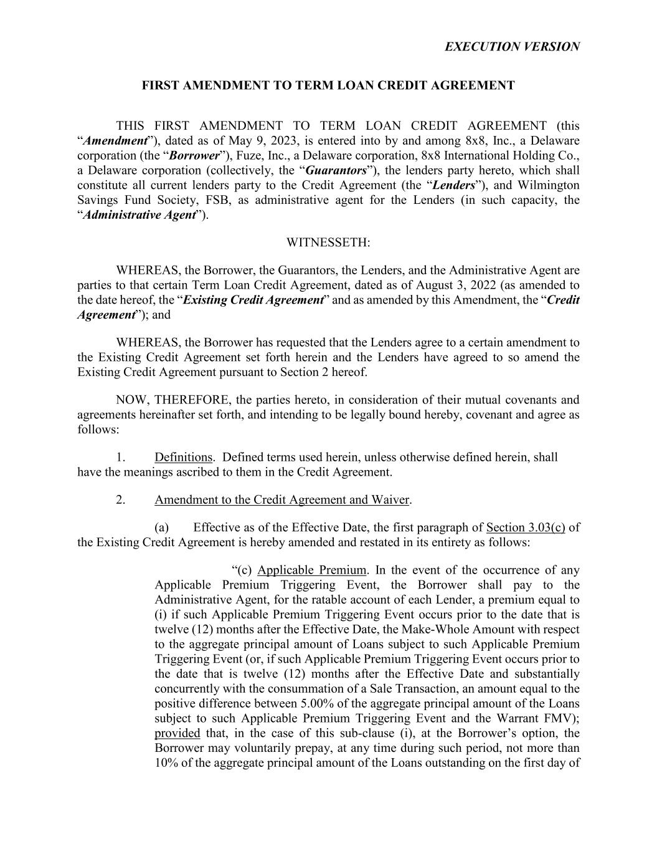
31
EXECUTION VERSION FIRST AMENDMENT TO TERM LOAN CREDIT AGREEMENT THIS FIRST AMENDMENT TO TERM LOAN CREDIT AGREEMENT (this “Amendment”), dated as of May 9, 2023, is entered into by and among 8x8, Inc., a Delaware corporation (the “Borrower”), Fuze, Inc., a Delaware corporation, 8x8 International Holding Co., a Delaware corporation (collectively, the “Guarantors”), the lenders party hereto, which shall constitute all current lenders party to the Credit Agreement (the “Lenders”), and Wilmington Savings Fund Society, FSB, as administrative agent for the Lenders (in such capacity, the “Administrative Agent”). WITNESSETH: WHEREAS, the Borrower, the Guarantors, the Lenders, and the Administrative Agent are parties to that certain Term Loan Credit Agreement, dated as of August 3, 2022 (as amended to the date hereof, the “Existing Credit Agreement” and as amended by this Amendment, the “Credit Agreement”); and WHEREAS, the Borrower has requested that the Lenders agree to a certain amendment to the Existing Credit Agreement set forth herein and the Lenders have agreed to so amend the Existing Credit Agreement pursuant to Section 2 hereof. NOW, THEREFORE, the parties hereto, in consideration of their mutual covenants and agreements hereinafter set forth, and intending to be legally bound hereby, covenant and agree as follows: 1. Definitions. Defined terms used herein, unless otherwise defined herein, shall have the meanings ascribed to them in the Credit Agreement. 2. Amendment to the Credit Agreement and Waiver. (a) Effective as of the Effective Date, the first paragraph of Section 3.03(c) of the Existing Credit Agreement is hereby amended and restated in its entirety as follows: “(c) Applicable Premium. In the event of the occurrence of any Applicable Premium Triggering Event, the Borrower shall pay to the Administrative Agent, for the ratable account of each Lender, a premium equal to (i) if such Applicable Premium Triggering Event occurs prior to the date that is twelve (12) months after the Effective Date, the Make-Whole Amount with respect to the aggregate principal amount of Loans subject to such Applicable Premium Triggering Event (or, if such Applicable Premium Triggering Event occurs prior to the date that is twelve (12) months after the Effective Date and substantially concurrently with the consummation of a Sale Transaction, an amount equal to the positive difference between 5.00% of the aggregate principal amount of the Loans subject to such Applicable Premium Triggering Event and the Warrant FMV); provided that, in the case of this sub-clause (i), at the Borrower’s option, the Borrower may voluntarily prepay, at any time during such period, not more than 10% of the aggregate principal amount of the Loans outstanding on the first day of

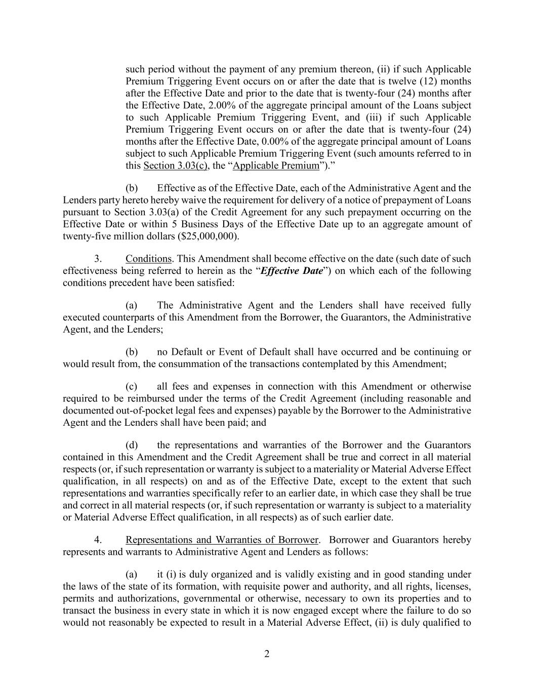
2 such period without the payment of any premium thereon, (ii) if such Applicable Premium Triggering Event occurs on or after the date that is twelve (12) months after the Effective Date and prior to the date that is twenty-four (24) months after the Effective Date, 2.00% of the aggregate principal amount of the Loans subject to such Applicable Premium Triggering Event, and (iii) if such Applicable Premium Triggering Event occurs on or after the date that is twenty-four (24) months after the Effective Date, 0.00% of the aggregate principal amount of Loans subject to such Applicable Premium Triggering Event (such amounts referred to in this Section 3.03(c), the “Applicable Premium”).” (b) Effective as of the Effective Date, each of the Administrative Agent and the Lenders party hereto hereby waive the requirement for delivery of a notice of prepayment of Loans pursuant to Section 3.03(a) of the Credit Agreement for any such prepayment occurring on the Effective Date or within 5 Business Days of the Effective Date up to an aggregate amount of twenty-five million dollars ($25,000,000). 3. Conditions. This Amendment shall become effective on the date (such date of such effectiveness being referred to herein as the “Effective Date”) on which each of the following conditions precedent have been satisfied: (a) The Administrative Agent and the Lenders shall have received fully executed counterparts of this Amendment from the Borrower, the Guarantors, the Administrative Agent, and the Lenders; (b) no Default or Event of Default shall have occurred and be continuing or would result from, the consummation of the transactions contemplated by this Amendment; (c) all fees and expenses in connection with this Amendment or otherwise required to be reimbursed under the terms of the Credit Agreement (including reasonable and documented out-of-pocket legal fees and expenses) payable by the Borrower to the Administrative Agent and the Lenders shall have been paid; and (d) the representations and warranties of the Borrower and the Guarantors contained in this Amendment and the Credit Agreement shall be true and correct in all material respects (or, if such representation or warranty is subject to a materiality or Material Adverse Effect qualification, in all respects) on and as of the Effective Date, except to the extent that such representations and warranties specifically refer to an earlier date, in which case they shall be true and correct in all material respects (or, if such representation or warranty is subject to a materiality or Material Adverse Effect qualification, in all respects) as of such earlier date. 4. Representations and Warranties of Borrower. Borrower and Guarantors hereby represents and warrants to Administrative Agent and Lenders as follows: (a) it (i) is duly organized and is validly existing and in good standing under the laws of the state of its formation, with requisite power and authority, and all rights, licenses, permits and authorizations, governmental or otherwise, necessary to own its properties and to transact the business in every state in which it is now engaged except where the failure to do so would not reasonably be expected to result in a Material Adverse Effect, (ii) is duly qualified to

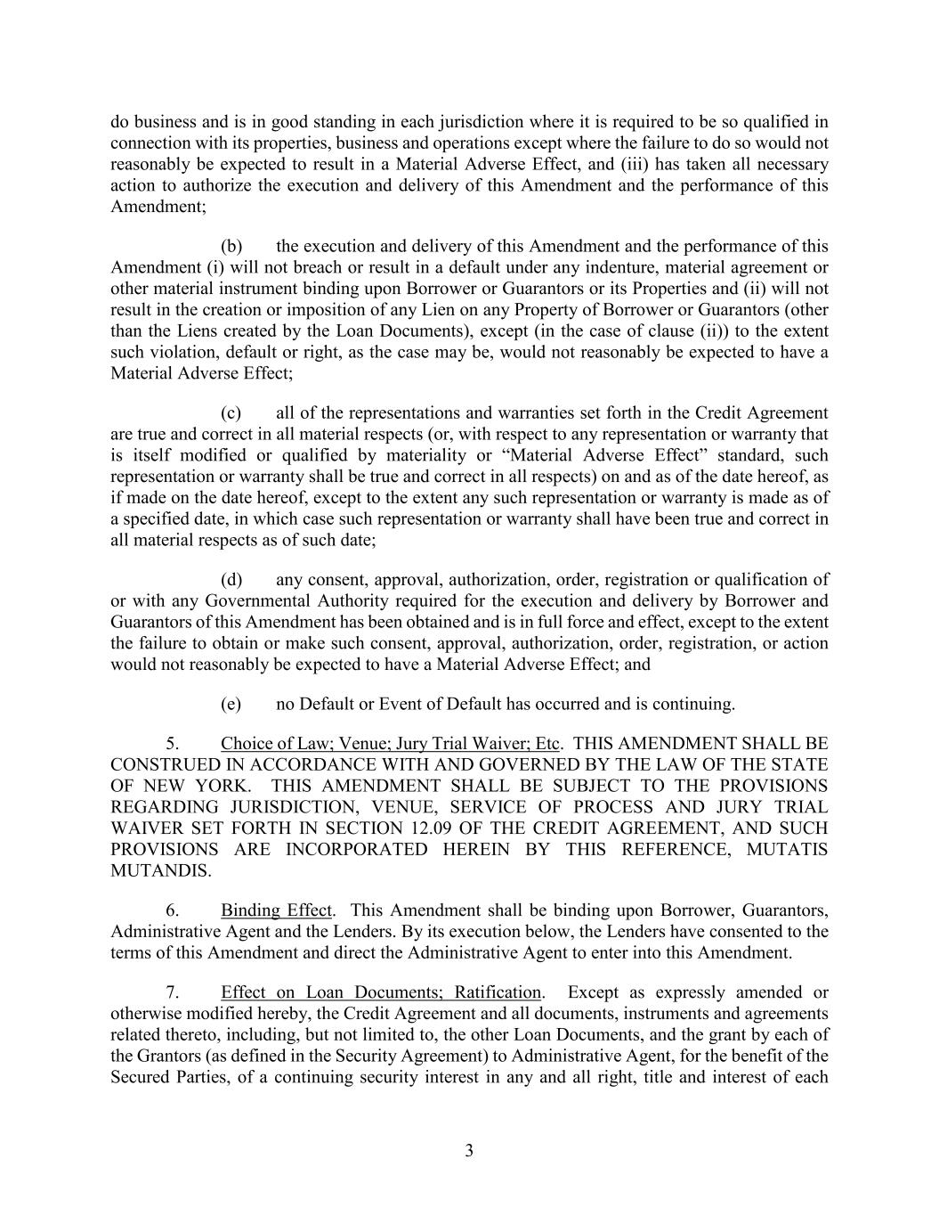
3 do business and is in good standing in each jurisdiction where it is required to be so qualified in connection with its properties, business and operations except where the failure to do so would not reasonably be expected to result in a Material Adverse Effect, and (iii) has taken all necessary action to authorize the execution and delivery of this Amendment and the performance of this Amendment; (b) the execution and delivery of this Amendment and the performance of this Amendment (i) will not breach or result in a default under any indenture, material agreement or other material instrument binding upon Borrower or Guarantors or its Properties and (ii) will not result in the creation or imposition of any Lien on any Property of Borrower or Guarantors (other than the Liens created by the Loan Documents), except (in the case of clause (ii)) to the extent such violation, default or right, as the case may be, would not reasonably be expected to have a Material Adverse Effect; (c) all of the representations and warranties set forth in the Credit Agreement are true and correct in all material respects (or, with respect to any representation or warranty that is itself modified or qualified by materiality or “Material Adverse Effect” standard, such representation or warranty shall be true and correct in all respects) on and as of the date hereof, as if made on the date hereof, except to the extent any such representation or warranty is made as of a specified date, in which case such representation or warranty shall have been true and correct in all material respects as of such date; (d) any consent, approval, authorization, order, registration or qualification of or with any Governmental Authority required for the execution and delivery by Borrower and Guarantors of this Amendment has been obtained and is in full force and effect, except to the extent the failure to obtain or make such consent, approval, authorization, order, registration, or action would not reasonably be expected to have a Material Adverse Effect; and (e) no Default or Event of Default has occurred and is continuing. 5. Choice of Law; Venue; Jury Trial Waiver; Etc. THIS AMENDMENT SHALL BE CONSTRUED IN ACCORDANCE WITH AND GOVERNED BY THE LAW OF THE STATE OF NEW YORK. THIS AMENDMENT SHALL BE SUBJECT TO THE PROVISIONS REGARDING JURISDICTION, VENUE, SERVICE OF PROCESS AND JURY TRIAL WAIVER SET FORTH IN SECTION 12.09 OF THE CREDIT AGREEMENT, AND SUCH PROVISIONS ARE INCORPORATED HEREIN BY THIS REFERENCE, MUTATIS MUTANDIS. 6. Binding Effect. This Amendment shall be binding upon Borrower, Guarantors, Administrative Agent and the Lenders. By its execution below, the Lenders have consented to the terms of this Amendment and direct the Administrative Agent to enter into this Amendment. 7. Effect on Loan Documents; Ratification. Except as expressly amended or otherwise modified hereby, the Credit Agreement and all documents, instruments and agreements related thereto, including, but not limited to, the other Loan Documents, and the grant by each of the Grantors (as defined in the Security Agreement) to Administrative Agent, for the benefit of the Secured Parties, of a continuing security interest in any and all right, title and interest of each

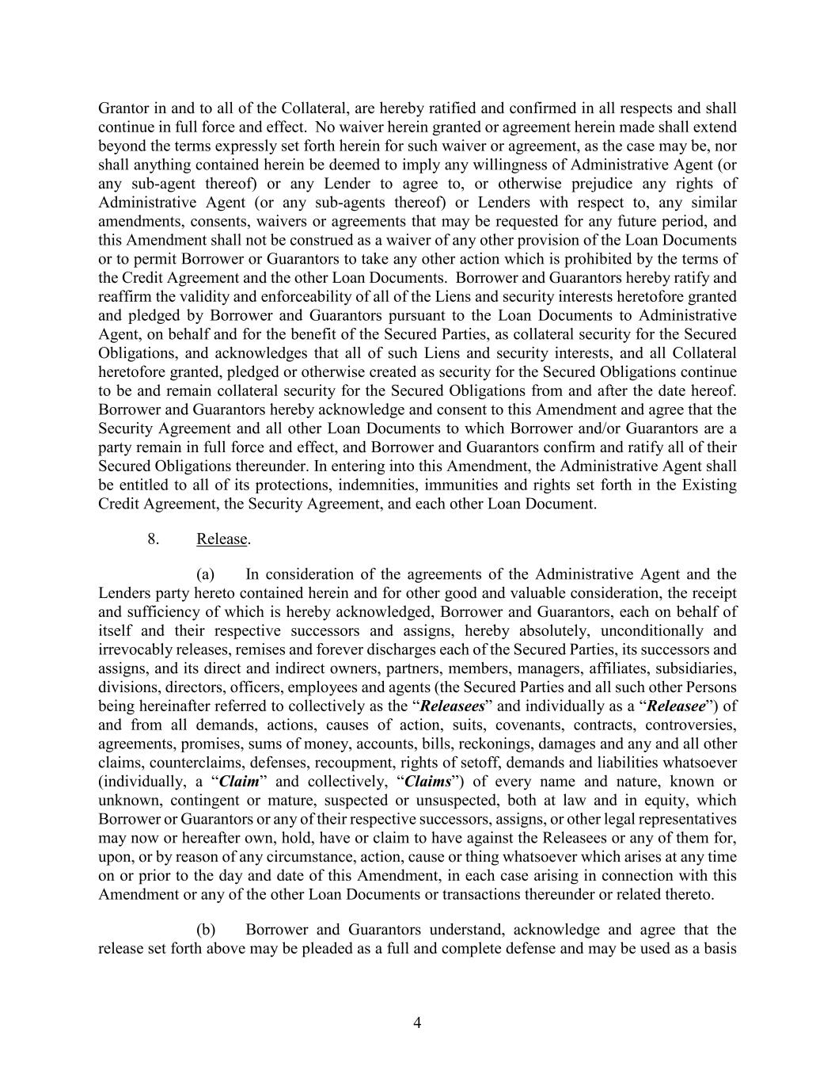
4 Grantor in and to all of the Collateral, are hereby ratified and confirmed in all respects and shall continue in full force and effect. No waiver herein granted or agreement herein made shall extend beyond the terms expressly set forth herein for such waiver or agreement, as the case may be, nor shall anything contained herein be deemed to imply any willingness of Administrative Agent (or any sub-agent thereof) or any Lender to agree to, or otherwise prejudice any rights of Administrative Agent (or any sub-agents thereof) or Lenders with respect to, any similar amendments, consents, waivers or agreements that may be requested for any future period, and this Amendment shall not be construed as a waiver of any other provision of the Loan Documents or to permit Borrower or Guarantors to take any other action which is prohibited by the terms of the Credit Agreement and the other Loan Documents. Borrower and Guarantors hereby ratify and reaffirm the validity and enforceability of all of the Liens and security interests heretofore granted and pledged by Borrower and Guarantors pursuant to the Loan Documents to Administrative Agent, on behalf and for the benefit of the Secured Parties, as collateral security for the Secured Obligations, and acknowledges that all of such Liens and security interests, and all Collateral heretofore granted, pledged or otherwise created as security for the Secured Obligations continue to be and remain collateral security for the Secured Obligations from and after the date hereof. Borrower and Guarantors hereby acknowledge and consent to this Amendment and agree that the Security Agreement and all other Loan Documents to which Borrower and/or Guarantors are a party remain in full force and effect, and Borrower and Guarantors confirm and ratify all of their Secured Obligations thereunder. In entering into this Amendment, the Administrative Agent shall be entitled to all of its protections, indemnities, immunities and rights set forth in the Existing Credit Agreement, the Security Agreement, and each other Loan Document. 8. Release. (a) In consideration of the agreements of the Administrative Agent and the Lenders party hereto contained herein and for other good and valuable consideration, the receipt and sufficiency of which is hereby acknowledged, Borrower and Guarantors, each on behalf of itself and their respective successors and assigns, hereby absolutely, unconditionally and irrevocably releases, remises and forever discharges each of the Secured Parties, its successors and assigns, and its direct and indirect owners, partners, members, managers, affiliates, subsidiaries, divisions, directors, officers, employees and agents (the Secured Parties and all such other Persons being hereinafter referred to collectively as the “Releasees” and individually as a “Releasee”) of and from all demands, actions, causes of action, suits, covenants, contracts, controversies, agreements, promises, sums of money, accounts, bills, reckonings, damages and any and all other claims, counterclaims, defenses, recoupment, rights of setoff, demands and liabilities whatsoever (individually, a “Claim” and collectively, “Claims”) of every name and nature, known or unknown, contingent or mature, suspected or unsuspected, both at law and in equity, which Borrower or Guarantors or any of their respective successors, assigns, or other legal representatives may now or hereafter own, hold, have or claim to have against the Releasees or any of them for, upon, or by reason of any circumstance, action, cause or thing whatsoever which arises at any time on or prior to the day and date of this Amendment, in each case arising in connection with this Amendment or any of the other Loan Documents or transactions thereunder or related thereto. (b) Borrower and Guarantors understand, acknowledge and agree that the release set forth above may be pleaded as a full and complete defense and may be used as a basis

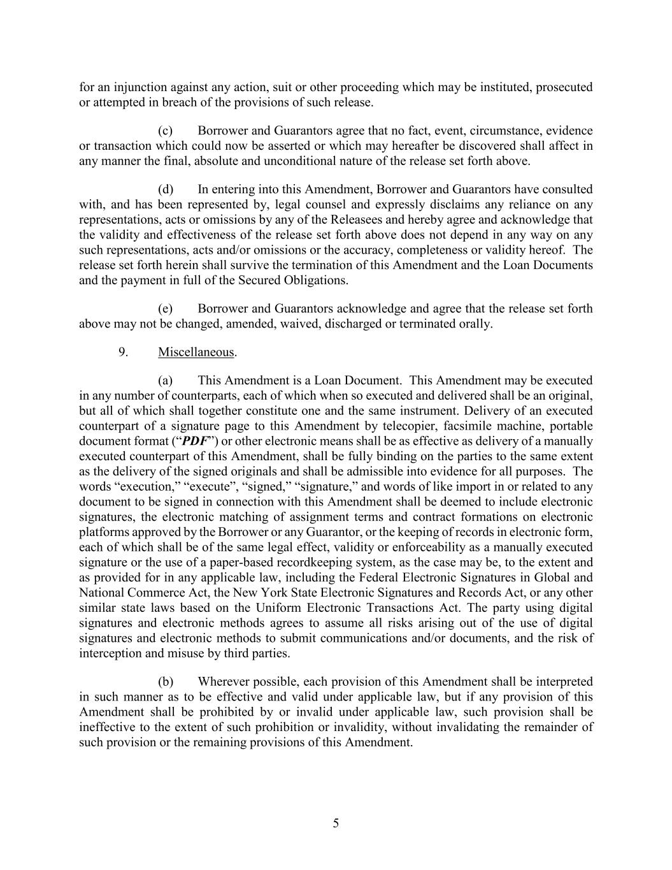
5 for an injunction against any action, suit or other proceeding which may be instituted, prosecuted or attempted in breach of the provisions of such release. (c) Borrower and Guarantors agree that no fact, event, circumstance, evidence or transaction which could now be asserted or which may hereafter be discovered shall affect in any manner the final, absolute and unconditional nature of the release set forth above. (d) In entering into this Amendment, Borrower and Guarantors have consulted with, and has been represented by, legal counsel and expressly disclaims any reliance on any representations, acts or omissions by any of the Releasees and hereby agree and acknowledge that the validity and effectiveness of the release set forth above does not depend in any way on any such representations, acts and/or omissions or the accuracy, completeness or validity hereof. The release set forth herein shall survive the termination of this Amendment and the Loan Documents and the payment in full of the Secured Obligations. (e) Borrower and Guarantors acknowledge and agree that the release set forth above may not be changed, amended, waived, discharged or terminated orally. 9. Miscellaneous. (a) This Amendment is a Loan Document. This Amendment may be executed in any number of counterparts, each of which when so executed and delivered shall be an original, but all of which shall together constitute one and the same instrument. Delivery of an executed counterpart of a signature page to this Amendment by telecopier, facsimile machine, portable document format (“PDF”) or other electronic means shall be as effective as delivery of a manually executed counterpart of this Amendment, shall be fully binding on the parties to the same extent as the delivery of the signed originals and shall be admissible into evidence for all purposes. The words “execution,” “execute”, “signed,” “signature,” and words of like import in or related to any document to be signed in connection with this Amendment shall be deemed to include electronic signatures, the electronic matching of assignment terms and contract formations on electronic platforms approved by the Borrower or any Guarantor, or the keeping of records in electronic form, each of which shall be of the same legal effect, validity or enforceability as a manually executed signature or the use of a paper-based recordkeeping system, as the case may be, to the extent and as provided for in any applicable law, including the Federal Electronic Signatures in Global and National Commerce Act, the New York State Electronic Signatures and Records Act, or any other similar state laws based on the Uniform Electronic Transactions Act. The party using digital signatures and electronic methods agrees to assume all risks arising out of the use of digital signatures and electronic methods to submit communications and/or documents, and the risk of interception and misuse by third parties. (b) Wherever possible, each provision of this Amendment shall be interpreted in such manner as to be effective and valid under applicable law, but if any provision of this Amendment shall be prohibited by or invalid under applicable law, such provision shall be ineffective to the extent of such prohibition or invalidity, without invalidating the remainder of such provision or the remaining provisions of this Amendment.

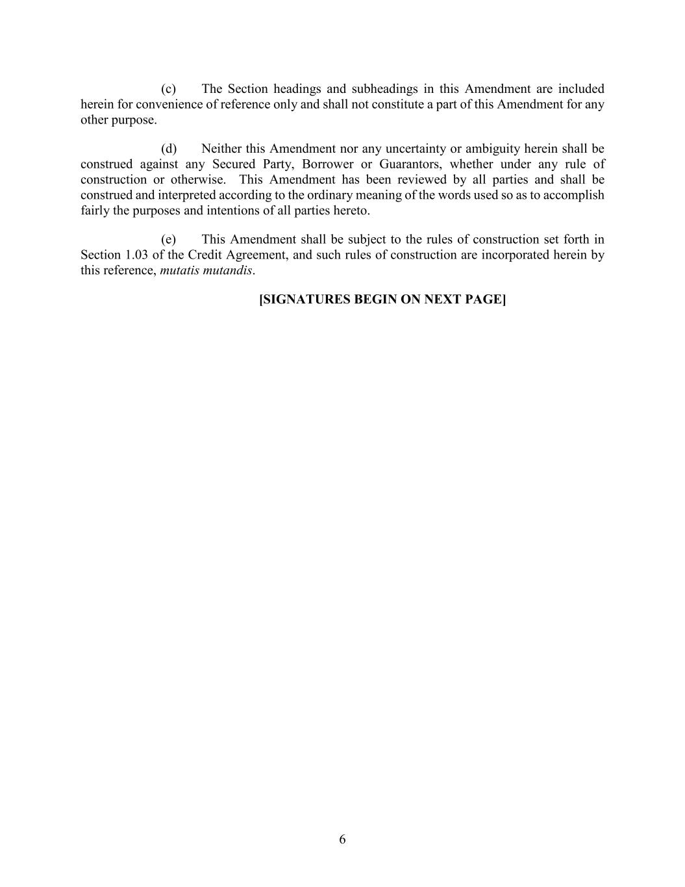
6 (c) The Section headings and subheadings in this Amendment are included herein for convenience of reference only and shall not constitute a part of this Amendment for any other purpose. (d) Neither this Amendment nor any uncertainty or ambiguity herein shall be construed against any Secured Party, Borrower or Guarantors, whether under any rule of construction or otherwise. This Amendment has been reviewed by all parties and shall be construed and interpreted according to the ordinary meaning of the words used so as to accomplish fairly the purposes and intentions of all parties hereto. (e) This Amendment shall be subject to the rules of construction set forth in Section 1.03 of the Credit Agreement, and such rules of construction are incorporated herein by this reference, mutatis mutandis. [SIGNATURES BEGIN ON NEXT PAGE]

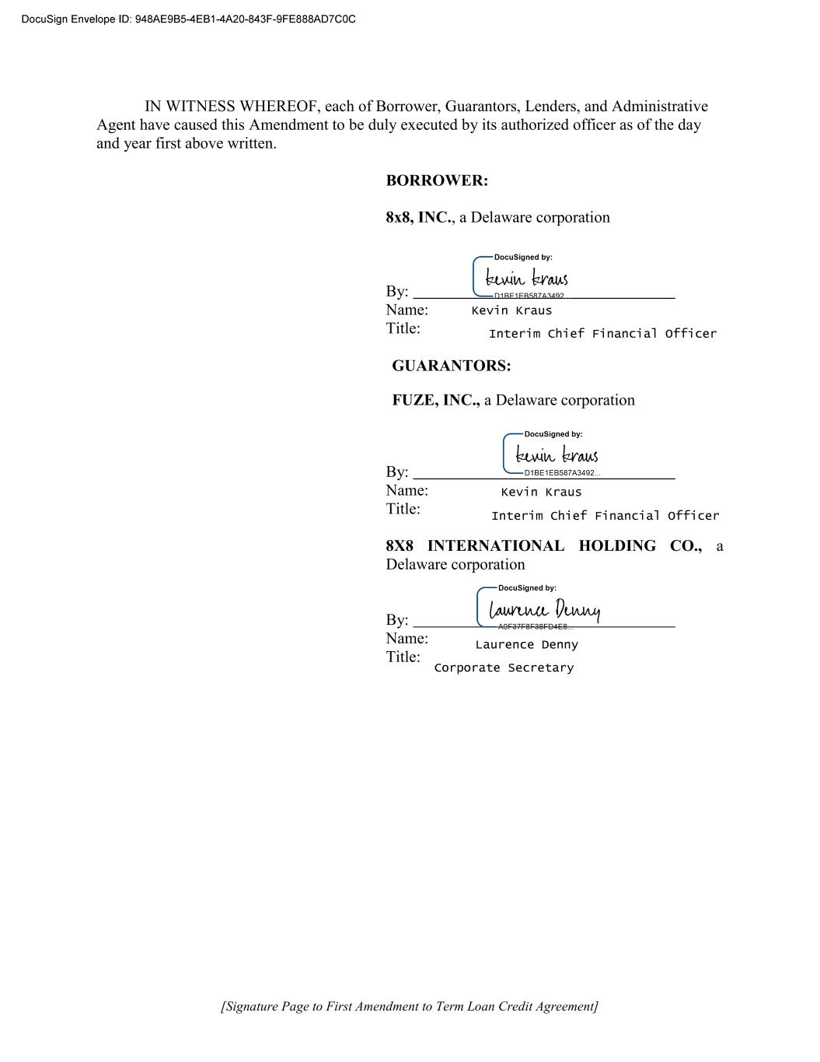
[Signature Page to First Amendment to Term Loan Credit Agreement] IN WITNESS WHEREOF, each of Borrower, Guarantors, Lenders, and Administrative Agent have caused this Amendment to be duly executed by its authorized officer as of the day and year first above written. BORROWER: 8x8, INC., a Delaware corporation By: Name: Title: GUARANTORS: FUZE, INC., a Delaware corporation By: Name: Title: 8X8 INTERNATIONAL HOLDING CO., a Delaware corporation By: Name: Title:

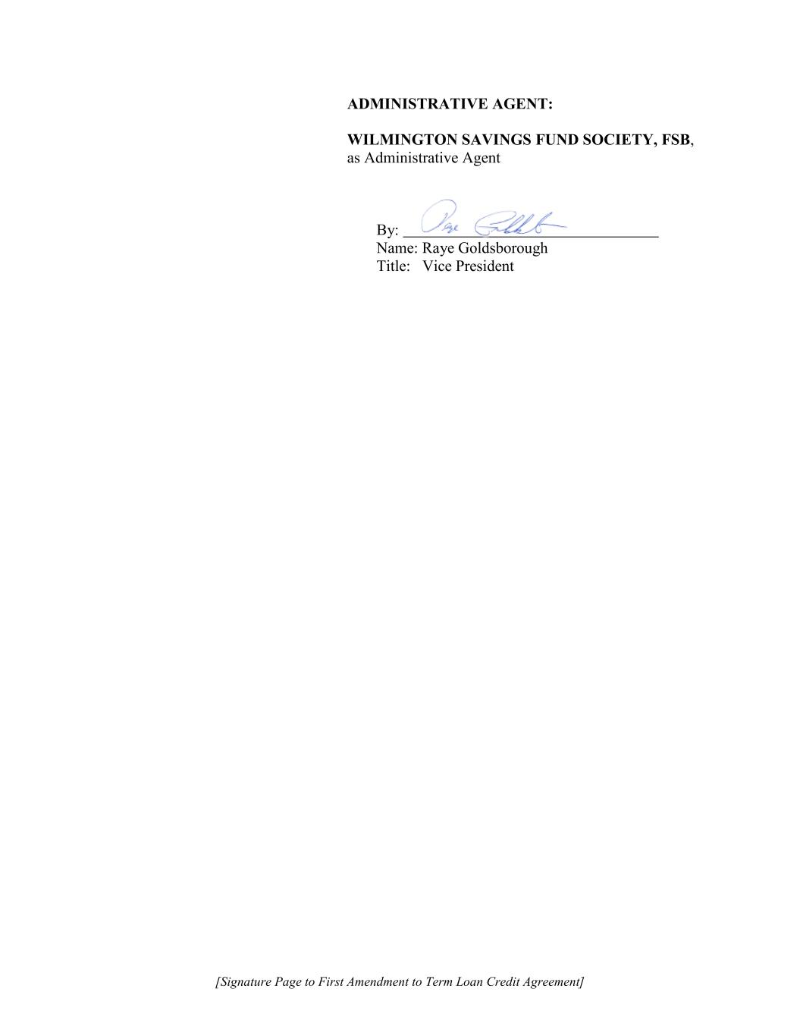
[Signature Page to First Amendment to Term Loan Credit Agreement] ADMINISTRATIVE AGENT: WILMINGTON SAVINGS FUND SOCIETY, FSB, as Administrative Agent By: Name: Raye Goldsborough Title: Vice President

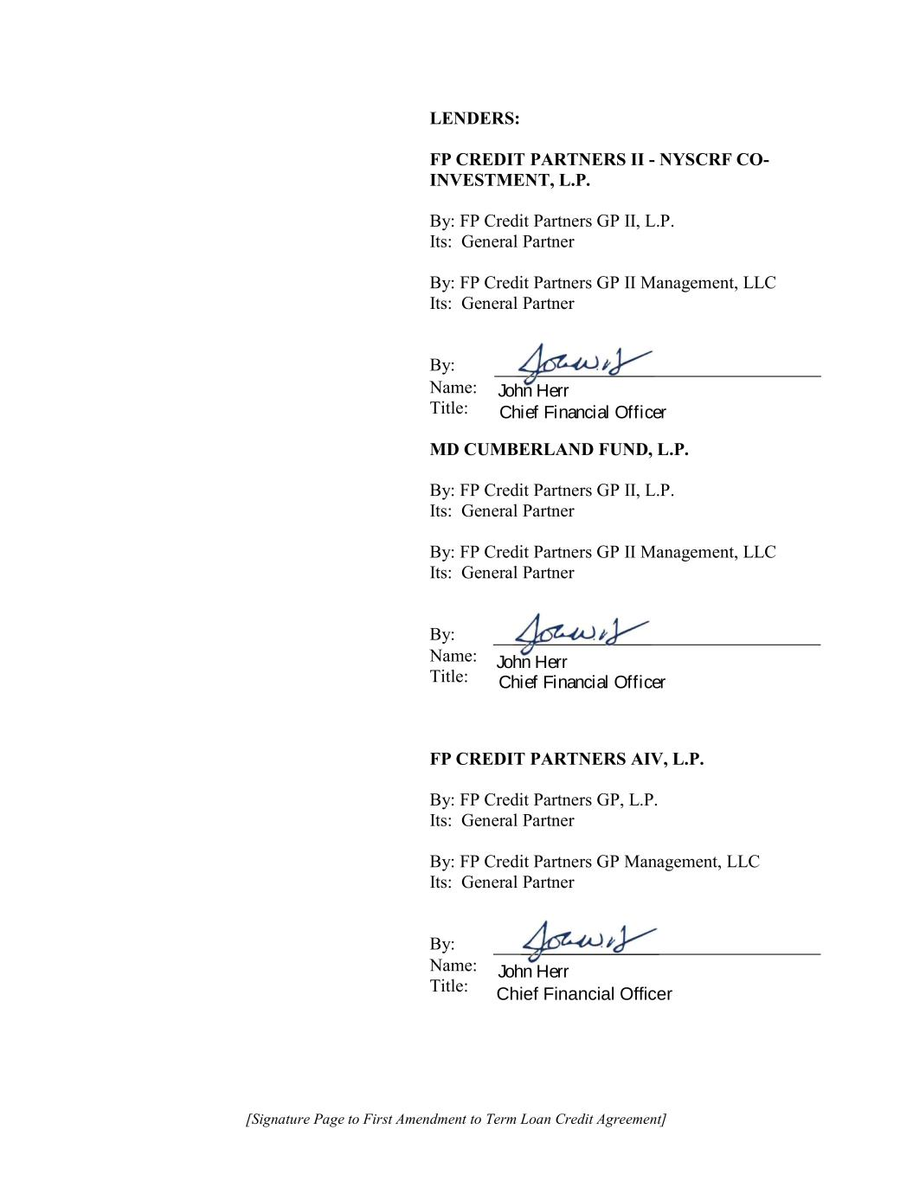
[Signature Page to First Amendment to Term Loan Credit Agreement] LENDERS: FP CREDIT PARTNERS II - NYSCRF CO- INVESTMENT, L.P. By: FP Credit Partners GP II, L.P. Its: General Partner By: FP Credit Partners GP II Management, LLC Its: General Partner By: Name: Title: MD CUMBERLAND FUND, L.P. By: FP Credit Partners GP II, L.P. Its: General Partner By: FP Credit Partners GP II Management, LLC Its: General Partner By: Name: Title: FP CREDIT PARTNERS AIV, L.P. By: FP Credit Partners GP, L.P. Its: General Partner By: FP Credit Partners GP Management, LLC Its: General Partner By: Name: Title: John Herr Chief Financial Officer John Herr Chief Financial Officer John Herr Chief Financial Officer

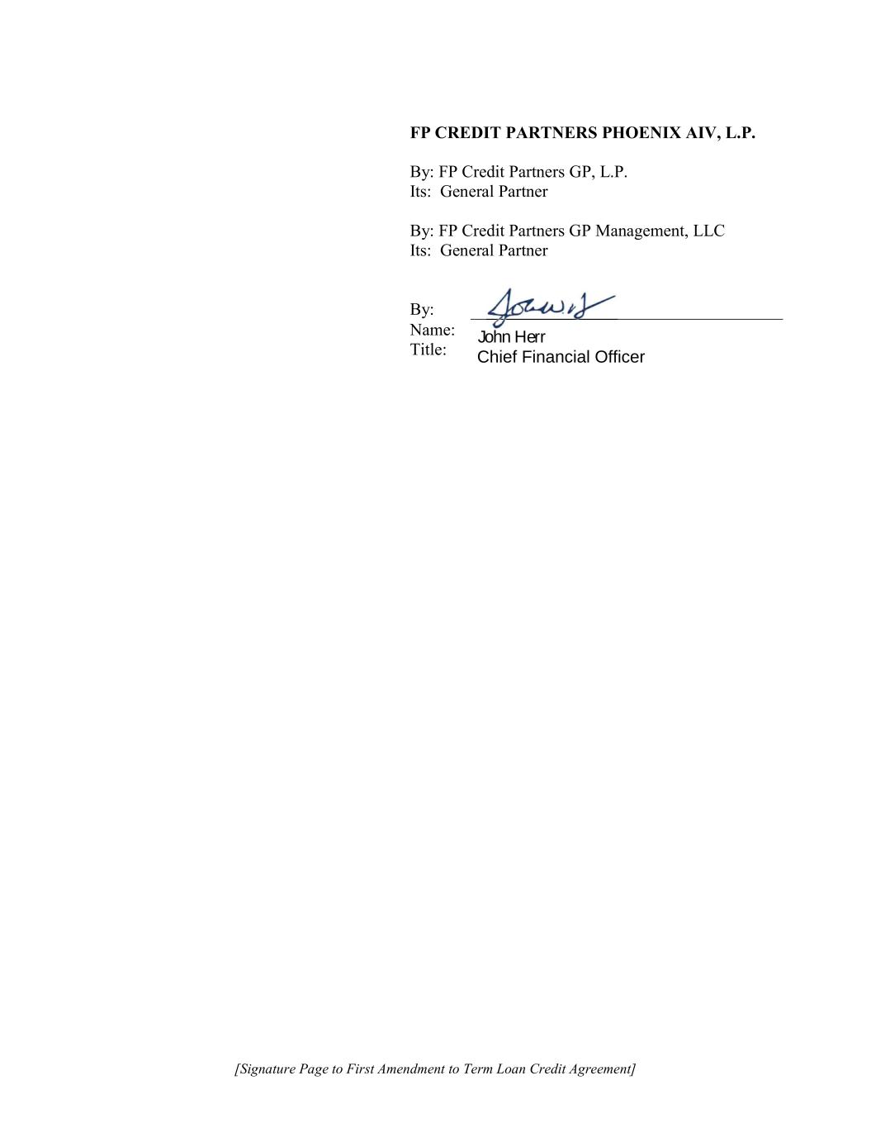
[Signature Page to First Amendment to Term Loan Credit Agreement] FP CREDIT PARTNERS PHOENIX AIV, L.P. By: FP Credit Partners GP, L.P. Its: General Partner By: FP Credit Partners GP Management, LLC Its: General Partner By: Name: Title: John Herr Chief Financial Officer

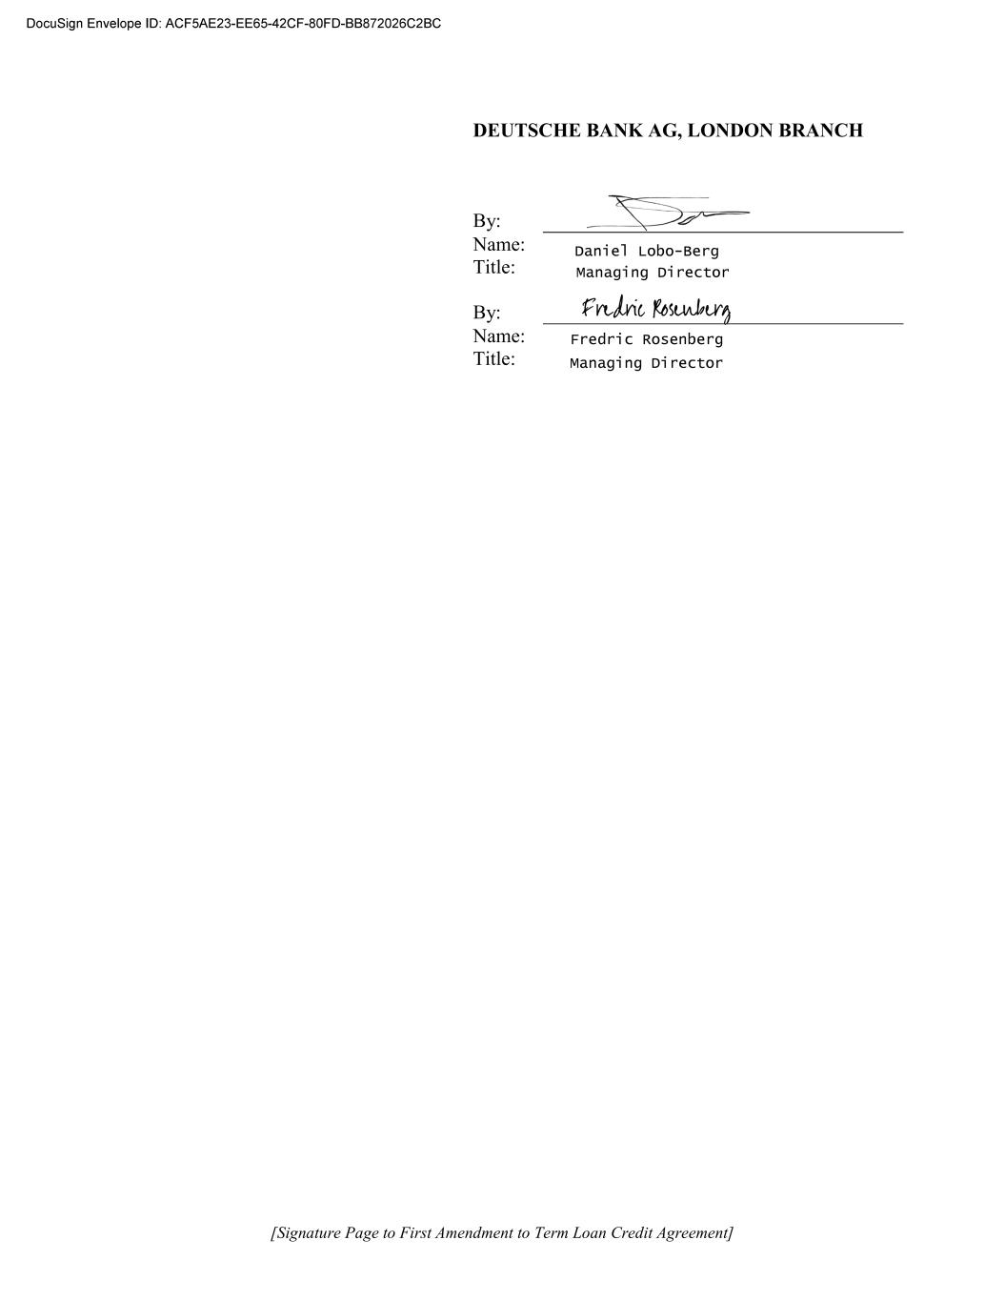
[Signature Page to First Amendment to Term Loan Credit Agreement] DEUTSCHE BANK AG, LONDON BRANCH By: Name: Title: By: Name: Title:

Exhibit 31.1
CERTIFICATION PURSUANT TO
RULES 13a-14(a) AND 15d-14(a) UNDER THE SECURITIES EXCHANGE ACT OF 1934
AS ADOPTED PURSUANT TO
SECTION 302 OF THE SARBANES-OXLEY ACT OF 2002
I, Samuel Wilson, certify that:
1.I have reviewed this quarterly report on Form 10-Q of 8x8, Inc.;
2.Based on my knowledge, this report does not contain any untrue statement of a material fact or omit to state a material fact necessary to make the statements made, in light of the circumstances under which such statements were made, not misleading with respect to the period covered by this report;
3.Based on my knowledge, the financial statements, and other financial information included in this report, fairly present in all material respects the financial condition, results of operations and cash flows of the registrant as of, and for, the periods presented in this report;
4.The registrant's other certifying officer and I are responsible for establishing and maintaining disclosure controls and procedures (as defined in Exchange Act Rules 13a-15(e) and 15d-15(e)) and internal control over financial reporting (as defined in Exchange Act Rules 13a-15(f) and 15d-15(f)) for the registrant and have:
a.Designed such disclosure controls and procedures, or caused such disclosure controls and procedures to be designed under our supervision, to ensure that material information relating to the registrant, including its consolidated subsidiaries, is made known to us by others within those entities, particularly during the period in which this report is being prepared;
b.Designed such internal control over financial reporting, or caused such internal control over financial reporting to be designed under our supervision, to provide reasonable assurance regarding the reliability of financial reporting and the preparation of financial statements for external purposes in accordance with generally accepted accounting principles;
c.Evaluated the effectiveness of the registrant's disclosure controls and procedures and presented in this report our conclusions about the effectiveness of the disclosure controls and procedures as of the end of the period covered by this report based on such evaluation; and
d.Disclosed in this report any change in the registrant's internal control over financial reporting that occurred during the registrant's most recent fiscal quarter (the registrant's fourth fiscal quarter in the case of an annual report) that has materially affected, or is reasonably likely to materially affect, the registrant's internal control over financial reporting; and
5.The registrant's other certifying officer and I have disclosed, based on our most recent evaluation of internal control over financial reporting, to the registrant's auditors and the audit committee of the registrant's board of directors (or persons performing the equivalent functions):
a.All significant deficiencies and material weaknesses in the design or operation of internal control over financial reporting which are reasonably likely to adversely affect the registrant's ability to record, process, summarize and report financial information; and
b.Any fraud, whether or not material, that involves management or other employees who have a significant role in the registrant's internal control over financial reporting.

February 1, 2024
/s/ Samuel Wilson
Samuel Wilson
Chief Executive Officer

Exhibit 31.2
CERTIFICATION PURSUANT TO
RULES 13a-14(a) AND 15d-14(a) UNDER THE SECURITIES EXCHANGE ACT OF 1934
AS ADOPTED PURSUANT TO
SECTION 302 OF THE SARBANES-OXLEY ACT OF 2002
I, Kevin Kraus, certify that:
1.I have reviewed this Quarterly report on Form 10-Q of 8x8, Inc.;
2.Based on my knowledge, this report does not contain any untrue statement of a material fact or omit to state a material fact necessary to make the statements made, in light of the circumstances under which such statements were made, not misleading with respect to the period covered by this report;
3.Based on my knowledge, the financial statements, and other financial information included in this report, fairly present in all material respects the financial condition, results of operations and cash flows of the registrant as of, and for, the periods presented in this report;
4.The registrant's other certifying officer and I are responsible for establishing and maintaining disclosure controls and procedures (as defined in Exchange Act Rules 13a-15(e) and 15d-15(e)) and internal control over financial reporting (as defined in Exchange Act Rules 13a-15(f) and 15d-15(f)) for the registrant and have:
a.Designed such disclosure controls and procedures, or caused such disclosure controls and procedures to be designed under our supervision, to ensure that material information relating to the registrant, including its consolidated subsidiaries, is made known to us by others within those entities, particularly during the period in which this report is being prepared;
b.Designed such internal control over financial reporting, or caused such internal control over financial reporting to be designed under our supervision, to provide reasonable assurance regarding the reliability of financial reporting and the preparation of financial statements for external purposes in accordance with generally accepted accounting principles;
c.Evaluated the effectiveness of the registrant's disclosure controls and procedures and presented in this report our conclusions about the effectiveness of the disclosure controls and procedures as of the end of the period covered by this report based on such evaluation; and
d.Disclosed in this report any change in the registrant's internal control over financial reporting that occurred during the registrant's most recent fiscal quarter (the registrant's fourth fiscal quarter in the case of an annual report) that has materially affected, or is reasonably likely to materially affect, the registrant's internal control over financial reporting; and
5.The registrant's other certifying officer and I have disclosed, based on our most recent evaluation of internal control over financial reporting, to the registrant's auditors and the audit committee of the registrant's board of directors (or persons performing the equivalent functions):
a.All significant deficiencies and material weaknesses in the design or operation of internal control over financial reporting which are reasonably likely to adversely affect the registrant's ability to record, process, summarize and report financial information; and
b.Any fraud, whether or not material, that involves management or other employees who have a significant role in the registrant's internal control over financial reporting.

February 1, 2024
/s/ Kevin Kraus
Kevin Kraus
Chief Financial Officer

Exhibit 32.1
CERTIFICATION PURSUANT TO
18 U.S. C. SECTION 1350,
AS ADOPTED PURSUANT TO
SECTION 906 OF THE SARBANES-OXLEY ACT OF 2002
In connection with the Quarterly Report on Form 10-Q of 8x8, Inc. (the "Company") for the period ended December 31, 2023, as filed with the Securities and Exchange Commission on the date hereof (the "Report"), I, Samuel Wilson, Chief Executive Officer of the Company, hereby certify, pursuant to 18 U.S.C. Section 1350, as adopted pursuant to Section 906 of the Sarbanes-Oxley Act of 2002, that:
1.The Report fully complies with the requirements of Section 13(a) or 15(d) of the Securities Exchange Act of 1934; and
2.The information contained in the Report fairly presents, in all material respects, the financial condition and results of operations of the Company.

/s/ Samuel Wilson
Samuel Wilson
Chief Executive Officer
February 1, 2024
This certification accompanies this Report pursuant to § 906 of the Sarbanes-Oxley Act of 2002 and shall not, except to the extent required by the Sarbanes-Oxley Act of 2002, or otherwise required, be deemed filed by the Company for purposes of § 18 of the Securities Exchange Act of 1934, as amended.

Exhibit 32.2
CERTIFICATION PURSUANT TO
18 U.S. C. SECTION 1350,
AS ADOPTED PURSUANT TO
SECTION 906 OF THE SARBANES-OXLEY ACT OF 2002
In connection with the Quarterly Report on Form 10-Q of 8x8, Inc. (the "Company") for the period ended December 31, 2023, as filed with the Securities and Exchange Commission on the date hereof (the "Report"), I, Kevin Kraus, Chief Financial Officer of the Company, hereby certify, pursuant to 18 U.S.C. Section 1350, as adopted pursuant to Section 906 of the Sarbanes-Oxley Act of 2002, that:
1.The Report fully complies with the requirements of Section 13(a) or 15(d) of the Securities Exchange Act of 1934; and
2.The information contained in the Report fairly presents, in all material respects, the financial condition and results of operations of the Company.

/s/ Kevin Kraus
Kevin Kraus
Chief Financial Officer
February 1, 2024
This certification accompanies this Report pursuant to §906 of the Sarbanes-Oxley Act of 2002 and shall not, except to the extent required by the Sarbanes-Oxley Act of 2002, or otherwise required, be deemed filed by the Company for purposes of §18 of the Securities Exchange Act of 1934, as amended.

