UNITED STATES
SECURITIES AND EXCHANGE COMMISSION
Washington, D.C. 20549
 |  |  | FORM |  |  | 8-K
CURRENT REPORT
Pursuant to Section 13 or 15(d) of the Securities Exchange Act of 1934
August 3, 2026
Date of Report (Date of earliest event reported)
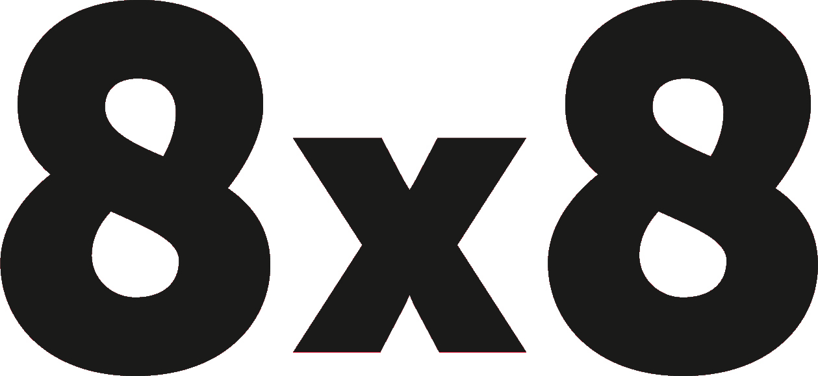
(Exact name of registrant as specified in its charter)
Delaware |  |  |  |  |  | 001-38312 |  |  |  |  |  | 77-0142404
(State or other jurisdiction of incorporation) |  |  |  |  |  | (Commission File Number) |  |  |  |  |  | (I.R.S. Employer Identification Number)
675 Creekside Way
Campbell, CA 95008
(Address of principal executive offices including zip code)
(408) 727-1885
(Registrant's telephone number, including area code)
Not Applicable
(Former Name or Former Address, if Changed Since Last Report)
Check the appropriate box below if the Form 8-K filing is intended to simultaneously satisfy the filing obligation of the registrant under any of the following provisions:
☐ Written communications pursuant to Rule 425 under the Securities Act (17 CFR 230.425)
☐ Soliciting material pursuant to Rule 14a-12 under the Exchange Act (17 CFR 240.14a-12)
☐ Pre-commencement communications pursuant to Rule 14d-2(b) under the Exchange Act (17 CFR 240.14d-2(b))
☐ Pre-commencement communications pursuant to Rule 13e-4(c) under the Exchange Act (17 CFR 240.13e-4(c))
Securities registered pursuant to Section 12(b) of the Act:
Title of each class |  |  |  |  |  | Trading Symbol |  |  |  |  |  | Name of each exchange on which registered
COMMON STOCK, PAR VALUE $0.001 PER SHARE |  |  |  |  |  | EGHT |  |  |  |  |  | Nasdaq Global Select Market
Indicate by check mark whether the registrant is an emerging growth company as defined in Rule 405 of the Securities Act of 1933 (§230.405 of this chapter) or Rule 12b-2 of the Securities Exchange Act of 1934 (§240.12b-2 of this chapter).
Emerging growth company ☐
If an emerging growth company, indicate by check mark if the registrant has elected not to use the extended transition period for complying with any new or revised financial accounting standards provided pursuant to Section 13(a) of the Exchange Act. ☐

Item 5.07. Submission of Matters to a Vote of Security Holders.
On August 3, 2026, 8x8, Inc. (the “Company”) held its annual meeting of stockholders for the calendar year 2026 (the "Annual Meeting") at which a quorum for the transaction of business was present virtually or represented by proxy. There were 141,782,325 shares of common stock entitled to be voted at the Annual Meeting, of which 113,553,670 shares were voted. The stockholders voted on the following proposals at the Annual Meeting:
1. Election of eight directors to hold office until the 2027 Annual Meeting of Stockholders of the Company, and until their respective successors have been duly elected and qualified. The Company's nominees were Jaswinder Pal Singh, Monique Bonner, Andrew Burton, Todd Ford, Alison Gleeson, John Pagliuca, Elizabeth Theophille and Samuel Wilson.
2. Approval, through an advisory vote, of the Company's executive compensation for the fiscal year ended March 31, 2026.
3. Ratification of the appointment of Grant Thornton LLP as the Company's independent registered public accounting firm for the fiscal year ending March 31, 2027.
4. Approval of an amendment to the Amended and Restated 2022 Equity Incentive Plan to increase the number of shares of common stock available for issuance thereunder by 8,338,000 shares.
The final voting results were as follows:
Proposal One: Election of Directors
 |  |  | For |  |  |  |  |  | Withheld |  |  |  |  |  | Broker Non-Vote
Jaswinder Pal Singh |  |  | 79,583,180 |  |  |  |  |  | 8,499,668 |  |  |  |  |  | 25,470,822
Monique Bonner |  |  | 86,656,448 |  |  |  |  |  | 1,426,400 |  |  |  |  |  | 25,470,822
Andrew Burton |  |  | 87,117,096 |  |  |  |  |  | 965,752 |  |  |  |  |  | 25,470,822
Todd Ford |  |  | 86,835,814 |  |  |  |  |  | 1,247,034 |  |  |  |  |  | 25,470,822
Alison Gleeson |  |  | 86,805,517 |  |  |  |  |  | 1,277,331 |  |  |  |  |  | 25,470,822
John Pagliuca |  |  | 87,116,847 |  |  |  |  |  | 966,001 |  |  |  |  |  | 25,470,822
Elizabeth Theophille |  |  | 86,961,520 |  |  |  |  |  | 1,121,328 |  |  |  |  |  | 25,470,822
Samuel Wilson |  |  | 86,780,049 |  |  |  |  |  | 1,302,799 |  |  |  |  |  | 25,470,822
Each of the Company's nominees was elected to serve as a director until the next Annual Meeting of Stockholders, and until such director's successor has been duly elected and qualified.
Proposal Two: Advisory Vote on Executive Compensation
For |  |  |  |  |  | Against |  |  |  |  |  | Abstain |  |  |  |  |  | Broker Non-Vote
85,481,353 |  |  |  |  |  | 2,383,751 |  |  |  |  |  | 217,744 |  |  |  |  |  | 25,470,822
The stockholders approved, on an advisory basis, the Company's executive compensation for the fiscal year ended March 31, 2026.
Proposal Three: Ratification of Independent Registered Public Accounting Firm
For |  |  |  |  |  | Against |  |  |  |  |  | Abstain |  |  |  |  |  | Broker Non-Vote
112,266,764 |  |  |  |  |  | 529,978 |  |  |  |  |  | 756,928 |  |  |  |  |  | —
The stockholders ratified the appointment of Grant Thornton LLP as the Company's independent registered public accounting firm for the fiscal year ending March 31, 2027.
Proposal Four: Approval of Amendment to the Amended and Restated 2022 Equity Incentive Plan.
For |  |  |  |  |  | Against |  |  |  |  |  | Abstain |  |  |  |  |  | Broker Non-Vote
79,479,534 |  |  |  |  |  | 8,562,761 |  |  |  |  |  | 40,553 |  |  |  |  |  | 25,470,822
The stockholders approved the amendment to the Amended and Restated 2022 Equity Incentive Plan to increase the number of shares of common stock available for issuance thereunder by 8,338,000 shares.

SIGNATURES
Pursuant to the requirements of the Securities Exchange Act of 1934, as amended, the Registrant has duly caused this report to be signed on its behalf by the undersigned hereunto duly authorized.
Date: August 3, 2026
8x8, Inc.
By: /s/ LAURENCE DENNY
Laurence Denny
Chief Legal Officer

